SoLongSucker User Guide

Written by:
Steven Braeger
Sarah Loewy
Andrew Marsh

COP 4331
Spring 2009

Table of Contents

1.0 Overview of Application 3
2.0 Model of the Virtual World 3
3.0 Description of User Interface 3
3.1 Input File Specification (Steve:Map to Lab4) 3
3.2 Output File Specification (Steve: Leave blank (for Friday))
3.3 Interactive Inputs (Steve: Map to Lab4) 4
4.0 Describe Installation and Configuration Requirements 4

List of Figures:

List of Tables:

Your User Guide shall be structured as described by the outline and document format given below.
- Overview of Application
Describe the name and purpose of the application and enumerate its functional capabilities from the user’s perspective. Since there may be several different user types (actors), describe the system from each of their viewpoints.

Steve: Base on 2.1 from Lab4)

- Model of the Virtual World

Rules of the game:

Flow of the game:
- Assign each player a designated color.
- Give each player 7 chips of their given color.
- Randomly decide which player will make the first move. Play begins.
- Play continues until only one player remains.

Winning/Losing:
- If it becomes a player's turn, and that player has no chips to play, that player is removed from the game.
- The last player who has not been removed from the game is declared the winner.

Order of Play(within a move):
- A move is performed by placing a chip onto the table. This involves either placing a chip on a pile (laying on) or creating a new pile (laying off).
- The move is then given to another player based on a number of options.
a)If a player is defeated, the move goes to the player who just gave the defeated player the move and play continues.
b) If a capture has just occurred, the player whose color made the capture must make the next move and play continues.
c) If all players are represented in the stack, the move goes to the player whose most recently played chip is farthest down in that pile and play continues.
d) Otherwise, the player with the current move can select any player whose chip is not in that pile. If the current player lays off, any other player can be selected for the next move and play continues.

Captures:
- A capture occurs when two consecutive chips of the same color are played on the same pile.
- The player making the capture takes all the chips in the pile.
- One of the chips in the pile must be killed.
- Play continues with the player whose color made the capture as listed in the rules for Order of Play.

Bargaining:
- A bargain can occur at any time during the game.
- A bargain must be discussed openly at the playing table.
- A bargain can be accepted or denied at any time during the game.
- Any player can decide to not uphold the bargain without a penalty.

- Description of User Interface

3.1 Input File Specification (Steve:Map to Lab4)

This section describes the input file specifications relevant to successfully create a test run of the software. This software follows the Object Oriented Design Data specification. Specifically, the input file format serializes each set that will be needed to create and simulate any number of games.

Relevant tags:
SoLongSucker{ }SoLongSucker
This tag initializes and runs exactly one execution of the simulated environment.
It has only one property: numChips, which specifies the number of chips each player in the game has.
NancyNice{ }NancyNice
This tag initializes and runs exactly one Player with the AI strategy of NancyNice.
JacobJerk{ }JacobJerk
This tag initializes and runs exactly one Player with the AI strategy of JacobJerk.
RandyRandom{ }RandyRandom
This tag initializes and runs exactly one Player with the AI strategy of RandyRandom.

The following is an example of two valid input files, representing two games, one with 50% NancyNice and JacobJerk, to simulate a half and half game, and the second, with 3 RandyRandom players.

SoLongSucker{
numChips: 5
NancyNice{}NancyNice
JacobJerk{}JacobJerk
JacobJerk{}JacobJerk
NancyNice{}NancyNice
}SoLongSucker

SoLongSucker{
numChips: 3
RandyRandom{}RandyRandom
RandyRandom{}RandyRandom
RandyRandom{}RandyRandom
}SoLongSucker

3.2 Output File Specification (Steve: Leave blank (for Friday))

3.3 Interactive Inputs (Steve: Map to Lab4)
The interactive user interface, considering that this is a discrete event simulator, is very little. To begin, the user will be prompted to enter the input file controlling the simulation. It will then be prompted to enter the desired file containing the output from the simulation. A screen-shot of this process is here:

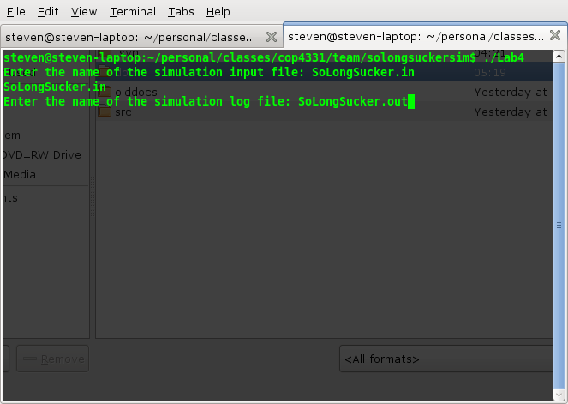

- Describe Installation and Configuration Requirements
Describe how to install the Application and run it. Give descriptions of any additional inputs or outputs required to properly configure the system for execution; describe configuration input file(s), their contents, and formatting requirements.
Steve: Map to Lab4, directions for installation (olympus server requirements).

Installation Procedure:
This section provides an in-depth guide on how to compile the source files on UCF's Olympus server.
- Upload the source code into a directory on the server and navigate to that directory using the command line.
- Type: make. This will compile the source code using the makefile and will also produce an executable application called SoLongSuckerApp.
- Type: ./SoLongSuckerApp. This will run the application.
- The prompt will now display: Enter the name of the simulation input file: Type the name of the input file to be simulated (parameters for the input file are given above).
- The next prompt will display: Enter the name of the simulation log file: Type any name desired for the log file. The log file created will contain all the messages and data produced in the simulation.

