

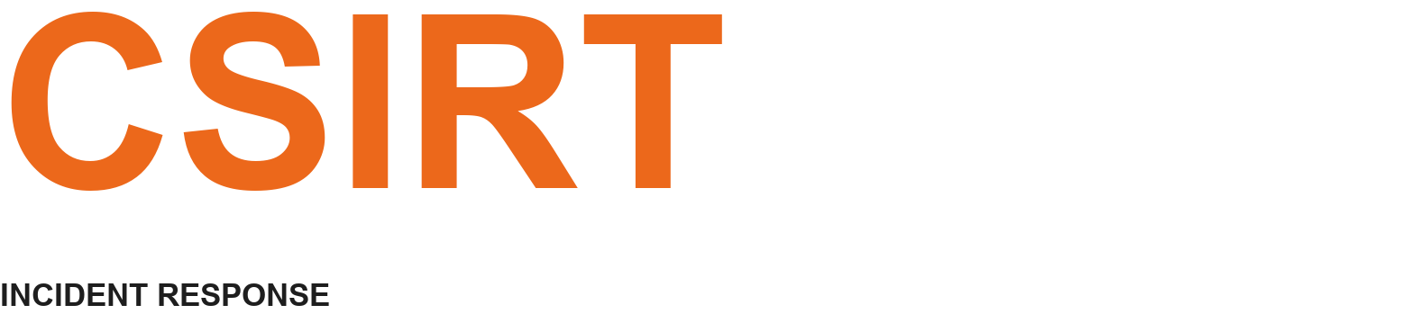

SECURITY
INCIDENT
REPORT
━━━━

▣ | CLIENT NAME  <client_name>
□ | SERVICE PROVIDER  CSIRT
◇ | PROJECT  Computer Security Incident Response
○ | NOTIFICATION DATE  <date>
▤ | PROJECT TEAM  [Head of Cyber Response Services / Forensic Investigator / Analyst]

CSIRT | Incident Response

1 Table of Contents

1 Table of Contents 1
2 Executive Summary 3
3 Scope 3
4 Analysis 3
4.1 Host 1 3
4.1.1 Remote Connections 3
4.1.2 Evidences of Execution 3
4.1.3 File System Analysis 3
4.1.4 Files and Folders Access 3
4.2 Host 2 3
4.3 Cloud 4
4.3.1 Risk Detections 4
4.3.2 Sign-in Logs 4
4.3.3 Audit Logs 4
4.4 Threat Analysis 4
4.5 Scope 4
5 Recommendations 4
6 Conclusions
6.1 Incident Categorization 4
6.2 MITRE Techniques 4
6.3 Indicators of Compromise (IOCs) 5
6.4 Compromised Devices 5
6.5 Compromised Identities 5
7 Appendix 5
7.1 Action Plan 5
7.2 Timeline 5
7.3 Forensic Evidences 6

2 Executive Summary

<Context: why the mission has been ordered by the client, what were the first findings from the client>
<Overview of report’s content, for example: “The report provides a comprehensive overview and detailed account of the findings uncovered through the forensic analysis conducted. Finally, CSIRT offers several recommendations designed to help the client enhance their level of security.”>
Here is a summary of the findings:
- <overview of the findings in a bullet points format>
Here is an overview of actions taken:
- <overview of the actions in a bullet points format>
To strengthen its security posture and prevent similar incidents from occurring in the future, the CSIRT recommends that the client:
- <recommendations in a bullet points format>

3 Scope

- <List what you’ve done in a bullet points style, what was the scope of the analysis>

4 Analysis

<Main section of the report, explain what you discovered during the analysis. Use screenshots and support your words with evidences>

4.1 Host 1

4.1.1 Remote Connections

4.1.2 Evidences of Execution

4.1.3 File System Analysis

4.1.4 Files and Folders Access

4.2 Host 2

4.3 Cloud

4.3.1 Risk Detections

4.3.2 Sign-in Logs

4.3.3 Audit Logs

4.4 Threat Analysis

4.5 Scope

<use EDR or other equivalent solutions to look for case IOCs at scale and determine the scope of the incident in terms of host/asset and identities.>

5 Recommendations

- <list of recommendations in a bullet points format with details>

6 Conclusions

6.1 Incident Categorization

<align with the internal incident categorization process>
Incident Type | Ransomware (aligned with ENISA incident taxonomy)
Impact Level | Major
Impacts | Data unavailable (encryption)  Data exfiltration
Urgency | Immediate
Priority | P1 – Critical Incident

6.2 MITRE Techniques

<make Copilot generate the entries based on the timeline in Timeline file>
Technique ID | Technique | Tactic(s)
T1133 | External Remote Services | Initial Access
T1078 | Valid Accounts | Initial Access / Persistence / Privilege Escalation / Defense Evasion
T1021.001 | Remote Services: Remote Desktop Protocol | Lateral Movement
T1021.002 | Remote Services: SMB/Windows Admin Shares | Lateral Movement
T1187 | Forced Authentication | Credential Access
T1105 | Ingress Tool Transfer | Command and Control
T1059.001 | Command and Scripting Interpreter: PowerShell | Execution
T1046 | Network Service Scanning | Discovery
T1562.001 | Impair Defenses: Disable or Modify Tools | Defense Evasion
T1484.001 | Domain Policy Modification | Defense Evasion / Privilege Escalation
T1014 | Rootkit | Defense Evasion / Persistence
T1098 | Account Manipulation | Persistence / Privilege Escalation
T1567.002 | Exfiltration to Cloud Storage | Exfiltration
T1486 | Data Encrypted for Impact | Impact
T1555.003 | Credentials from Password Stores: Credentials from Web Browsers | Credential Access

6.3 Indicators of Compromise (IOCs)

Type | Value | Comment
File Name | tool.exe | Tool used by TA
SHA1 | 86233a285363c2a6863bf642deab7e20f062b8eb | File hash of tool.exe
URL | Pawned.com | Download URL for tool.exe
URL | storage.com | URL of storage service used to exfiltrate data
IP | 1.2.3.4 | IP address of storage.com
IP | 4.3.2.1 | Remote IP of threat actor while connection with compromised account

6.4 Compromised Devices

Asset Name | Comment
RDS1 | Entry point

6.5 Compromised Identities

Account | Comment | SID
EXEMPLE\Administrator | Used by the threat actor to perform activities on the domain with maximum privileges. | S-1-5-21-25368491-1093847629-875392112-500

7 Appendix

7.1 Action Plan

<copy action plan from ActionPlan Excel file if it’s been filled in. Otherwise, list the actions taken by KIRT in a bullet point format>

7.2 Timeline

<copy timeline from Timeline Excel file>

7.3 Forensic Evidences

<list forensic evidences collected through the analysis and uploaded to S3 along with their filename and hash>
Number | Name | Description | SHA256
001 | 260505-server-disk1.E01 | Disk 1 SERVER | c40390f18a8db479b3c4e19dad6875838257269b472ad78d9e468e328c5db82c
002 | 260505-server-disk2.E01 | Disk 2 SERVER | 6716f4468cfe88ade216b8f3a12921add9eeae83978693faad520b8c4ebbf716
003 | 260505-server-disk3.E01 | Disk 3 SERVER | bc33bc1497f844f8e4deb2e7e883f5c1f8d1a84f51d687c43e9868d21d2ff30a

