WiRE3SoftwareTriggerTest

This project requires Microsoft Visual Studio 2010 and uses WTL and ATL.

To test the triggering in WiRE3:

N.B. Software triggering will not fully work unless the firmware version in the RenCam is 1.01 or newer.

Close all software and then run WIRE.
Run the WiRE3SoftwareTriggerDemo app

Setup a new measurement.
Go to the time tab, and set it up to have 10 acquisitions and to use both in and out triggering – see image:

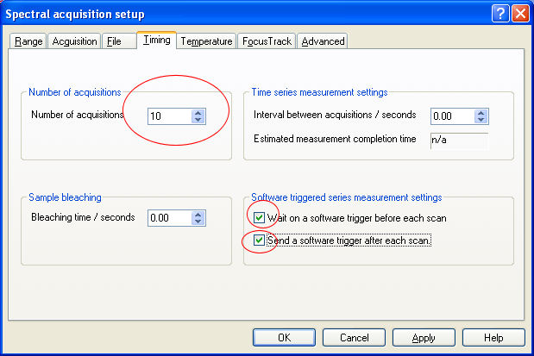

Then run the measurement – it should not (yet) collect any data.

Now go to the trigger test tool and click on the autorun button:

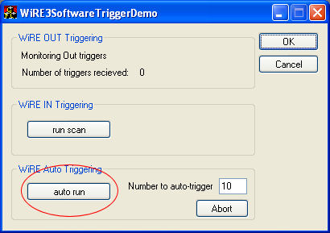

WiRE should collect all 10 spectra. During the collection the SoftwareTriggerTest app should appear as follows, with the current scan number shown and the autorun button greyed out.
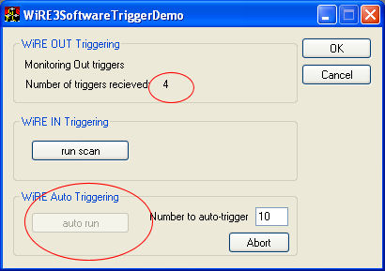

On completion, the autorun button will re-enable itself, and the Number of Triggers received field should show “10”.

