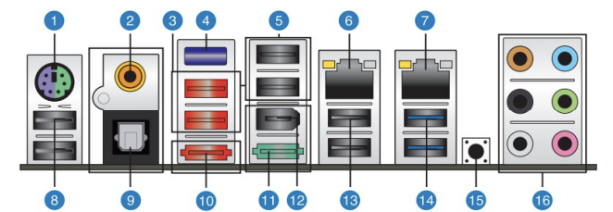
1. PS/2 keyboard/mouse
2. Coaxial
3. USB 2.0
4. Bluetooth
6. RJ-45
9. S/PDIF
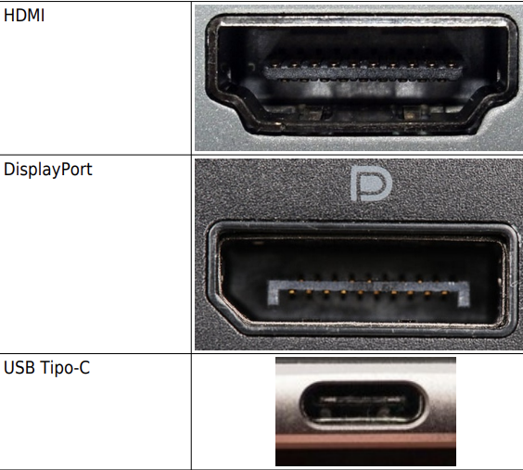
10. External Sata
11. power External port
12. IEEE 1394a (FireWire)
14. USB 3.0
15. Clear CMOS
16. Audio I/O ports (verde audio,rosa microfono)

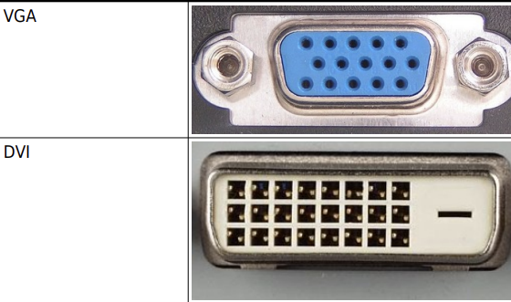

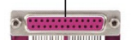
pata

usb 1
usb 2
usb 3.1 gen1
usb 3.1 gen2
usb 3.2

Memery
tipo de modulos(encapsulado)
DIP (Dual Inline Package)
SIMM(Single In-Line Memmory Modules)
DIMM(Dual In-Line Memmory Modules)
SO-DIMM(Small Outline DIMM)

DDR4(canal de 64 bits)
DDR5 (2 canales de 32 bits)

form factor 1.8/2.5/3.5

Interface SATA
IDE
AHCI
NCQ
Hot_pluggable
RAID
Interface PCI-e
AHCI
NMVe

SMART

