CART 411 – Project Ideas Steve Berthiaume

Idea #1 – Atlasphere Game

In Crash Bandicoot: The Wrath of Cortex (2001), one of the occasional vehicle stage gimmicks involves a physics-based rolling ball going through various structures. The movement of the sphere consists much of the fun of these stages, as they feel like playgrounds constructed for the very impressive physics involved. Another game franchise which utilized rolling ball physics is Super Monkey Ball, whose most beloved games game out around the same period. The rolling in Monkey Ball is made into a more arcade-y system, in which the obstacle courses are far shorter and more challenging.

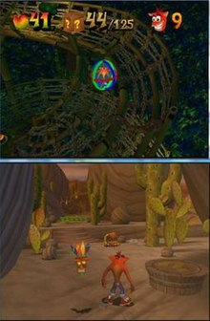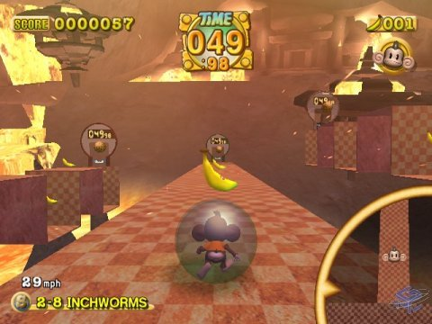

My pitch here would be to create a game focusing entirely on this sort of ball physics system in the Godot engine, preferring the former game’s approach of longer levels with explorative windings over the latter’s short, arcade-style bursts. My aesthetic leaning for this game is at present undefined but I aim to work in a fantasy/carnival style with the main character as a visible outlier to it. Narrative significance for this pitch is unlikely to ever evolve beyond something simple, with the focus remaining entirely on gameplay feel.

Idea #2 – Retail Simulator Game

Another game format I’m interested in as a project is of a small simulator simulating the strange and niche interactions which occur between retail workers and customers, coming from my experience in the field acquired over the span of 6 years. The basic framework for the interactivity between a player and the randomized customers would be somewhat similar to that within the Papa’s series of flash games, although heavily modified for a 3D format.

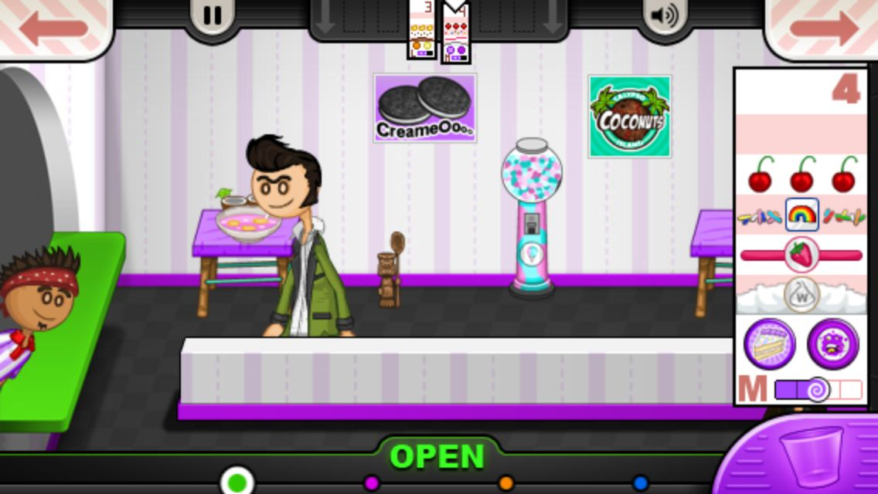

Given the relative simplicity involved in randomizing aspects of a customer request in a simulation such as this, I’m confident that the project would be both simple enough to realize within the semester timeframe and interesting enough to make for distinct, replayable interactions.

Prior Works –

3D Modelling Scene Work