rEach Installation and Setup Guide | https://github.com/SteveBenner/rEach/archive/refs/heads/main.zip
Getting Set Up: Your AI Partner and rEach

In your course you work alongside an AI partner: an app on your own computer that can read, write and check work with you. rEach is a free add-on (a “plugin”) that connects that app to your course, so it can help with your assignments and hand them in. Getting set up takes three steps, about 20 to 30 minutes in total. You do not need any technical background: where a step asks you to type something, this handout gives you the exact words.
1 Install your AI app  Pick one AI partner and install its app on your computer. | 2 Paste one message  Copy the message in Step 2 into the app. Your AI partner installs rEach for you. | 3 Enroll with your passkey  Type your course passkey, username and student ID. rEach does the rest.

Before you start
- A Mac (macOS 12 or newer), a Windows PC (Windows 10 or 11), or a Linux computer.
- An internet connection and about 30 minutes.
- An account with the AI company you choose (see the table below). You do not need administrator rights for rEach.
Choose your AI partner
If you want to use… | Install this app | Account you need
ChatGPT (OpenAI) | ChatGPT desktop app, in Codex mode | ChatGPT Plus, Pro, Business or Edu
Claude (Anthropic) | Claude desktop app, in Cowork | A paid Claude plan (Pro, Max, Team or Enterprise)
Gemini (Google) | Google Antigravity | A Google account
Open models (Nous Research) | Hermes Agent | Free app; you connect a model provider of your choice
You only need one. If you already pay for one of these, pick that one.
How to open a Terminal (only needed for some steps)
Mac | Press ⌘ Command + Space, type Terminal, press Return.
Windows | Click Start, type PowerShell, open “Windows PowerShell”.
Linux | Press Ctrl + Alt + T.
To run a command, paste it into the Terminal window and press Enter (Return on a Mac).
1 | STEP 1 Install your AI app  Follow only the option you chose, and only the row for your computer.

Option A — ChatGPT: the ChatGPT desktop app (Codex)
Official download: chatgpt.com/download
Mac | 1. Go to chatgpt.com/download and click the download for Mac.  2. Open the downloaded file (it ends in .dmg) and drag the app into your Applications folder.  3. Open it from Applications.
Windows | 1. Go to chatgpt.com/download and click the download for Windows.  2. Open the downloaded installer and follow the prompts. If the Microsoft Store opens, click Install.  3. Open it from the Start menu.
Linux (preview) | 1. Supported: Ubuntu 24.04 or 26.04, Debian 13, Fedora 43 or 44.  2. Go to chatgpt.com/download and download the package for your system (.deb for Ubuntu and Debian, .rpm for Fedora).  3. Open the package with your Software app, or open a Terminal and run: sudo apt install ./Downloads/<the file name>.deb

Then, on any computer
1. Sign in with your ChatGPT account.
2. Use the switch above the message box to choose Codex, then start a New chat.
3. When asked where to work, open a folder (your Documents folder is fine).
Good to know After rEach is installed, Codex asks you to review and trust rEach’s “hooks” (its safety checks). Choose Trust. rEach cannot keep your work on track without them. The page “Approvals and other extra steps” after Step 2 walks you through it.

Option B — Claude: the Claude desktop app (Cowork)
Official download: claude.com/download
Mac | 1. Requires macOS 11 or newer. Go to claude.com/download and click the download for Mac.  2. Open the downloaded .dmg file and drag Claude into your Applications folder.  3. Open Claude from Applications.
Windows | 1. Requires Windows 10 or newer. Go to claude.com/download and click the download for Windows.  2. Open the downloaded installer and follow the prompts.  3. Open Claude from the Start menu.
Linux (beta) | 1. Requires Ubuntu 22.04 or newer, or Debian 12 or newer. Cowork on Linux also needs 8 GB of memory and about 25 GB of free disk space.  2. Go to claude.com/download and download the Linux file (it ends in .deb).  3. Open a Terminal and run: sudo apt install ~/Downloads/claude-desktop_amd64.deb

Then, on any computer
1. Sign in with your Claude account.
2. Choose Cowork in the message box. (In the newest version Cowork is built into Claude, so you may not see a separate button. Just start a new task.)
Good to know Cowork works inside a protected space, so it cannot install rEach onto your computer by itself. When you paste the Step 2 message, Claude will ask you to add rEach yourself. It takes four clicks: Customize › Plugins › Add › Add marketplace, paste https://github.com/SteveBenner/rEach , add rEach, then start a new task.

Option C — Gemini: Google Antigravity
Official download: antigravity.google/download
Mac | 1. Requires macOS 12 or newer. Go to antigravity.google/download and pick the Mac tab.  2. Under Antigravity 2.0, choose Apple Silicon or Intel. Not sure? Apple menu › About This Mac: “Chip: Apple M…” means Apple Silicon.  3. Open the downloaded .dmg file and drag Antigravity into Applications, then open it.
Windows | 1. Requires Windows 10 (64-bit) or newer. Go to antigravity.google/download and pick the Windows tab.  2. Under Antigravity 2.0, choose x64 (most PCs). Choose ARM64 only if your PC has a Snapdragon or other ARM chip.  3. Open the downloaded installer, follow the prompts, then open Antigravity from the Start menu.
Linux | 1. Works on Ubuntu 20 or newer, Debian 10 or newer, Fedora 36 or newer.  2. Go to antigravity.google/download, pick the Linux tab, and under Antigravity 2.0 choose x64 (most computers) or ARM64.  3. Install the downloaded file with your Software app, then open Antigravity.

Then, on any computer
1. Sign in with your Google account. The first start takes two or three minutes.
2. Start a new conversation with the agent.
Good to know Use Antigravity, not the regular Gemini app or website. The Gemini app cannot run add-ons like rEach.

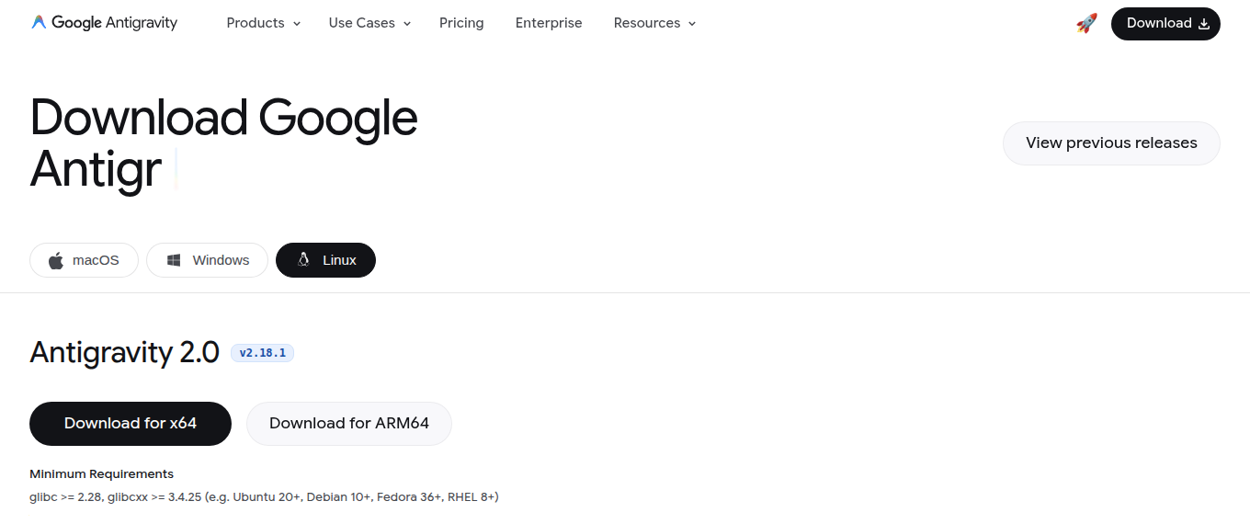
The Antigravity download page. It opens on your own system’s tab; choose the Antigravity 2.0 download.

Option D — Open models: Hermes Agent (Nous Research)
Official download: hermes-agent.nousresearch.com
Hermes also has a desktop app, but rEach works with Hermes through its Terminal version, so install it with the command for your system. Hermes installs everything else it needs by itself.
Mac | Open a Terminal and run: curl -fsSL https://hermes-agent.nousresearch.com/install.sh | bash
Windows | Open Windows PowerShell and run: iex (irm https://hermes-agent.nousresearch.com/install.ps1)
Linux | Open a Terminal and run: curl -fsSL https://hermes-agent.nousresearch.com/install.sh | bash

Then, on any computer
1. Close the Terminal window and open a new one, so it finds Hermes.
2. Run hermes setup and choose which AI model provider Hermes should use. The quickest route is hermes setup --portal , which signs you in to Nous Portal. You can also connect an account you already have, such as OpenAI, Anthropic or OpenRouter. Some providers charge for use.
3. Run hermes to start chatting. This is where you paste the Step 2 message.
Good to know After rEach is installed it prints one command for opening your course work, for example ~/.reach/bin/reach work --harness hermes . Write it down and always start your coursework with that exact command, not by typing hermes on its own. rEach only watches over your work when Hermes is started this way.

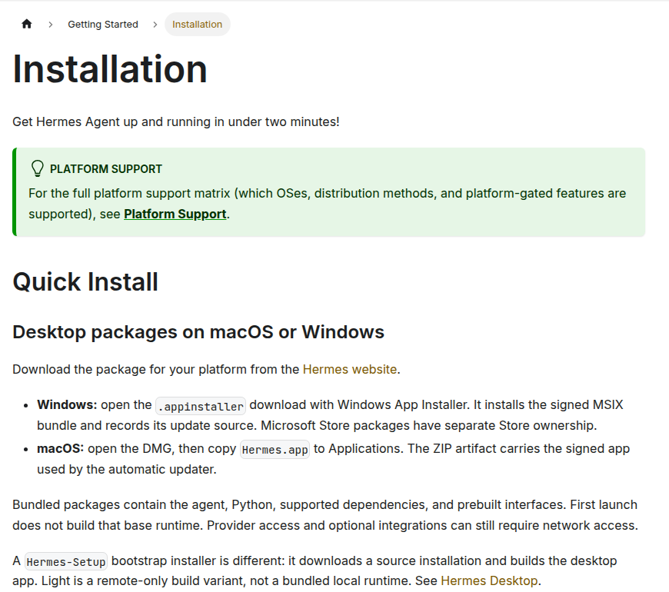
Hermes Agent’s official installation guide, at hermes-agent.nousresearch.com/docs.

2 | STEP 2 Paste one message: your AI partner installs rEach  This single message downloads, unpacks and installs rEach for you.

1. Open your AI app and start a new chat or task (Hermes users: run hermes in a Terminal).
2. Copy the whole message in the box below, exactly as written, paste it into the message box, and send it.
COPY EVERYTHING IN THIS BOX
Please install the rEach course plugin for me.
1. Download rEach from GitHub as a ZIP file. Do not use git and do not clone the repository. The ZIP file is here: https://github.com/SteveBenner/rEach/archive/refs/heads/main.zip
2. Unpack the ZIP file and open the INSTALL.md file inside it.
3. Follow INSTALL.md exactly to install and set up rEach for the app you are running in. The project page is https://github.com/SteveBenner/rEach
Before each step that changes my computer, tell me in one sentence what you are about to do. Do not use sudo or install anything for all users, and ask me before installing anything else.

What happens next
- Your AI partner explains each step before it does it. When it asks for permission, check the request against “Approvals and other extra steps” on the next page, then say yes.
- rEach runs on Ruby, a free programming tool. Macs already have it. On Windows or Linux your AI partner may ask to install it. Say yes.
- You are done when it says “rEach is installed and ready.” It may then tell you one more thing to do, such as starting a new session, or trusting rEach’s hooks in Codex. Do what it says.
- Claude Cowork users: follow the four clicks Claude gives you (see Option B).
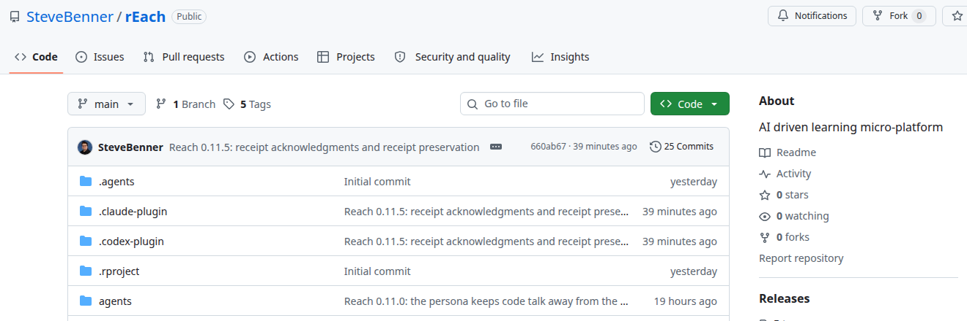
The rEach project on GitHub. You do not need to visit it: your AI partner downloads it for you. Cowork users paste this page’s address when adding rEach.

+ | ALSO NEEDED Approvals and other extra steps  Your app and your computer ask your permission at a few points. Here is each one and what to choose.

Some of these happen while your AI partner installs rEach in Step 2, some right after it, and some the first time you use rEach. Do only the parts for your app and your computer. rEach does not work until the parts for your app are done, and for Codex the most important one is trusting rEach’s hooks.
The rule for every permission request
- First read the one-sentence explanation your AI partner gives. It should match what you asked for: downloading rEach and installing it into a folder named .reach in your home folder.
- Approve requests that mention rEach, .reach, github.com/SteveBenner/rEach, raw.githubusercontent.com/SteveBenner/rEach or Ruby.
- When you can choose, allow it once or for this session only. rEach never needs an “always allow” choice.
- Say no to anything during the rEach install that asks for your computer password, sudo, an administrator, or installing “for all users”. rEach never needs them. The only exceptions in this whole handout are installing the app itself in Step 1, and Codex’s one-time sandbox setup on Windows (below).
- Not sure? Choose No or Deny and ask your AI partner what the request is for. Saying no is always safe, because it can ask again.
If you use ChatGPT (Codex)
Codex has four extra steps. The second one, trusting rEach’s hooks, is the one students most often miss.
A. Let Codex run the install outside its sandbox
1. Codex runs commands in a protected space, its sandbox, with no internet. Installing rEach needs the internet and writes to the .reach folder in your home folder, so Codex asks your permission to run the install command outside the sandbox.
2. Before you approve, check the command. On a Mac or Linux it begins mkdir -p ~/.reach/bootstrap, and on Windows it begins New-Item -ItemType Directory. On every computer it contains raw.githubusercontent.com/SteveBenner/rEach.
3. Approve it for this one command. If the request offers to remember the choice for every future command, don’t pick that one.
4. If Codex asks again for a follow-up step that runs reach setup, approve that too.
5. If Codex cannot leave its sandbox, your AI partner asks you to change the chat’s permissions. This happens on Windows, where the install stops with “access denied” on .reach. Open the permissions menu under the message box (it may read “Ask for approval” or “Default permissions”), choose Full access, and send your install request again. Keep Full access for your rEach chats until your instructor tells you otherwise.
B. Trust rEach’s hooks (required)
rEach’s “hooks” are small checks that Codex runs at set moments: when a chat starts and each time you send a message. They are how rEach greets you, asks for your course passkey, and keeps your course work on track. Codex never runs a new plugin’s hooks until you review and trust them, so until you do this rEach stays silent.
1. When setup finishes, start a New chat. Or quit the app completely and open it again.
2. Codex tells you that hooks need review. Open the review. In the desktop app, open it from that notice, or open Settings and go to Hooks. In Codex in a Terminal, type /hooks and press Enter.
3. Find rEach’s two hooks. Both commands start with ruby and point to rEach’s exe/reach. One ends in hello and runs when a chat starts. The other ends in gate enroll and runs when you send a message.
4. Choose Trust for each of rEach’s hooks. Leave alone any hooks you don’t recognize.
5. Start another New chat. rEach should greet you and ask for your course passkey (Step 3). If Codex answers like plain Codex instead, a hook is still untrusted. Open the review again.
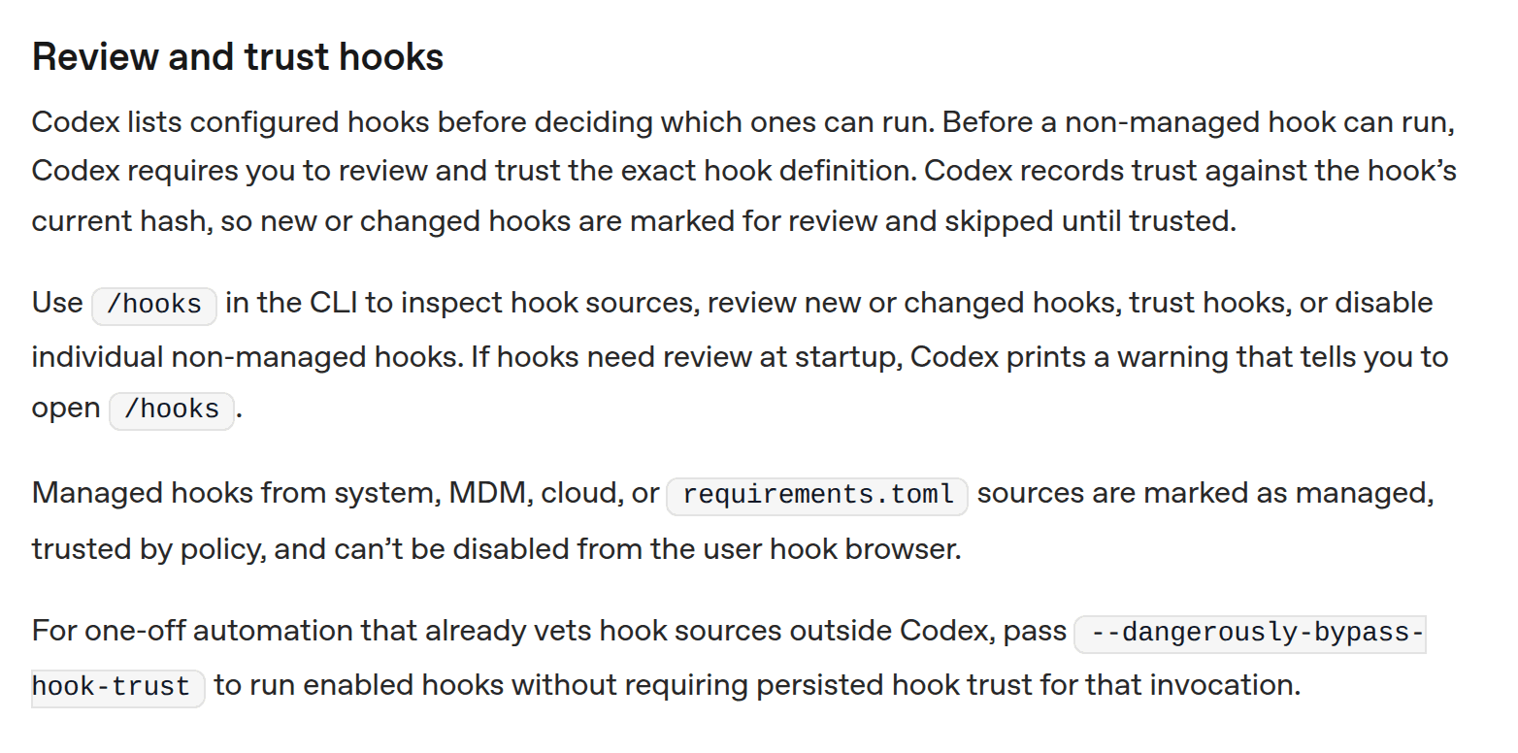
OpenAI’s explanation of hook review, from the Codex documentation (learn.chatgpt.com/docs/hooks). Trust is recorded for each exact hook, so a changed hook asks again.
C. Trust each course folder once
After you enroll, rEach makes a folder for each part of your course work. Each folder has its own rEach settings and checks. The first time you open one of these folders in Codex, Codex may ask whether you trust the folder, and ask you to review that folder’s hooks. Trust the folder, and trust the hooks whose commands run reach. You do this once per folder.
D. After an rEach update
rEach updates itself. If an update changes one of its hooks, Codex marks that hook for review again. Trust it again the same way as in B.
Windows only: Codex’s sandbox setup
The first time Codex runs a command on Windows, it sets up its sandbox. That needs Windows’ own approval box, “Do you want to allow this app to make changes to your device?” Choose Yes if you can. If you can’t, for example on a work laptop without administrator rights, choose No. Codex then uses a lighter sandbox and rEach still works. This box belongs to Codex, not rEach, and it is the only administrator box in the whole setup.
If you use Claude Code (in a Terminal or the desktop app’s Code tab)
1. Claude asks before it runs the install command and shows you the command. Check it as in Codex A.2 above, then choose Yes. You don’t need the choice that stops Claude asking again.
2. When setup finishes, start a new session, or type /reload-plugins, so rEach loads.
3. The first time you open one of your course folders, Claude asks whether you trust the files in this folder. Say yes for your course folders. Claude runs rEach’s hooks without a separate review, so there is nothing else to trust.
If you use Claude Cowork
Cowork cannot install rEach by itself, so you add it with four clicks: open Customize in the sidebar, then Plugins, then Add marketplace. Paste https://github.com/SteveBenner/rEach, choose rEach, click Install, then start a new task.
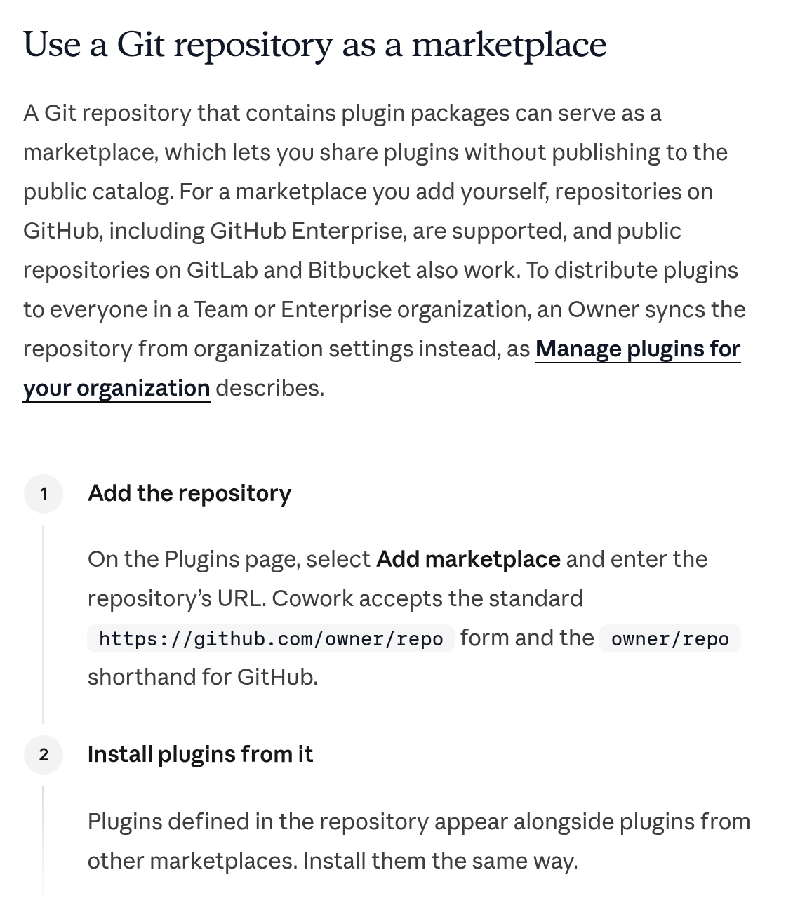
Anthropic’s instructions for adding a plugin marketplace in Cowork (claude.com/docs/cowork/guide/plugins). For rEach, the address to paste is https://github.com/SteveBenner/rEach.
If you use Google Antigravity
Under Antigravity’s Default permission setting, commands run in a sandbox without internet. Antigravity therefore asks to run the rEach install outside its sandbox, in a permission card. Check the command as in Codex A.2 and click Allow. If your setting is Request Review, Antigravity asks before every command. Approve the ones that mention rEach. When setup finishes, start a new conversation.
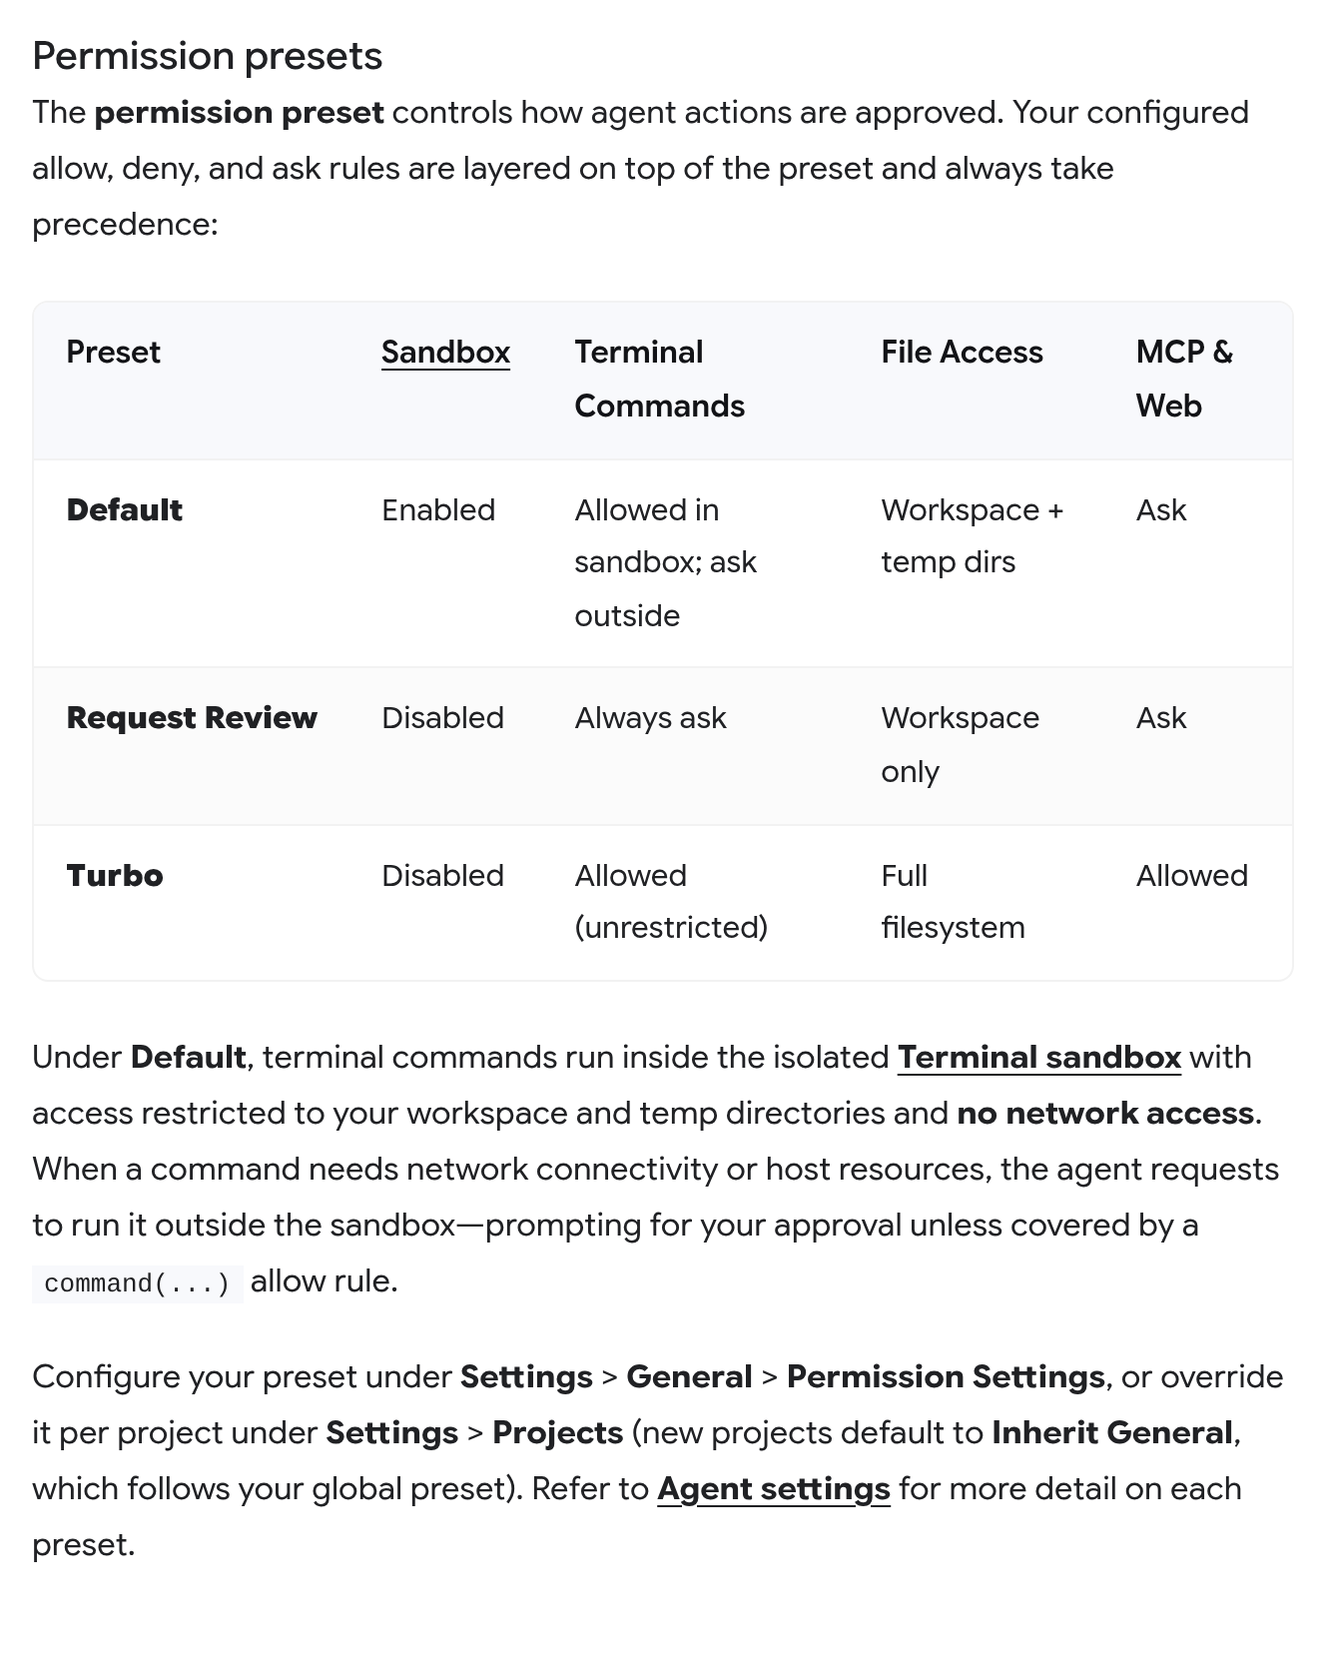
Antigravity’s permission settings, from its documentation (antigravity.google/docs/permissions). Under Default, commands that need the internet ask to run outside the sandbox.
If you use Hermes Agent
Hermes stops before commands it considers risky and shows [o]nce | [s]ession | [a]lways | [d]eny. For rEach’s install, type o (once) and press Enter. Never type a (always) for rEach. When setup finishes, always open your course work with the command rEach prints, such as ~/.reach/bin/reach work --harness hermes.
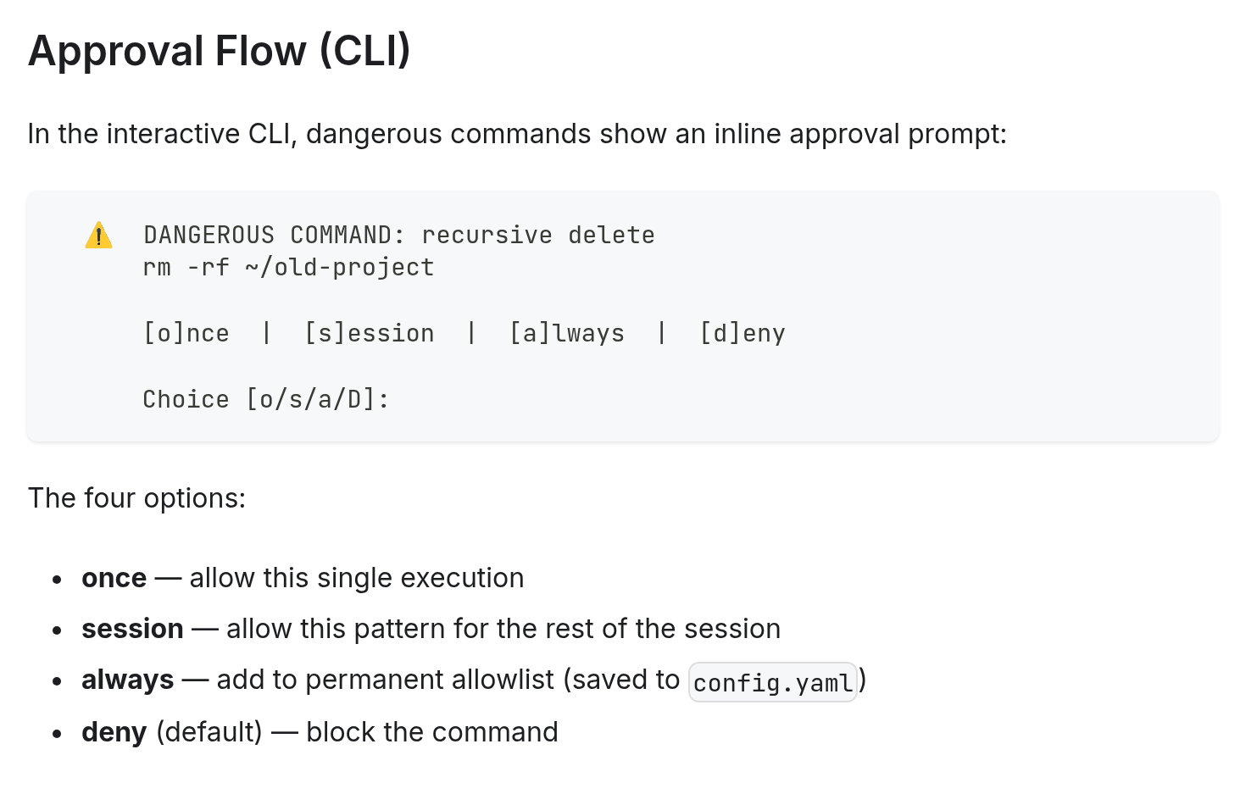
Hermes Agent’s approval prompt, from its security guide (hermes-agent.nousresearch.com/docs/user-guide/security).
On your computer
Mac
- The first time you open an app you downloaded, your Mac asks whether you’re sure you want to open it. If the app came from one of the official downloads in Step 1, click Open.
- If your app asks to use your Documents folder (“… would like to access files in your Documents folder”), click Allow. Your course folders live there.
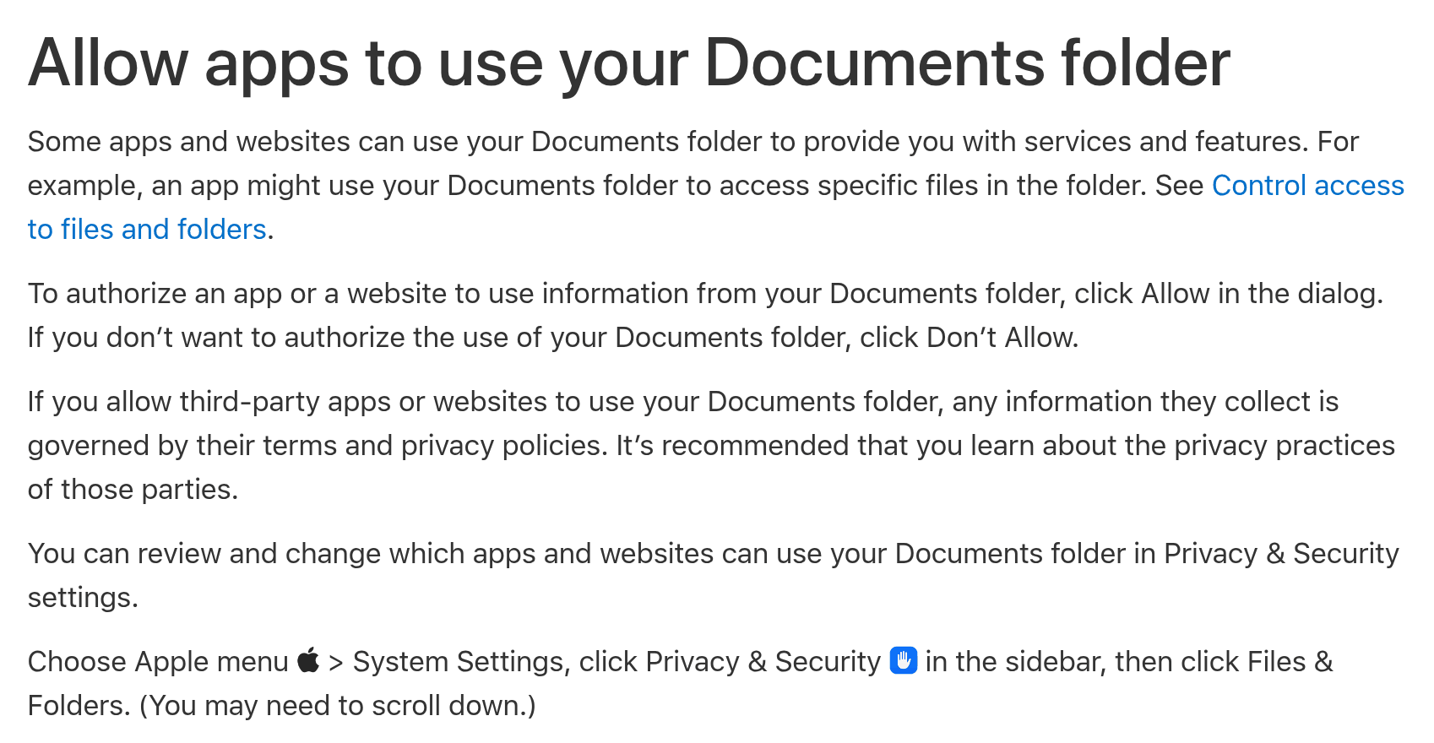
Apple’s guide to the Documents folder request (support.apple.com, Mac User Guide). You can change it later under System Settings › Privacy & Security › Files & Folders.
Windows
- rEach runs on Ruby. If Ruby isn’t on your PC, your AI partner asks whether it may install Ruby 4.0 from rubyinstaller.org, for you only. Say yes.
- If it asks you to run the installer yourself, download Ruby+Devkit 4.0 (x64) (the one marked =>), or the (arm) one on a Snapdragon PC. Open the file, choose “Install for me only”, and keep the other defaults. Then close your AI app and open it again so it finds Ruby.
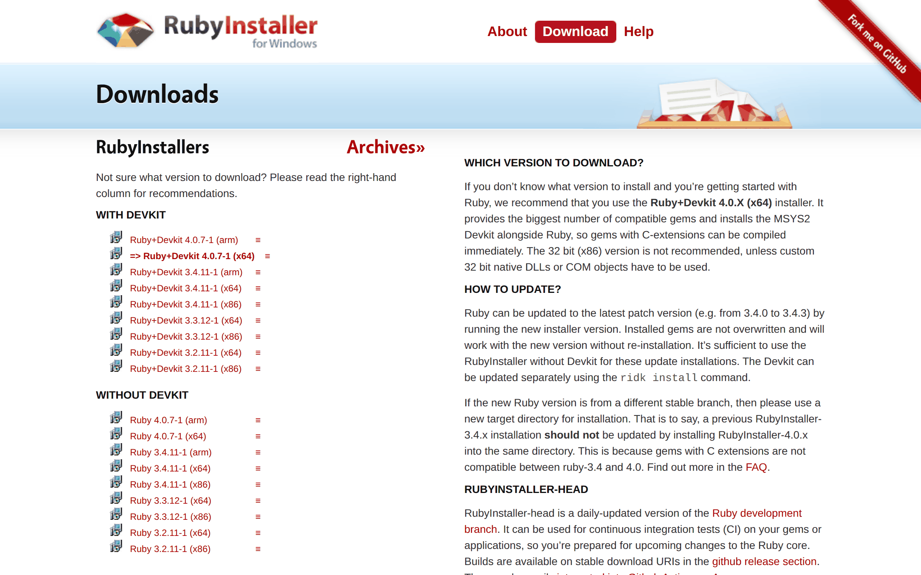
The RubyInstaller downloads page (rubyinstaller.org/downloads). The recommended installer is marked with =>.
- If Windows shows “Windows protected your PC” for a file from the official addresses in this handout, click More info and check the publisher (OpenAI, Anthropic, Google or RubyInstaller). Only then click Run anyway. If it names any other publisher, stop and ask your instructor.
Linux
- You may need your password (sudo) to install the app itself in Step 1. rEach itself never needs it.
The first time rEach starts
- In its first session, rEach downloads its checking tools (about 250 MB) in the background. Keep the app open and online. There is nothing to approve.
- If rEach says it is installing an update, let it finish. Your work is safe. Codex users: you may need to trust the hooks again (D above).
Never skip this. If rEach never greets you, or never asks for your course passkey, your app is not running rEach’s hooks yet. Go back to the part above for your app. For Codex, that is B.

3 | STEP 3 Enroll with your course passkey  Your course passkey connects rEach to your course, securely.

Start a new chat after rEach is installed. Before anything else, rEach greets you and asks for your course passkey. Until you are enrolled, rEach runs this conversation itself. Your AI partner cannot see what you type here, and it won’t help with anything else yet.
Have these three things ready
- The course passkey your instructor gives you. It is the course followed by eight letters and numbers, like ABC101-K7QX-94TD. Spaces and small letters are fine.
- Your school username. It is usually your school email address. rEach tells you the exact form your school uses.
- Your student ID, the number on your student card.
Then answer rEach, one thing at a time
1. Type your course passkey. rEach shows the course name and term.
2. Type your username.
3. Type your student ID.
4. Check the summary rEach shows, then type yes. If something is wrong, type no to start over.
rEach confirms that you are enrolled and gives you the command for starting your course work. Write it down. After that, rEach asks a few getting-to-know-you questions. Answer as many or as few as you like.
About your passkey
• Only use it for yourself, and don’t post it anywhere public.
• It works until the course ends. If rEach says it has expired, ask your instructor for the current one.
• Made a typo? Type start over at any point.
• Too many wrong tries locks enrollment for 15 minutes. Wait, then try again.
• If rEach says your username and student ID don’t match the class list, type them again carefully. If it still fails, ask your instructor to check the class list.

After you enroll
- Each new session starts with sign-in. rEach asks for your student ID, then asks “Am I speaking with …?”. Type yes. Your AI partner never sees your ID.
- Your enrollment belongs to this computer and this computer account. rEach keeps a scrambled fingerprint of them, never your files or passwords.
- To use a second computer, enroll there with the same passkey. Your instructor must approve it first. Once they have, type yes there.
- Everything you and your AI partner say in your course folders, and your assignment code, is saved in your course record, which your instructor can read. Files in your extracurricular folder stay on your computer, and what you type outside your course folders is not saved.
- Codex users: trust each course folder and its hooks the first time you open it (C on the extra-steps page).
If something goes wrong
- Something looks wrong? Ask your AI partner: Please run reach doctor. It checks your setup and tells you the one step that fixes it.
- Stuck on an install screen? Close the app, open it again, and paste the Step 2 message again. Running it twice is safe: rEach keeps a backup of anything it replaces.
- rEach never greets you, or never asks for your passkey? Your app is not running rEach’s hooks yet. See Approvals and other extra steps. For Codex, that is part B.
Checklist
☐ My AI app is installed and I can sign in.
☐ I pasted the Step 2 message and saw “rEach is installed and ready.”
☐ I approved the install and did the extra steps for my app (Codex: I trusted rEach’s hooks).
☐ I started a new chat and rEach greeted me.
☐ I typed my course passkey, username and student ID, and rEach said I’m enrolled.

If you run into issues
Ask your instructor. It helps if you say which computer you have (Mac, Windows or Linux), which AI app you chose, and include a screenshot of any error message.

