Project Plan

Icons of Gaming

<Company>

Table of Contents
1. Introduction 3
1.1 Foreword 3
1.2 Background 3
2. Project Organization 3
2.1 Development Model 3
2.2 Project Team 4
3. Risk Analysis 5
4. Hardware and Software Requirements 5
5. Schedule and Breakdown Structure 6
6. Market and Design Research 7

1. Introduction

1.1 Foreword
The purpose of this document is to provide information about the Icons of Gaming site. It will include the project schedules, risks, project team, and the work break down structure. This plan will:
- Provide a general product description.
- Identify required resources.
- Identify schedules and activities to be performed.

1.2 Background

Our site will delve into the history of gaming, more specifically the originators or founding fathers early pc and console gaming. The site will provide information on who the founding fathers were, which companies they started, which companies they still have a hand in today, and what great games they created and influenced with what limited technology they had to work with in their generation

2. Project Organization

2.1 Development Model

2.2 Project Team
The table below lists the members of the Icons of Gaming project team. The project Team consists of Steven Birkner and scott Burnett

Project Team
Scott Burnett (Project Management and Development)
Steven Birkner (Systems Engineering)
Scott Burnett (Developer and Internal Tester)
Steven Birkner and Scott Burnett (Architecture)
Steven Birkner (Developer and Internal Tester)
xxx (External Tester)
xxx (External Tester)
xxx (External Tester)
xxx (External Tester)
xxx (External Tester)

3. Risk Analysis

3.1 Risk Analysis
Risk | Affects | Descriptions
Lack of knowledge | Negative | Not knowing about the early game designers
HTML/CSS | Neutral | Might be a few tags that we don’t know yet that we have to use.
Design | Negative | Not strong with design

3.2 Risk Analysis (i)
Risk | Probability | Effects

3.2 Risk Analysis Strategy
Risk | Solution / Mitigation
Lack of knowledge | Read up on the subject
HTML/CSS | Learn about the tags and how to style things
Design | Keep the design simple and iterate on past ideas

4. Hardware and Software Requirements

Requirements for hardware and software will be very low. Any PC that can run a modern browser like Firefox or Chrome will be able to access the site.

5. Schedule and Work Breakdown Structure
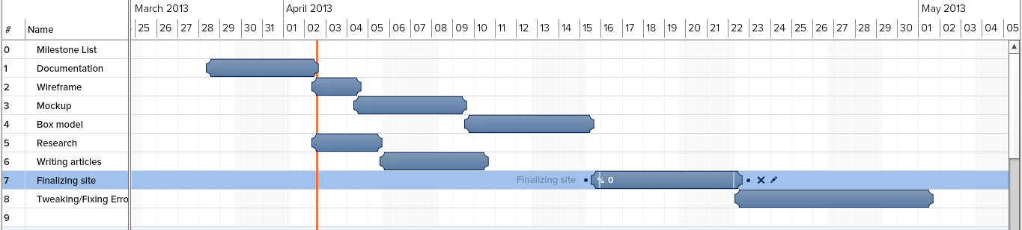

6. Market and Design Research

Audience:

Around 70% of gamers are over the age of 18 and 37% of gamers are older than 35. This web site will target both young adult and older adult video game players. The website will have info on the games that the older generations played and their creators and what they are doing now. It will also be targeted to younger gamers who are curious to how older games defined genres.

Screenshots of Similar Websites:
Polygon 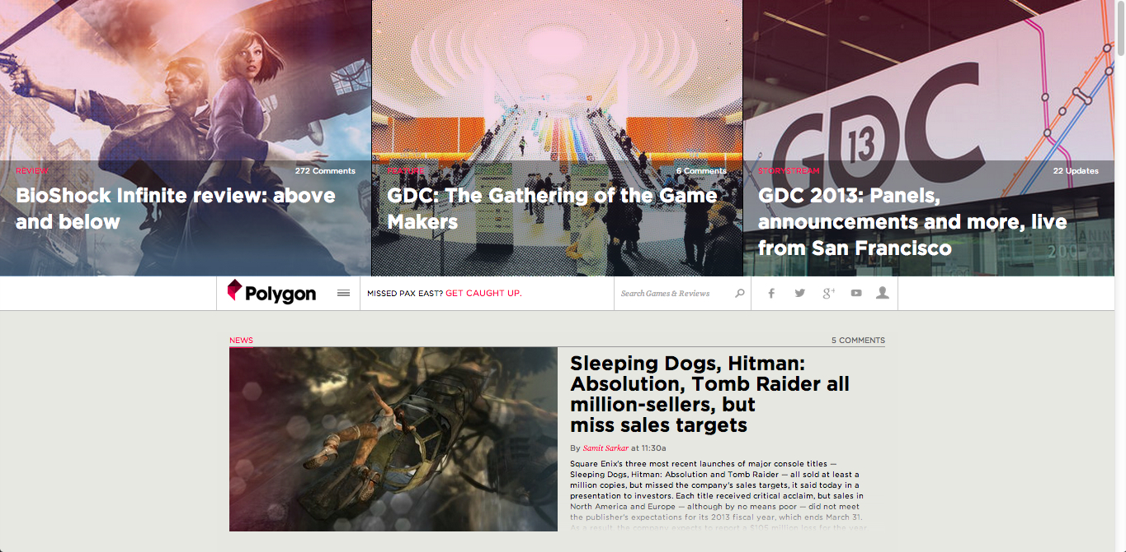

Giant Bomb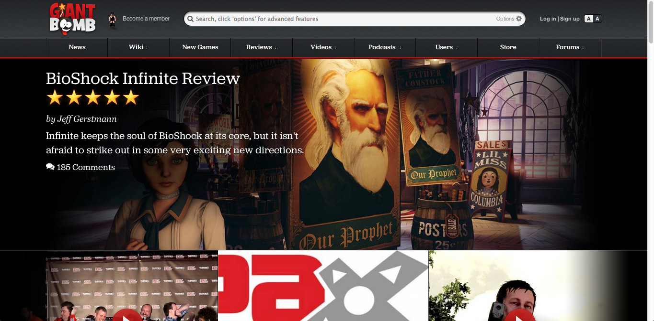

Destructoid 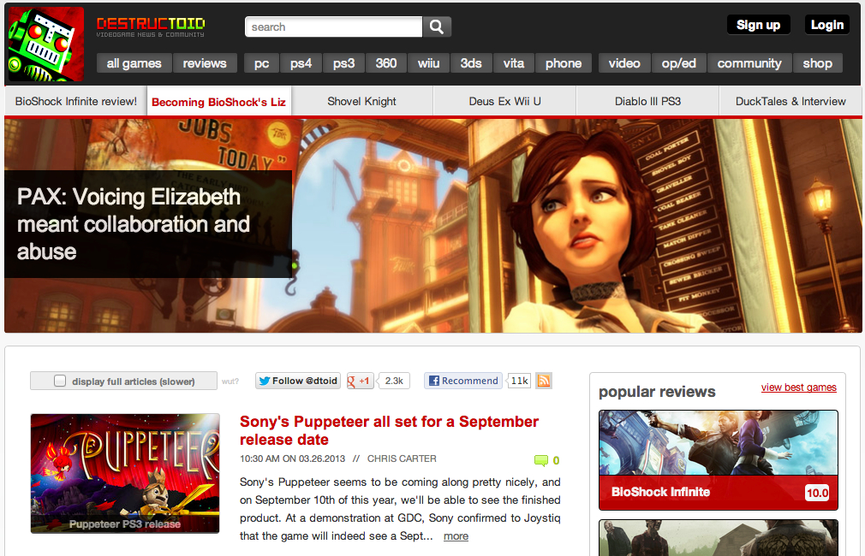

Monetization
The obvious way to make money off this site would be ads. This would be very easy to do since we know the people accessing this website like video games and more specifically older video games. There is a website called Good Old Games that sells all the older pc games. An advertising deal with them could be an option. Also we could link to the Good Old Games store from the games info page.

7. Lean Canvas

