**Project Plan**

**Social Product Reviews**

**<Company>**

1. Introduction 3

1.1 Foreword 3

1.2 Background 3

2. Project Organization 3

2.1 Development Model 3

2.2 Project Team 4

3. Risk Analysis 5

4. Hardware and Software Requirements 5

5. Schedule and Breakdown Structure 6

# **1. Introduction**

## ***1.1 Foreword***

The purpose of this document is to provide information about the Social Product Reviews project. It will include the project schedules, risks, project team, and the work break down structure. This plan will:

* Provide a general product description.
* Identify required resources.
* Identify schedules and activities to be performed.

## ***1.2 Background***

When someone looks at products online one thing they like to look at are the reviews. One thing we know is that some of these reviews could be biased or planted by the company. What we want to do is when you search for a product to also search on twitter for tweets of that product and than display the tweets to the user as a form of crowd sourced reviews. This will provide people with unbiased opinions of the product they want to purchase.

# **2. Project Organization**

## ***2.1 Development Model***

We’ll use the SCRUM model and divide the project into smaller sprints to achieve certain tasks or functionality goals eventually leading to a full project.

## ***2.2 Project Team***

The table below lists the members of the Product Reviews App project team. The project Team consists of Steven Birkner and Matthew Toegel

|  |
| --- |
| **Project Team** |
| Steven Birkner (Project Management and Development) |
| Steven Birkner and Matthew Toegel (Systems Engineering) |
| Steven Birkner (Developer and Internal Tester) |
| Matthew Toegel and Steven Birkner (Architecture) |
| Matthew Toegel (Developer and Internal Tester) |
| xxx (External Tester) |
| xxx (External Tester) |
| xxx (External Tester) |
| xxx (External Tester) |
| xxx (External Tester) |

# **3. Risk Analysis**

### **3.1 Risk Analysis**

|  |  |  |
| --- | --- | --- |
| **Risk** | **Affects** | **Descriptions** |
| **Best Buy API** | **Lack of products and product info.** | **Not known but low risk due to familiarity with other APIs** |
| **Twitter API** | **`Lack of twitter feeds related to product.** | **Little known and low risk due to familiarity with other APIs** |
|  |  |  |
|  |  |  |
|  |  |  |
|  |  |  |
|  |  |  |

### **3.2 Risk Analysis (i)**

|  |  |  |
| --- | --- | --- |
| **Risk** | **Probability** | **Effects** |
| **Best Buy API** | **Low** |  |
| **Twitter API** | **Low** |  |
|  |  |  |
|  |  |  |
|  |  |  |
|  |  |  |
|  |  |  |

### 

### **3.2 Risk Analysis Strategy**

|  |  |
| --- | --- |
| **Risk** | **Solution / Mitigation** |
| **Twitter API** | **Reading the documentation and looking at examples** |
| **Best Buy API** | **Reading the documentation and looking at examples** |
|  |  |
|  |  |
|  |  |
|  |  |
|  |  |

# **4. Hardware and Software Requirements**

For our product we will be using current web technologies to create this app as a web app and will then be packaged as a phone-gap app and published on multiple smart phone platforms.

Software Requirements:

* Modern web browser (Chrome, Firefox, Safari)

Hardware Requirements:

* A computer capable of running latest versions of JQuery
* Mobile Device with web capabilities.

# **5. Schedule and Work Breakdown Structure**

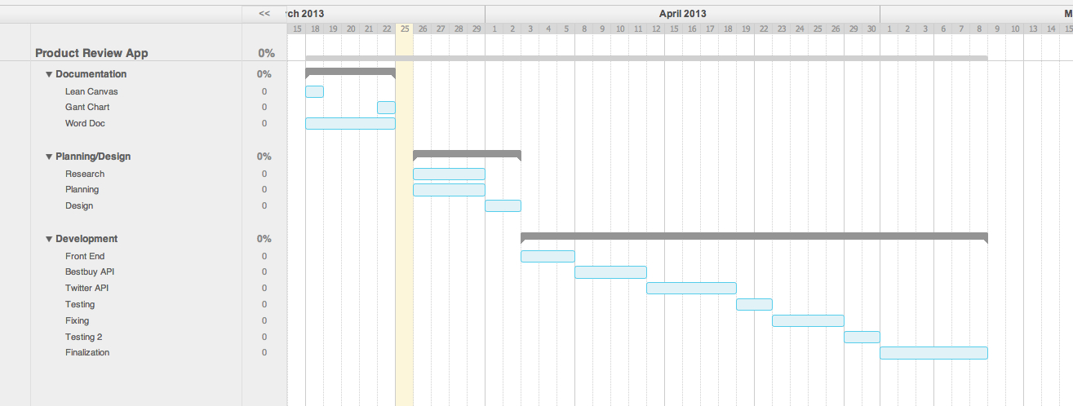

**6. Lean Canvas**

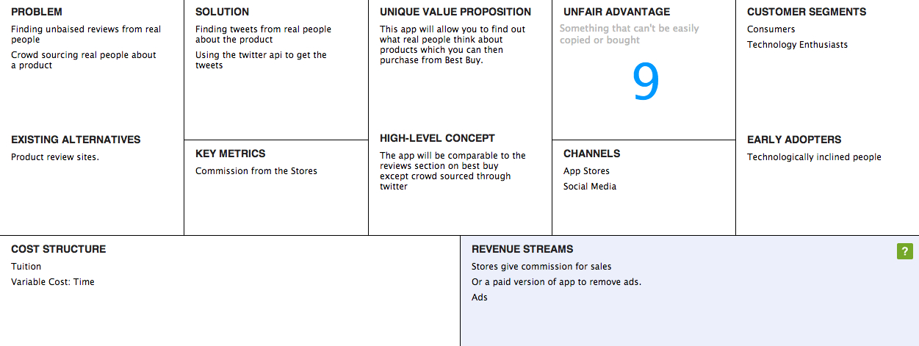

http://leancanvas.com/canvases/66435