Observing climate change with a

3D-printed Moon Rabbit

Over the past few decades, the concentration of CO2 in Earth's atmosphere has increased significantly. When I was born, atmospheric CO2 concentration was around 320 parts per million (ppm); today, it stands at 427 ppm. The Figure below shows data from researchers at the Mauna Loa Observatory in Hawaii. The growth has been almost linear despite international agreements, such as the Kyoto Protocol, the Paris Accord and 29 annual United Nations Climate Change Conferences, the latest being COP29.

Figure 1. The scientific community has been aware of the effect of CO2 on the climate since 1896, when Professor Svante Arrhenius published his epoch defining paper entitled *“On the influence of Carbonic Acid in the Air upon the Temperature of the Ground”*. And as you can see on the right, no limitation on the growth of CO2 rates has been forthcoming. 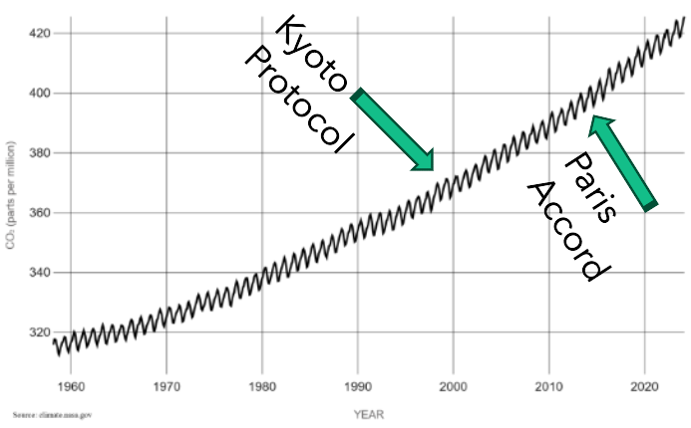

Although CO2 is measured in PPM, eg 427 ppm, that’s still only 0.0427 % CO2 of the composition of the atmosphere, the bulk being Nitrogen and Oxygen (78 % & 21 % respectively). It seems too little to do much damage. Yet, you have to remember that the lowest layer of the Earth’s atmosphere, the Troposphere, is about ten kilometres thick, and even a small change, magnified by the thickness of the lower atmosphere, will have a material change. The Sun heats the Earth’s surface. The Earth emits infrared radiation in accordance with Planck’s law. Atmospheric CO2 absorbs the IR radiation and warms the atmosphere, so a rise in atmospheric CO2 will absorb consequently more of the heat from the Earth's surface.

Figure 2. Going back a bit further, research in Polar Ice Cores (see left) shows CO2 concentrations going back 2000 years.  
  
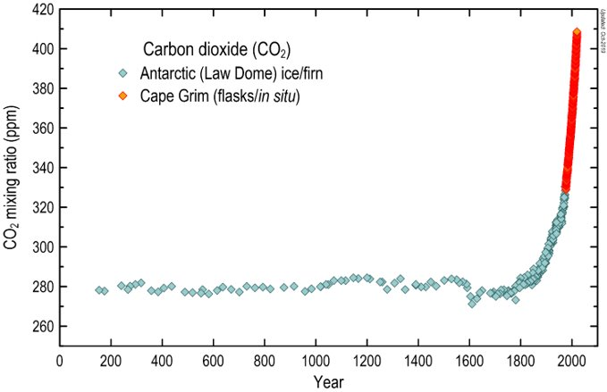

Investigations show that, using similar tactics to the Tobacco industry, the oil industry has been involved in disseminating counter-information about climate change since the 1950s according to work by the BBC, The Guardian

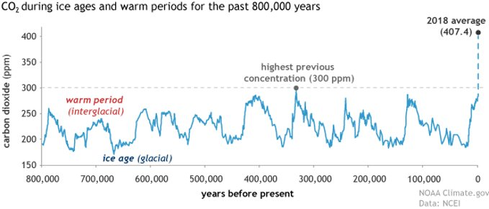Figure 3. I hear many people talking about the cyclical nature of CO2 and climate change. This is true, as the graph shows, but at 427 ppm, we are already 40% above the previous maximum for the last 800,000 years. In fact, the last time CO2 was at current levels was 20 million years ago, during the Cenozoic Era, a period that saw the evolution of first giraffes, hyenas, and giant anteaters, and a large increase in bird diversity.

Figure 4. The Paris Accord's goals to limit warming and reduce emissions have had a token effect, as now we are now beginning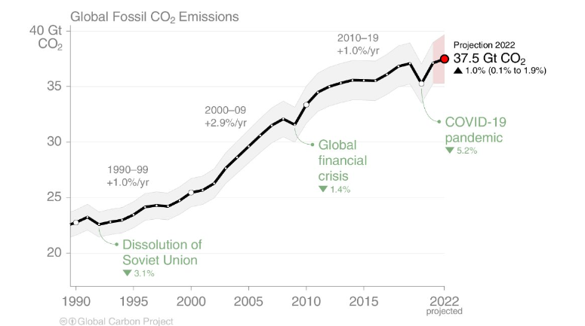 to level off at about 35 gigatonnes per year. This is still an enormous volume of CO2, continuing to build up a carbon debt that future generations will have to pay back. A quick calculation of the CO2 emitted over the course of the time period of figure 1 gives us 1,400 gigatonnes of accumulated carbon debt (ie 20 gigatonnes per year, the average of 35 and 5, times 70 years of build-up). Previous carbon emissions are not absorbed quickly by the planet as carbon dioxide has a half-life of about 120 years in the atmosphere before being absorbed. Trees and plants absorb about 35 % with oceans dissolving the remaining 65 % (and warming oceans will dissolve less). If we stopped all CO2 output today, half of our current CO2 debt would still be there in 2144.

Figure 5. As you can see, last year in 2023, we crossed the 1.5-degree level for a single year, but not yet the rolling average.   
  
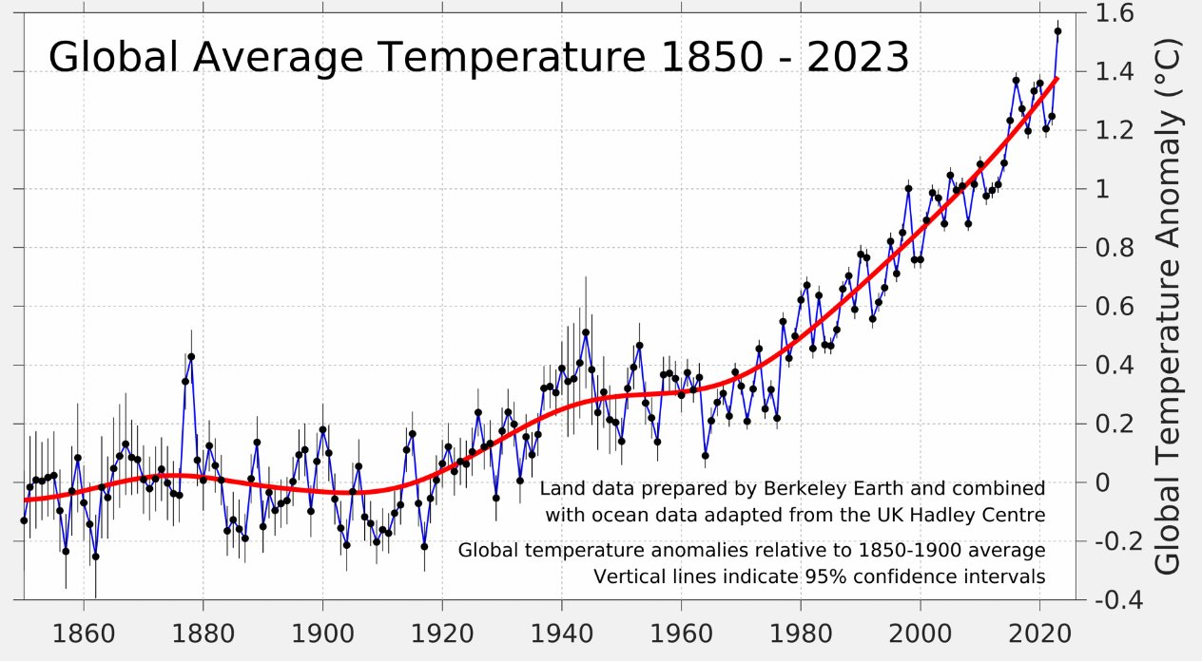

The Mauna Loa Observatory in Hawaii is recognised as the global standard for CO2 readings. Data has been collected by researchers there since 1958. And NASA too funds considerable satellite-based CO2 measurement. How can we contribute to respond to this growing, systemic instability in our environment?

The prototype described here is an attempt to democratise this data and educate and empower us all to help save our planet.

This is a CO2 monitoring prototype, using similar, but consumer grade, NDIR (Nondispersive infrared) technology, to that used at Mauna Loa, based on the Senserion SCD30 sensor and a Raspberry Pi Zero 2 W. I call it the Moon Rabbit. In case you don’t know Moon Rabbit, or Jade Rabbit, is the Asian equivalent of the Man in the Moon. In the same way that a similar Pi-based earthquake detector is called “The Raspberry Shake” I wanted a meme-based, astronomical brand name that would appeal across cultures. That's 4 billion potential astronomers and climate researchers.

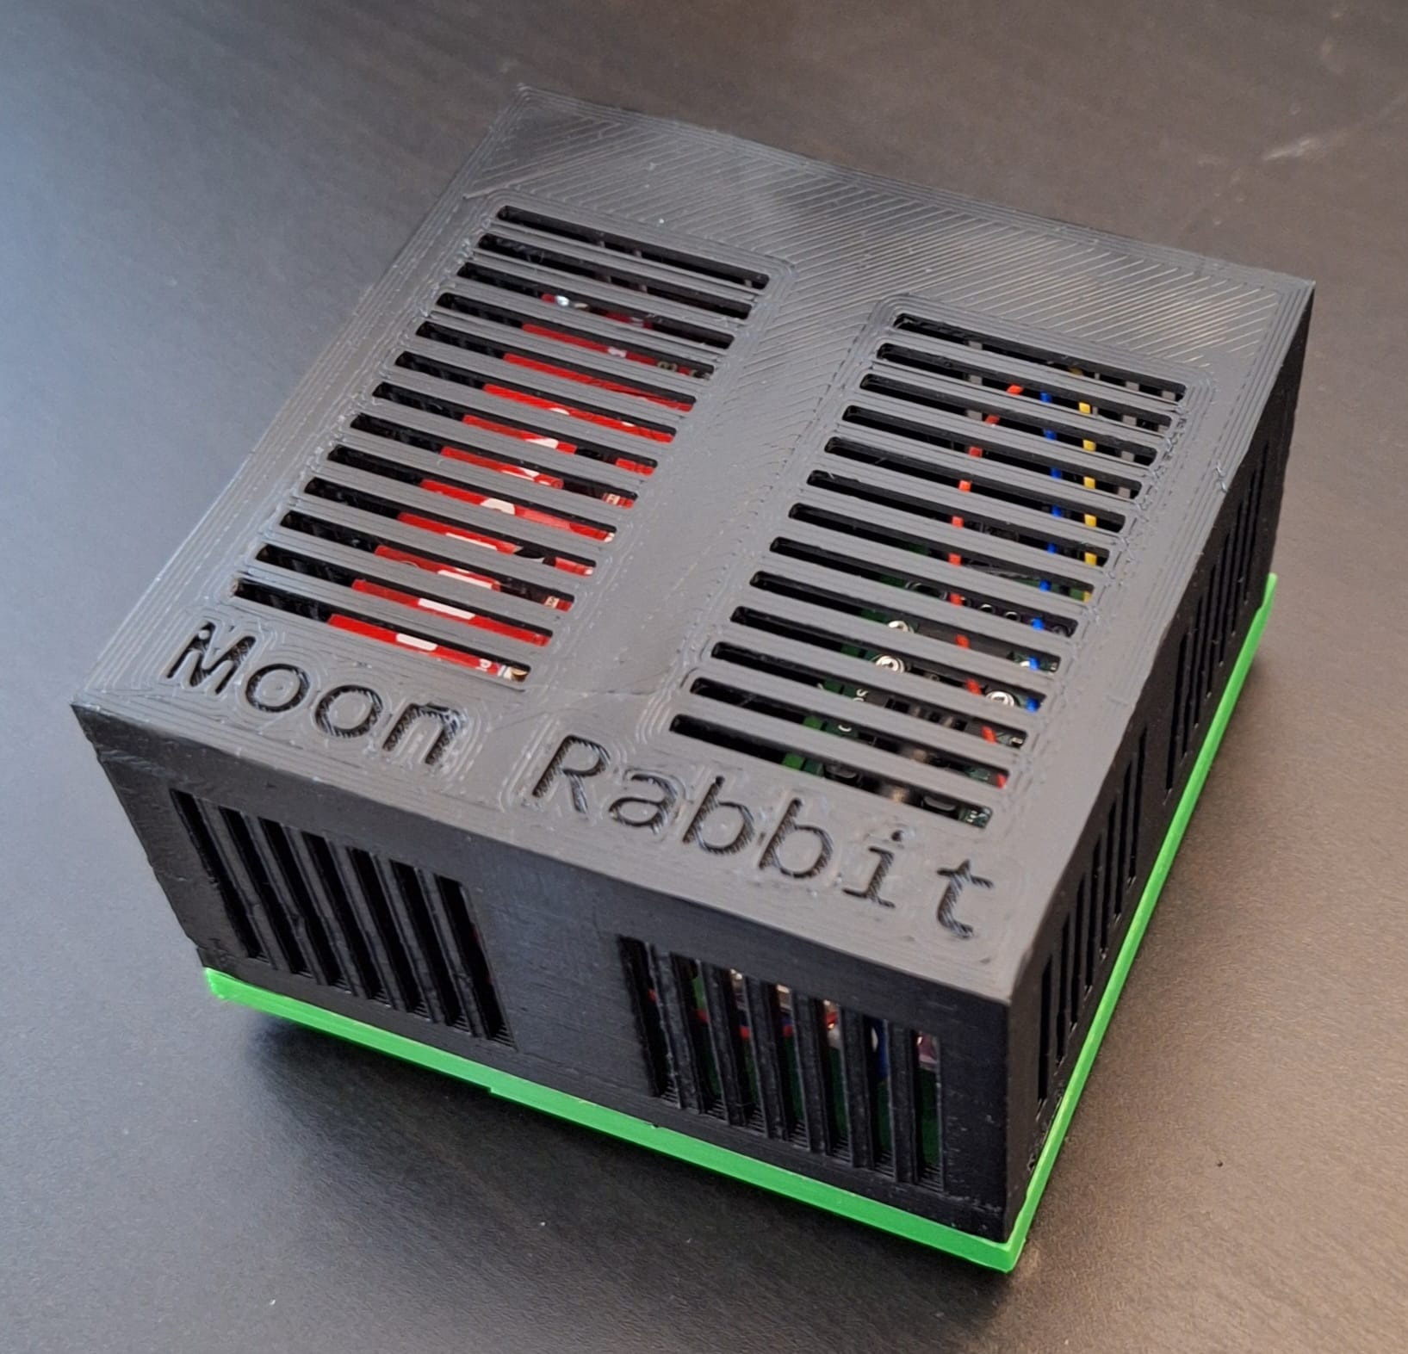Figure 6. The 3D printed Moon Rabbit runs Python and INDI and can connect to other astronomical devices, such as the Lunatica Cloudwatcher or the Davis Vantage Pro, to collect and share other weather data across the local community. We can imagine a site based on mapping technology showing dynamic weather crossing our locality. When it starts to rain in Haywards Heath, and the weather is moving North, we can see it will only be 15 or 20 minutes before it’s raining in Crawley. A friend of mine in the US is already running sessions of joint observing, where he takes spectra of a selected Be star, such as Omicron Andromedae, and tracks these over 12 hours using amateur astronomers in each time-zone from Europe to the West coast of the US. Such a project could facilitate such data exchanges. The project would also capture and publish real-time data on CO2 levels and weather conditions.

A significant material expense is calibration, and I need ideas about how to do this better. I currently buy calibration gas for calibration. A calibration for one to four instruments currently costs around £50.

Figure 7. This plot shows a Moon Rabbit being moved from my back garden, near a heath, to the front of my house with a road. The greater mean value and volatility is presumably down to traffic. It needs research to find out.

Use cases:

1) Living near a road

2) Urban versus rural living (CO2)

3) Gas central heating (CO2)

4) Living near an industrial area (CO2)

5) Year-on-year change (CO2)

6) Tracking a storm or clouds (Astronomy/Weather)

7) Analysing weather effects on seeing (Astronomy/Weather)

8) Collaboratively imaging the same object – comets, variable stars etc (Astronomy)

We need to start to collect and analyse our own data, especially on topics like climate change, rather than relying solely on scientists and governments. We can start to develop tools for community-based data collection on CO2 levels to better understand and address climate change.

But this is just the first step: getting people involved and informing them. Next, armed with data, we communicate, we can reach out and spread the word through websites, influencers and social media. We can democratise local data, providing the data to support our families and friends to write to democratic representatives and directors of companies and institutions. Finally, we need to innovate potential solutions, including taxes based on carbon emissions for industries and punitive taxes for those who don't capture their carbon emissions at source. We might consider replanting the Sahara or artificially cooling the ocean. We could replace the already mandatory catalytic converters on each car with miniature carbon capture devices.

There are other similar projects in progress including some for methane, such as the Airmo project.

Either way, at the end of this, if we survive, there will be opportunities for everyone. I am hugely optimistic: this is like a space-race for the whole planet. We're going to need a lot of new technologies. It's an advance that affects the whole world. A cleaner Earth could be a better Earth.

I invite you to join me.

References

MoonRabbit (https://github.com/SteveBz/MoonRabbit)

Carbon dioxide in Earth's atmosphere - Wikipedia (https://en.wikipedia.org/wiki/Carbon_dioxide_in_Earth%27s_atmosphere)

Svante Arrhenius’ original paper (https://www.rsc.org/images/Arrhenius1896_tcm18-173546.pdf)

Latest CO2 data from the Cape Grim Baseline monitoring station in Tasmania. (https://blog.csiro.au/co2-data-twitter/)

Fossil Fuel and Cement emissions (https://www.icos-cp.eu/sites/default/files/inline-images/essd2021_FossilFuel_and_Cement_emissions_1959.png)

Last 800,000 years of CO2 (https://www.climate.gov/media/14305)

Fossil fuel industry knew of climate danger as early as 1954, (https://www.theguardian.com/us-news/2024/jan/30/fossil-fuel-industry-air-pollution-fund-research-caltech-climate-change-denial)

Global Average Temperature (https://berkeleyearth.org/global-temperature-report-for-2023/)