Steve Dubon

November 21, 2017

Inst326

HomeWork 8: ERDS and Data Dictionaries

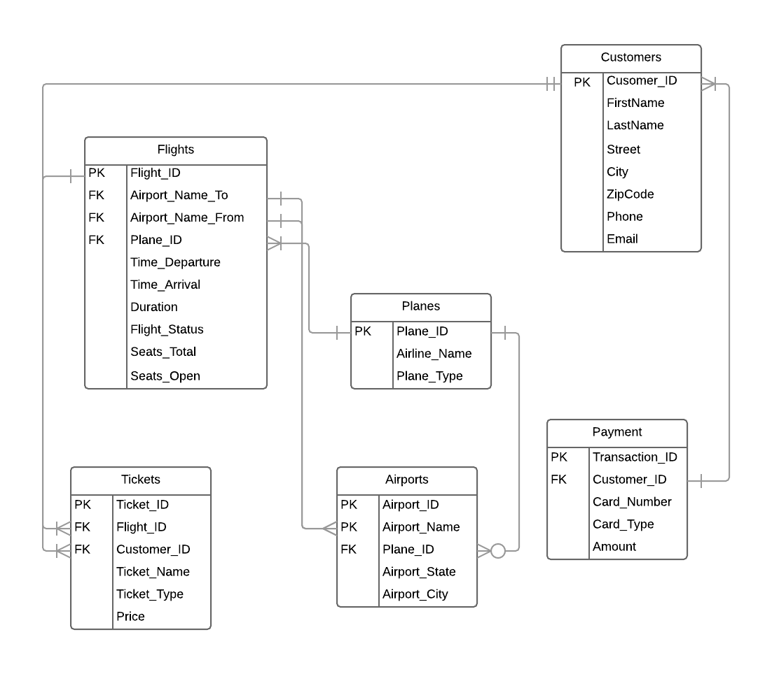***ERDs***

***Flights***

|  |  |  |  |  |  |
| --- | --- | --- | --- | --- | --- |
| **P/F** | **Filed Name** | **Caption** | **Data Type** | **Field Size** | **Notes** |
| PK | Flight_ID |  | Autonumber |  |  |
| FK | Airport_Name_To | Departing Airport | Text | 30 | Name of Airport |
| FK | Airport_Name_From | Arriving Airport | Text | 30 | Name of Airport |
| FK | Plane_ID | Plane’s Identification Number | Long Interger |  |  |
|  | Time_Departure | Departure Time | Date/Time | 10 | 00:00 A.M.  00:00 P.M. |
|  | Time_Arrival | Arrival Time | Date/Time | 10 | 00:00 A.M.  00:00 P.M. |
|  | Duration | Flight’s Duration | Text | 9 | 00:00 HRS |
|  | Flight_Status | Flight’s Status | Text | 10 | “In air”, “On ground”, “Delayed”, “On-time” |
|  | Seats_Total | Total Seats | Text | 10 | 000 Seats |
|  | Seats_Open | Open Seats | Text | 10 | 000 Seats |

***Tickets***

|  |  |  |  |  |  |
| --- | --- | --- | --- | --- | --- |
| **P/F** | **Filed Name** | **Caption** | **Data Type** | **Field Size** | **Notes** |
| PK | Ticket_ID |  | Autonumber |  |  |
| FK | Flight_ID | Flight’s Identification Number | Long Interger |  |  |
| FK | Customer_ID | Customer’s Identification Number | Long Interger |  |  |
|  | Ticket_Name | Customer’s Name | Text | 25 | Name of customer on ticket |
|  | Ticket_Type | Type of Ticket | Text | 15 | “First class”, “Business class”, “Economy class” |
|  | Price | Price of Ticket | Text | 7 | $000,000 |

***Planes***

|  |  |  |  |  |  |
| --- | --- | --- | --- | --- | --- |
| **P/F** | **Filed Name** | **Caption** | **Data Type** | **Field Size** | **Notes** |
| PK | Plane_ID |  | Autonumber |  |  |
|  | Airline_Name | Name of Airline | Text | 20 |  |
|  | Plane_Type | Type of Plane | Text | 25 | “Business Jets”, “Single engine”, “Light Sport Aircraft”, “Helicopter” |

***Airports***

|  |  |  |  |  |  |
| --- | --- | --- | --- | --- | --- |
| **P/F** | **Filed Name** | **Caption** | **Data Type** | **Field Size** | **Notes** |
| PK | Airport_ID |  | Autonumber |  |  |
| FK | Plane_ID | Plane’s Identification Number | Long Interger |  |  |
|  | Airport_Name | Name of Airport | Text | 25 |  |
|  | Airport_State | Airport Location (State) | Text | 25 |  |
|  | Airport_City | Airport Location (City) | Text | 25 |  |

***Customers***

|  |  |  |  |  |  |
| --- | --- | --- | --- | --- | --- |
| **P/F** | **Filed Name** | **Caption** | **Data Type** | **Field Size** | **Notes** |
| PK | Customer_ID |  | Autonumber |  |  |
|  | First_Name | First Name | Text | 20 |  |
|  | Last_Name | Last Name | Text | 20 |  |
|  | Street | Address (Street) | Text | 30 |  |
|  | City | Address (City) | Text | 30 |  |
|  | ZipCode | Address (Zip-Code) | Text | 5 | 00000 |
|  | Phone | Phone Number | Text | 13 | (000)000-0000 |
|  | Email | Email | Text | 30 |  |

***Transactions***

|  |  |  |  |  |  |
| --- | --- | --- | --- | --- | --- |
| **P/F** | **Filed Name** | **Caption** | **Data Type** | **Field Size** | **Notes** |
| PK | Transaction_ID |  | Autonumber |  |  |
| FK | Customer_ID | Customer’s Identification Number | Long Interger |  |  |
|  | Card_Number | Card Number | Text | 19 | 0000-0000-0000-0000 |
|  | Card_Type | Card Type | Text | 10 | "Debit”, “Credit” |
|  | Amount | Amount Paid |  |  |  |