TECHNICAL ARCHITECTURE BRIEF
Bart Ehrman Blog Search Integration
Current technology stack, target architecture, and implementation plan
Purpose: Integrate Keyword Search and Browse by Topic into the existing WordPress site
Current data scale: 4,385 indexed posts | 272 topics | 1,571 secondary keywords | 41 categories | 10 subject areas
Recommended delivery: A custom WordPress plugin that reuses existing posts, URLs, and membership controls
Prepared: July 2026

Recommendation: Implement the new functionality as a self-contained WordPress plugin. Keep WordPress posts as the authoritative content, use wpId to connect curated metadata to those posts, and maintain indexed relational mappings for fast browsing and multi-term search.

Executive Summary
The Bart Ehrman Blog already has the essential platform capabilities needed for this work: WordPress content management, an Avada-based frontend, membership enforcement through MemberPress, and a conventional relational database. The proposed search experience does not require a replacement website, a second copy of the posts, or a vector database.
A custom plugin would add two reader-facing paths: Keyword Search for readers who know what they want, and Browse by Topic for readers who want guided discovery. The plugin would import the curated topic hierarchy, secondary keywords, and descriptions; expose indexed queries through WordPress; and return links to the existing post permalinks.

1. Current Technology Stack
The following architecture is based on publicly observable HTML, asset paths, and browser behavior. The origin host, database version, PHP version, and private administrative plugins are not visible from the public site.
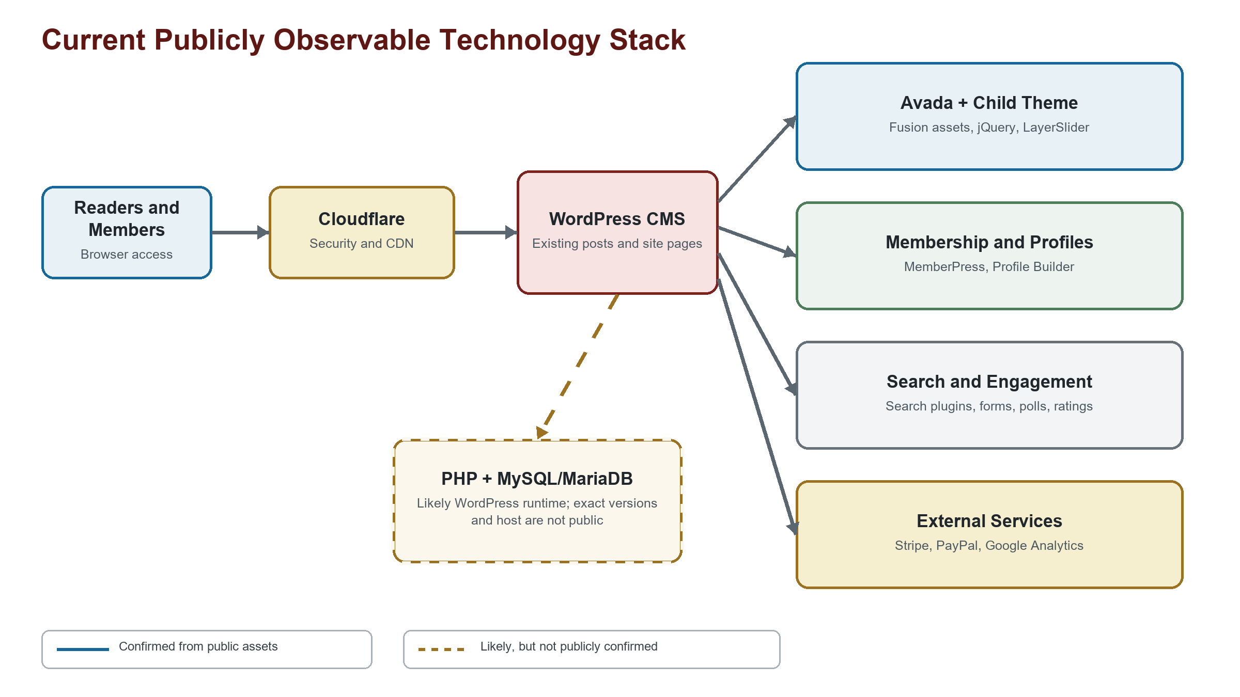
Figure 1. Current publicly observable technology stack. Dashed components are inferred, not confirmed.
Layer | Technology | Role | Confidence
Edge and security | Cloudflare | CDN and managed browser challenge | Confirmed
CMS | WordPress | Posts, pages, users, comments, media, and plugin framework | Confirmed
Theme | Avada + Avada Child Theme | Visual presentation and Fusion-generated assets | Confirmed
Membership | MemberPress; Profile Builder | Accounts, membership access, and profiles | Confirmed
Search | Search & Filter Pro; Ajax Search Pro; custom filters | Current site search and filtering utilities | Confirmed
Engagement | Contact Form 7; polls; ratings; PDF/RSS tools | Forms and supporting reader features | Confirmed
Payments and analytics | Stripe; PayPal; Google Tag Manager/Analytics | Payments, donations, and analytics | Confirmed
Application runtime | PHP | Expected WordPress application language | Likely
Database | MySQL or MariaDB | Expected WordPress relational database | Likely
Origin infrastructure | Hosting provider and web server | Hidden behind Cloudflare | Unknown

Integration boundary: The new search should coexist with Avada and the current plugins, but it should not be embedded in the theme. A plugin keeps the functionality portable, upgradeable, and independent of future theme changes.

2. Existing Curated Data
The proof of concept has already completed the labor-intensive editorial work: posts have stable WordPress identifiers, descriptions, topic assignments, secondary keywords, and ordered browse relationships. These files can seed the production plugin.
Current file | Contains | Production destination
ehrman_post_search_index.json | Post metadata, descriptions, topics, and secondary keywords | Post mappings, description storage, keyword index
ehrman_post_topics.json | Topic names, descriptions, category relationships, visibility | WordPress topic taxonomy and topic-category mapping
ehrman_post_categories.json | Category names, descriptions, and topic order | Category table and display order
ehrman_post_subject_areas.json | Subject-area names, descriptions, and category order | Subject-area table and category mapping
ehrman_post_subject_areas_2.json | Alternative browse hierarchy for evaluation | Optional test import; only one hierarchy should remain in production

Identity and Source of Truth
WordPress remains the source of truth for titles, publication dates, authors, post status, content, and canonical URLs. The importer uses each record's wpId to link metadata to wp_posts.ID. This avoids duplicate articles and ensures that title or permalink changes in WordPress are reflected automatically.
The curated files initially remain the source of truth for topic assignments, descriptions, browse ordering, and secondary keywords. After launch, the organization can either continue controlled JSON imports or make the WordPress administration interface authoritative and export backups from WordPress.

Validation During Import
Check | Required behavior
Post matching | Every wpId exists and points to the expected WordPress post
Controlled vocabulary | Every assigned topic has topic metadata and a valid category relationship
Hierarchy integrity | Every category belongs to a valid subject area; all ordering values are unique within their parent
Term hygiene | Case-insensitive duplicate keywords and accidental topic/keyword duplication are reported
Publication safety | Imports run through staging tables or a transaction before replacing the active index

3. Target Architecture
The target design adds a focused search layer inside WordPress. It does not replace the existing blog application and does not bypass MemberPress.
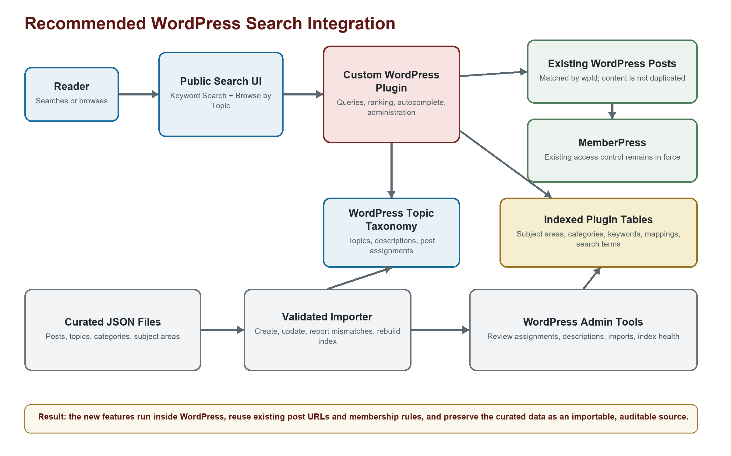
Figure 2. Recommended production architecture for Keyword Search and Browse by Topic.

Recommended Plugin Components
Module | Responsibility
Public interface | Keyword Search, Browse by Topic, autocomplete, result sorting, descriptions, responsive layouts
Query service | Resolves terms, intersects post sets, ranks matches, applies category scope, and returns counts
Administration | Imports files, edits descriptions and relationships, reports unmatched posts, and rebuilds indexes
WordPress integration | Registers topic taxonomy, generates permalinks with get_permalink(), and honors post visibility
Data layer | Stores hierarchy, keywords, mappings, display order, and a rebuildable search-term index

4. WordPress Data Design
A hybrid design provides the best balance between WordPress administration and predictable search performance. Topics should use a custom WordPress taxonomy attached to the existing post type. Flexible many-to-many relationships and secondary-keyword search should use plugin-managed tables.
Storage | Proposed name | Purpose
WordPress core | wp_posts | Existing posts; authoritative content and wpId target
WordPress taxonomy | ehrman_topic | Topic names, slugs, descriptions, and post-topic relationships
Plugin table | {prefix}ehrman_categories | Category names, descriptions, slugs, and ordering
Plugin table | {prefix}ehrman_subject_areas | Subject-area names, descriptions, slugs, and ordering
Mapping table | {prefix}ehrman_topic_categories | Many-to-many topic-category relationships and topic position
Mapping table | {prefix}ehrman_subject_area_categories | Many-to-many subject-area/category relationships and category position
Plugin table | {prefix}ehrman_keywords | Canonical and normalized secondary-keyword labels
Mapping table | {prefix}ehrman_post_keywords | Post-to-secondary-keyword relationships
Generated index | {prefix}ehrman_post_search_terms | Unified topic/keyword rows used for autocomplete, counts, filtering, and ranking
Post metadata | _ehrman_post_description | Short post description used in hover and expanded result displays

Required Indexes
Index | Supports
normalized term + post_id | Exact term resolution, multi-term intersection, and autocomplete counts
topic_id + post_id | Topic result pages and topic counts
keyword_id + post_id | Secondary-keyword filtering
category_id + topic_id + position | Category browsing and ordered topic display
subject_area_id + category_id + position | Subject-area browsing and ordered category display
post date and title | Newest/oldest sorting and title-match ranking

Scale: The current corpus is small for an indexed relational database: 4,385 searchable posts, 272 topics, and 1,571 normalized secondary keywords. MySQL or MariaDB can handle these intersections without a vector database.

5. Reader Experience and Search Behavior

Keyword Search
Readers can select up to four topics or secondary keywords. Each additional term narrows the current result set. Autocomplete suggestions are calculated from posts that already satisfy the selected terms, so adding a term cannot increase the result count.
Behavior | Production rule
Term matching | Case-insensitive exact labels with whole-word phrase handling; no matching inside unrelated words
Combination | AND semantics across selected terms
Ranking | Topic matches receive the highest weight, followed by secondary-keyword matches and title-match boosts
Sorting | Ranked by default, with newest-first and oldest-first alternatives
Autocomplete | Topics are favored; counts reflect the current combined selection; duplicate selections are unavailable
Descriptions | Displayed by default in search results and available consistently on topic result pages

Browse by Topic
The browse path follows Subject Area to Category to Topic to Posts. A category may also expose all posts connected through its topics, with the keyword controls scoped to terms found in that category.
Page | Behavior
Subject-area page | Shows ordered categories and category post counts
Category page | Shows ordered topics, topic post counts, and an optional view-all-posts action
Topic page | Shows related posts with the same ranking and filtering controls used by Keyword Search
Post link | Uses the existing WordPress permalink and opens the normal MemberPress-controlled post page

Access Control
Search endpoints should return only the metadata approved for public display. Full post content remains behind the existing WordPress and MemberPress checks. Administrative endpoints require a WordPress capability check, a nonce where appropriate, and a REST permission callback.

6. Integration Workflow
1. Build the plugin foundation. Register the topic taxonomy, create versioned plugin tables with the WordPress database prefix, and add upgrade handling.
2. Create the validated importer. Load the four production JSON datasets, match records by wpId, validate every relationship, and stage changes before activation.
3. Implement the query service. Port the demo's term normalization, AND filtering, ranking, category scope, constrained autocomplete, counts, and sorting into indexed SQL queries.
4. Rebuild the interface inside WordPress. Implement Keyword Search and Browse by Topic using a shortcode, block, or plugin page template styled to match Avada.
5. Integrate access and navigation. Add menu links, use existing post permalinks, and verify MemberPress behavior for logged-out and member users.
6. Test on staging. Compare representative searches and browse paths against the current demo; test desktop, mobile, accessibility, performance, and error states.
7. Launch and monitor. Back up production, deploy the plugin, import the approved dataset, warm caches, monitor errors and slow queries, and retain rollback controls.

Ongoing Content Updates
Change | Recommended process
New post | Create the WordPress post normally; assign existing topics, description, and supporting keywords through admin or import
Topic rename | Update the taxonomy term and rebuild the generated search-term index
Topic/category move | Update mapping and display position; post assignments remain intact
Keyword cleanup | Update canonical label and post mappings, then rebuild affected autocomplete counts
Bulk refresh | Import validated JSON with a preview report and rollback point

7. Risks and Controls
Risk | Control
Plugin or theme conflict | Namespace all PHP, CSS, REST routes, and database tables; test against Avada and current search plugins on staging
Membership leakage | Return only approved metadata; never return protected post content from public endpoints; test every membership state
Stale mappings | Validate wpId on import, report missing posts, and provide index-health diagnostics
Slow autocomplete | Use normalized composite indexes, cap suggestions, cache frequent queries, and constrain suggestions to the current post set
Import failure | Use staging tables or transactions, retain the prior active index, and support rollback
Editorial drift | Define whether JSON or WordPress admin is authoritative and record every bulk change
Theme replacement | Keep business logic and data in the plugin; isolate Avada-specific presentation in a small stylesheet/template layer

Acceptance Criteria
Area | Release requirement
Data | Every imported wpId is matched or explicitly reported; no orphaned topic/category/subject-area relationships
Search | One to four terms produce the same or narrower results; ranking and date sorts are deterministic
Autocomplete | Suggestions show correct intersected counts and distinguish Topic from Keyword
Browse | Every visible subject area, category, and topic reaches the correct ordered page and post set
Access | Protected content remains protected; normal WordPress permalinks and membership rules are preserved
Performance | Common searches and autocomplete requests remain responsive under expected traffic
Accessibility | Keyboard navigation, visible focus, labels, responsive layouts, and screen-reader semantics are verified
Operations | Administrators can preview imports, see validation errors, rebuild the index, and roll back safely

Recommended Decision
Proceed with a staging plugin: The proof of concept has already established the editorial model and user experience. The remaining work is a contained WordPress engineering effort: import the curated relationships, reproduce the indexed search behavior, integrate the presentation with Avada, and verify MemberPress access before launch.

Sources
The Bart Ehrman Blog homepage
WordPress Plugin Handbook: Working with Custom Taxonomies
WordPress Plugin Handbook: Creating Tables with Plugins
WordPress REST API Handbook: Routes and Endpoints
WordPress Plugin Handbook: Scheduling WP-Cron Events

