Author: Steve Eckardt
Revised: 10/14/22
Description: Deliverables for the start of week 4.
Open Avenues and Businessolver Internship

1) Clean the data as much as you can?

I started by duplicating the material included in the lecture notes. Including text to lowercase, stripping out punctuation, removing stop words, removing frequent words, removing fragments, remove rare words.
I added a code block to remove all numbers from the text string.

numbers = '0123456789'
%timeit
def remove_numbers(text):
return text.translate(str.maketrans('','',numbers))

df['text_wo_numb'] = df['text_wo_freqrare'].apply(lambda text: remove_numbers(text))

2) Top twitter users by number of tweets,

The top 20 authors of inbound tweets.

inbound_df = full_df[full_df['inbound']==True]
inbound_df['author_id'].value_counts().head(20)

115911 1286
120576 1010
115913 563
116230 454
169172 448
117627 406
115888 332
116136 295
116421 276
115722 252
115714 250
115850 243
115990 243
121239 210
203476 197
115725 194
115798 181
127296 176
170351 174
169916 172
Name: author_id, dtype: int64

3) Top Authors by response

The top 20 text responses.

df['text_wo_numb'].value_counts().head(20)

here’s work around issue it’s fixed future software update httpstcoxxaxeesrt 5168
awaiting response resolve ur issue pls provide within next hrs rgds idea care 1529
1242
amazonhelp 1068
offer support via twitter english contact preferred language httpstcoibiyvmgpj 1064
immediately connected critical response line click call button enter number httpstcojojkltck
978
send email address connect 950
applesupport 838
send email address assist 808
offer support via twitter english spanish httpstcoibiyvmgpj join httpstcooczyrxios
778
applesupport 767
send email address details follow 649
reaching workaround httpstcoxxaxeesrt still need httpstcogdrquypt 606
apologize inconvenience happy account number jp 574
sent direct message via twitter instructions 565
ubersupport 556
take seriously send email address connect asap 506
wed happy could use info could follow amp xboxsupport gamertag amp details ez 503
amazonhelp thank 472
apologize inconvenience glad assist name acct phone jb 448
Name: text_wo_numb, dtype: int64

4) Tweets by date

I converted the created_at text string into a datetime object and then grouped The tweets by day of the week.

import datetime
pd.to_datetime(full_df['created_at']).dt.dayofweek.value_counts()

4 453028
2 445838
3 440361
1 423052
0 387847
5 332606
6 329042
Name: created_at, dtype: int64

5) Perform as much as analysis as you can?

For analysis, I converted the word frequency index back into a data frame.

count_df = pd.DataFrame.from_dict(cnt, orient='index').reset_index()
count_df.columns = ['word','count']

Using the describe function, I got the count, mean, standard deviation, and quadrants.

count_df['count'].describe()

count 1.560486e+06
mean 2.064757e+01
std 9.842111e+02
min 1.000000e+00
25% 1.000000e+00
50% 1.000000e+00
75% 2.000000e+00
max 4.512620e+05
Name: count, dtype: float64

I created a bar graph of the 20 most common words and a boxplot of word frequency distribution.

count_df.boxplot(column =['count'], showfliers=False)
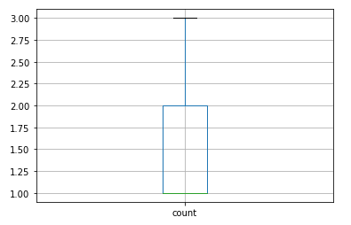
count_df.sort_values('count').tail(20).plot.bar(x='word', y='count', rot=270)
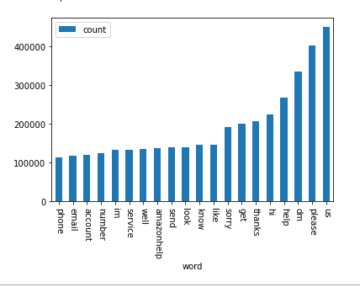

6) Compose a message to one of the people you identified last week

Hello name,
I hope all is going well.
I'm reaching out to let you know that I'm in the job market and looking for a computer engineering position.
I understand you've been in this industry for a while, and I would appreciate any suggestion or help you could offer.
[or]
I know you're not a technical person, but I would certainly appreciate any help or suggestions you would have about communicating with recruiters and improving my social media presence.
I have attached a copy of my latest resume to bring you up to speed.
Steve

