Author: Steve Eckardt
Revised: 10/18/22
Description: Deliverables for the start of week 5.
Open Avenues and Businessolver Internship

The work is still in the state which I categorize as a rough draft. I thought it would be useful to submit what I had before this week's meeting.

1) Organize your work by step-by-step visualization.

I'll start by describing the steps taken in the data-cleaning process.
* We start with the text string are a tweet.
* All the text is reduced to lowercase.
* Following this, all the punctuation marks are stripped out of the text string.
* Next, stopwords are filtered from the text string. Stopwords are common words with little value in the text string.
* The most frequently used words are then filtered.
* The rare words are also filtered.
* And finally, all numbers are removed from the text string.

2) Use python visualization library (any one or more you prefer) and create an interactive visualization to allow to better understand the data.

This raised the question of how much of the original data set was removed by the cleaning process.

Starting size 5.9 * 10e8 bytes
Size after cleaning 4.3 * 10e8 bytes
Text removed 1.6 * 10e8 bytes

28% of the original text wes removed to create the cleaned data set.

The following python code was used to generate the numbers listed above.

text_size = df.memory_usage(deep=True)
text_size
Index 128
text 590460669
text_lower 590460885
text_wo_punct 568936667
text_wo_stop 460470380
text_wo_freq 446385069
text_wo_freqrare 446384825
text_wo_numb 426658625
dtype: int64

text_size[1]-text_size[7]
163802044

1-text_size[7]/text_size[1]
0.2774139796261349

A curious observation is the text size grew when it was reduced to lower case.

3) Create some visualizations of your data product.

For a visualization I created a bar-graph showing the text size at each stage of the cleaning process.

df.memory_usage(deep=True).plot.bar(x='columns', y='size', rot=270)
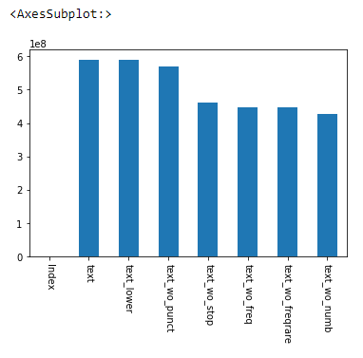

4) Write a short summary in your portfolio introducing yourself and your specialty.

I'm a computer science student returning to the workforce after a hiatus for health reasons. I was in an injury accident. As part of my rehabilitation, I started taking computer science classes and studying programming. I found I had an aptitude for the work and enjoyed doing it. And this also provided me with an avenue to find gainful employment. My studies include the Java programming language. And web development, including HTML, CSS, and JavaScript.

5) Write a summary of this project in the STAR format

The situation is I'm participating in an internship where we're studying text sent to and from a chatbot.
The task was to clean the text strings or incoming chats to make them easier for us to understand.
The action, we removed punctuation, numerical data, stop words, frequent words, and rare words from the text strings and then parsed the result into an index of word frequency and usage.
The result was we could demonstrate graphically and numerically which words were commonly used when a client spoke to the chatbot.

