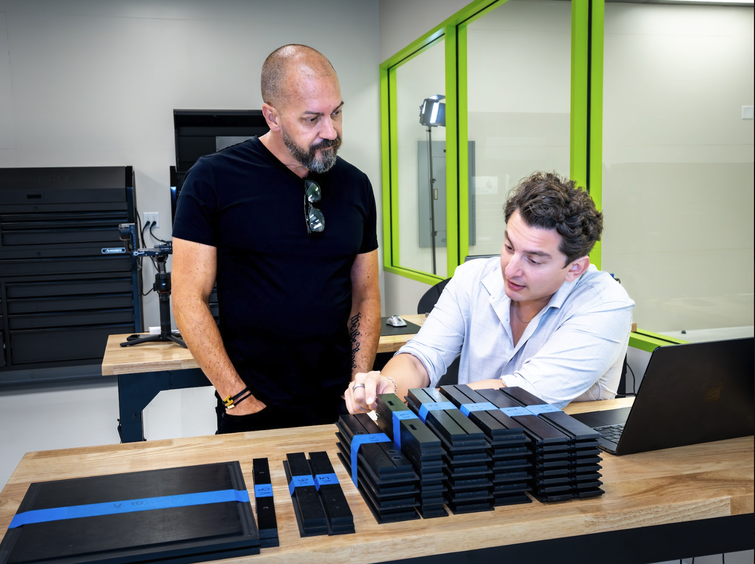
Alt Text: Jason Herring and Zac DelVecchio examining stacked component parts on a workbench in VIVIFY's lab.

Next-Generation Engineering Talent Joins VIVIFY Technology
Multidisciplinary operator joins VIVIFY to help accelerate product development, systems design, and execution across the company’s clean air, hydrogen, and infrastructure modernization platform
VIVIFY Technology announced that it has appointed Zac DelVecchio as Director of Innovations and Solutions, adding a multidisciplinary builder with experience spanning digital infrastructure, design, manufacturing, and execution to the company’s growing leadership team.
DelVecchio joins VIVIFY as the company advances a platform focused on transforming legacy energy infrastructure into near-zero-emission power systems through clean air and hydrogen technologies. VIVIFY describes itself as a solution-backed industrial infrastructure platform built to modernize existing systems rather than force a choice between reliability and environmental progress. Its technology stack includes scalable retrofit applications, on-demand hydrogen generation, self-powered emissions systems, and modular integration across coal, diesel, and natural gas environments.
“Zac brings the kind of cross-functional execution mindset VIVIFY needs at this stage,” said Jason Herring, Founder and CEO of VIVIFY. “We are building technologies meant to operate at infrastructure scale. That requires more than engineering in isolation. It requires creative systems thinking, disciplined execution, and the ability to move from concept to deployment with clarity and speed.”
In his role, DelVecchio will support product development, rendering and modeling workflows, sourcing strategy, manufacturing practicality, cost efficiencies, digital systems, and broader operational execution across the business. “As Director of Innovations and Solutions, I focus on bridging vision and execution,” DelVecchio explained. “That means taking something from concept to reality—whether that’s developing renderings, refining the bill of materials, identifying sourcing pathways, improving manufacturability, reducing costs, or building the systems that support the work around it. I’m involved across the business because real innovation doesn’t happen in silos. It happens when technology, business strategy, and execution are aligned.”
DelVecchio said his approach is rooted in human-centered design, which he describes as building systems around how people actually live, work, and use energy. In practical terms, he said, that means creating solutions that are logical, intuitive, simple, and efficient—not just technically advanced. He added that this perspective is especially important in energy, where technologies like hydrogen are often misunderstood or framed too narrowly. For DelVecchio, the real opportunity is not simply to build a plant, but to understand where energy is needed, how demand is evolving, and how VIVIFY’s solutions can be applied in ways that are practical, scalable, and meaningful over time.
His appointment comes as VIVIFY continues to position its core platform around measurable technical performance. According to the company, VIVIFY’s technologies have reached approximately TRL 7–8 through multiple multi-million-dollar prototypes and have demonstrated the ability to remove more than 99% of pollutants and greenhouse gases from exhaust emissions while simultaneously generating electricity without increasing fuel consumption per watt. VIVIFY also states that its Clean Air Technology™ operates with effectively zero parasitic load, enhancing plant efficiency instead of draining it.
That technical foundation is central to the company’s long-range vision. VIVIFY says its platform is designed not only for emissions conversion and power generation, but also for broader applications in wastewater treatment, potable water restoration, habitat protection, waste-to-energy conversion, and carbon capture. The company frames this work as infrastructure modernization at systems scale, not incremental product development.
For DelVecchio, that scale is what made the opportunity compelling.
“We’re going to change the world,” DelVecchio said. “I’ve been around the block, I’ve been involved in dozens and dozens of businesses, and I’ve never met anything like VIVIFY. The second I came down to Delray and saw the technology, I immediately understood that we are about to change the history of mankind.” He added that he wants VIVIFY to become “the first-ever name-brand energy company” that reshapes how people view energy, how it is applied, and where the industry goes next.
Before joining VIVIFY, DelVecchio built a multidisciplinary career spanning digital infrastructure, design, and manufacturing. That breadth of experience now informs the way he works across technical development, commercial strategy, and operational execution. His background has also earned outside recognition, including a Forbes feature, Nashville 30 Under 30 honors in 2021, LA Weekly coverage, and teaching engagements with Harvard’s MBA program.
As VIVIFY builds toward broader commercial deployment, the company says additions like DelVecchio reflect a larger priority: assembling a team capable of translating advanced science into executable infrastructure.

About VIVIFY
VIVIFY Technology is a hydrogen energy company headquartered in South Florida, engineering platforms that address some of the most pressing challenges facing modern energy infrastructure. The company's CAT™ platform retrofits directly onto legacy coal, diesel, and natural-gas infrastructure — no teardown required — removing virtually every pollutant from exhaust streams while supporting reliable baseload electricity. Its hydrogen platforms, HOG™ and Flying Pig™, deliver independent, near-zero-emission power behind the meter.
VIVIFY is built at the intersection of science, engineering, and infrastructure, engineered to eliminate pollutants rather than manage them, preserving grid stability, protecting jobs, and meeting tightening emissions standards. Beyond power generation, VIVIFY is advancing hydrogen-based technology across water restoration, waste-to-energy conversion, and broader infrastructure modernization.
For more information, visit www.vivify-technology.com.

Media Contact
Ashley Stevenson
Chief Marketing Officer
VIVIFY Technology
ashley@vivify-technology.com
www.vivify-technology.com
Instagram | LinkedIn | Facebook | X

