Insert your name, centre number and candidate number into the header above.
Save this evidence document as evidence_ followed by your centre number_ candidate number. For example: evidence_ zz999_9999.doc
Screenshots or program listings must be copied into appropriate cells in the following tables.
Examiners must be able to read the contents including any screenshots without the use of a magnifying glass. Answers that are not readable or missing will not be awarded any marks.
Save this evidence document at regular intervals, for example, every 10 minutes.
Question 1
Part 1(a)
{Copy and paste program code listing for question 1(a) here}

HeadPointer = -1 # Stores the index of the first element in the Queue, initialised to -1
TailPointer = -1 # Stores the index of the last element in the Queue, initialised to -1
Queue = [-1 for i in range(50)] # Global 1D array to type integer, all elements are initialised to -1

Part 1(b)
{Copy and paste program code listing for question 1(b) here}

def Enqueue(num):
global Queue, HeadPointer, TailPointer
if TailPointer >= 49:
return False

TailPointer +=1

Queue[TailPointer] = num
return True

Part 1(c)
{Copy and paste program code listing for question 1(c) here}

def Dequeue():
global Queue, HeadPointer, TailPointer
if HeadPointer >= TailPointer or HeadPointer == -1:
return -1

data = Queue[HeadPointer]
HeadPointer+=1
return data

Part 1(d)
{Copy and paste program code listing for question 1(d) here}

def CreateQueue():
global Queue, HeadPointer, TailPointer
try:
f = open("QueueData.txt", 'r')
temp = int(f.readline().readline().strip())
if not Enqueue(temp):
print("Queue full")

except:
print("error")

Part 1(e)(i)
{Copy and paste program code listing for question 1(e)(i) here}

CreateQueue()

sum = 0
print(HeadPointer)
for i in range(len(Queue)):
num = Dequeue()
print(num)
if num == -1:
continue
else:
sum+=num

print(sum)

Part 1(e)(ii)
{Copy and paste screenshot for question 1(e)(ii) here}

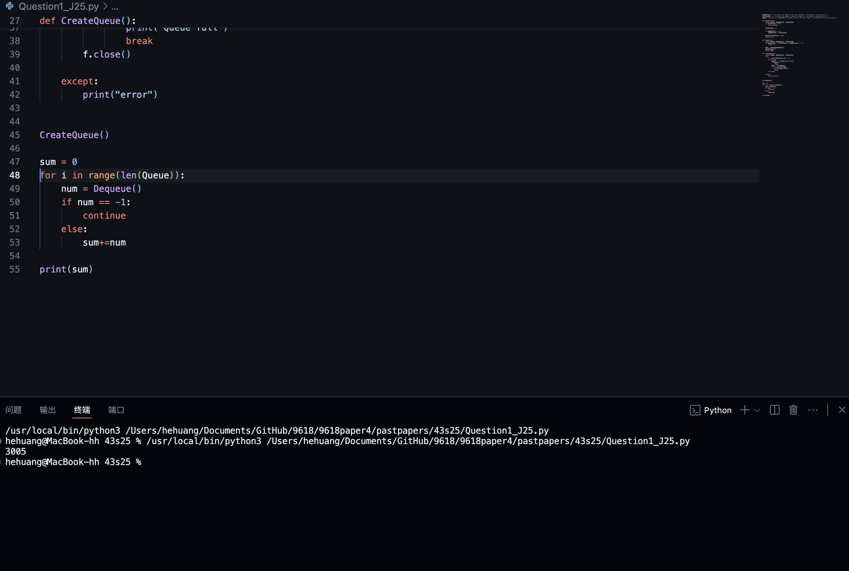

Question 2
Part 2(a)
{Copy and paste program code listing for question 2(a) here}

DataArray = [0,3,4,56,67,44,43,32,31,345,45,6,54,1]# 1D array with 14 elements

Part 2(b)
{Copy and paste program code listing for question 2(b) here}

def InsertionSort(arr):
k = len(arr)

for i in range(1,k):
temp = arr[i]
HolePosition = i
while arr[HolePosition-1] > temp and HolePosition>0:
arr[HolePosition] = arr[HolePosition-1]
HolePosition-=1
arr[HolePosition] = temp

Part 2(c)
{Copy and paste program code listing for question 2(c) here}

def OutputArray(arr):
ResultStr = ""
for i in range(len(arr)):
ResultStr+=str(arr[i])
if i < len(arr)-1:
ResultStr+=" "

print(ResultStr)

Part 2(d)(i)
{Copy and paste program code listing for question 2(d)(i) here}

OutputArray(DataArray)
InsertionSort(DataArray)
OutputArray(DataArray)

Part 2(d)(ii)
{Copy and paste screenshot for question 2(d)(ii) here}

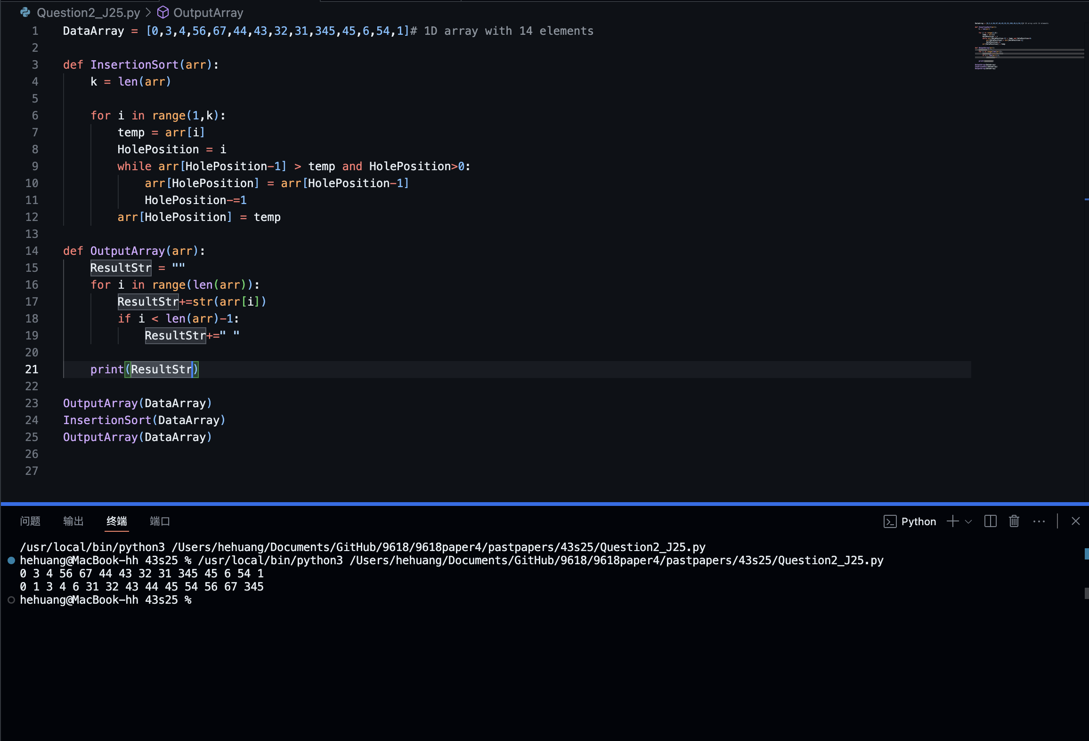

Part 2(e)
{Copy and paste program code listing for question 2(e) here}

def Search(DataArray, ItemToFind):
lower = 0
upper = len(DataArray)-1
while lower<=upper:
mid = (lower+upper)//2
if DataArray[mid] == ItemToFind:
return mid
elif DataArray[mid] < ItemToFind:
lower = mid+1
else:
upper = mid-1

return -1

Part 2(f)(i)
{Copy and paste program code listing for question 2(f)(i) here}

Targets = [0,345,67,2]
for num in Targets:
result = Search(DataArray,num)
if result == -1:
print("The number was not found.")
else: print(f"The number is in the index of {result}.")

Part 2(f)(ii)
{Copy and paste screenshot for question 2(f)(ii) here}

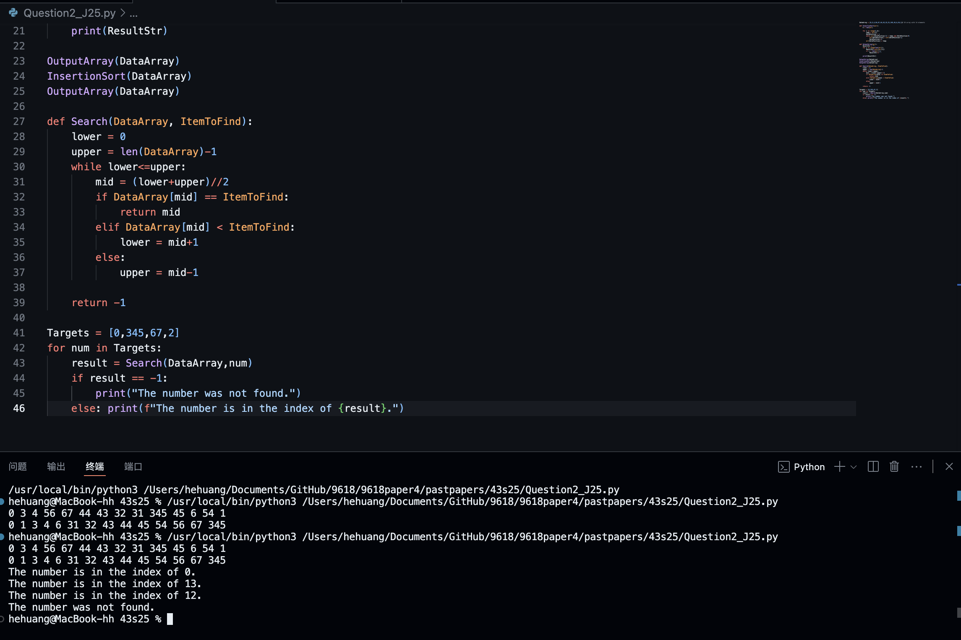

Question 3
Part 3(a)(i)
{Copy and paste program code listing for question 3(a)(i) here}

class Node:
def __init__(self, TheData):
self.__TheData = TheData # TheData is a private member with integer type, stores the data, TheData is initilised to the value of the parameter
self.__NextNode = None # NextNode is a private member,stores the next node in the linked list, NextNode is initilised to a null value

Part 3(a)(ii)
{Copy and paste program code listing for question 3(a)(ii) here}

def GetData(self):
return self.__TheData

def GetNextNode(self):
return self.__NextNode

Part 3(a)(iii)
{Copy and paste program code listing for question 3(a)(iii) here}

def SetNextNode(self, Node):
self.__NextNode = Node

Part 3(b)(i)
{Copy and paste program code listing for question 3(b)(i) here}

class LinkedList:
def __init__(self):
self.HeadNode = None # The first node in the linked list, initilised to a null value

Part 3(b)(ii)
{Copy and paste program code listing for question 3(b)(ii) here}

def InsertNode(self,num):
NewNode = Node(num)
NewNode.SetNextNode(self.HeadNode)

self.HeadNode = NewNode

Part 3(b)(iii)
{Copy and paste program code listing for question 3(b)(iii) here}

def Traverse(self):
ptr = self.HeadNode
ResultStr = ""
while ptr is not None:
ResultStr+=str(ptr.GetData())
ResultStr+=' '
ptr = ptr.GetNextNode()
return ResultStr

Part 3(b)(iv)
{Copy and paste program code listing for question 3(b)(iv) here}
def RemoveNode(self,num):
if self.HeadNode is None:
return False
elif self.HeadNode.GetData() == num:
self.HeadNode = self.HeadNode.GetNextNode()
return True
else:
ptr = self.HeadNode.GetNextNode()
while ptr is not None:

if ptr.GetNextNode().GetData() == num:
temp = ptr.GetNextNode().GetNextNode()
ptr.SetNextNode(temp)
return True

ptr = ptr.GetNextNode()
return False

Part 3(c)(i)
{Copy and paste program code listing for question 3(c)(i) here}

LinkedLST = LinkedList()
LinkedLST.InsertNode(10)
LinkedLST.InsertNode(20)
LinkedLST.InsertNode(30)
LinkedLST.InsertNode(40)
LinkedLST.InsertNode(50)
print(LinkedLST.Traverse())
LinkedLST.RemoveNode(30)
print(LinkedLST.Traverse())

Part 3(c)(ii)
{Copy and paste screenshot for question 3(c)(ii) here}

