Insert your name, centre number and candidate number into the header above.
Save this evidence document as evidence_ followed by your centre number_ candidate number. For example: evidence_ zz999_9999.doc
Screenshots or program listings must be copied into appropriate cells in the following tables.
Examiners must be able to read the contents including any screenshots without the use of a magnifying glass. Answers that are not readable or missing will not be awarded any marks.
Save this evidence document at regular intervals, for example, every 10 minutes.
Question 1
Part 1(a)
{Copy and paste program code listing for question 1(a) here}

Part 1(b)
{Copy and paste program code listing for question 1(b) here}

Part 1(c)(i)
{Copy and paste program code listing for question 1(c)(i) here}

Part 1(c)(ii)
{Copy and paste screenshot for question 1(c)(ii) here}

Part 1(d)(i)
{Copy and paste program code listing for question 1(d)(i) here}

Part 1(d)(ii)
{Copy and paste program code listing for question 1(d)(ii) here}

Part 1(d)(iii)
{Copy and paste screenshot for question 1(d)(iii) here}

Part 1(e)(i)
{Copy and paste program code listing for question 1(e)(i) here}

Part 1(e)(ii)
{Copy and paste program code listing for question 1(e)(ii) here}

Part 1(e)(iii)
{Copy and paste screenshot for question 1(e)(iii) here}

Question 2
Part 2(a)(i)
{Copy and paste program code listing for question 2(a)(i) here}

class Tree:
def __init__(self,TreeName, HeightGrowth, MaxHeight, MaxWidth, Evergreen):
self.__TreeName = TreeName # self.__TreeName is STRING
self.__HeightGrowth = HeightGrowth # self.__HeightGrowth is INTEGER
self.__MaxHeight = MaxHeight # self.__MaxHeight is INTEGER
self.__MaxWidth = MaxWidth # self.__MaxWidth is INTEGER
self.__Evergreen = Evergreen # self.__Evergreen is STRING

Part 2(a)(ii)
{Copy and paste program code listing for question 2(a)(ii) here}

def getTreeName(self):
return self.__TreeName

def getHeightGrowth(self):
return self.__HeightGrowth

def getMaxHeight(self):
return self.__MaxHeight

def getMaxWidth(self):
return self.__MaxWidth

def getEvergreen(self):
return self.__Evergreen

Part 2(b)
{Copy and paste program code listing for question 2(b) here}

def ReadData(filename):
Trees = []
try:
f = open(filename, "r")
for i in range(9):
temp = f.readline()
temp1 = temp.strip().split(",")
Name = Tree(temp1[0], int(temp1[1]), int(temp1[2]), int(temp1[3]), temp1[4])
Trees.append(Name)
f.close()
return Trees

except: print("File not found.")

Part 2(c)
{Copy and paste program code listing for question 2(c) here}

def PrintTrees(NameOfTree):
if NameOfTree.getEvergreen() == "Yes":
print(f"{NameOfTree.getTreeName()} has a maximum height {NameOfTree.getMaxHeight()} a maximum width {NameOfTree.getMaxWidth()} and grows {NameOfTree.getHeightGrowth()} cm a year. It does not lose its leaves.")
else: print(f"{NameOfTree.getTreeName()} has a maximum height {NameOfTree.getMaxHeight()} a maximum width {NameOfTree.getMaxWidth()} and grows {NameOfTree.getHeightGrowth()} cm a year. It loses its leaves each year.")

Part 2(d)(i)
{Copy and paste program code listing for question 2(d)(i) here}

temp = ReadData("/Users/hehuang/Documents/GitHub/9618/9618paper4/pastpapers/41s24/Trees.txt") # temp stores the returned array
PrintTrees(temp[0])

Part 2(d)(ii)
{Copy and paste screenshot for question 2(d)(ii) here}

Part 2(e)(i)
{Copy and paste program code listing for question 2(e)(i) here}

def ChooseTrees(Array):
MatchedTrees = [] # Stores all the trees that meet the user's requirements
AcceptableMaxHeight = int(input("Enter the maximum height of the tree you want.\n"))
AcceptableMaxWidth = int(input("Enter the maximum width of the tree you want.\n"))
AcceptEvergreen = input("Do you want the tree evergreen? Enter Yes or No ONLY, otherwise you need to re-enter.\n")
while AcceptEvergreen !="Yes" or AcceptEvergreen !="No":
AcceptEvergreen = input("Do you want the tree evergreen? Enter Yes or No ONLY, otherwise you need to re-enter\n.")

for i in range(len(Array)):
if Array[i].getMaxHeight() <= AcceptableMaxHeight and Array[i].getMaxWidth() <= AcceptableMaxWidth and Array[i].getEvergreen() == AcceptEvergreen:
MatchedTrees.append(Array[i])
PrintTrees(Array[i])

if len(MatchedTrees) == 0:
print("There are no trees meet all your requirements")

Part 2(e)(ii)
{Copy and paste program code listing for question 2(e)(ii) here}

def ChooseTrees(Array):
MatchedTrees = [] # Stores all the trees that meet the user's requirements
AcceptableMaxHeight = int(input("Enter the maximum height of the tree you want.\n"))
AcceptableMaxWidth = int(input("Enter the maximum width of the tree you want.\n"))
AcceptEvergreen = input("Do you want the tree keeps its leaves or loses its leaves? Enter Yes or No ONLY, otherwise you need to re-enter\n")
while AcceptEvergreen !="Yes" and AcceptEvergreen !="No":
AcceptEvergreen = input("Do you want the tree keeps its leaves or loses its leaves? Enter Yes or No ONLY, otherwise you need to re-enter\n")

for i in range(len(Array)):
if Array[i].getMaxHeight() <= AcceptableMaxHeight and Array[i].getMaxWidth() <= AcceptableMaxWidth and Array[i].getEvergreen() == AcceptEvergreen:
MatchedTrees.append(Array[i])
PrintTrees(Array[i])

if len(MatchedTrees) == 0:
print("There are no trees meet all your requirements")
else:
Cart = input("Enter the name of the tree you want to buy\n")

TargetHeight = int(input("Enter the height of the tree in cm when it is bought\n"))
for i in range(len(Array)):
if Cart == Array[i].getTreeName():
TargetPlace = i

k = (Array[TargetPlace].getMaxHeight() - TargetHeight) / Array[TargetPlace].getHeightGrowth()
if k - (Array[TargetPlace].getMaxHeight() - TargetHeight) // Array[TargetPlace].getHeightGrowth() !=0:
result = int(k) +1
else: result = k

print(f"The tree will take {result} years to reach its maximum height of {Array[TargetPlace].getMaxHeight()}.")

Part 2(e)(iii)
{Copy and paste screenshot for question 2(e)(iii) here}

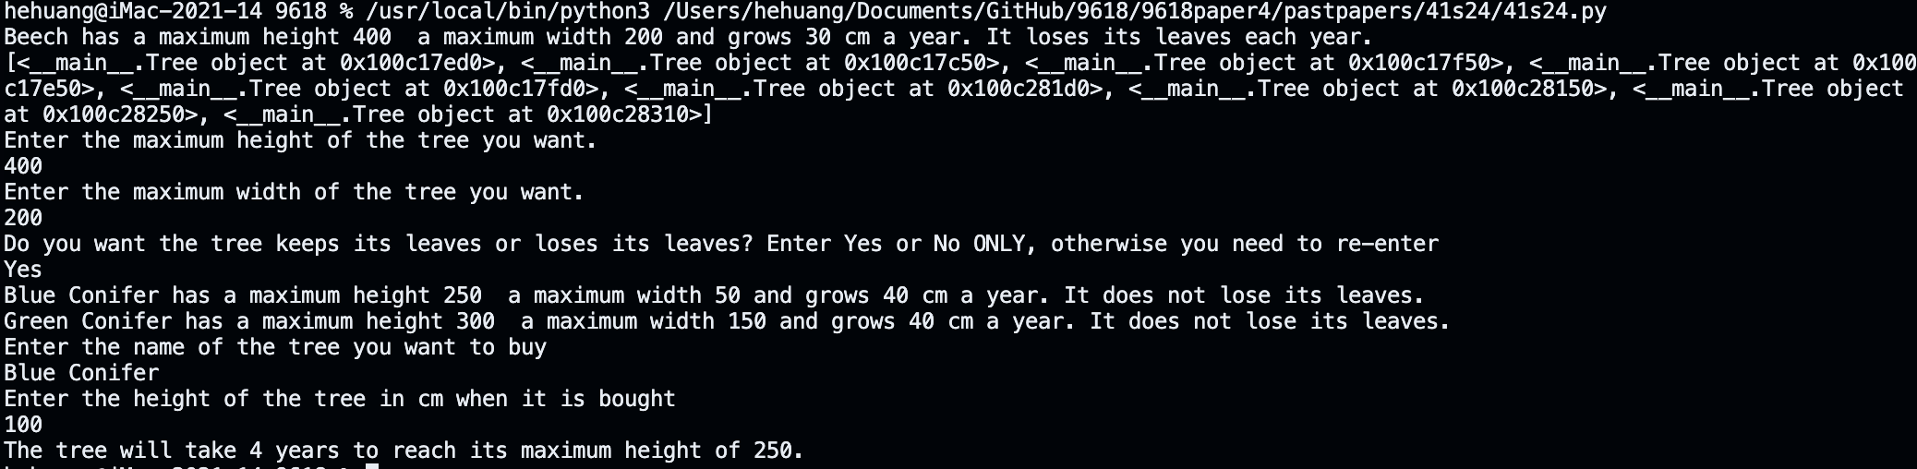

Question 3
Part 3(a)
{Copy and paste program code listing for question 3(a) here}

Part 3(b)
{Copy and paste program code listing for question 3(b) here}

Part 3(c)
{Copy and paste program code listing for question 3(c) here}

Part 3(d)(i)
{Copy and paste program code listing for question 3(d)(i) here}

Part 3(d)(ii)
{Copy and paste program code listing for question 3(d)(ii) here}

Part 3(d)(iii)
{Copy and paste screenshot for question 3(d)(iii) here}

