Screenshots or program listings must be copied into appropriate cells in the following table.
Save this evidence document as evidence_ followed by your centre number_ candidate number. For example: evidence_ zz999_9999 and insert your name, centre number and candidate number into the header above.
Examiners must be able to read the contents including any screenshots without the use of a magnifying glass. Answers that are not readable or missing will not be awarded any marks.
Save this evidence document at regular intervals, for example, every 10 minutes.
Question 1
Part 1(a)
{Copy and paste the program code for question 1(a) here}

Part 1(b)(i)
{Copy and paste the program code for question 1(b)(i) here}

Part 1(b)(ii)
{Copy and paste the screenshot for question 1(b)(ii) here}

Part 1(c)
{Copy and paste the program code for question 1(c) here}

Part 1(d)(i)
{Copy and paste the program code for question 1(d)(i) here}

Part 1(d)(ii)
{Copy and paste the screenshot(s) for question 1(d)(ii) here}

Question 2
Part 2(a)
{Copy and paste the program code for question 2(a) here}

Part 2(b)
{Copy and paste the program code for question 2(b) here}

Part 2(c)
{Copy and paste the program code for question 2(c) here}

Part 2(d)
{Copy and paste the program code for question 2(d) here}

Part 2(e)
{Copy and paste the program code for question 2(e) here}

Part 2(f)
{Copy and paste the program code for question 2(f) here}

Part 2(g)
{Copy and paste the program code for question 2(g) here}

Part 2(h)
{Copy and paste the screenshot(s) for question 2(h) here}

Question 3
Part 3(a)
{Copy and paste the program code for question 3(a) here}

ArrayNodes = [[None for i in range(3)] for i in range(20)] # An 2D array stores nodes
RootPointer = -1 #ingeger datatype, initialised to -1, points to the first node in the binary tree
FreeNode = 0 #ingeger datatype, initialised to 0, points to the first empty node in the array

Part 3(b)
def AddNode():
global ArrayNodes, RootPointer, FreeNode
NodeData = int(input("Enter the data.\n"))
if FreeNode <= 19:
ArrayNodes[FreeNode][0] = -1
ArrayNodes[FreeNode][1] = NodeData
ArrayNodes[FreeNode][2] = -1
if RootPointer == -1:
RootPointer = 0
else:
Placed = False
CurrentNode = RootPointer
while Placed == False:
if NodeData <= ArrayNodes[CurrentNode][1]:
if ArrayNodes[CurrentNode][0] == -1:
ArrayNodes[CurrentNode][0] = FreeNode
Placed = True
else:
CurrentNode = ArrayNodes[CurrentNode][0]
else:
if ArrayNodes[CurrentNode][2] == -1:
ArrayNodes[CurrentNode][2] = FreeNode
Placed = True
else:
CurrentNode = ArrayNodes[CurrentNode][2]

FreeNode += 1

else:
print("Tree is full")

Part 3(c)
{Copy and paste the program code for question 3(c) here}

def PrintAll():
global ArrayNodes
for i in range(len(ArrayNodes)):
if ArrayNodes[i][1] !=None:
print(f"{ArrayNodes[i][0]} {ArrayNodes[i][1]} {ArrayNodes[i][2]}")
else: continue

Part 3(d)(i)
{Copy and paste the program code for question 3(d)(i) here}

Part 3(d)(ii)
{Copy and paste the screenshot for question 3(d)(ii) here}

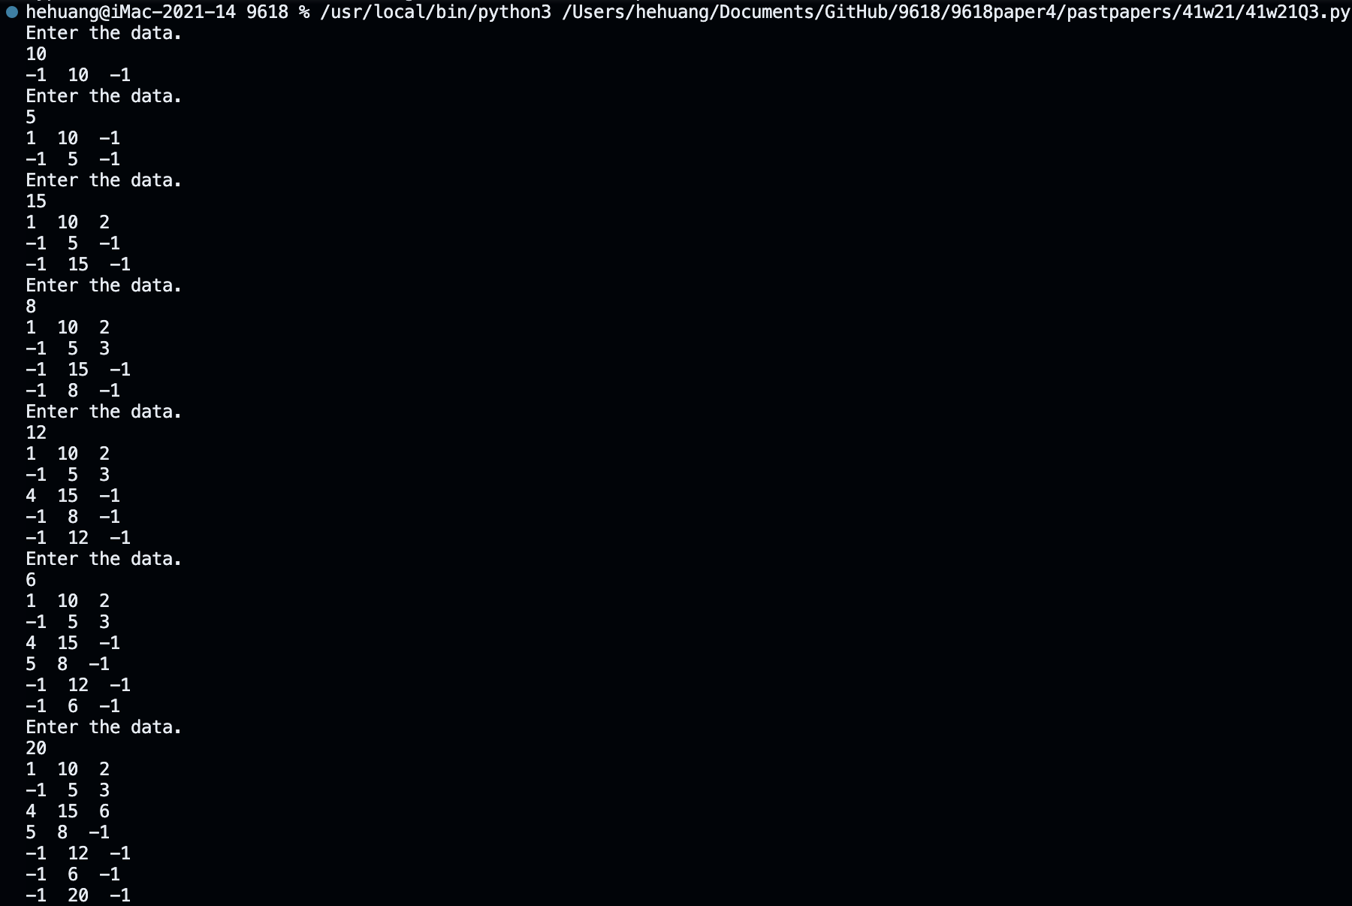
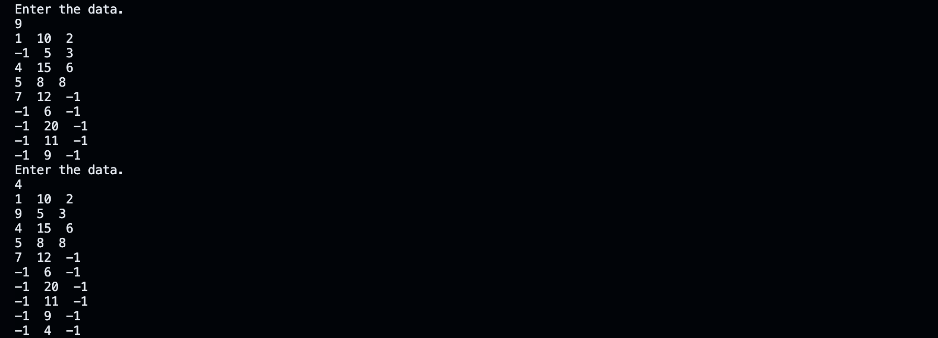

Part 3(e)(i)
{Copy and paste the program code for question 3(e)(i) here}

def InOrder(ptr):
global ArrayNodes

if ArrayNodes[ptr][1] != None:
InOrder(ArrayNodes[ptr] [0])
print(ArrayNodes[ptr][1])
InOrder(ArrayNodes[ptr][2])

Part 3(e)(ii)
{Copy and paste the screenshot for question 3(e)(ii) here}

