Insert your name, centre number and candidate number into the header above.
Save this evidence document as evidence_ followed by your centre number_ candidate number. For example: evidence_ zz999_9999.doc
Screenshots or program listings must be copied into appropriate cells in the following tables.
Examiners must be able to read the contents including any screenshots without the use of a magnifying glass. Answers that are not readable or missing will not be awarded any marks.
Save this evidence document at regular intervals, for example, every 10 minutes.
Question 1
Part 1(a)
{Copy and paste program code listing for question 1(a) here}

Queue = [-1 for i in range(20)]

HeadPointer = -1 # Global variable of integer type, initialised to –1, points to the first element in the queue.
TailPointer = -1 # Global variable of integer type, initialised to –1, points to the last element in the queue
NumberItems = 0 # Global variable of integer type, initialised to 0, stores the number of items in the queue.

Part 1(b)
{Copy and paste program code listing for question 1(b) here}

def Enqueue(num):
global Queue, HeadPointer, TailPointer, NumberItems
if NumberItems == 20:
return False

temp = NumberItems

NumberItems+=1

if TailPointer == len(Queue)-1:
TailPointer = 0

else:
TailPointer +=1

Queue[TailPointer] = num

if temp == 0:
HeadPointer = TailPointer

return True

Part 1(c)
{Copy and paste program code listing for question 1(c) here}

for i in range(1, 26):
if Enqueue(i): print(f"{i} Successful")
else: print(f"{i} Unsuccessful")

Part 1(d)
{Copy and paste program code listing for question 1(d) here}

def Dequeue():
global Queue, HeadPointer, TailPointer, NumberItems
if NumberItems == 0: return -1

data = Queue[HeadPointer]
NumberItems -=1

if HeadPointer == len(Queue)-1:
HeadPointer = 0
else:
HeadPointer +=1

return data

Part 1(e)(i)
{Copy and paste program code listing for question 1(e)(i) here}

print(Dequeue())
print(Dequeue())

Part 1(e)(ii)
{Copy and paste screenshot for question 1(e)(ii) here}

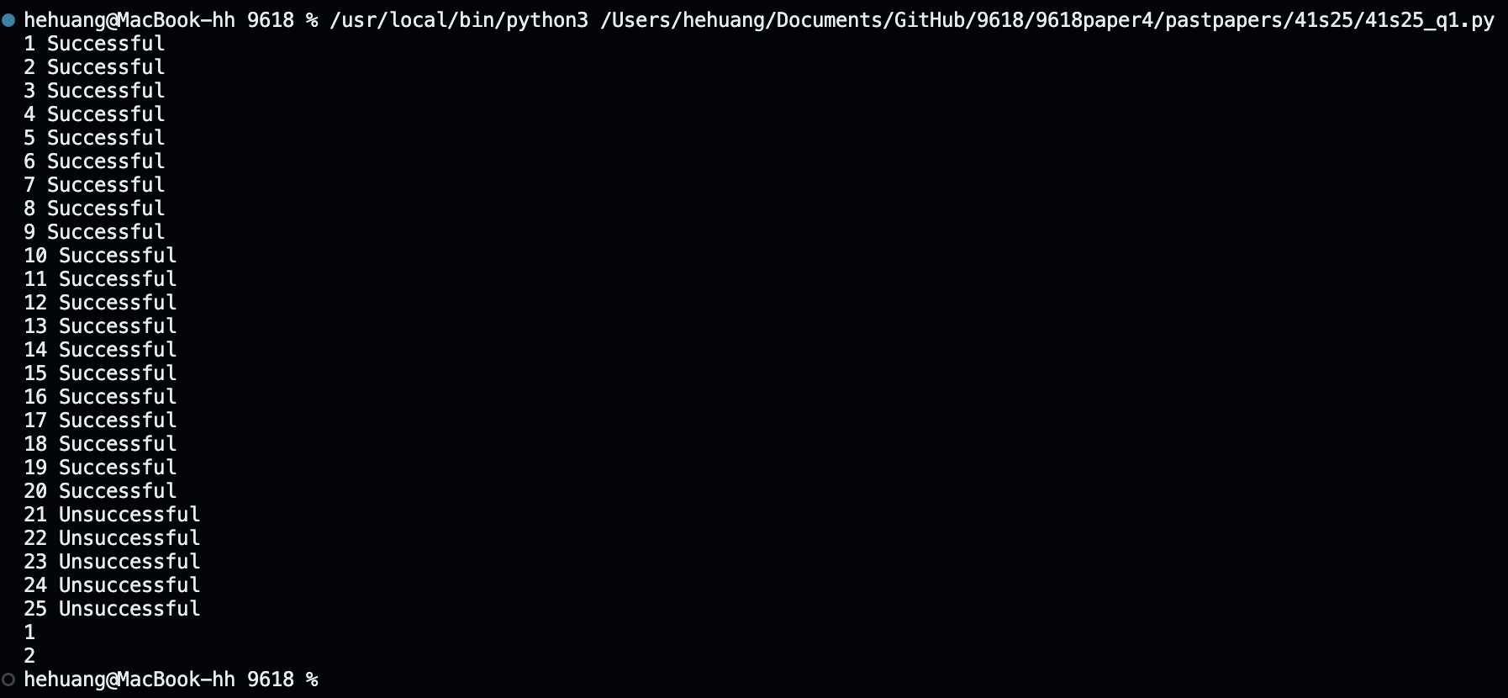

Question 2
Part 2(a)
{Copy and paste program code listing for question 2(a) here}

def ReadData():
name = input("Enter the name of the file\n")
arr = [] # it will be returned
try:
f = open(name, "r")
for i in range(72):
temp = f.readline()

if temp is None:
continue
arr.append(temp.strip())
f.close()
return arr
except:
print("error")

Part 2(b)
{Copy and paste program code listing for question 2(b) here}

def SplitData(DataArray):
red = []
green = []
blue =[]
orange = []
yellow = []
pink = []

for i in range(72):
temp = DataArray[i]
temparr = temp.split(',')
if temparr[1] == "red":
red.append(int(temparr[0]))
elif temparr[1] == "green":
green.append(int(temparr[0]))
elif temparr[1] == "blue":
blue.append(int(temparr[0]))
elif temparr[1] == "orange":
orange.append(int(temparr[0]))
elif temparr[1] == "yellow":
yellow.append(int(temparr[0]))
elif temparr[1] == "pink":
pink.append(int(temparr[0]))

Part 2(c)
{Copy and paste program code listing for question 2(c) here}

def StoreData(DataToStore, name):
try:
f = open(name, "a")
for i in range(len(DataToStore)):
print(DataToStore[i])
if DataToStore[i] is None:
continue
f.write(str(DataToStore[i])+'\n')

f.close()
except:
print("error")

Part 2(d)
{Copy and paste program code listing for question 2(d) here}

def SplitData(DataArray):
red = []
green = []
blue =[]
orange = []
yellow = []
pink = []

for i in range(72):
temp = DataArray[i]
temparr = temp.split(',')
if temparr[1] == "red":
red.append(int(temparr[0]))
elif temparr[1] == "green":
green.append(int(temparr[0]))

elif temparr[1] == "blue":
blue.append(int(temparr[0]))
elif temparr[1] == "orange":
orange.append(int(temparr[0]))

elif temparr[1] == "yellow":
yellow.append(int(temparr[0]))
elif temparr[1] == "pink":
pink.append(int(temparr[0]))

StoreData(red, "Red.txt")
StoreData(green, "Green.txt")
StoreData(blue, "Blue.txt")
StoreData(orange, "Orange.txt")
StoreData(yellow, "Yellow.txt")
StoreData(pink, "Pink.txt")

Part 2(e)(i)
{Copy and paste program code listing for question 2(e)(i) here}

arr = ReadData()

SplitData(arr)

Part 2(e)(ii)
{Copy and paste screenshot(s) for question 2(e)(ii) here}

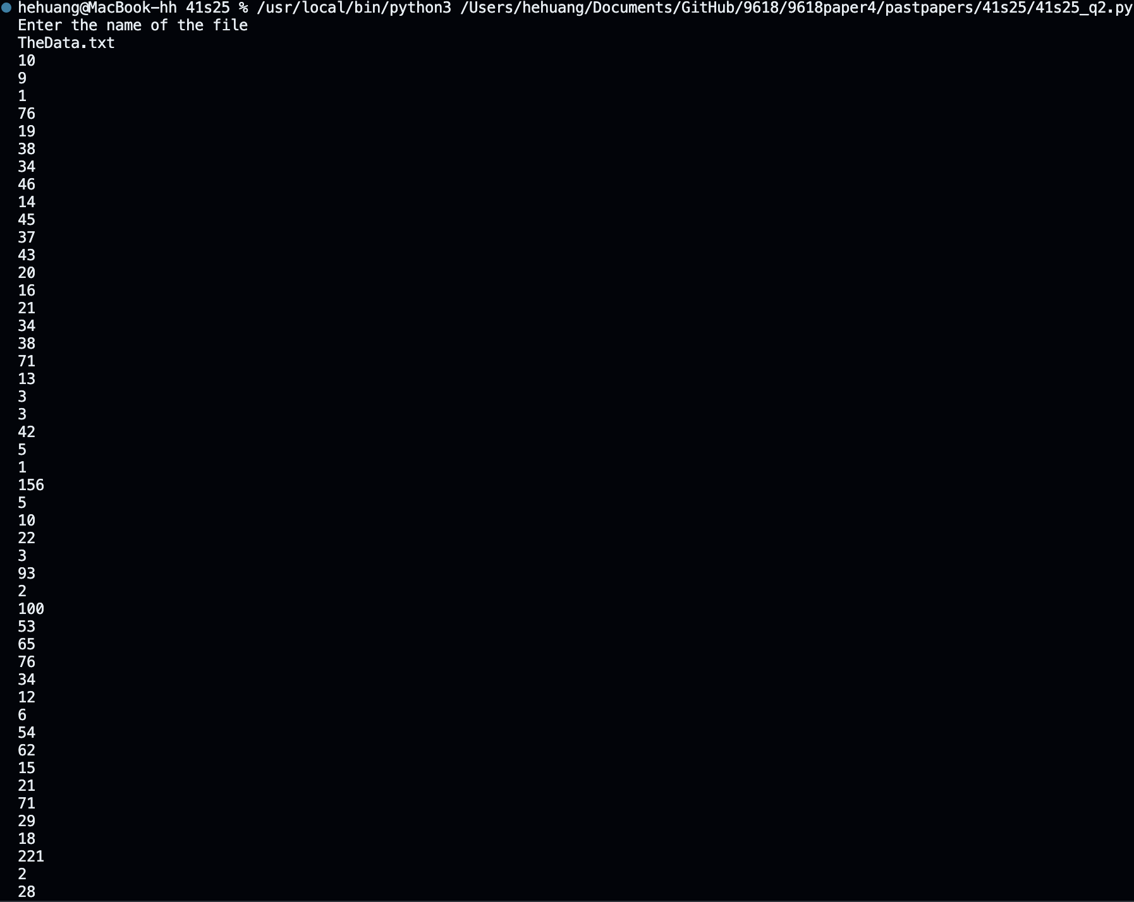
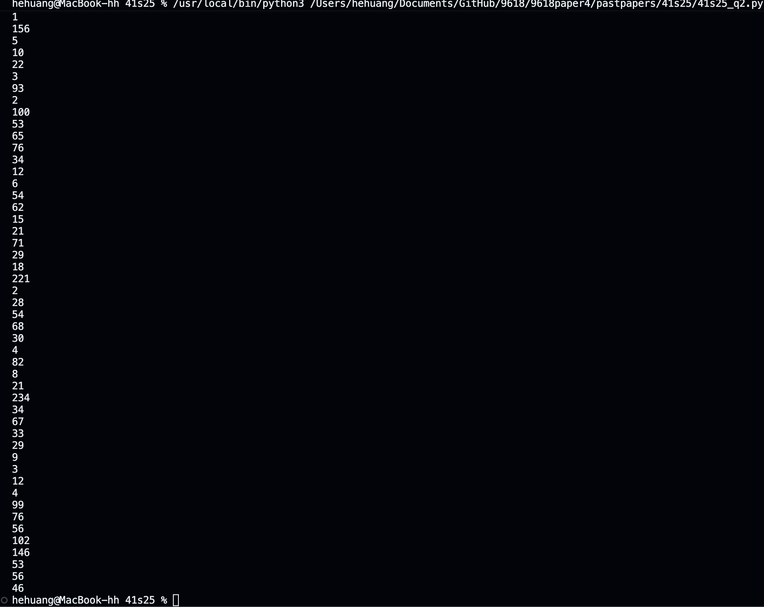
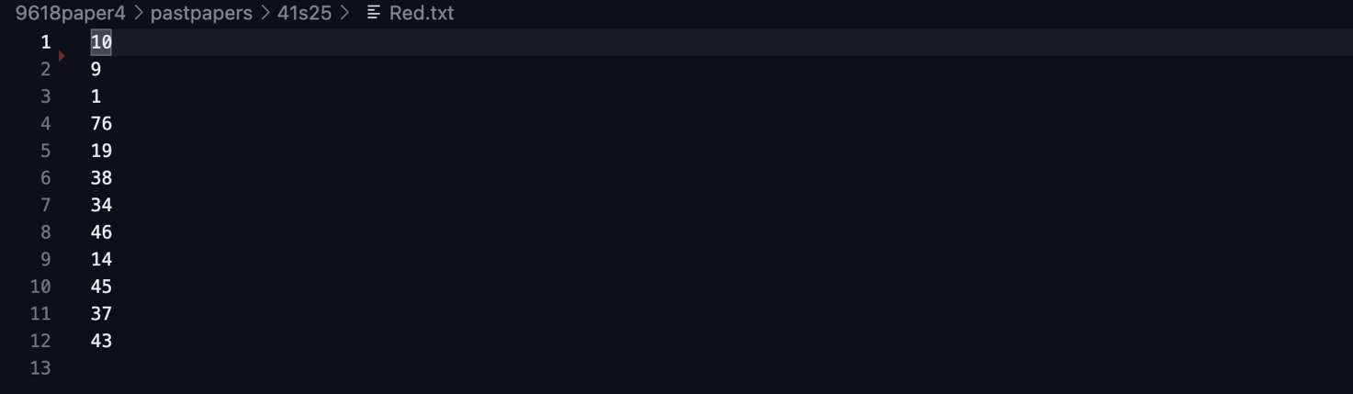

Question 3
Part 3(a)(i)
{Copy and paste program code listing for question 3(a)(i) here}

class Node:
def __init__(self, data):
self.__NodeData = data # Integer datatype, stores the node’s integer data
self.__LeftNode = None # Stores the node that is stored to the left of the current node, or a null value if there is no node to the left
self.__RightNode = None # stores the node that is stored to the right of the current node, or a null value if there is no node to the right

Part 3(a)(ii)
{Copy and paste program code listing for question 3(a)(ii) here}

def GetLeft(self):
return self.__LeftNode

def GetRight(self):
return self.__RightNode

def GetData(self):
return self.__NodeData

Part 3(a)(iii)
{Copy and paste program code listing for question 3(a)(iii) here}

def SetLeft(self, Node):
self.__LeftNode = Node

def SetRight(self, Node):
self.__RightNode = Node

Part 3(b)
{Copy and paste program code listing for question 3(b) here}

Node1 = Node(10)
Node2 = Node(20)
Node3 = Node(5)
Node4 = Node(15)
Node5 = Node(7)

Part 3(c)(i)
{Copy and paste program code listing for question 3(c)(i) here}

class Tree:
def __init__(self, Root): # Initialises FirstNode to its parameter value
self.__FirstNode = Root # Stores the root node in the tree, initialised to the value of Root.

Part 3(c)(ii)
{Copy and paste program code listing for question 3(c)(ii) here}

def GetRootNode(self):
return self.__FirstNode

Part 3(c)(iii)
{Copy and paste program code listing for question 3(c)(iii) here}

def Insert(self, Node):
Root = self.GetRootNode()

Found = False
while not Found:

if Node.GetData() > Root.GetData():
if Root.GetRight() == None:
Root.SetRight(Node)
Found = True
Root = Root.GetRight()
else:
if Root.GetLeft() == None:
Root.SetLeft(Node)
Found = True
Root = Root.GetLeft()

Part 3(d)
{Copy and paste program code listing for question 3(d) here}

def OutputInOrder(Node):
if Node is not None:
OutputInOrder(Node.GetLeft())
print(Node.GetData())
OutputInOrder(Node.GetRight())

Part 3(e)(i)
{Copy and paste program code listing for question 3(e)(i) here}

Tree1 = Tree(Node1)
Tree1.Insert(Node2)
Tree1.Insert(Node3)
Tree1.Insert(Node4)
Tree1.Insert(Node5)

OutputInOrder(Node1)

Part 3(e)(ii)
{Copy and paste screenshot for question 3(e)(ii) here}

