Insert your name, centre number and candidate number into the header above.
Save this evidence document as evidence_ followed by your centre number_ candidate number. For example: evidence_ zz999_9999.doc
Screenshots or program listings must be copied into appropriate cells in the following tables.
Examiners must be able to read the contents including any screenshots without the use of a magnifying glass. Answers that are not readable or missing will not be awarded any marks.
Save this evidence document at regular intervals, for example, every 10 minutes.
Question 1
Part 1(a)
{Copy and paste program code listing for question 1(a) here}

TopOfStack = -1 # TopOfStack, a global variable of type integer, initialised to -1

Stack = ["-1" for i in range(20)] # Stack, a global 1D array, type of string, all elements are initialised to "-1"

Part 1(b)
{Copy and paste program code listing for question 1(b) here}

def Push(name):
global Stack, TopOfStack
if TopOfStack >= len(Stack)-1:
return -1

TopOfStack +=1
Stack[TopOfStack] = name

return 1

Part 1(c)
{Copy and paste program code listing for question 1(c) here}

def Pop():
global Stack, TopOfStack
if TopOfStack == -1:
return "-1"

data = Stack[TopOfStack]
TopOfStack -=1

return data

Part 1(d)
{Copy and paste program code listing for question 1(d) here}

def ReadData(FileName):
global Stack, TopOfStack
try:
f = open(FileName, "r")
for i in range(len(Stack)):
temp = f.readline()
temp = temp.strip()
if temp == '':
break

result = Push(temp)

if result == -1:
status = "Stack full"
print(status)

f.close()
except:
print("error")

Part 1(e)
{Copy and paste program code listing for question 1(e) here}

def Calculate():
global Stack, TopOfStack
result = int(Pop())
status = "okay"
while status != "-1":
temp = Pop()

if temp == "+":
result += int(Pop())
elif temp == "-":
result -= int(Pop())
elif temp == "/":
result /= int(Pop())
elif temp == "*":
result *= int(Pop())
elif temp == "^":
result **= int(Pop())

if temp == "-1":
status = temp

print(result)

Part 1(f)(i)
{Copy and paste program code listing for question 1(f)(i) here}

ReadData(input("Enter the name of the file\n"))
Calculate()

Part 1(f)(ii)
{Copy and paste screenshot for question 1(f)(ii) here}

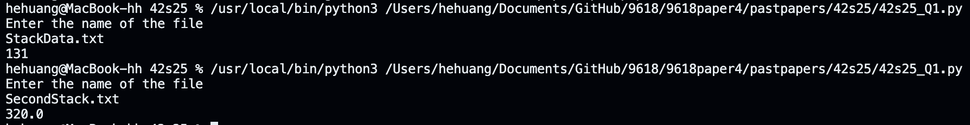

Question 2
Part 2(a)
{Copy and paste program code listing for question 2(a) here}

class NewRecord:
def __init__(self,key, Item1, Item2):
self.Key = key
self.Item1 = Item1
self.Item2 = Item2

Part 2(b)(i)
{Copy and paste program code listing for question 2(b)(i) here}

HashTable = [None for i in range(200)] # an global 1D array with size 200 elements, type of NewRecord
Spare = [None for i in range(100)] # an global 1D array with size 100 elements, type of NewRecord

Part 2(b)(ii)
{Copy and paste program code listing for question 2(b)(ii) here}

def Initialise():
global HashTable, Spare
for i in range(200):
HashTable[i] = NewRecord(-1,-1,-1)
if i <100:
Spare[i] = NewRecord(-1,-1,-1)

Part 2(c)
{Copy and paste program code listing for question 2(c) here}

def CalculateHash(Key):
return Key%200

Part 2(d)
{Copy and paste program code listing for question 2(d) here}

def InsertIntoHash(data):
global HashTable, Spare
index = CalculateHash(data.Key)
if HashTable[index].Key != -1:
for i in range(100):
if Spare[i].Key == -1 and (Spare[i].Item1 == -1 and Spare[i].Item2 == -1):
Spare[i].Key = data.Key
Spare[i].Item1 = data.Item1
Spare[i].Item2 = data.Item2
break
else:
HashTable[index].Key = data.Key
HashTable[index].Item1 = data.Item1
HashTable[index].Item2 = data.Item2

Part 2(e)
{Copy and paste program code listing for question 2(e) here}

def CreateHashTable():
f = open("HashData.txt", 'r')
for i in range(200):
temp = f.readline().strip()
if temp == '': continue
temparr = temp.split(",")
tempRec = NewRecord(int(temparr[0]), int(temparr[1]), int(temparr[2]))
InsertIntoHash(tempRec)

Part 2(f)(i)
{Copy and paste program code listing for question 2(f)(i) here}

def PrintSpare():
global Spare
for i in range(100):
if Spare[i].Key == -1 and (Spare[i].Item1 == -1 and Spare[i].Item2 == -1): break
else: print(Spare[i].Key)

Part 2(f)(ii)
{Copy and paste program code listing for question 2(f)(ii) here}

Initialise()
CreateHashTable()
PrintSpare()

Part 2(f)(iii)
{Copy and paste screenshot for question 2(f)(iii) here}

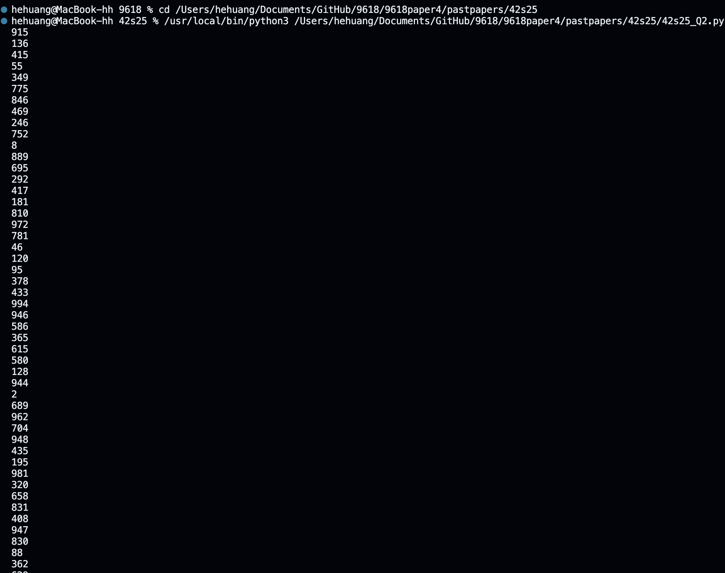

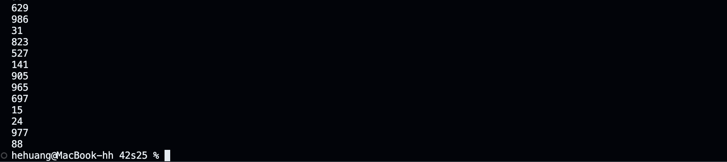

Question 3
Part 3(a)(i)
{Copy and paste program code listing for question 3(a)(i) here}

class Animal:
def __init__(self, name, sound, size, intelligence):
self.Name = name # Name, type of string
self.Sound = sound # Sound, type of string
self.Size = size # Size, type of integer
self.Intelligence = intelligence # Intelligence, type of integer

Part 3(a)(ii)
{Copy and paste program code listing for question 3(a)(ii) here}

def Description(self):
result = f"The animal's name is {self.Name}, it makes a{self.Sound} its size is {self.Size} and its intelligence level is {self.Intelligence} "
return result

Part 3(b)(i)
{Copy and paste program code listing for question 3(b)(i) here}

class Parrot(Animal):
def __init__(self, name, sound, size, intelligence, wingSpan, numwords):
super().__init__(name, sound, size, intelligence)
self.WingSpan = wingSpan # WingSpan, type of integer
self.NumberWords = numwords #NumberWords, type of integer

def ChangeNumberWords(self, num):
self.NumberWords+=num

Part 3(b)(ii)
{Copy and paste program code listing for question 3(b)(ii) here}

def Description(self):
result = f"The animal's name is {self.Name}, it makes a {self.Sound}, its size is {self.Size} and its intelligence level is {self.Intelligence}. It has a wingspan of {self.WingSpan} cm and can say {self.NumberWords} words."
return result

Part 3(c)(i)
{Copy and paste program code listing for question 3(c)(i) here}

class Wolf(Animal):
def __init__(self, name, sound, size, intelligence, TerritorySize):
super().__init__(name, sound, size, intelligence)
self.TerritorySize = TerritorySize # TerritorySize, type of integer
def SetTerritorySize(self, num):
self.TerritorySize += num

Part 3(c)(ii)
{Copy and paste program code listing for question 3(c)(ii) here}

def Description(self):
result = f"The animal's name is {self.Name}, it makes a {self.Sound}, its size is {self.Size} and its intelligence level is {self.Intelligence}. Its territory {self.TerritorySize} square miles."
return result

Part 3(d)(i)
{Copy and paste program code listing for question 3(d)(i) here}

p1=Parrot("Chewie", "Squawk", 1, 10, 30, 29) # Chewie
w1=Wolf("Nighteyes", "Howl", 8, 7, 100) # Nighteyes
a1=Animal("Copper", "Neigh", 10, 6) # Copper

Part 3(d)(ii)
{Copy and paste program code listing for question 3(d)(ii) here}

w1.SetTerritorySize(-20)
p1.ChangeNumberWords(2)

print(p1.Description())
print(w1.Description())
print(a1.Description())

Part 3(d)(iii)
{Copy and paste screenshot for question 3(d)(iii) here}

