Questions (Place your answer under each question after you have read the supplied chapter) – You will not get them all correct but do your level best.

1. Define each of the following terms:

a. Data are raw facts such as a birth date, telephone number or customer name. Data has very little meaning if it is not organized logically.

b. Field is used to define and store data. The character or characters have a specific meaning and can be alphabetic or numeric.

c. Record is a group of data about one person, place or thing. E.g a football players record could consist of his name,age,teams played for,goals scored, assists etc.

d. File is a collection of records e.g information on an entire football team

2. What is data redundancy, and which characteristics of the file system can lead to it?

Data redundancy is the term used when the same data is stored unnecessarily in different places. A file system with a lack of procedures where data can be entered in similar ways can lead to data redunancy.

3. What is data independence, and why is it lacking in file systems?

Data independence is the term used to describe data storage characteristics that can be altered without affecting the programs function of accessing that data. It is lacking in file systems because file systems are structurally dependent. Programs are affected by changes in the file structure when a system is structurally dependent.

4. What is a DBMS, and what are its functions?

A database management system is a group of programs. These programs run the database structure and allow access to the end user access to the data.

5. What is structural independence, and why is it important?

Structural independence is when you can change the file structure without affecting the applications ability to access the data. It is very important as it streamlines a database for the end user allows the end user to get accurate information from the database.

6. Explain the differences among data, information, and a database.

Data is raw information that is entered into a database. This raw data must be transformed into information to produce an accurate database. Information is gathered by compiling this raw data. A database holds accurate information and can answer pre-determined requests for the end user.

7. What is the role of a DBMS, and what are its advantages? What are its disadvantages?

The role of a database management system is to store files in the database structure and give the end user access to these files through a simple interface. The advantages of a DBMS are improved data sharing, consistency, access, decision making and end user productivity. A possible disadvantage is if an element within the DBMS fails that it could be complicated to find. If the DBMS failed in a bank this would cause chaos to the end users. As many of todays DBMS are easy to use many business owners tend to create over simplified databases. These oversimplified databases produce false information that business decisions are made on. If this happened within the health service medication quantities could be wrong etc. The negative implications of not having an expert implement a database can be extreme.

8. List and describe the different types of databases.

Number of users

Single user database: Only one user can use the database at a time.
Multi-User database: Multiple users can use the database at the same time.
Workgroup database: Multiple users up to 50 can use the database at the same time. A specific department.
Enterprise database: Multiple users over 50 can use the database at the same time. An entire organization.

Data Location

Centralized database: Data located at a single site.
Distributed database: Data located at multiple sites.

Data Usage

Analytical database: Stores data on historic facts and figures etc.
Operational database: Stores data on day to day operations.

XML database: manages and stores semi structured data.

9. What are the main components of a database system?

People (System administrator, Database designers, System analysts, programmers) Procedures (Rules, Regulations), Software (DBMS, Operating systems) Hardware (PC's, Super computers, printers etc),. All of these must coincide to create a database system.

10. What are metadata?

Meta data are data about data. Metadata components store information about data components e.g (text,numeric,dates) The meta data gives a more complete picture and expands the use of the data.

11. Explain why database design is important.

Database design is so important for a number of reasons. The data that an organization holds on their employees and customers is very important. Strategic decisions are often based on this data and if it is not recorded accurately in a database the end user will either be guessing or making strategic decisions based on false information.

12. What are the potential costs of implementing a database system?

Costs are potentially very high for implementing and maintaing a good database system. An organization needs to take costs of hardware, software and highly skilled personnel into account. They also need to take into account upgrade, training and regulation and compliance costs.

13. Use examples to compare and contrast unstructured and structured data. Which type is more prevalent in a typical business environment?

Unstructured data are data in their raw state. This data cannot be used for information until structured. Conversely structured data is processed unstructured data that can be used for processing information. An example of unstructured data is the following... If you take the number 11081984 this could be an address or a sales figure. To structure the data it must be stored in the relevant format. If the data is a sales figure and you would like to run calculations the data format must be stored as numeric. If the number is an address it must be stored as text.

In a business environment structured data is essential to show accurate financial figures. Unstructured data can also be useful for marketing purposes. Internal or external emails for example will have unstructured data that could give valuable information to an organization about their staff or customers. In my opinion both forms of data can be useful but structured data is more important as it gives the most accurate information.

14. What are some basic database functions that a spreadsheet cannot perform?

Spreadsheets cannot perform database functions such as enforcement of data types to maintain consistency of data in a column. Define relationships within tables or ensure consistent data across various tables.

15. What common problems does a collection of spreadsheets created by end users share with the typical file system?

Spreadsheets created by end users cause discrepancies in the information. If two end users enter data about an individual client they may enter the same data but in a different format. E.g 11/08/1984, 1984/11/08.

16. Explain the significance of the loss of direct, hands-on access to business data that end users experienced with the advent of computerized data repositories.

The significance of this loss would have being high because strategic business decisions would have been delayed as it would have taken longer for the end user to receive the information.

MORE ADVANCED QUESTIONS (Try your best at these, they are quite difficult).
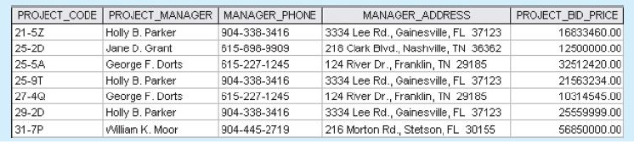

17. With regards to the above file structure:

a. How many records does the file contain? How many fields are there per record?

7 records, 5 fields.

b. What problem would you encounter if you wanted to produce a listing by city? How would you solve this problem by altering the file structure?

The city names are in the middle of address field. You could add a field named city and add the city names or possibly move the city name to the front of the current record e.g Gainesville, 3334 Lee Rd. FL 37123

c. If you wanted to produce a listing of the file contents by last name, area code, city, state, or zip code, how would you alter the file structure?

For the end user to access this information easily I would suggest creating a separate field for last names, area codes, city, state and Zip codes.

d. What data redundancies do you detect? How could those redundancies lead to anomalies?

George F . Dorts has two record entries and Holly B. Parker has three. The project bid prices vary and would lead to data anomalies in the following way. When the client calls to discuss their bid price the end user will be faced with varying information and will have to edit each record to the correct bid price. This is also embarrassing for the end user as they may be dealing with important clients.
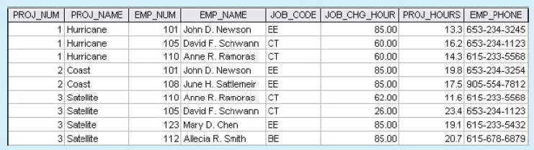

18. With regard to the above:

a. Identify and discuss the serious data redundancy problems exhibited by the file structure shown in the above figure.

Every field bar the Project hours has data redundancy which will lead to data anomalies. To improve the data redundancy issues I suggest distributing the data into more fields.

b. Looking at the EMP_NAME and EMP_PHONE contents in the above figure, what change(s) would you recommend?

I would recommend splitting the first and second names into two separate fields. I would recommend that the names only appear once and that the phone numbers only appear once.

c. Identify the various data sources in the file you examined in 18 a.

PROJ_NUM, PROJ_NAME, EMP_NUM, EMP_NAME, JOB_CODE, JOB_CHG_HOUR,
PROJ_HOURS, EMP_PHONE

d. Given your answer to part c, what new files should you create to help eliminate the data redundancies found in the file shown in the above figure?

Table 1 Employees
Emp_ID/ Emp_name F/ Emp_name L/ Emp_Phone/
101 / John D / Newson / 653-234-3245
105 / David F. / Schwann / 653-234-1123

Table 2 Job Code
Emp_ID/ Job Code EE/JC CT/ JC BE/
101 / Yes / /
105 / / Yes /

Table 3 Job Hours
Emp_ID/ Total Job Hrs/ Hurricane 1/ Coast 2/ Satellite 3
101 / 33.2 / 13.3 / 19.8 /
105 / 39.6 / 16.2 / / 23.4

Table 4 Employee Rates
Emp_ID/ Hurricane 1 Hourly Charge/ Coast 2 HC/ Satellite 3 HC
101 / 85.00 / 85.00 /
105 / 60.00 / / 26.00
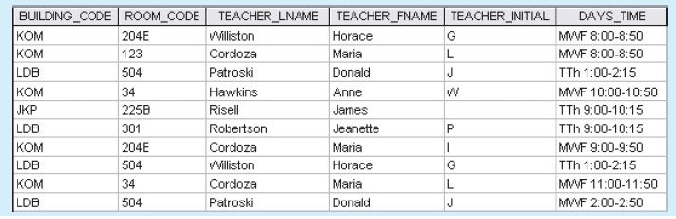

19. With regard to the above:

a. Identify and discuss the serious data redundancy problems exhibited by the file structure shown in the above figure (The file is meant to be used as a teacher class assignment schedule. One of the many problems with data redundancy is the likely occurrence of data inconsistencies—e.g. different initials have been entered for the teacher named Maria Cordoza.)

Repeating text in records within the same field e.g BUILDING_CODE KOM, LDB. TEACHER LNAME/FNAME Horace Williston.

Repeating numeric values e.g Room Codes and Times.

Numeric and text mixed together in one field.

Missing teacher initial

b. Given the file structure shown in the above figure, what problem(s) might you encounter if building KOM were deleted?

If building KOM was deleted the end user may end up in the wrong building by using the room code.

