|  |
| --- |
|  |
| User’s Manual V 1.2 |
| Fonts.com Web Fonts Module for Drupal |
|  |
| **Prepared by** |
|  |

WebFonts.fonts.com

Monotype Imaging Inc.

Date: June 29 2010

|  |
| --- |
|  |

|  |  |
| --- | --- |
|  | **Updated:** |
| 1. | July 13, 2010 |
| 2. | July 18, 2010 |
| 3.  4.  5. | July 21, 2010  July 27, 2010  August 9, 2010 |
|  |  |

Contents

Introduction 2

Requirements for Web Fonts Module 3

What You Need 3

Setting up Web fonts module in Drupal 4

Web fonts configuration 5

Authentication 5

Web fonts Projects Listings Page 7

More Actions 9

Projects Details Page 11

Configure tab 11

Work on Style sheet tab 16

Domain tab 20

Web fonts module and WYSIWYG editor 22

Font Dropdown Menu 24

Uninstalling Module 26

Make “Full HTML” global 27

References 28

*i.* Drupal 28

*ii.* Web Fonts 28

# Introduction

Web Fonts module for Drupal helps you use real web fonts in any Drupal-powered website. With the help of this module one can use fonts of their choice in their websites without the restriction of using limited fonts available.

This user guide explains the steps of setting up Web Fonts module in Drupal-powered sites and familiarizes you with the basic information needed to use Drupal successfully.

Drupal is a *content management system* whose goal is to help users compose and present web-site content such as articles, photos, and other content types. Drupal is a "dynamic" system; rather than forcing users to specify a fixed, pre-declared arrangement of content, Drupal takes care of the details of how information is arranged and presented, and lets users focus on the actual content to be displayed.

# Requirements for Web Fonts Module

### What You Need

To use Web Fonts module in your website, you need:

* An **account** on Fonts.com, a Web Fonts service.
* A project with your **domain** registered under those projects.
* **Drupal** installed in your website.
* **JavaScript** enabled in your browser.

***NOTE:***

1. *To open an account on Fonts.com, a Web Fonts site, visit this website:* [http://Web Fonts.fonts.com](http://webfonts.fonts.com)
2. *“WFS” refers to fonts.com Web Fonts site in this document.*

# Setting up Web fonts module in Drupal

Steps for setting up Web Fonts module in Drupal:

* **Download the Web Fonts module from the site**. *The module version must be compatible with your version of Drupal.*
* **Extract the compressed files with your respective extractor**. *When you first get the module, it will appear in a compressed file format such as 'tar.gz' or ‘zip’. On Windows, use programs like* [*7-zip*](http://www.7-zip.org/) *to extract it. On other operating systems use their respective extractor programs.*
* **Upload the folder**. FTP your files to the desired modules folder in your Drupal installation.
* **Enable the module**. Navigate to *Administer > Site building > Modules*. Check the checkbox corresponding to the web fonts and click on 'Save Configuration' button at the bottom
* **Adjust settings**. Click on Web Fonts menu located under *Administer > Site configuration*. Here you can make necessary configuration based upon your requirement for the site.
* In case of problems, search the module's issue queue and the forum. If your problem doesn’t get addressed, post a question or issue and someone will try to help you out.

***NOTE:*** *The detail user guide of using the module will be described in next section*

# Web fonts configuration

### Authentication

1. When you click on the Web Fonts menu located in *Administer > Site configuration > Web Fonts, the first screen that will appear is the Web Fonts authentication page.*

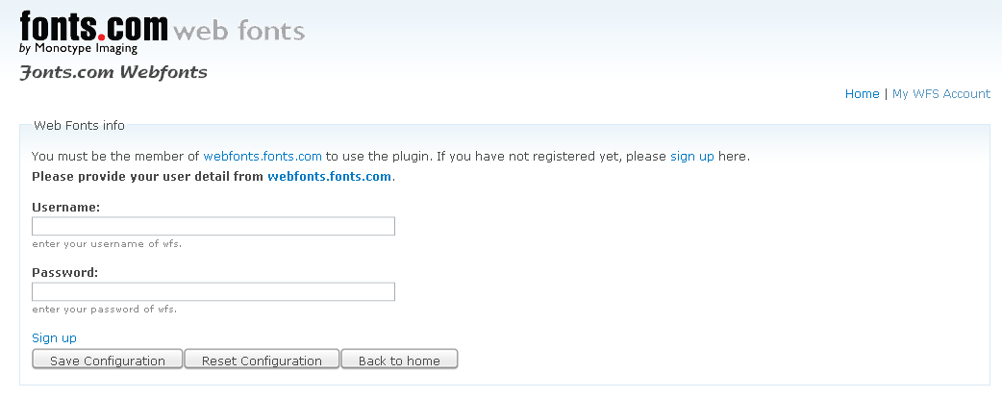

1. Enter the WFS username and password to login.
2. In case of authentication failure, the following screen will appear.

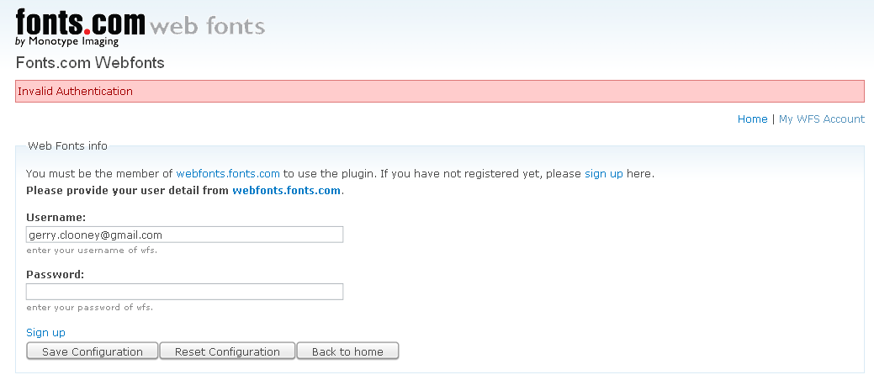

1. If the login details are correct then you will be redirected to “Project listing page”.

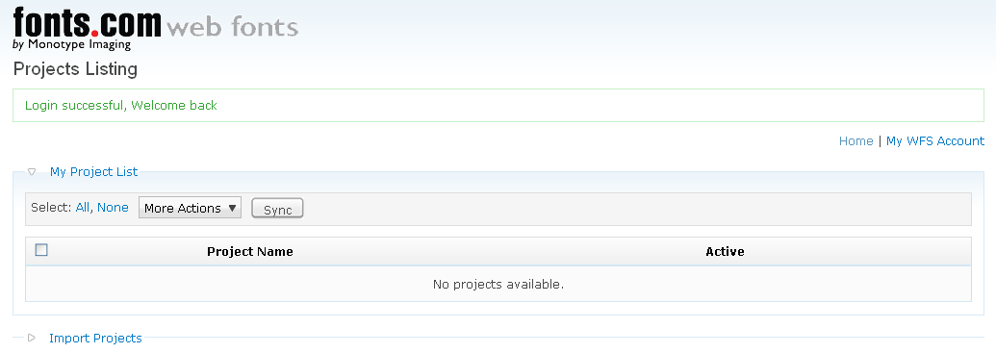

# Web fonts Projects Listings Page

After you login to the web fonts system then you will be redirected to “Project listing page”. The projects added to Drupal database are listed in **My Project List** sections**.** Initially, the project listing page will not have any project listing. You need to manually add each project you want to use from WFS site. The projects that you have created in WFS are listed in **Import Projects** Section. The import projects section will appear collapsed in its initial stage. Following are the steps for adding the projects In Drupal database.

1. In the Web fonts projects page, click on “Import Projects” link at the bottom.



1. After you click on “Import Projects”, a list of projects that is associated with your account in WFS will be listed.

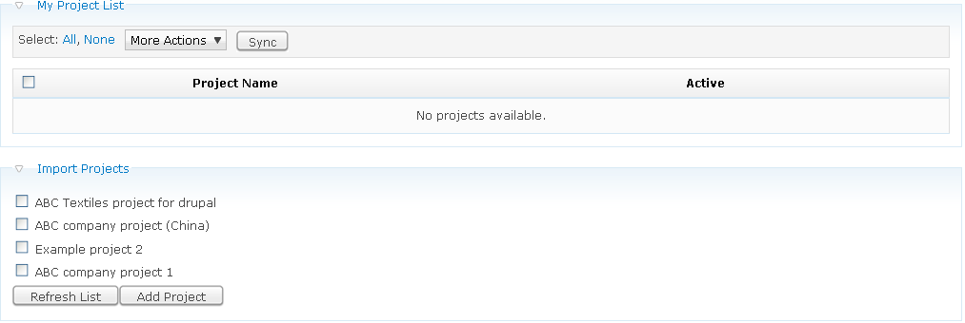

1. Check the project(s) that you want to use and click on *Add Project* button.

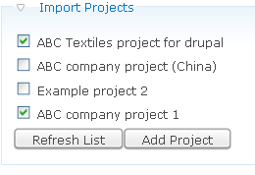

Refresh List Button***:*** *Clicking on “Refresh List” button will refresh the list of Projects from WFS.*

1. After clicking on *Add Project,* the project will be added to Drupal database and you will get a success message.

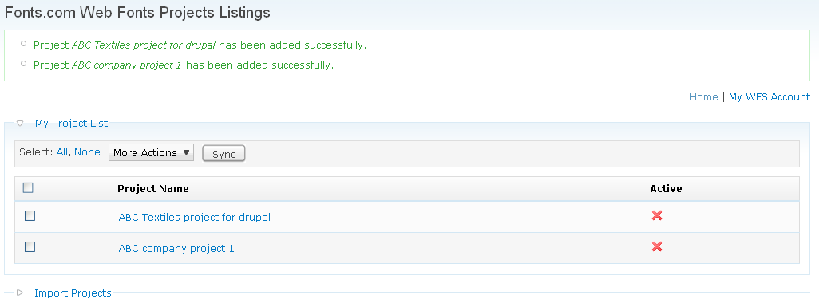

### More Actions

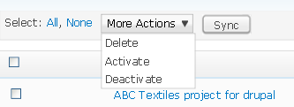

#### Activate

To use the project(s) in *front end* of the website, the project(s) needs to be activated. Until and unless the project(s) are activated the changes will be not reflect in the front end. The Status on corresponding projects shows the projects that have been activated. The check sign indicates the activated projects and cross sign shows the deactivated projects. Following are the procedures for activating the projects.

1. Make sure you have imported the project(s) to Drupal database.
   1. Check on the project(s) you want to activate.
   2. Click on “*More Action”* Option on the top of the project listing table
2. Click on “*Activate”* option

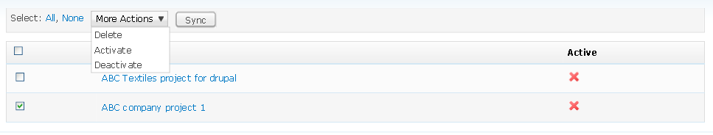

*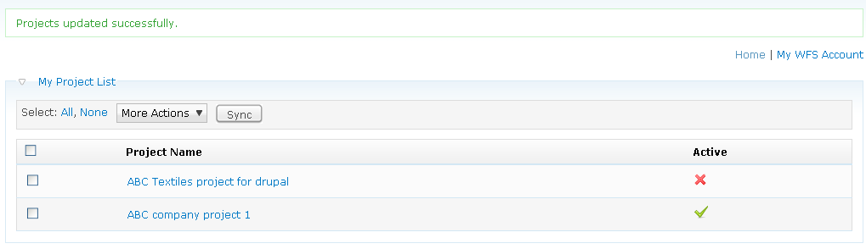Once the project(s) are activated the following success screen appears.*

Project activated status display

#### Deactivate

Deactivate option is to deactivate the currently activated project(s). The steps for deactivating the project(s) are similar to activating projects.

1. Check on the project(s) you want to deactivate.
2. Click on “*More Action”* Option on the top of the project listing table
3. Click on *De*a*ctivate* option

#### Delete

Delete option is to delete the project(s) from Drupal database. The procedure for deleting projects is also similar to that of Activating and Deactivating. The steps for deleting the projects are as follows.

1. Check on the project(s) you want to delete.
2. Click on “*More Action”* Option on the top of the project listing table
3. Click on “*Delete”* option

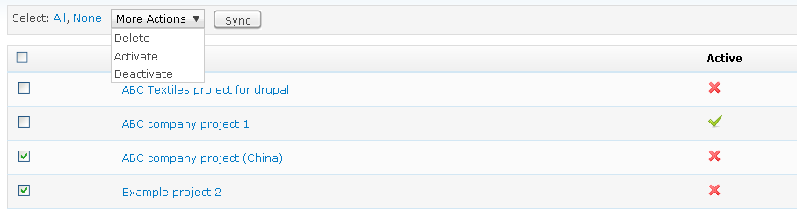

***NOTE:*** *Deleting project here does not affect on WFS account.*

#### Sync

*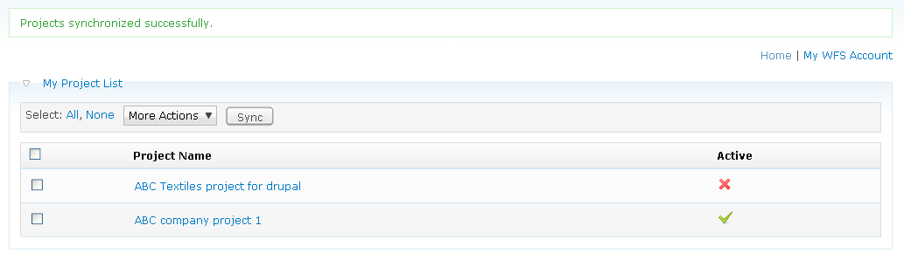Sync* is acronym for synchronization. The purpose of this is to reflect any changes that have been made on WFS account for the projects that have been added to the Drupal database. You don’t need to check the checkboxes for this option because the “*sync”* option will automatically synchronize all the projects that have been added to Drupal database. To use sync option, just click on the sync button

.

#### Other options

**Select:  *All-*** *Used to select all the checkboxes at once.*

***None-*** Used to remove selection of the checkboxes selected.

# Projects Details Page

When you click on each project in project listing page, you will be redirected to its “details page”. The “project details page” comprises of **Configure**, **Work on StyleSheet** and **Domain** tabs. Each tab has its own importance. The output of the changes made depends on these configurations.

## Configure tab

The configure tab deals with the configuration of web fonts projects in Drupal. Following are the configuration selection you can perform with configuration tabs.

* Change the page visibility options
* Choose the day you want to use the current project.
* Options to JS method or Non-JS method for paid subscribers.
* Use of the Web Fonts font library for current project in WYSIWYG editors.

#### Page Display settings

The page display settings provide the use of Web Fonts module in the front end of Drupal website. Based on the selection the module output will reflect on front end. There are three options to choose from the setting.

1. **Show on every page except listed page, leave blank to show on all pages.**

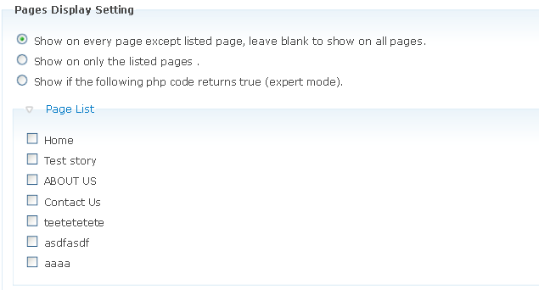

If you want to use the web fonts service in all the pages except some then you can use these options.

Following are the steps for using the options.

1. Select the ***Show on every page except listed page, leave blank to show on all pages***
2. Check the checkbox of corresponding projects for which you don’t want to use the module.
3. Click on *Save* at the bottom of the page.
4. **Show on only the listed page**

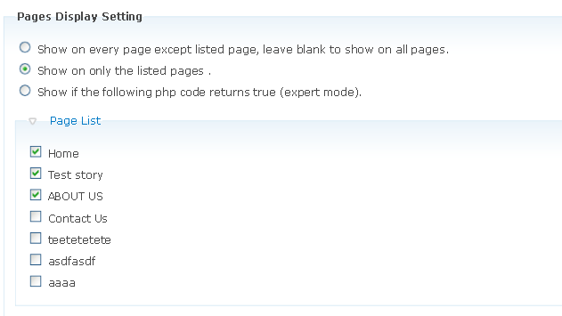

If you want to use the Web Fonts service in only the selected pages, we use this second option.

Following are the steps for using this option.

1. Select the ***Show on only the listed page.***
2. Check the checkbox of corresponding projects for which you want to use the module.
3. Click on *Save* at the bottom of the page.

**Show if the following PHP code returns true (expert mode).**

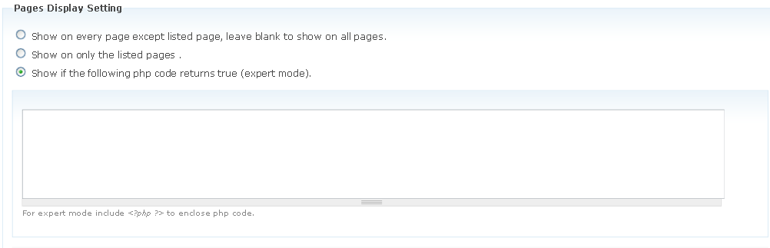

When you choose the third option the **Page List** area will be hidden and a “text area” will be displayed. The text area is to enter the Drupal standard PHP condition. Only if the condition is satisfied for that particular node, the Web Fonts service will be used in the Drupal website.

Following are the steps for using this option.

1. Select the ***Show if the following PHP code returns true*** option.
2. Enter the PHP code in the text area.
3. Click on *Save* at the bottom of the page.

***NOTE: This is for expert mode only. Use this option if you have coding knowledge of Drupal.***

#### Days selection

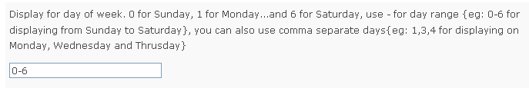The day selection field is for using the Web Fonts projects in particular day. If you have multiple projects activated then you can use these projects in different days. In day, 0 represents Sunday and 6 represents Saturday. If you want to use the day range then separate the days by “-”, for example: 0-4 for Sunday to Thursday. To use this to the activated projects, please make sure you don’t leave the field blank in the “day text field”. *If you leave this field blank then you will not be able to see the changes of the activated projects on the front end.*

#### StyleSheet/JavaScript

The Web Fonts service can be used on the site with either JS method or Non-JS method. This option will only be visible to paid subscribers of WFS. The free users are not allowed to select this option.

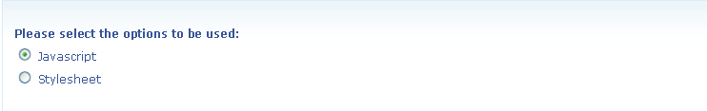For using this, select either of the options and click on *Save*

#### Web Fonts Editor Option

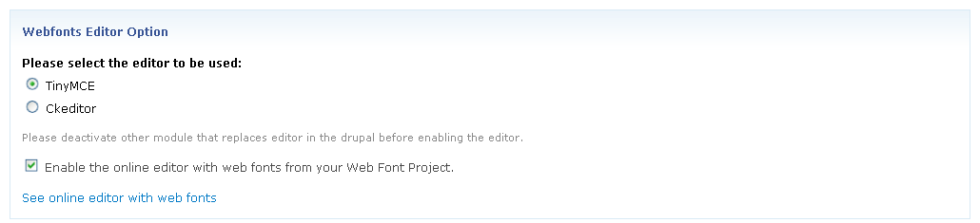Web Fonts Editor options lets you use the web fonts library fonts for your projects in WYSIWYG editor. It also lets you select between TinyMCE and Ckeditor to be the default editor in Drupal. Enabling the option will let you add the fonts in WYSIWYG editor fonts drop down. You cannot use this selection for multiple projects. The later selection will overwrite the previous selection. Also, you need make sure if you are using TinyMCE as your default editor then the radio button corresponding to TinyMCE is selected. If you are using TinyMCE and the Ckeditor is select then web fonts will not be reflected in the editor. If the drupal site does not have any other editor installed already, then it will add either TinyMce or Ckeditor itself based upon their selection in webfonts editor option. For better compatibility, please disable any other module that replaces the editor in the drupal site and then use the fonts.com webfonts module to add the editor in the drupal site.

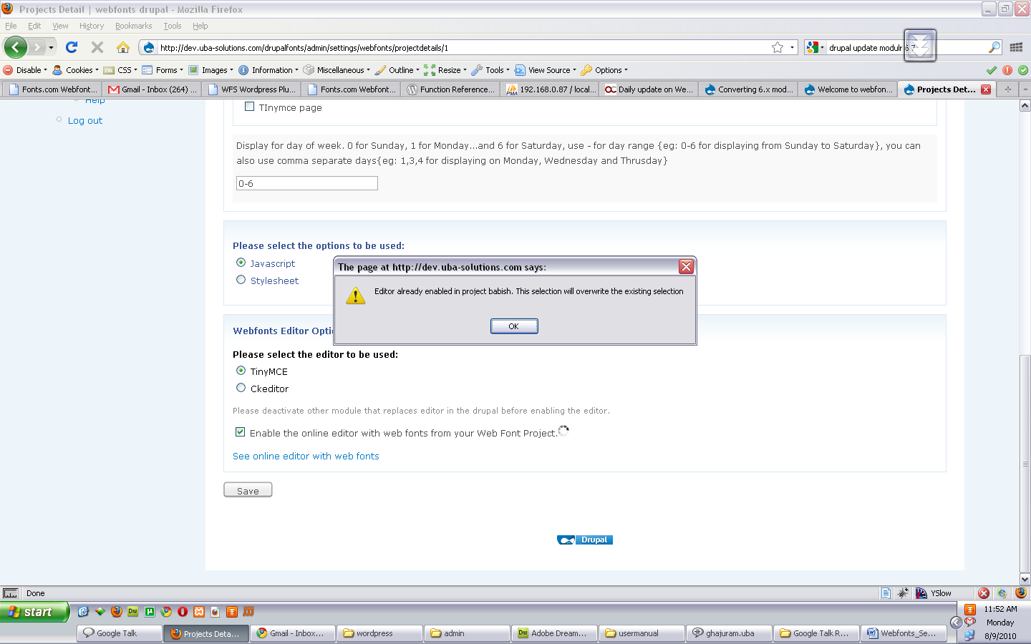If this option has already been saved in other projects then checking this checkbox in the project will show the following alert message.

If you click on *See online editor with web fonts* then it will display the sample TinyMCE and Ckeditor with fonts.com webfonts fonts.

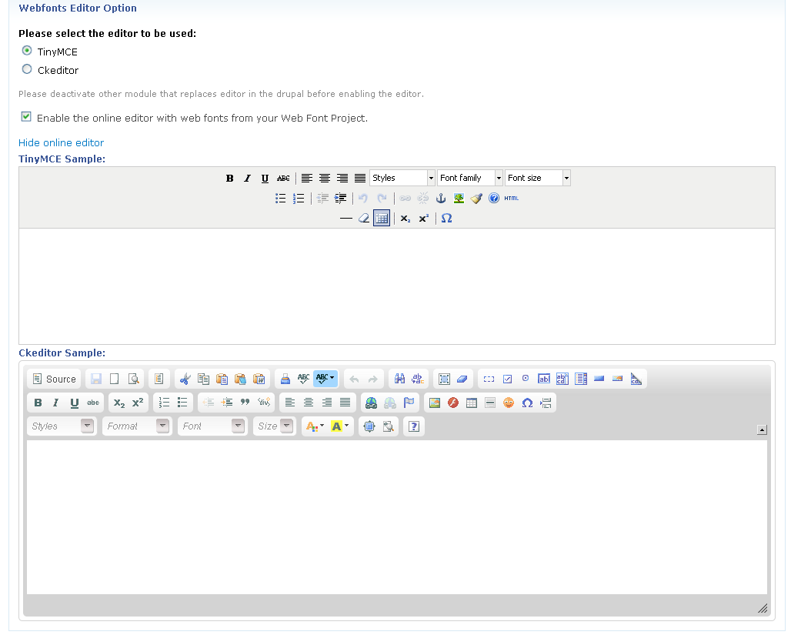

## Work on Style sheet tab

This tab consists of following settings:

* Display the list of fonts associated with the project.
* Display the list of selectors associated with the project.
* Display the font associated with the selectors.
* Display the list of selectors of current Drupal theme.
* Adding/Deleting selectors.

#### Selectors

The selectors section displays the list of selectors associated with the project. It displays the selector’s name, the font name associated with the selectors, preview text, remove link to delete the selectors and *Save button.*

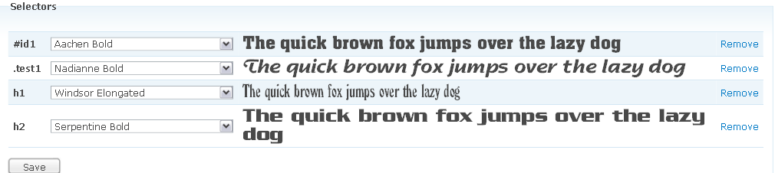

***Steps for assigning fonts to the selectors***

1. Select the font from the drop down menu for each corresponding selectors
2. 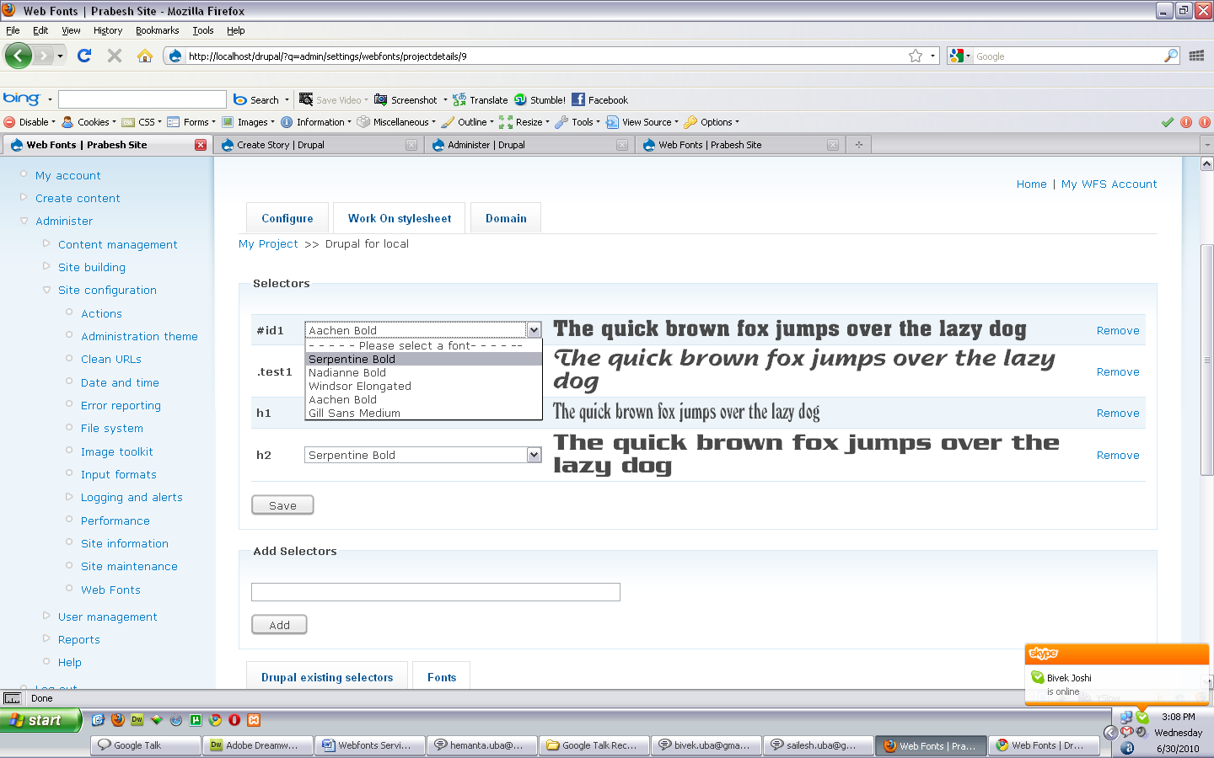 Click on *save* button.

#### Deleting the project

To delete the selectors click on corresponding *Remove* link. This will delete the selectors from the project. The selectors will be deleted on WFS account.

#### Add Selectors

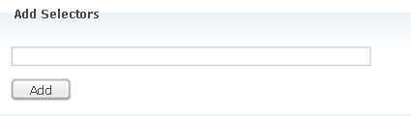The purpose of Add Selectors section is to add new selectors to the existing project. To add new selectors, users don’t have to visit the WFS site. With the help of this module user can add the selectors from Drupal module page itself.

Following are the steps for adding the selectors.

1. Type the name of the selector you want to add. *The selectors name should be same as the ones used for CSS*

*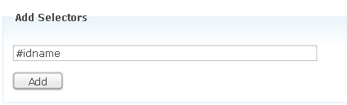.*

1. Click on *Add*. After you click on *Add* buttonthen the loading screen will appear on the selectors listing area.

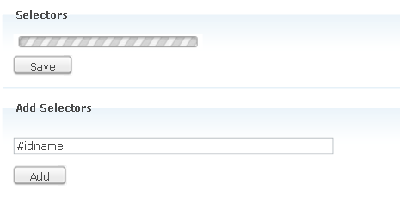

1. The new selectors will be displayed in the selectors listing section.

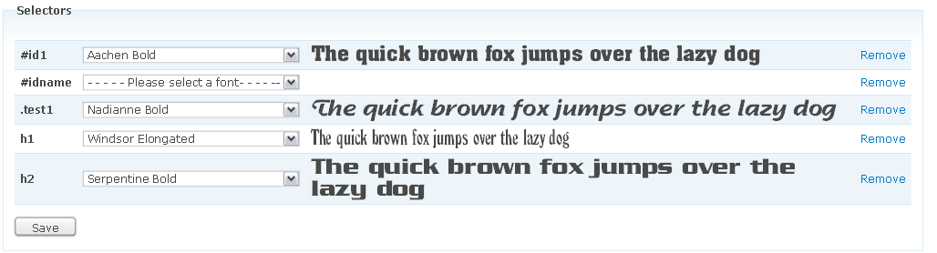

Newly add selector.

1. Now, select the font to the newly added selectors and click on *Save.*

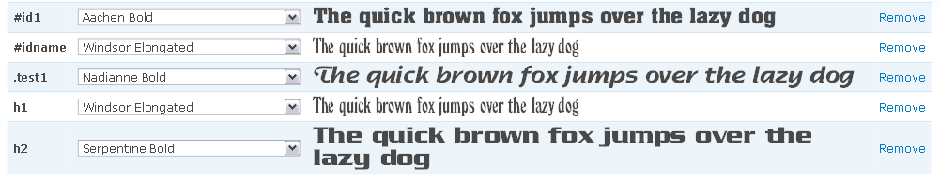

#### Fonts

The fonts section displays the list of fonts associated with the current project. The fonts preview test is displayed along with the font information.

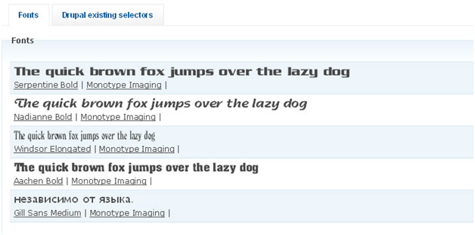

#### Drupal existing selectors

The Drupal existing selectors display the list of selectors used by current Drupal theme. User can add these selectors to their projects at one click.

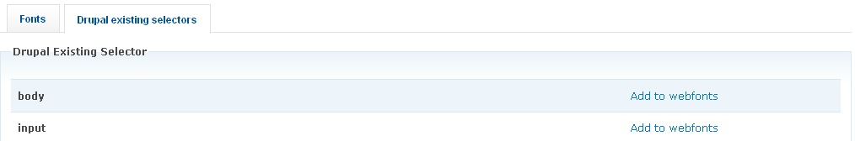

To add the Drupal existing selectors to web font, click on corresponding “*Add to Web Fonts”* link. This will automatically add the selectors to web fonts account. Rest of the function is similar to **Add Selectors**.

## Domain tab

Domain tab consists of following settings:

* Display the list of domains associated with the selected projects.
* Add Domain form for adding the domains to that project.

#### Domain

The domain section lists all the domains associated with that project. Here you can edit or remove the domain from the module itself.

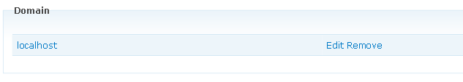

#### Editing Domain

Following are the steps for editing domain.

1. Click on the *Edit* link to edit the domain
2. The domain editing screen appears. Change the name of the domain and click on *Submit*. To go to previous screen click on Cancel.

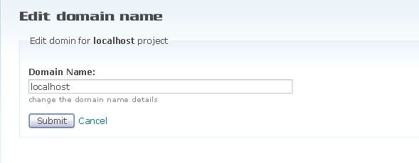

#### Delete Domain.

To delete the domain click on *Remove* Link on corresponding domain

#### Add Domain

The purpose of *Add Domain Section* is to add new domain to the existing project so that users do not have to visit the WFS site just to add the new domain. With the help of this module users can add the domain from Drupal web fonts module page itself.

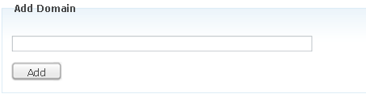

Following are the steps for adding new domain

1. Type the name of the domain you want to add and click on *Add* button.

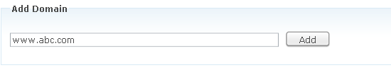

1. 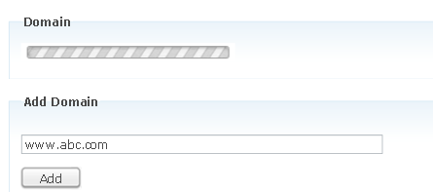 After you click on *Add* buttonthen the loading screen will appear on the domain listing area.
2. 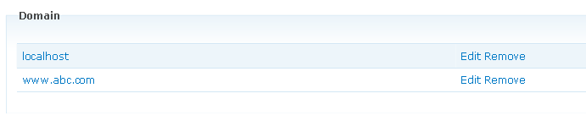The newly added domain will be then listed in Domain area.

# Web fonts module and WYSIWYG editor

To use WFS font library in WYSIWYG editor in Drupal, the projects must be activated. The fonts associated with that project are then listed on WYSIWYG editor in Drupal. The web fonts module will add its own CKEDITOR/TINYMCE if there is no editor installed in the Drupal website.

*In this release the font listing in WYSIWYG editor is only compatible for CKEDITOR and TinyMCE.*

#### Following is the screen shot of CKEDITOR using web fonts projects fonts.

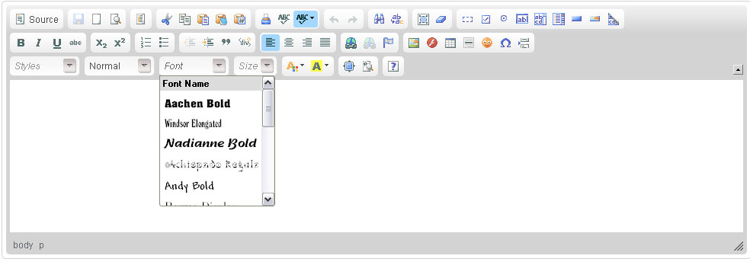

Fonts streamed from web fonts system for currently activated project.

#### Using the font in text editor

***Nadianne Bold*** font used in CKEDITOR

#### Following is the screen shot of TinyMCE using web fonts projects fonts.



Fonts used from webfonts.fonts.com

#### Using the font in text editor

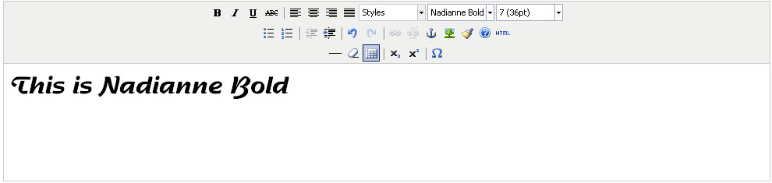

***Nadianne Bold*** font used in tinymce

## Font Dropdown Menu

There are 2 types of fonts displayed on the font drop down menu.

* 1. **Web Fonts from WFS account:**

The Web Fonts on the font dropdown will display the active project enabled from the project configure tab. It is dynamic in nature. The online editor will populate the Web Fonts on fonts menu during the run time.

* 1. **Default fonts:**

It is a set of common fonts provided by CKEDITOR/TINYMCE.

#### How to make the editor for non-admin user input.

There is an option to enable the Web Fonts Editor under configure tab of the project configuration page. There will be only one active project for the Editor. In case the option is checked and if any project is already enabled for the editor, an alert message is displayed. The last enabled project will overwrite the existing project for the editor.

#### Things to consider using Web Fonts library in Drupal WYSIWYG EDITOR

* If you have already installed any other editors make sure it is CKEDITOR/TINYMCE.
* Please do not activate multiple editor modules in Drupal.
* When saving the content, please select the input format in Drupal as full HTML. If you select filtered HTML when saving the content, changes to the font will not be reflected on the front end. To know how to make “full html” by default in Drupal click here.

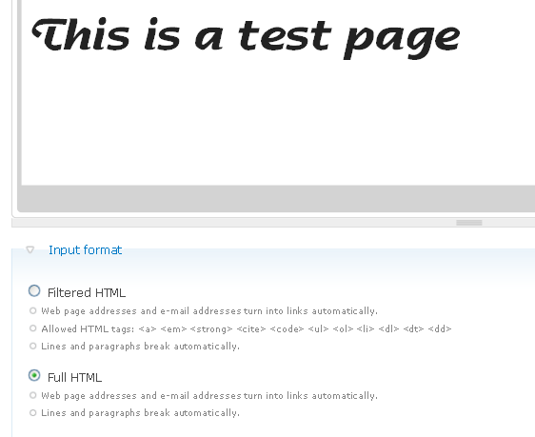

* Make sure the project has been activated with correct configuration for the changes to be displayed on the front end.

***NOTE:***

* *There is a problem in the browser compatibility for CKEDITOR and fonts.com Web Fonts.*
* *Enabling the ckeditor/TINYMCE will replace the text area with the CKEDITOR/TINYMCE in all browsers but the change of fonts.com web fonts will not be reflected in CKEDITOR/TINYMCE content area for browser such as CHROME and SAFARI.*
* *The CKEDITOR/TINYMCE uses iframe in its content area and since the web fonts need some referral to verify the domain to send the fonts, the iframe does not send the referral in the case of Chrome and Safari so it won’t display the external font changes.*
* *This is not the problem for IE and FIREFOX because in these two browsers it sends the current URL as a referrer. However, the changes will be reflected in front end of the page with the same content although if these are not reflected in CKEDITOR/TINYMCE.*

# Uninstalling Module

For uninstalling a module firstly we need to disable the module, and after that we need to uninstall it.

**Steps for disabling a module:**

1. Go to “Administer”=> “Site building” => “Modules”
2. Make sure that the top “List” is selected
3. Uncheck “Fonts.com Web Fonts”
4. Click “Save configuration” button

**Steps for Un-installing a module**:

1. Go to “Administer”=> “Site building” => “Modules”
2. Click “Uninstall” button at the top
3. Check “Fonts.com Web Fonts”
4. Click “Uninstall” button
5. It will ask for “confirm uninstall” click “Uninstall” button.

Your Un-installation process ends here.

# Make “Full HTML” global

Make "Full HTML" global, so users don't need to go check "Full HTML" option every time. Web Fonts module for Drupal doesn’t work if you are filtering the input i.e. while adding/editing page, story or comment.

For making "Full HTML" global we need to do the following steps:

* 1. Login to Drupal with administrator account
  2. Click "Administer" link
  3. Click "Site Configuration"
  4. Click "Input formats"
  5. Under "Input formats": select "Full HTML". Now click "Set default format" button to save this format.

# References

For further learning please see the followings:

### Drupal

**URL**: <http://www.drupal.org>

**Description**: Drupal.org is the official website of Drupal, an open source content management platform.

Equipped with a powerful blend of features, Drupal supports a variety of websites ranging from personal weblogs to large community-driven websites.

### Web Fonts

**URL**: [http:/WebFonts.fonts.com](http://www.webfonts.fonts.com)

**Description**: Widest selection of high quality Web fonts, Over 7,000 Web fonts from Linotype®, Monotype®, ITC® and others, Exclusive home to Helvetica®, Frutiger®, Univers® and other celebrated fonts, Diverse styles to support any project.