Blinky Bear – Assembly

The Blinky Bear has to be assembled. You might need some help if this is the first time you have used a soldering iron.

Caution – A soldering iron is very hot and needs to be handled with caution. Never place on a flammable surface and only pick it up by the handle.

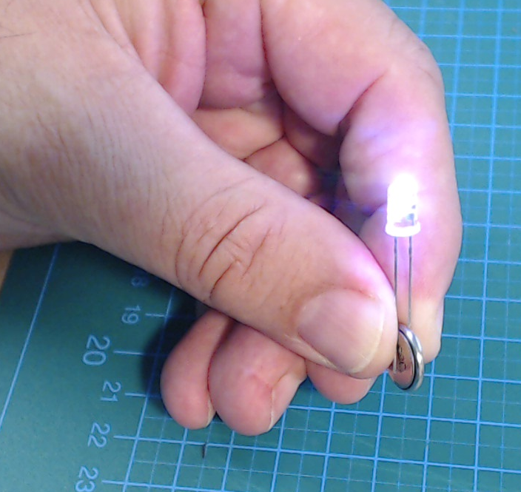
The Blinky Bear uses two very special lights called Light Emitting Diodes or LEDs for short. In this case, they are particularly special as they will blink in several colours all on their own. Normally you should never connect LEDs to a battery on its own. Otherwise you can damage both the LED and the battery. However the LEDs for the Blinky Bear are special and it is a neat experiment to connect these to see how they work.

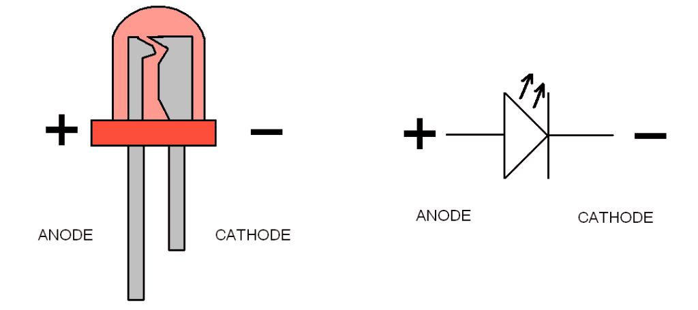
The leads of the LED are called Anode and Cathode for the positive (+) and the negative (-) side of the Diode. A batter has a positive (+) and a negative (-) pole. So the Anode must connect to the plus (+) pole of the battery and the Cathode must connect to the negative pole (-). You can tell which lead of a Diode is the Anode as it is the longer lead.

If the LED is connected the wrong way around, then nothing will happen. The LED just won't work. This is special characteristic of a Diode that it will conduct electricity on one direction only.

Step 1. The first thing is to “tin” the pad for the brooch pin. Heat up the pad that holds the pad and apply some solder. Let the solder flow the entire size of the pad.

Step 2. Using some tweezers or pliers, take the pin with a good grip and place this onto the soldered pad and heat this up with the soldering iron. This might take some time before the pin and the pad are hot enough to melt the solder.

Step 3. Now the pads for the battery can be “tinned”. Apply solder to each of the battery holder pads in turn in the same was as for the pin. Heat up each pad and apply solder.

Step 4. Using the pliers or tweezers again, take the battery holder and place this carefully over the two outer pads. Head each one up so that the solder melts and fuses the battery holder in place.

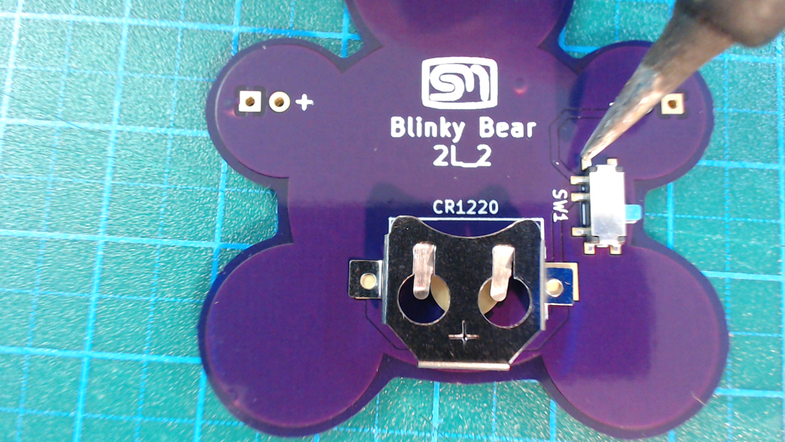
Step 5. Apply a small dob of solder on one of the pads for the switch.

Step 6. Hold the switch in place making sure the alignment pins are in their holes and solder a leg of the switch to the tinned pad.

Step 7. Solder the rest of the switch legs.
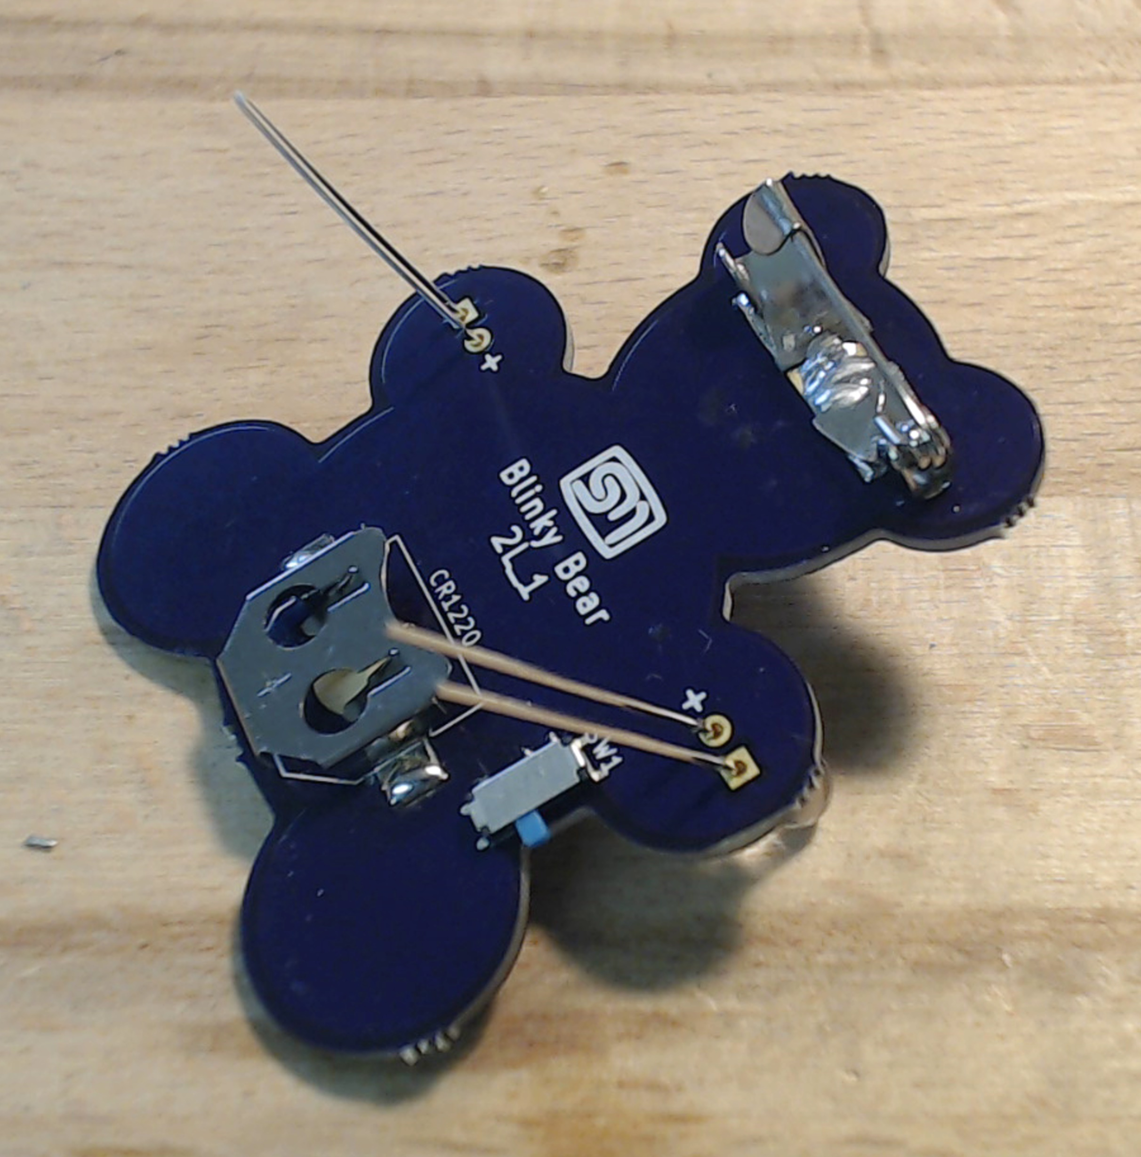
Step 8. Note that the Anode is the longer of the two leads. This is important to note for connecting this to the Blinky Bear, The leads need to be inserted through the holes such that the longest goes through the hole marked with the plus (+) sign.

Step 9. Solder the leads in place. Once soldered, use some Side Cutters to cut the leads flush near the board.

Step 10. Insert the battery wit the Plus Pole to the top and then switch on the Blinky Bear by sliding the switch to one side. If all is connected correctly, the LEDs should start blinking with random colours.


- Not suitable for Children under 5
- Be Careful with the pin, it is sharp!

- Dispose of the used battery responsibly

- Do not dispose the device with the regular domestic waste!
Electronic equipment must be disposed of at the local collection points for waste electronic equipment in compliance with the Waste Electrical and Electronic Equipment Directive.

