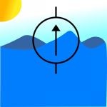
Current Sink or Swim

Specifications

Supply Voltage | 5V
Load Current – Max | 3A

Test Results
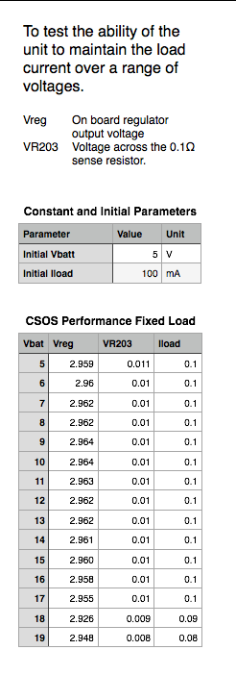

Constant current – Self powered configuration
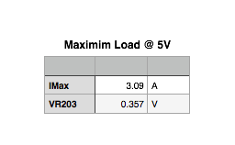

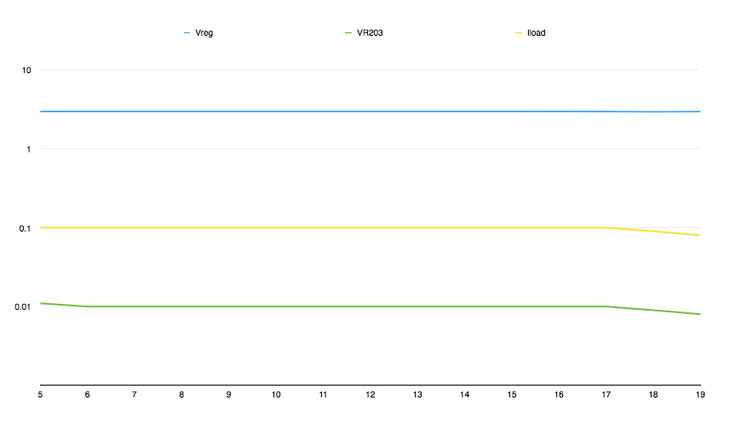

Voltage control cut off – Self powered configuration
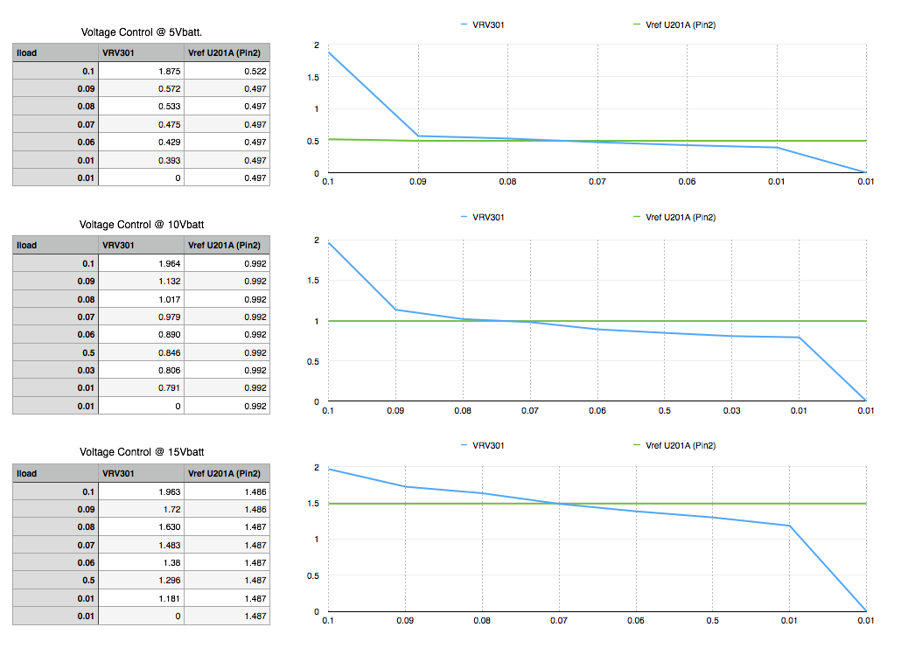

Self powered, External Powered configuration

Jumper Connector P101
1 – 2 | External Powered
2 – 3 | Self Powered

