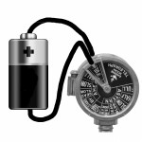 Full Charge Ahead

Specifications
 | Min | Nominal | Max
Supply Voltage | 3.75 | 5V (USB) | 6V
Charge Current |  | 100mA

Description
The Full Charge Ahead is a Lithium ION Battery charger based on the MCP73834 MSOP-10. The basic implementation is configured to deliver 100mA of charge to a single Lithium ION cell. The configuration is via the 10KΩ resistor for R106

Test results
The test results are based on a 150mAh battery discharged using the Current Sink or Swim (CsoS) module.

Discharge

Recharge

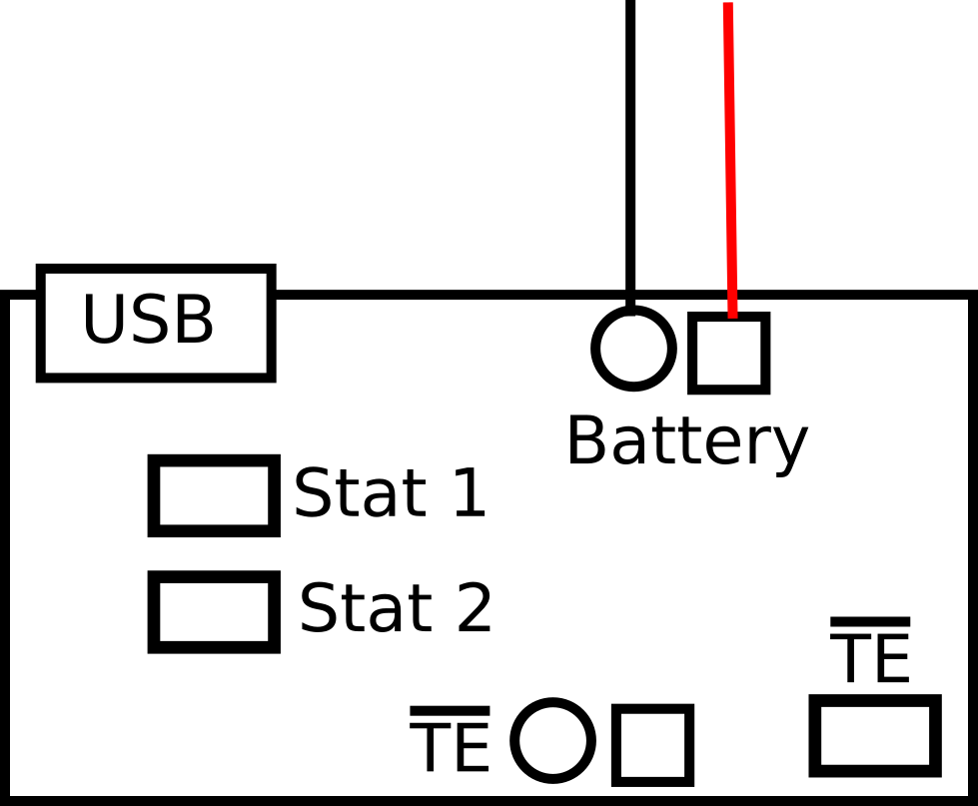

CHARGE CYCLE STATE | STAT1  D103 | STAT2  D103 | PG  D101
Shutdown
Standby |  |  | L
Charge in Progress | ON |  | L
Charge Complete (EOC) |  | ON | L
Temperature Fault |  |  | L
Timer Fault |  |  | L
System Test Mode | ON | ON | L

Schematic

