go! Go! GO! Motor Encoder

Specifications

 | Min | Max
Supply Voltage | 5V | 5V
Current
Output Voltage |  | 5V

- Translates the pulses from an encoder wheel to a sequence of 1s and 0s.

Description
The go! Go! GO! Motor encoder board uses a RPI-579N1 and an encoder wheel to produce a series of 1s and 0s on its output that can be interpreted by a receiving circuit to determine velocity and distance.
The signal from the RPI-579N1 is assessed by a LM 311D comparator to produce the required logic signals.

Wheel Design

Rev 1.
The first encoder disk was created using the PCBNew program from KiCad to create a PCB routed into the shape of a disk with eight slots.
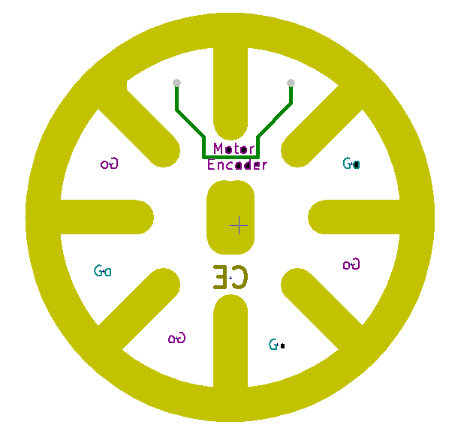

Rev 2.
Revision 2 of the enoder disk was a piece of 3mm acrylic laser cut with twelve 4mm slots.

Rev 3a and b
Revisions 3a and b, similar to the Revsion 2 are 3mm acrylic laster cut. The main difference being the width of the holes are now 1mm instead of 4. The difference between Revision 3a and 3b is the length of the slot. 3A has a 5mm slot where as the revision 3b, the slot is much shorter....

Test Results

Forward Full Speed
Backward Full Speed
Error

Results

Connection

