 Power Swap – Buck-Boost

Specifications

 | Min | Max
Supply Voltage | 3 | 3.8
Current |  | 500mA
Ouput Voltage |  | 3.3

- Constant output voltage over a range of input voltage
- Max 500mA

Description
The Power Swap – Buck Boost module provides a convenient way to supply a constant 3.3V from a lithium ION battery.

Test Results

Constant Supply
The test results show the behaviour of the system with a constant supply voltage and varied load from 0 through to 500mA. The system load represents the current drawn by the system as reported on the laboratory power supply.

System Test
The results show the behaviour of a full system test. This is the Power Swap Buck-Boost module being supplied by the Full Charge Ahead (FCA) module, which is also charging a Lithium ION battery. An active load will be simulated using the Current Sink or Swim (CSoS) module.
The idea is to ascertain how the system will behave over time under load with no charge and then again with a constant charge from the FCA module.

Set up
The modules are interconnected as per the diagram below. The CSoS acts as an active load drawing current from the Li-ION cell via the Power Swap Buck-Boost module. It is expected that the CSoS is delivered the required current at a constant voltage of 3.3V.

Expected Behaviour
When the system is supplied from an external source i.e. 5V supply via the USB connector, it is expected that there should be no variation in the behaviour of the system. Once the 5V supply is removed (on a fully charged system) no immediate change is expected from the perspective of the active load. The system will deliver the required current at the constant 3.3V.
After some time, the Lithium-ION cell will reduce its output voltage in the range from 4.2V down to about 3.2V before shutting off entirely. During this, the Power Swap Buck-Boost module will switch from Buck mode to Boost mode to continue to deliver the required current at 3.3V.

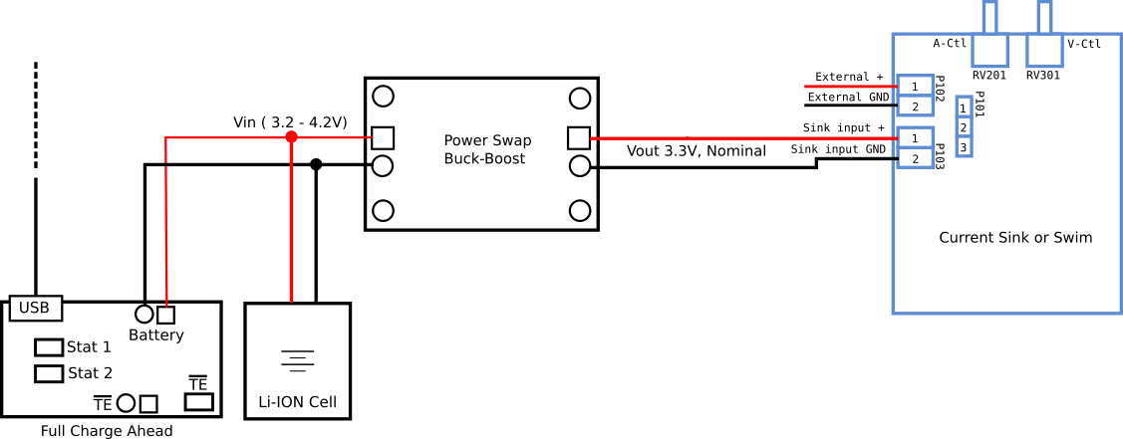

Results

Discharge
A constant load of approximately 60mA is applied using the CSoS. The battery voltage and Power Swap output voltage is measured at 5minute intervals.

Recharge
The USB supply was added to the system. It was found that neither the CSoS or Power Swap could be connected to the system to enable the battery to be charged.

Recharge Under Load
It was found during the recharge that the a completely depleted battery can not be effectively charged with the FCA with the Power Swap or CSoS connected. A further test is performed here to check the behaviour of the system when the batter is not completely depleted.
The results show that it is possible for the FCA to charge the battery and supply the System. However, the FCA will not indicate that the battery is fully charged – only when removing the Power Swap from the system will the FCA indicate a fully charged battery.

Connection

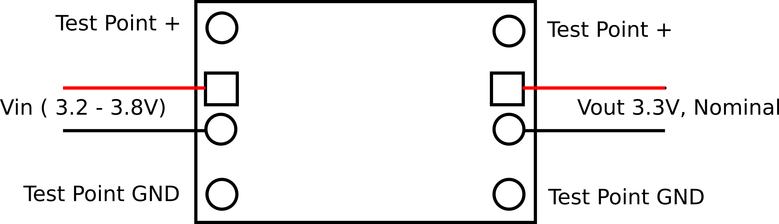

Schematic
