 Power Swap – Boost

Specifications

 | Min | Max
Supply Voltage | 3 | 4.2
Current |  | 750mA
Output Voltage |  | 7V

- Constant output voltage over a range of input voltage
- Output current 750mA

Description
The Power Swap – Buck Boost module provides a convenient way to supply a constant 3.3V from a lithium ION battery. The module is based on the TPS61087 650-kHz, 1.2MHz, 18.5-V Step-Up DC-DC Converter With 3.2-A Switch.

Test Results

Constant Supply
The test results show the behaviour of the system with a constant supply voltage and varied load from 0 through to 600mA. The system load represents the current drawn by the system as reported on the laboratory power supply.

3.2V Constant supply

4.2V Constant Supply

Connection

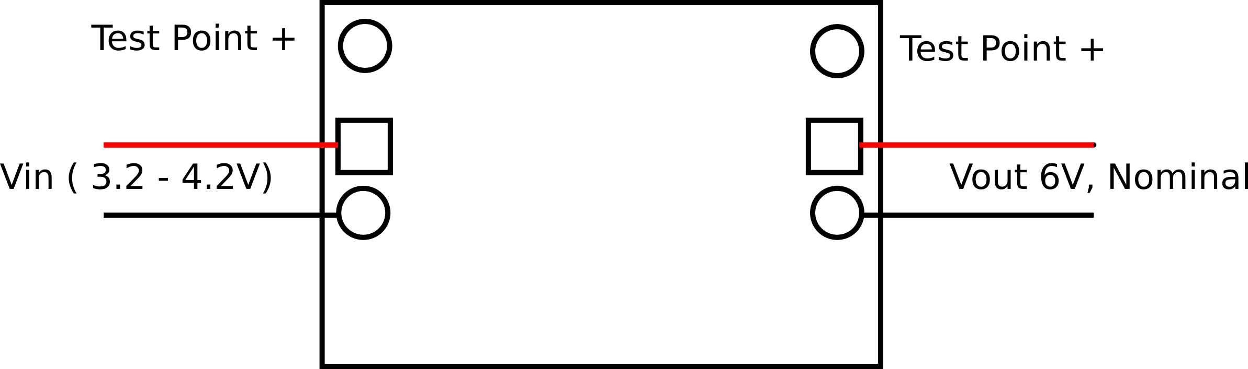

Schematic
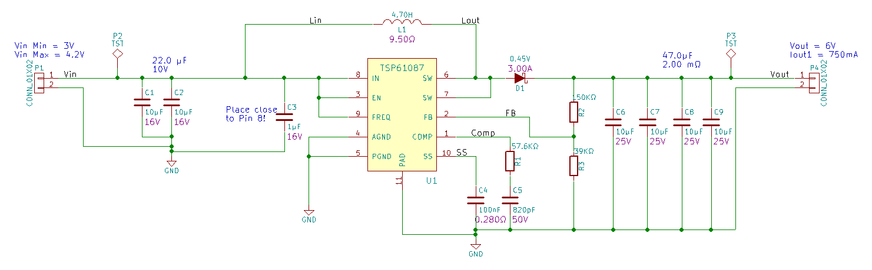

Reference Schematic
