**Day 12 Notes**

Example Circuit

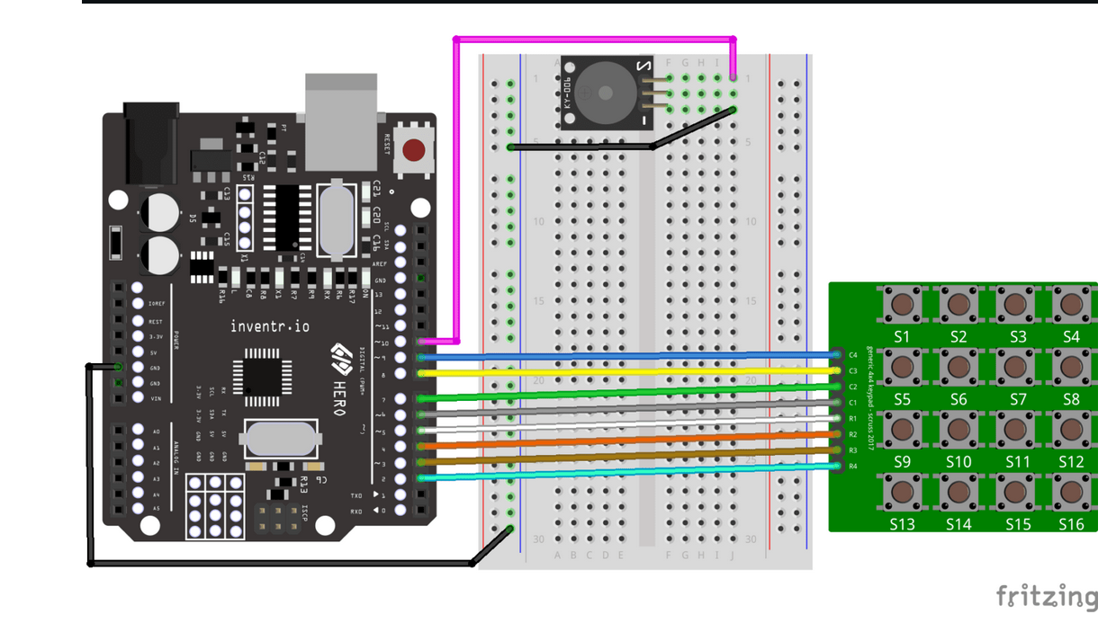

My Circuit

