**Day 24 Notes**

Example Circuit

My Circuit **(Corrected to use 10 KΩ resistors for pull down)**

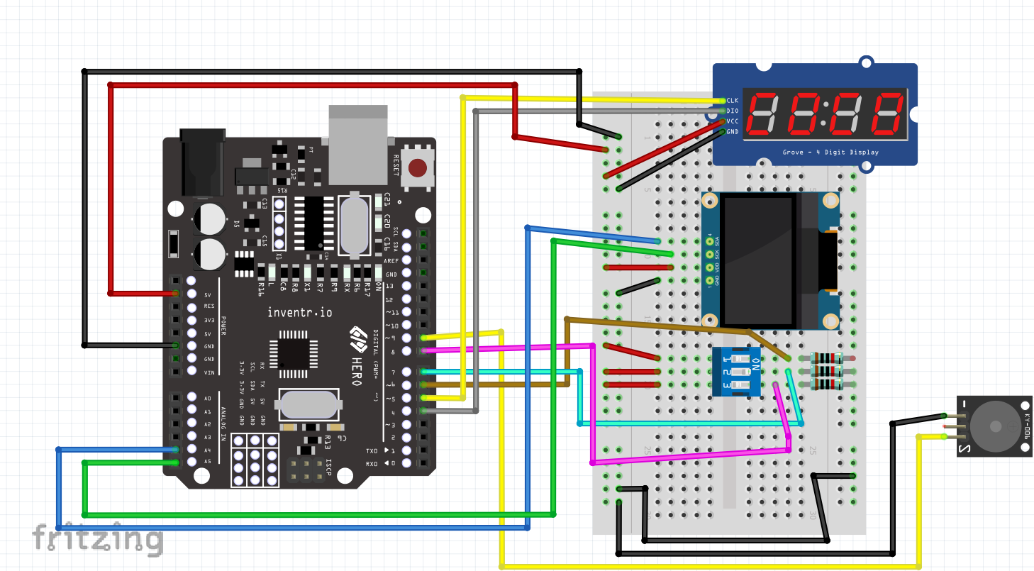

Troubleshooting

1. *~~Rewire and repeat Lesson 23~~*
2. *~~Rewire and repeat Lesson 24 with corrected resistors (10K for pull down)~~*

