**Day 28 Notes**

Example Circuit

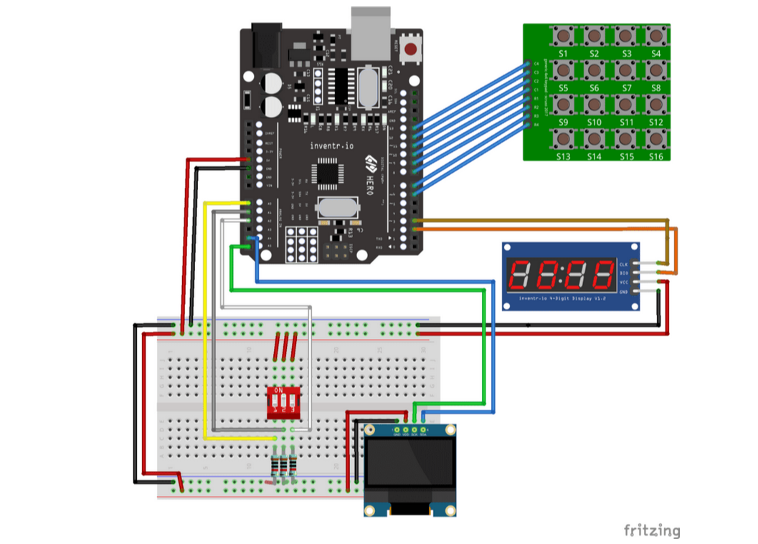

My Circuit

