**Day 29 Notes**

**Keep Day 28 CAD and Circuit**

Example Circuit

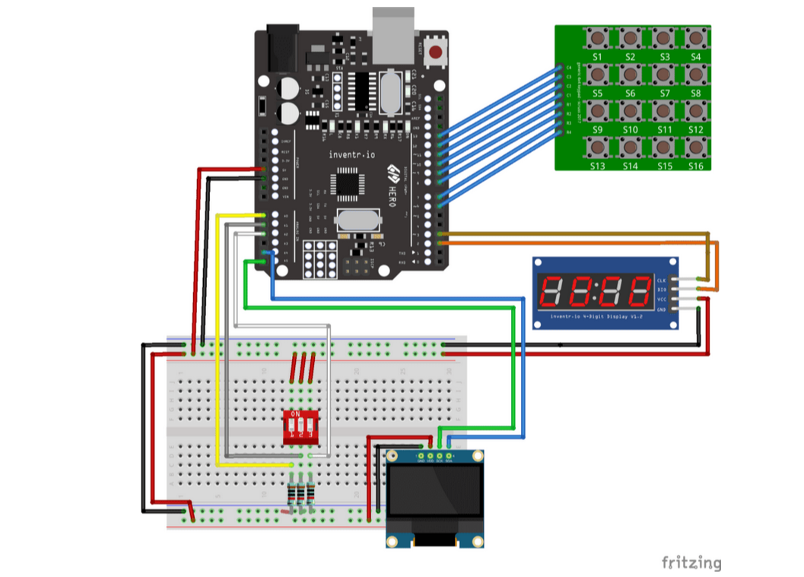

My Circuit

