**Day 1 Notes**

Astrid and Gear



Example Circuit

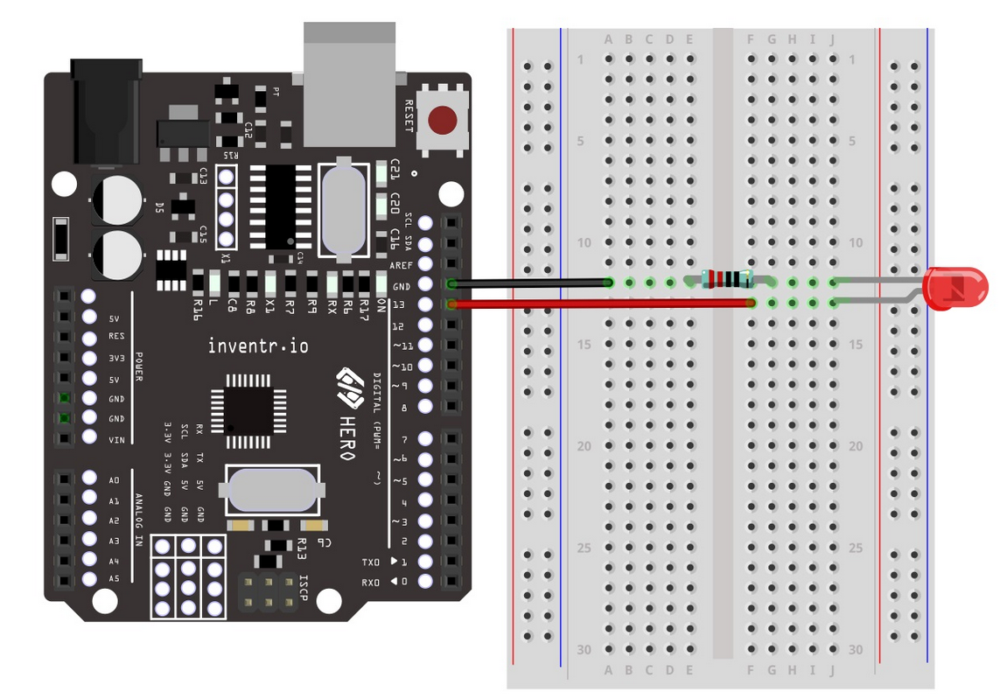

My Circuit

