**Day 10 Notes**

**Astrid and Gear**

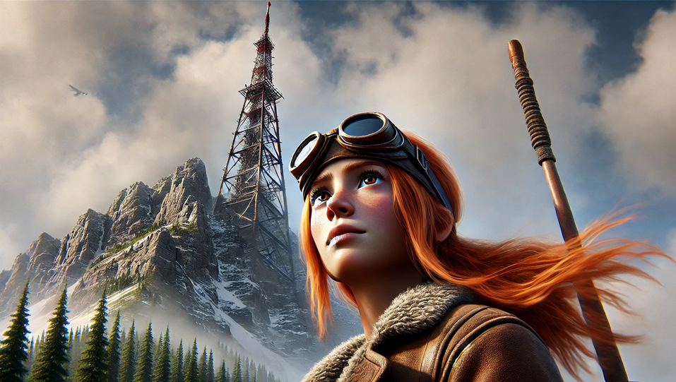

Example Circuit

220Ω Resister for LED

10KΩ Resistor for Photoresistor

My Circuit

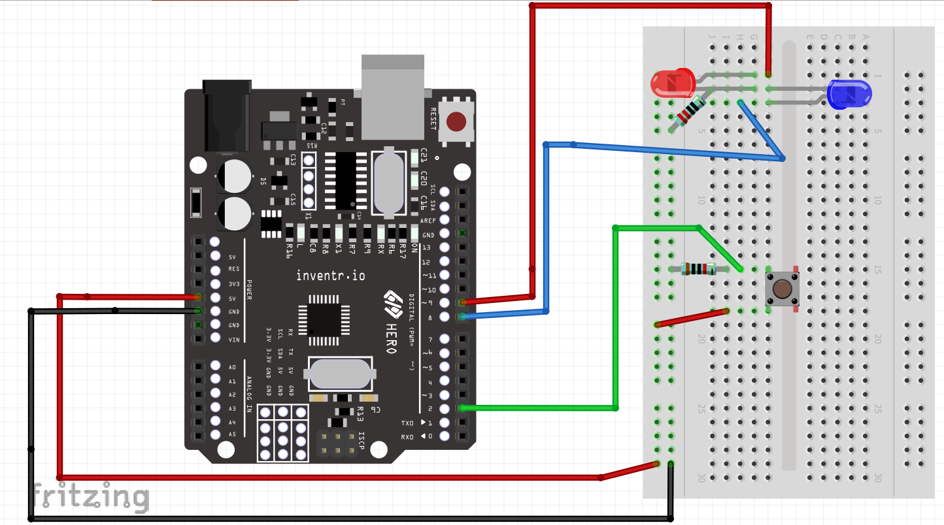

Pin List

9 – Red Led

8 – Blue Led

2 -- Button