**Day 2 Notes**

**Astrid and Gear**



Example Circuit

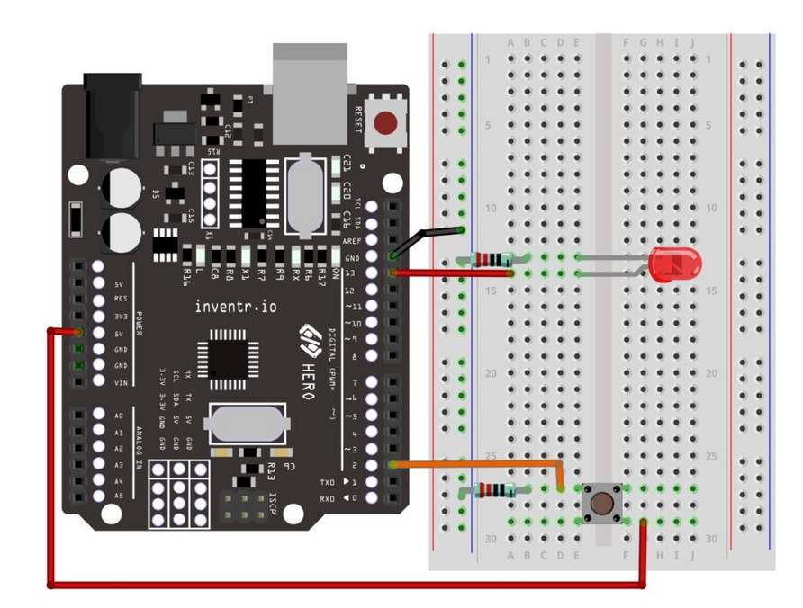

* 220 Ω to protect LED
* 10 K Ω to pull down DIP Switch
* Use Dip Switch 1 in place of button

My Circuit

