**Day 3 Notes**

**Astrid and Gear**



Example Circuit

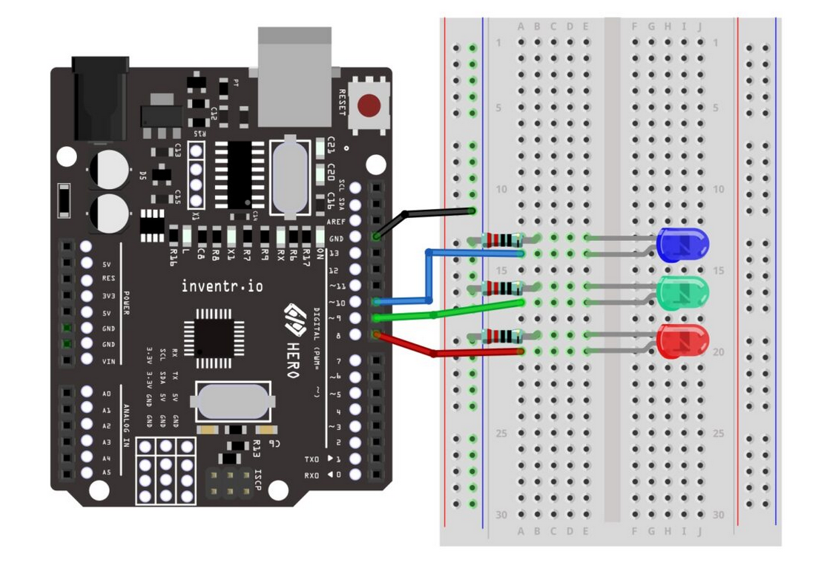

220Ω Resisters for LEDs

Check on NAT Routing with IPv4

My Circuit