**Day 8 Notes**

**Astrid and Gear**

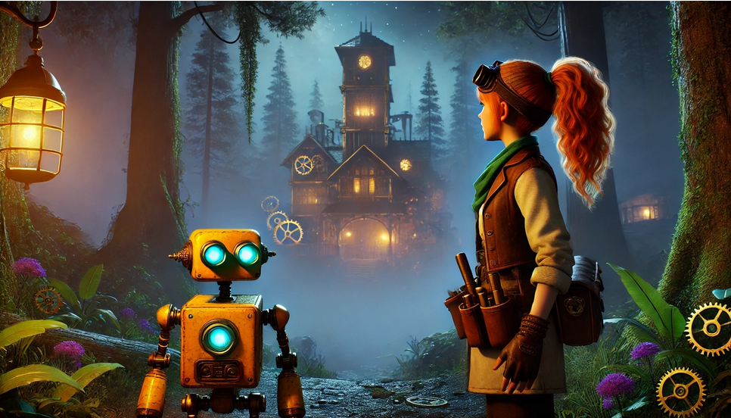

Example Circuit

220Ω Resister for LED

10KΩ Resistor for Photoresistor

My Circuit

A0 – Photo Resister

10 – Red LED

9 – Blus LED

7 – Fork

3 – Red Button

2 – Blue Button