**Day 9 Notes**

**Astrid and Gear**

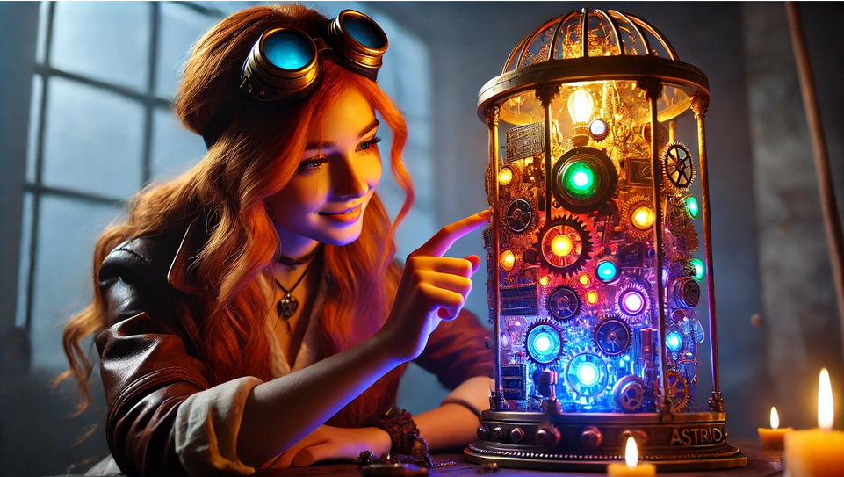

Example Circuit

220Ω Resister for LED

10KΩ Resistor for Photoresistor

My Circuit

Pin List

11 – Red LED

10 – Blue LED

9 – Green LED

2 -- Button