2025_06_03_Optimization

My Work Through: 1-Playing_with_Pi-Star

Today’s Changes

★ URL – Based on the hotspot callsign, this link is presented to the networks you connect to, forexample, BrandMeister. By default, the link is to QRZ: https://www.qrz.com/db/[CALLSIGN]. If youwant to use this, select Auto; alternatively, you can select Manual and add whatever link you want,for example, a link to your own website. Set to Auto (https://www.qrz.com/db/N5QC)

☆ APRS Host Enable – When enabled (default), your location will be public. Set to Enable
☆ APRS Host – Select your preferred APRS host, typically one of the rotating hosts or a nearby host server. Note: Per Tom, W1TG, in the Pi-Star User Forum: There are over 80 different T2 APRS Hosts around the world. A really good "Best Practice" is to select one of the Automatically Rotating T2 APRS Hosts. The Rotating Host will always get you to a working Tier2 APRS Server and if that link fails for some reason it'll move onto another working server. If you select an APRS Host without the Auto Rotate function and the server has a malfunction or goes offline, it can cause issues with your hotspot such as spontaneous disconnects. T2 APRS Host Servers that provide the Auto Rotate Function: rotate.aprs2.net (World Wide)
noam.aprs2.net (North America)
soam.aprs2.net (South America)
euro.aprs2.net (Europe)
aunz.aprs2.net (Australia/New Zealand)
asia.aprs2.net (Asia)

☆ Default Reflector – You can select your default reflector, as well as whether you want Pi-Star to connect to it automatically when it starts up.

REF 048 B Changed to Manual

★ 5l) Wireless Configuration

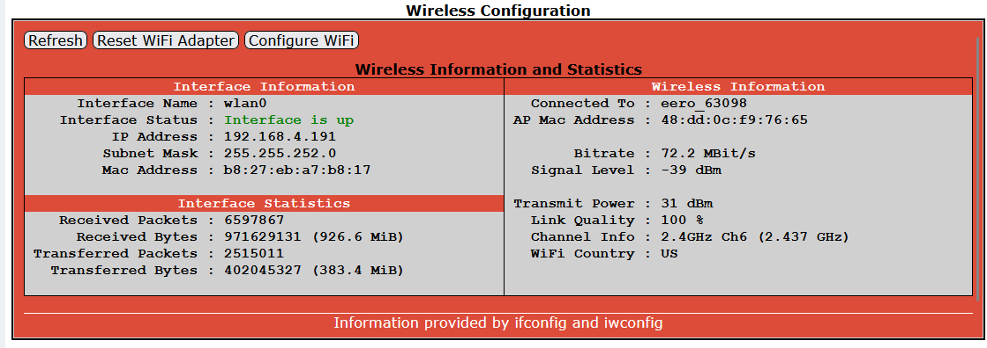

Auto AP SSID PSK
Used to create a unique password for connecting to the Auto AP access point, which would then override the default password, "raspberry".

Reset 2025_06_03 – See BitWarden

Remote Access Password
Used for accessing Pi-Star Admin and Configuration settings, and for SSH access.
★ Strongly recommended: In order to protect your settings and network, change the password from the default to something stronger and more challenging to hack. A challenging password is even more critical if you make your dashboard publicly accessible in the Firewall Configuration section.

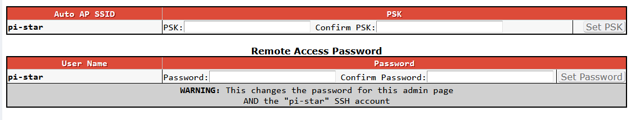

Reset 2025_06_03 – See BitWarden

REFERENCE – No Changes

sudo pistar-update
sudo pistar-upgrade
sudo reboot

If using Auto AP and setting up a new WiFi connection
Perform this step when you start Pi-Star for the first time or when you need to connect to a new WiFinetwork, for example, when traveling.
- If you're not already in Configuration view, click the Configuration link and log in with your Pi-Staruser name and password.
- In the Configuration view, scroll down to the Wireless Configuration section.
- To add or modify your WiFi network connections, click Configure WiFi.
- Select your country code and then click Scan for Networks. Wait 10 secs.Note: If the scan doesn't find the network you want, you can add it manually, as discussed below:
- In the list of networks found, select the one you want.
- PSK: Type the wireless network password. The PSK field will turn green.
- Click Save (and connect). When Auto AP is active, this step will only save; it won't connect. Wait afew moments for it to save (PSK field will turn white again), power off your Pi-Star hotspot, and then restart it.
- While the hotspot is restarting, reconnect your computer to the regular WiFi network you're using.
- After the hotspot restarts, Pi-Star will connect to the new WiFi network you added. On a Windows,Mac, or Linux-based computer (not the hotspot itself) that has WiFi enabled, open the Pi-Star dashboard by navigating again to: http://pi-star/ or http://pi-star.local/.If you can't re-open the dashboard, see the note Trouble re-opening the dashboard after updating.

Congratulations! You've finished the most difficult part of setting up Pi-Star.

Future:

Callsign Routing – Enable if you want callsign routing for D-STAR.

