DIY Hotspot Project Management

Scope

Hot Spot
- Order Stuff
- Check uSD Card Inventory
- Receive Stuff
- Assemble
- Test
- PDCA
- Play / Learn / Experiment

What You'll Need:
- Raspberry Pi Zero WH (with headers): This compact version of the Raspberry Pi comes with pre-soldered GPIO headers. Adafruit Store (Cost: $16) —> ACTUAL Total: $22.89 RECEIVED

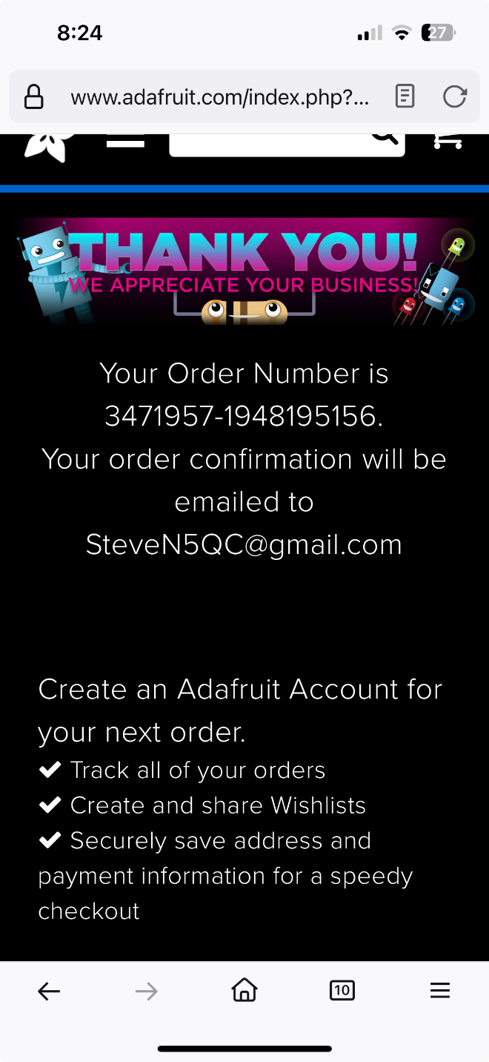

- MMDVM Hotspot Hat + Case + Antenna + Screen Kit: This kit includes everything you need to turn your Raspberry Pi into a digital mode hotspot. AliExpress (Cost: $17) —> ACTUAL Total: $13.26

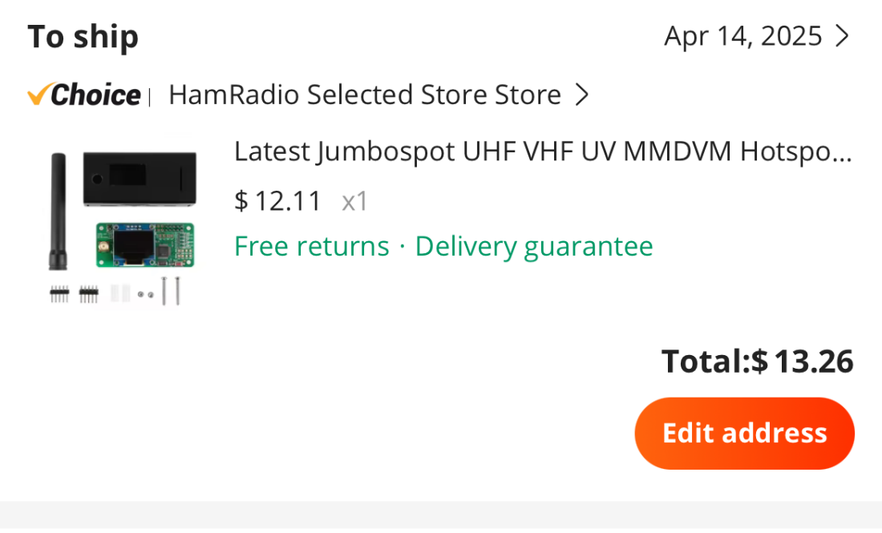

- Pi Zero Power Supply: To ensure your Raspberry Pi has a reliable power source. eBay (Cost: $7) —> ACTUAL Total: $9.84 Ordered and Received From Amazon

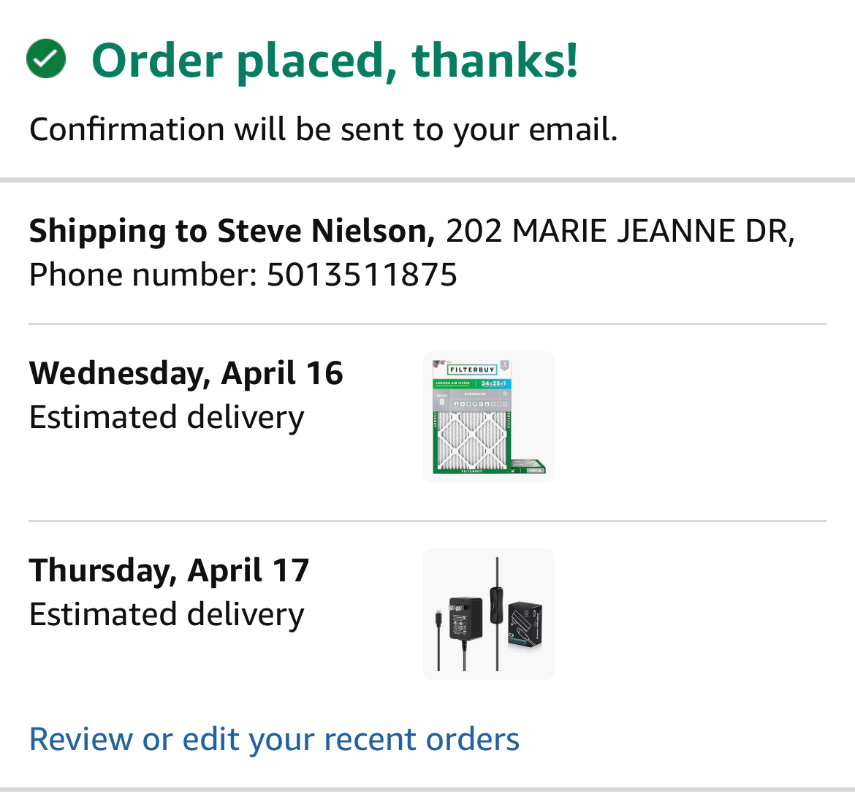

- MicroSD Card (8 GB minimum): For installing the Pi-Star operating system. eBay (Cost: $5) (Check Inventory)

Schedule

Initial Plan
WO 4/14
Planning
Procurement
Start Survey
Plan Hot Spot Schedule

Cost

Advertised: $45
Predict: $55

