**DigiPi Setup Notes**

**HP_20240414_Notes**

* Redo the 2024 04 08 Plan as follows:
  + **New Download of image on N5QC – HP Laptop**
  + **Image new card via Raspberry Pi Imager on N5QC – HP Laptop**
  + Try it out and make notes
* **Connect to the "DigiPi" hot spot with password "abcdefghij"**
* **In a web browser, visit** [**http://10.0.0.5/wifi.php**](http://10.0.0.5/wifi.php)
* **Enter your home wifi ssid and password and reboot.**
* **Once booted on your home network, visit the website** [**http://digipi/**](http://digipi/) **🡪 FAIL**
* *~~If that doesn’t work try~~* [*~~http://10.0.0.5/~~*](http://10.0.0.5/) *~~🡪 FAIL~~*
* **If that doesn’t work try [http://192.168.1.103 --> I am in!](http://10.0.0.5/)**

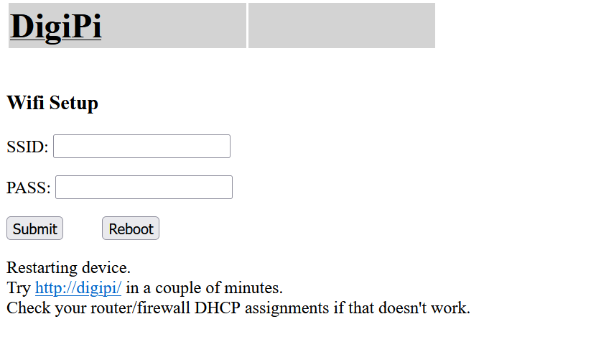

|  |  |  |  |
| --- | --- | --- | --- |
| 7 | digipi | 192.168.1.103 | E4:5F:01:50:16:2A |

**Eee_20240411_Notes**

**FAIL – Start over ALL on HP**

After re-imaging:

After

* Connect to the "DigiPi" hot spot with password "abcdefghij"
* In a web browser, visit <http://10.0.0.5/wifi.php>
* Enter your home wifi ssid and password and reboot.
* Once booted on your home network, visit the website <http://digipi/>.

**THINK and PLAN**

Restarting device.  
Try <http://digipi/> in a couple of minutes.  
Check your router/firewall DHCP assignments if that doesn't work.

**2024 04 10**

Troubleshooting Plan:

* Reboot Router – FAIL
  + Then retry with hitting Submit:

Wifi credentials updated.   
  
Press Reboot for changes to take effect

After Pressing Reboot:

Restarting device.  
Try <http://digipi/> in a couple of minutes.  
Check your router/firewall DHCP assignments if that doesn't work.

After a break, no go AND don’t even see DigiPi hotspot.

Next: Pull the plug and wait, then power up again. -- FAIL

<http://digipi/>

http://10.0.0.5/

* Re-Image and try normal
* Re-Image and try Eero
* Re-Image and try Wired
* Get on Patreon

**2024 04 09**

Troubleshooting Plan:

* Snapshot and list wireless connections.
* Plug in and try again
* Look for digipi on network (give it at least 10 min)
* Try connecting to and using Hot Spot
* Re-image – Copy and Paste WiFi Setup
* Try wired connection
* Get on forums

Troubleshooting Notes:

* Snapshot and list wireless connections.
* Plug in and try again
* Look for digipi on network (give it at least 10 min) -- **FAIL**
* Try connecting to and using Hot Spot
  + Connect to the "DigiPi" hot spot with password "abcdefghij" – Connected using yesterday’s stored credentials
  + Turned OFF VPN
  + Turned OFF Autoconnect to PATHFINDER_HOME
  + In a web browser, visit <http://10.0.0.5/wifi.php>
  + Enter your home wifi ssid and password and reboot.
  + Once booted on your home network, visit the website <http://digipi/>. -- **FAIL**
* Re-image – Copy and Paste WiFi Setup
  + Once booted on your home network, visit the website <http://digipi/>. – **FAIL**
  + Now 10 Wireless Clients

| **ID** | **Name** | **IP Address** | **MAC Address** |
| --- | --- | --- | --- |
| 1 | 9C76132DB716-mysimplelink | 192.168.1.10 | 9C:76:13:2D:B7:16 |
| 2 | TSTAT-49B9B2 | 192.168.1.17 | 48:A2:E6:49:B9:B2 |
| 3 | EeePC | 192.168.1.13 | E0:B9:A5:30:31:DD |
| 4 | LGwebOSTV | 192.168.1.18 | 60:8D:26:63:DD:EE |
| 5 | Unknown | 192.168.1.19 | E0:73:E7:76:AC:BB |
| ID | Name | IP Address | MAC Address |
| 6 | unknown | 192.168.1.11 | 00:1D:C9:35:8B:67 |
| 7 | Unknown | 192.168.1.16 | F6:41:8A:29:E0:D9 |
| 8 | Unknown | 192.168.1.14 | EA:59:67:83:E5:CE |
| 9 | Unknown | 192.168.1.12 | F2:6A:B0:45:1F:17 |
| 10 | DESKTOP-5MPBV9L | 192.168.1.22 | B4:6B:FC:CD:09:24 |

* + But only the EeePC and LGwebOSTV have been added so the DigiPi is NOT on this network.
  + DigiPi Hotspot is showing.
* Try wired connection
* Get on forums

TP-Link Connection Log BEFORE Pi Power on 8 Claimed

| **ID** | **Name** | **IP Address** | **MAC Address** |
| --- | --- | --- | --- |
| 1 | Unknown | 192.168.1.19 | E0:73:E7:76:AC:BB |
| 2 | 9C76132DB716-mysimplelink | 192.168.1.10 | 9C:76:13:2D:B7:16 |
| 3 | TSTAT-49B9B2 | 192.168.1.17 | 48:A2:E6:49:B9:B2 |
| 4 | Unknown | 192.168.1.16 | F6:41:8A:29:E0:D9 |
| 5 | unknown | 192.168.1.11 | 00:1D:C9:35:8B:67 |

| **ID** | **Name** | **IP Address** | **MAC Address** |
| --- | --- | --- | --- |
| 6 | Unknown | 192.168.1.12 | F2:6A:B0:45:1F:17 |
| 7 | DESKTOP-5MPBV9L | 192.168.1.22 | B4:6B:FC:CD:09:24 |
| 8 | Unknown | 192.168.1.14 | EA:59:67:83:E5:CE |

* After Plugging in DigiPi – No Change
* DigiPi is shown as an available wireless Network
* Analysis: DigiPi is not getting on the network

Restarting device.  
Try <http://digipi/> in a couple of minutes.  
Check your router/firewall DHCP assignments if that doesn't work.

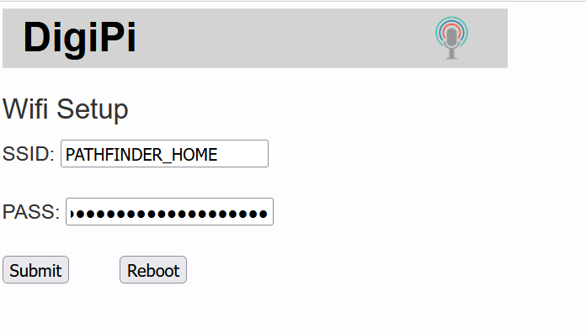

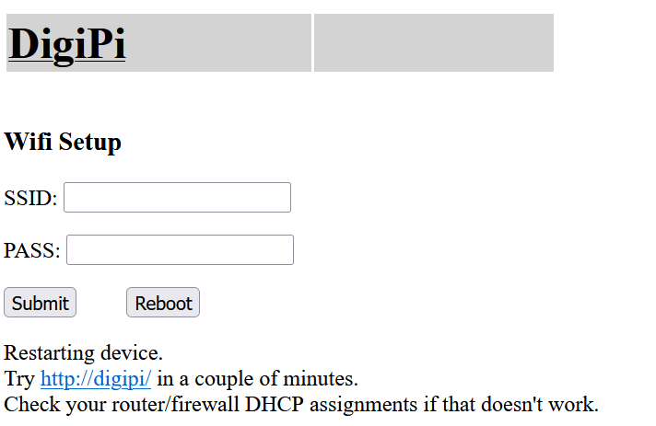

After Reboot:

* Connect to <http://digipi/> While in PATHFINDER_HOME 🡪 FAIL
* Connect to <http://digipi/> While in DigiPi 🡪 FAIL
* Still Same 8 Wireless Connections
* Analysis: FAIL
* Action: Reimage and Repeat

**2024 04 08**

* Boot the Raspberry Pi with the newly flashed SD card.
* Wait for the "DigiPi" wifi hot spot to appear on your phone or pc's wifi

settings.

* Connect to the "DigiPi" hot spot with password "abcdefghij"
* In a web browser, visit <http://10.0.0.5/wifi.php>
* Enter your home wifi ssid and password and reboot.

Once booted on your home network, visit the website <http://digipi/>.

**Looks like it is booting and I can set up WiFi in the first menu and reboot / see it’s WiFi Hotspot, but then can’t find it on the network.**

**Stop and Try Again**

**Troubleshooting Plan:**

1. **Snapshot and list wireless connections.**
2. **Plug in and try again**
3. **Look for digipi on network (give it at least 10 min)**
4. **Try connecting to and using Hot Spot**
5. **Re-image – Copy and Paste WiFi Setup**
6. **Try wired connection**
7. **Get on forums**

**2024 04 07**

The Author has requested that the code not be posted.

* Then flash it to your SD card.
* It'll fit on a 4G card with room to spare.
* Look up how to do this.
* On Linux, it's dd if=digipi-1.6-2.img of=/dev/sdX bs=4M
  + where sdX is the drive letter of your blank SD card (run dmesg to see).

FAT (32-bit version) — Not Mounted

/dev/sdb1

digipi-1.8-2.img

**dd if=digipi-1.8-2.img of=/dev/sdb bs=4M**

**Session Log 04/07/2024**

**Highlights:**

steve@EeePC:~/Downloads/DigiPi_Secure$ ls

digipi-1.8-2.img digipi-1.8-2.zip DigiPi_Secure_Notes.docx

steve@EeePC:~/Downloads/DigiPi_Secure$ dd if=digipi-1.8-2.img of=/dev/sdb bs=4M

dd: failed to open '/dev/sdb': Permission denied

steve@EeePC:~/Downloads/DigiPi_Secure$ sudo dd if=digipi-1.8-2.img of=/dev/sdb bs=4M

[sudo] password for steve:

1421+0 records in

1421+0 records out

5960105984 bytes (6.0 GB, 5.6 GiB) copied, 497.88 s, 12.0 MB/s

steve@EeePC:~/Downloads/DigiPi_Secure$

**Full Session:**

steve@EeePC:~$ ls

Desktop Downloads Music Public Templates

Documents linuxtutorialwork Pictures snap Videos

steve@EeePC:~$ cd ..

steve@EeePC:/home$ ls

steve

steve@EeePC:/home$ cd ..

steve@EeePC:/$ ls

bin cdrom etc lib lib64 lost+found mnt proc run snap sys usr

boot dev home lib32 libx32 media opt root sbin srv tmp var

steve@EeePC:/$ cd dev

steve@EeePC:/dev$ ls

autofs initctl nvram tty16 tty46 ttyS17 vcs4

block input port tty17 tty47 ttyS18 vcs5

bsg kmsg ppp tty18 tty48 ttyS19 vcs6

btrfs-control kvm psaux tty19 tty49 ttyS2 vcsa

bus log ptmx tty2 tty5 ttyS20 vcsa1

char loop0 pts tty20 tty50 ttyS21 vcsa2

console loop1 random tty21 tty51 ttyS22 vcsa3

core loop10 rfkill tty22 tty52 ttyS23 vcsa4

cpu loop11 rtc tty23 tty53 ttyS24 vcsa5

cpu_dma_latency loop12 rtc0 tty24 tty54 ttyS25 vcsa6

cuse loop13 sda tty25 tty55 ttyS26 vcsu

disk loop14 sda1 tty26 tty56 ttyS27 vcsu1

dm-0 loop15 sda2 tty27 tty57 ttyS28 vcsu2

dm-1 loop16 sda3 tty28 tty58 ttyS29 vcsu3

dm-2 loop17 sdb tty29 tty59 ttyS3 vcsu4

dma_heap loop18 sdb1 tty3 tty6 ttyS30 vcsu5

dri loop19 sg0 tty30 tty60 ttyS31 vcsu6

ecryptfs loop2 sg1 tty31 tty61 ttyS4 vfio

fb0 loop3 shm tty32 tty62 ttyS5 vga_arbiter

fd loop4 snapshot tty33 tty63 ttyS6 vgubuntu

full loop5 snd tty34 tty7 ttyS7 vhci

fuse loop6 stderr tty35 tty8 ttyS8 vhost-net

hpet loop7 stdin tty36 tty9 ttyS9 vhost-vsock

hugepages loop8 stdout tty37 ttyprintk udmabuf video0

hwrng loop9 tty tty38 ttyS0 uhid video1

i2c-0 loop-control tty0 tty39 ttyS1 uinput zero

i2c-1 mapper tty1 tty4 ttyS10 urandom zfs

i2c-2 mcelog tty10 tty40 ttyS11 userio

i2c-3 media0 tty11 tty41 ttyS12 v4l

i2c-4 mem tty12 tty42 ttyS13 vcs

i2c-5 mqueue tty13 tty43 ttyS14 vcs1

i2c-6 net tty14 tty44 ttyS15 vcs2

i2c-7 null tty15 tty45 ttyS16 vcs3

steve@EeePC:/dev$ cd ..

steve@EeePC:/$ ls

bin cdrom etc lib lib64 lost+found mnt proc run snap sys usr

boot dev home lib32 libx32 media opt root sbin srv tmp var

steve@EeePC:/$ cd home

steve@EeePC:/home$ ls

steve

steve@EeePC:/home$ cd steve

steve@EeePC:~$ ls

Desktop Downloads Music Public Templates

Documents linuxtutorialwork Pictures snap Videos

steve@EeePC:~$ cd Desktop

steve@EeePC:~/Desktop$ ls

Dummy_Git_Directory 'Old Firefox Data'

steve@EeePC:~/Desktop$ cd ..

steve@EeePC:~$ cd Downloads

steve@EeePC:~/Downloads$ ls

DigiPi_Secure

expressvpn_3.10.0.9-1_amd64.deb

imager_1.6.2_amd64.deb

invite.ics

tor-browser-linux64-10.5.4_en-US.tar.xz

tor-browser-linux64-10.5.4_en-US.tar.xz.sig

veracrypt-1.24-Update7-Ubuntu-20.04-amd64.deb

veracrypt-1.24-Update7-Ubuntu-20.04-amd64.deb.sig

steve@EeePC:~/Downloads$ cd DigiPi_Secure

steve@EeePC:~/Downloads/DigiPi_Secure$ ls

digipi-1.8-2.img digipi-1.8-2.zip DigiPi_Secure_Notes.docx

steve@EeePC:~/Downloads/DigiPi_Secure$ dd if=digipi-1.8-2.img of=/dev/sdb bs=4M

dd: failed to open '/dev/sdb': Permission denied

steve@EeePC:~/Downloads/DigiPi_Secure$ sudo dd if=digipi-1.8-2.img of=/dev/sdb bs=4M

[sudo] password for steve:

1421+0 records in

1421+0 records out

5960105984 bytes (6.0 GB, 5.6 GiB) copied, 497.88 s, 12.0 MB/s

steve@EeePC:~/Downloads/DigiPi_Secure$