Eee_20240411_Notes

FAIL – Start over ALL on HP

After re-imaging:

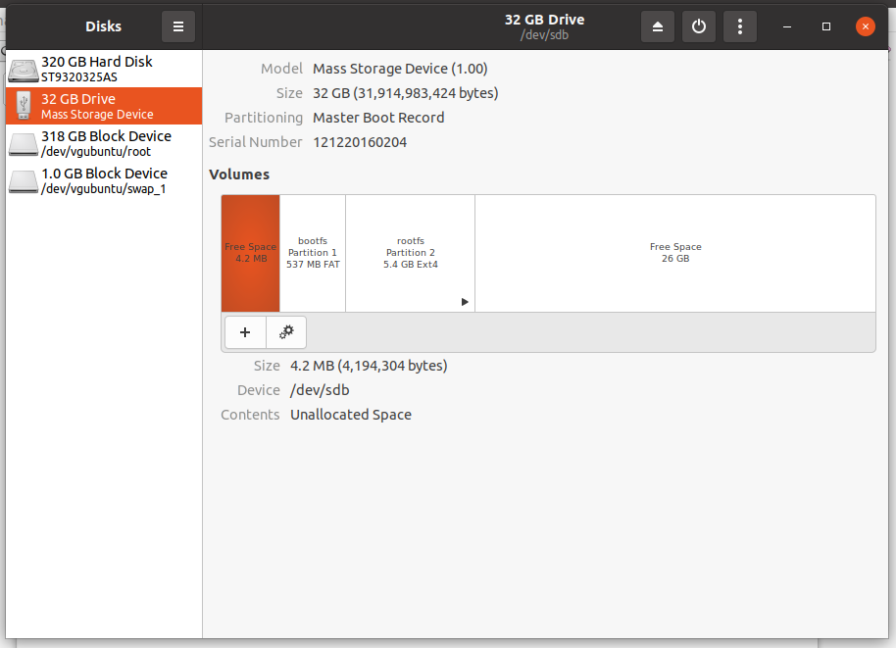

After

- Connect to the "DigiPi" hot spot with password "abcdefghij"
- In a web browser, visit http://10.0.0.5/wifi.php
- Enter your home wifi ssid and password and reboot.
- Once booted on your home network, visit the website http://digipi/.

THINK and PLAN

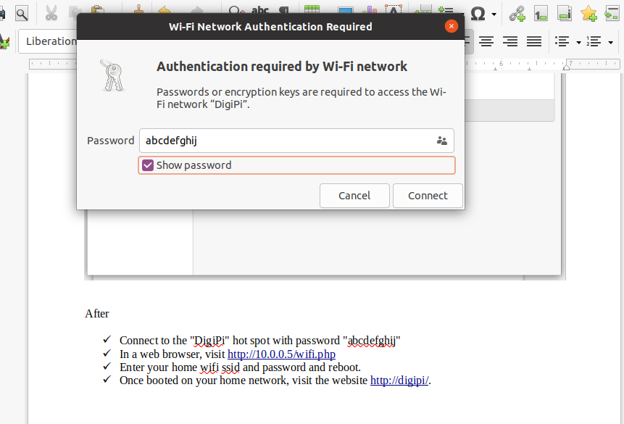
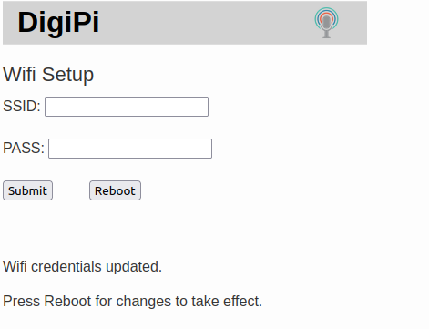

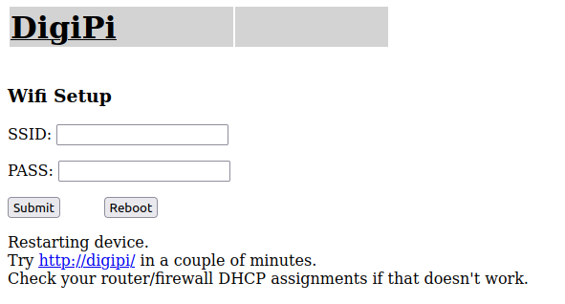

Restarting device.
Try http://digipi/ in a couple of minutes.
Check your router/firewall DHCP assignments if that doesn't work.

