**Raspberry_Pi_SSH_and_VNC_Bluetooth**

**Rev. 0 – Created – 5/6/2024**

<https://www.youtube.com/watch?v=zumnEOAk9aI>

sudo apt install network-manager-gnome blueman

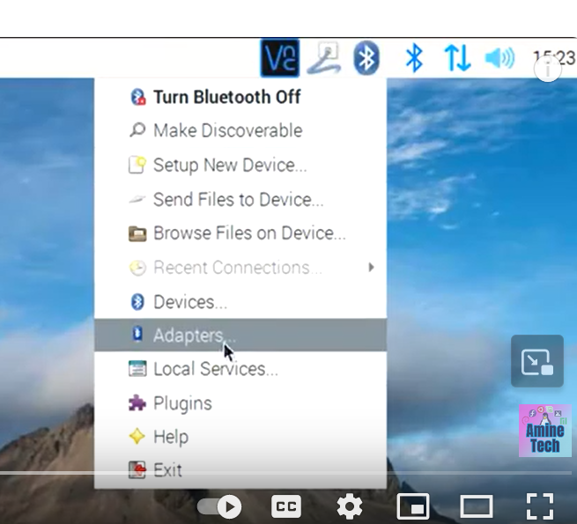

Search and Look for my computer





