**Lesson_4_Notes_and_Journal**

**2024.04.26**

* Look at Code
* Look at Circuit
* Draw Circuit
* Build Circuit
* Start Lesson

**Code**

* Glance at Code
* import machine
* import time
* # Define GPIO pins for the LED and button
* led_pin = machine.Pin(14, machine.Pin.OUT)
* button_pin = machine.Pin(15, machine.Pin.IN, machine.Pin.PULL_DOWN)
* # Function to measure reaction time
* def reaction_time_tester():
* time.sleep(5)
* led_pin.on() # Turn on the LED
* start_time = time.ticks_ms() # Get start time in milliseconds
* # Wait for button press
* while True:
* if button_pin.value() == 1:
* end_time = time.ticks_ms() # Get end time in milliseconds
* reaction_time = end_time - start_time # Calculate reaction time
* print('Reaction Time:', reaction_time, 'ms')
* break
* led_pin.off() # Turn off the LED
* # Call the function to start the reaction time tester
* reaction_time_tester()

**Circuit**

* Theirs

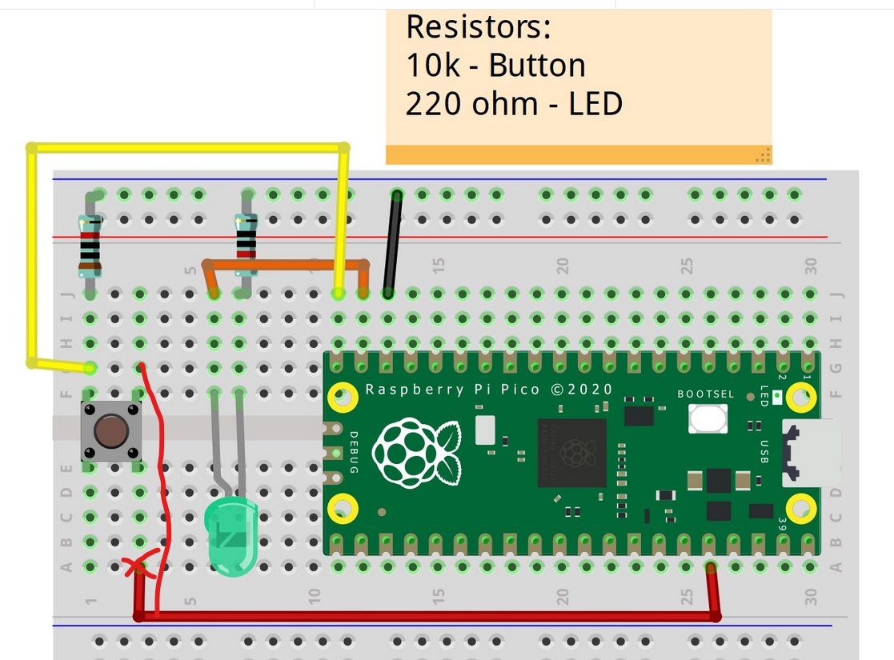

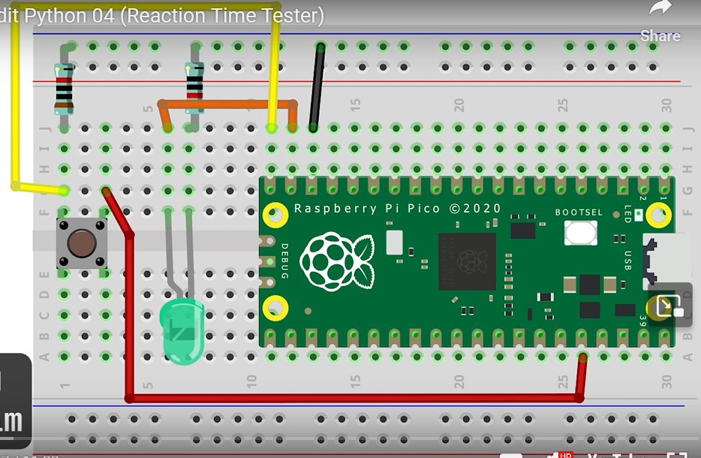

Brown 1

Black 0

Black 0

Red 2

Silver? ± 10%

10000 = 10 K Ω ± 10%

??? Red 2

Red 2

Black 0

Black 0

Silver? ± 10%

220 Ω ± 10%

Black – GND

Orange – GP14 -- LED

Yellow – GP15 -- Button

Red – 36 3V3 (OUT)

* Mine

Original from Web Site

Corrected

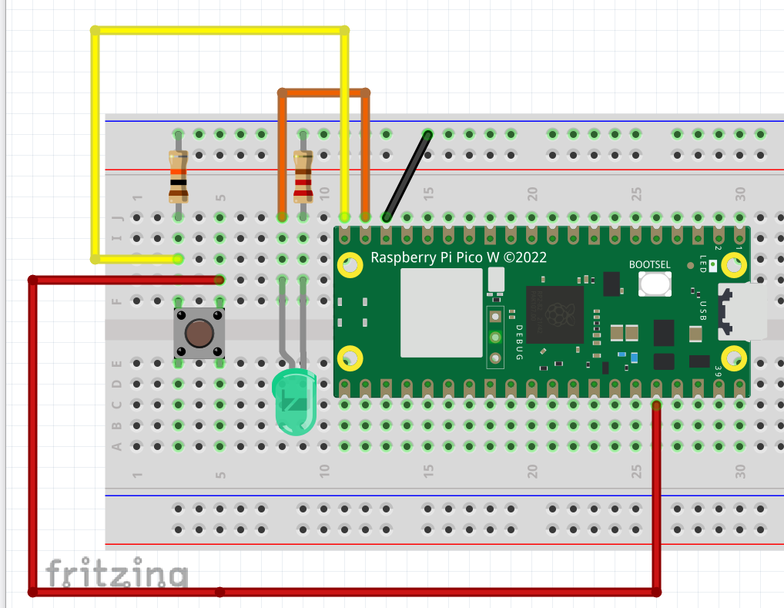

* As built