**Lesson_6_Notes_and_Journal**

**2024.05.02**

* Look at Code
* Look at Circuit
* Draw Circuit
* Build Circuit
* Start Lesson

**Code**

* Glance at Code

import machine

import time

# Define GPIO pins for the 4 LEDs

led_pins = [

machine.Pin(0, machine.Pin.OUT),

machine.Pin(1, machine.Pin.OUT),

machine.Pin(2, machine.Pin.OUT),

machine.Pin(3, machine.Pin.OUT)

]

button_pin = machine.Pin(8, machine.Pin.IN, machine.Pin.PULL_DOWN)

# Initialize LED states for 4 LEDs

led_states = [0] * len(led_pins)

# Function to update LED states

def update_led_states():

for i, led in enumerate(led_pins):

if led_states[i] == 1:

led.on()

else:

led.off()

# Function to create a padded binary string

def padded_binary_string(value, length):

binary_str = bin(value).replace("0b", "")

while len(binary_str) < length:

binary_str = '0' + binary_str

return binary_str

# Function to increment binary counter

def increment_counter():

# Convert LED states to integer

binary_value = int(''.join(map(str, led_states)), 2)

binary_value += 1

# If value is 16 (10000 in binary), reset to 0

if binary_value >= 16:

binary_value = 0

binary_string = padded_binary_string(binary_value, len(led_pins))

# Update LED states

for i, bit in enumerate(binary_string):

led_states[i] = int(bit)

# Main loop

while True:

if button_pin.value() == 1:

increment_counter()

update_led_states()

time.sleep(0.2) # Button debounce delay

**Circuit**

* Theirs

* Mine

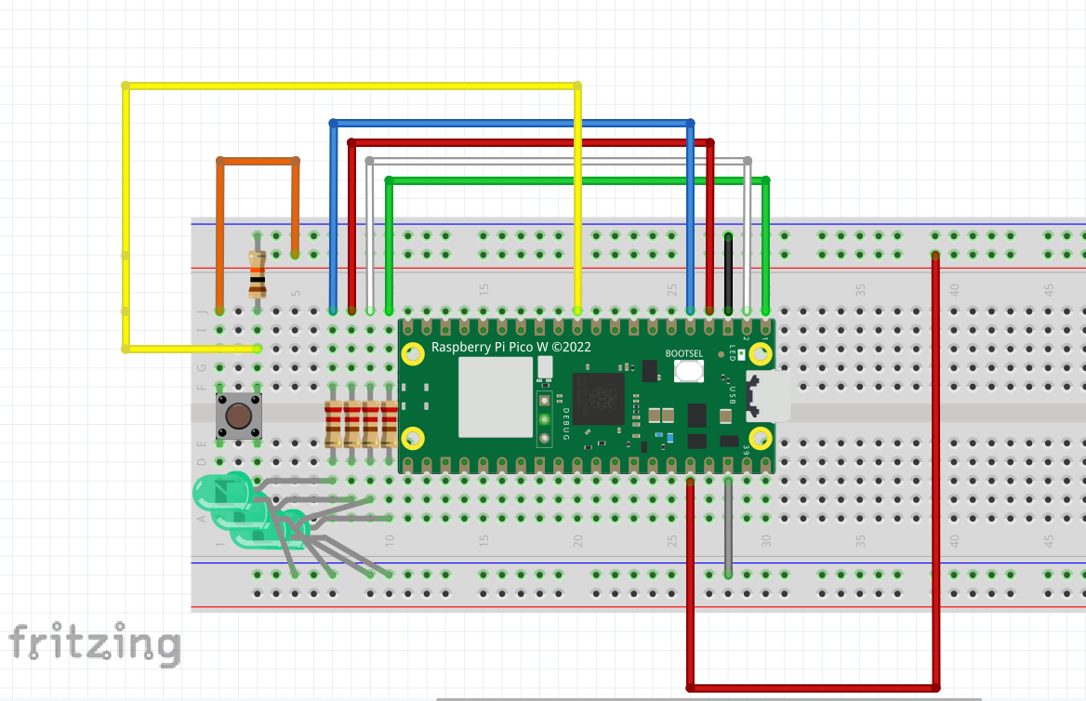

* As built