Python Full Course for Beginners | Complete All-in-One Tutorial | 9 Hours

Python Full Course for Beginners | Complete All-in-One Tutorial | 9 Hours
Dave Gray

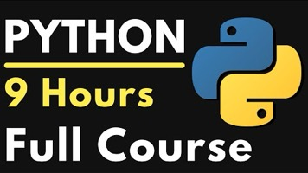

https://youtu.be/H2EJuAcrZYU

