N5QCsPi
Rev. 0 – 4/22/25 – Created @ 202 Marie Jeanne

IP on PATHFINDER_HOME: 192:168.1.103

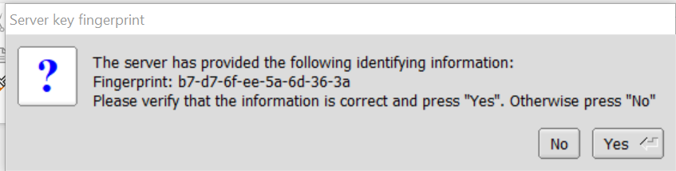

ssh Random3884@192.168.1.11

ssh Gibberish5600@192.168.1.11

