N5QC SDR Background

Project Git and File Structure Created 4/16/2024

Current Phase Pre-Planning
- Pre-Planning Activities
- Background Documentation
- Reading
  - Background Articles Here
  - Other Historical Resources
  - Do some surfing
- Brainstorming
  - Do a Mmind Map
  - Integrate with Pico Pi Python Class Exercises
- Project Skeleton Development
- Scope
  - Start with Bench Test
- Schedule
  - Fill in as time allows
  - Build this as it gets more refined
- Cost
  - One Time and Infrastructure / Overhead
  - Build a First Flight Costed BOM
  - Build a Second Flight Costed BOM
  - Repetitive Consumables

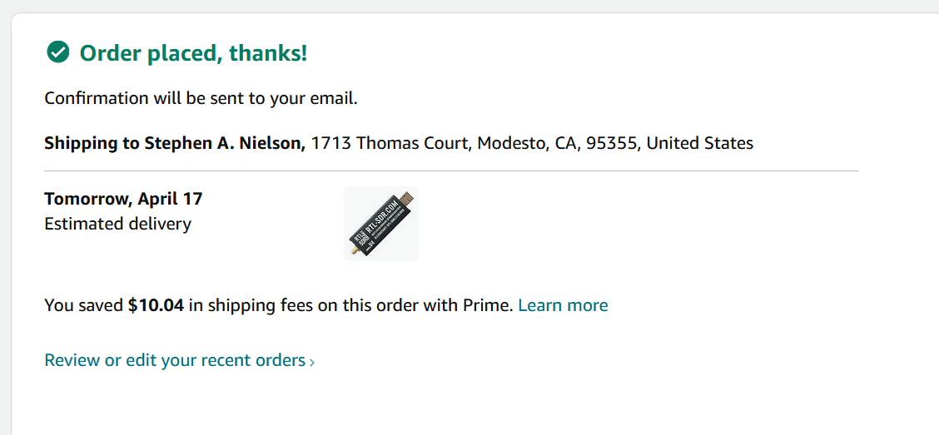

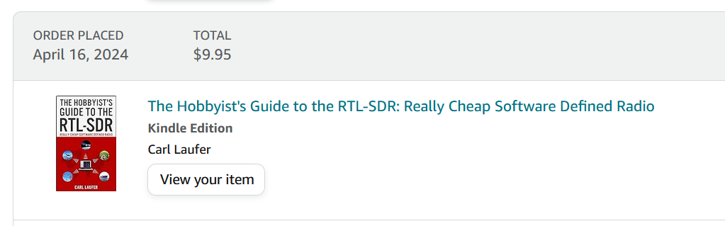

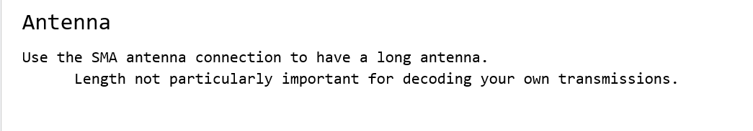

https://www.meinbergglobal.com/english/sw/ntp.htm#ntp_stable

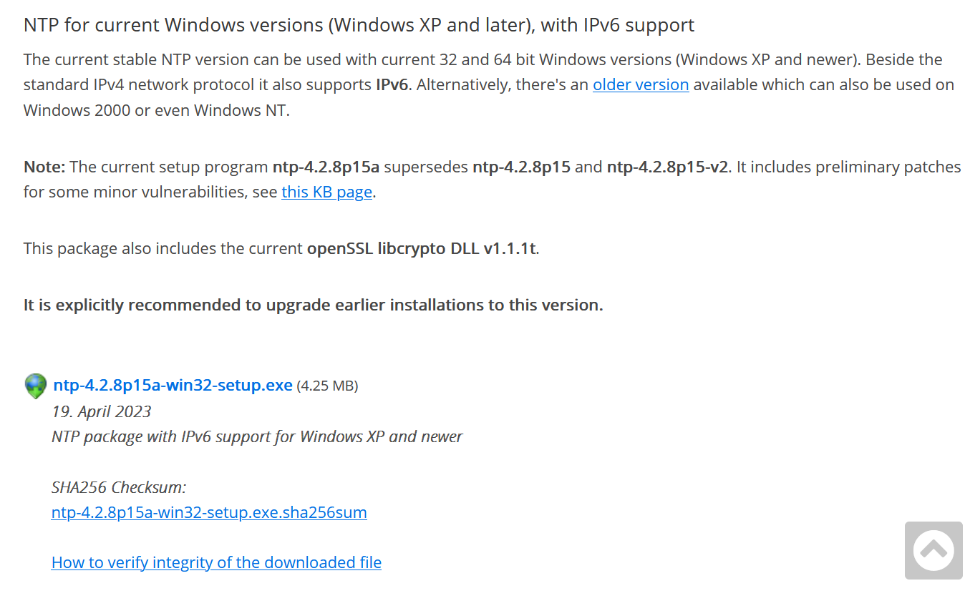

Place_Holder.txt

This file intentionally left blank.

