Frequency Survey Project Management

Scope

RTL-SDR Survey
- Gather Parts
  - R Pi
  - RTL-SDR
  - Antenna
  - Connectors
- Check uSD Card Inventory
- Follow Instructions
- Gather Data
- PDCA

New uSD Card DS 1 dot Validrive Report (PASS – ACCEPT):

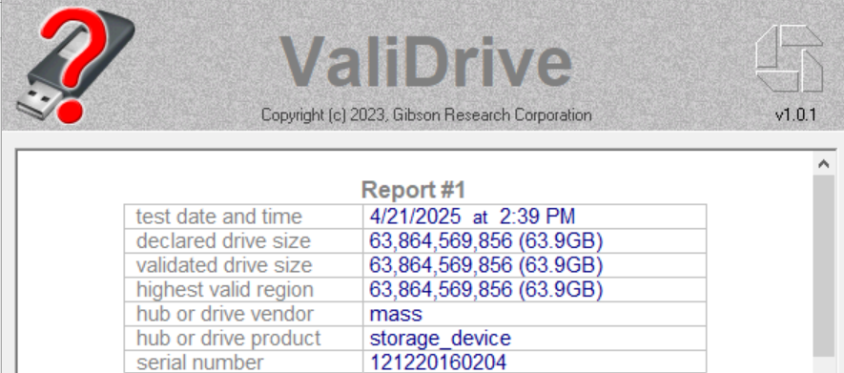

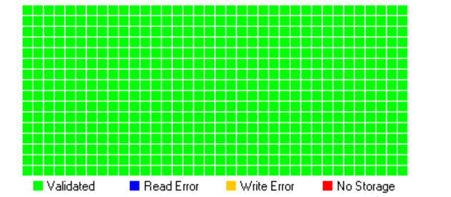

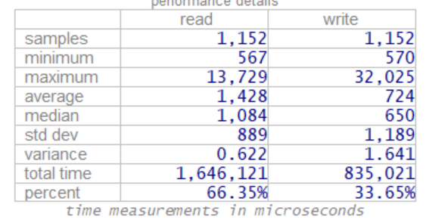

New uSD Card DS 2 dot Validrive Report (PASS – ACCEPT):

Report #1
test date and time | 4/21/2025 at 2:47 PM
declared drive size | 63,864,569,856 (63.9GB)
validated drive size | 63,864,569,856 (63.9GB)
highest valid region | 63,864,569,856 (63.9GB)
hub or drive vendor | mass
hub or drive product | storage_device
serial number | 121220160204

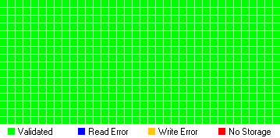
performance details
 | read | write
samples | 1,152 | 1,152
minimum | 551 | 566
maximum | 16,838 | 31,767
average | 1,451 | 737
median | 1,100 | 666
std dev | 994 | 1,175
variance | 0.685 | 1.593
total time | 1,671,909 | 850,080
percent | 66.29% | 33.71%
time measurements in microseconds

Install OS

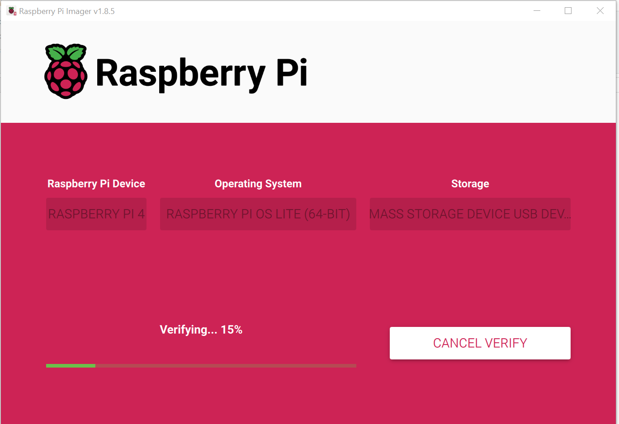

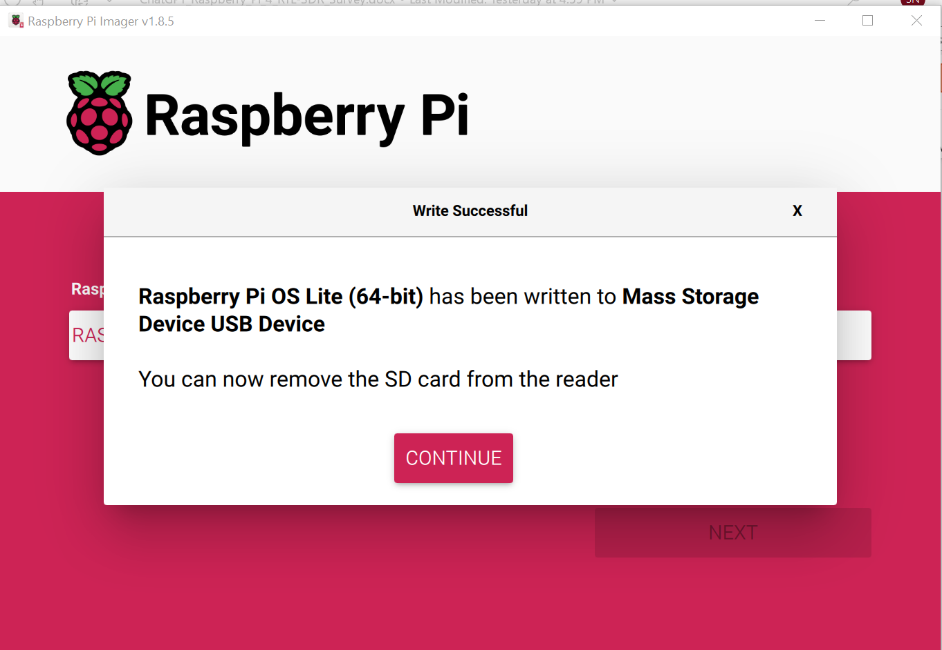

4/23/25

S S H < U S E R > @ < I P >
Connects to another Linux system with SSH
Example: ssh pat@192.168.1.1

ssh unicycle9312@198.168.4.190

To SSH into a Raspberry Pi, you need to ensure that SSH is enabled on the device. If it's not enabled, you can create a file named "ssh" in the boot directory of the SD card, then insert it back into the Raspberry Pi and boot it up to enable SSH

FAIL – Try Reimaging

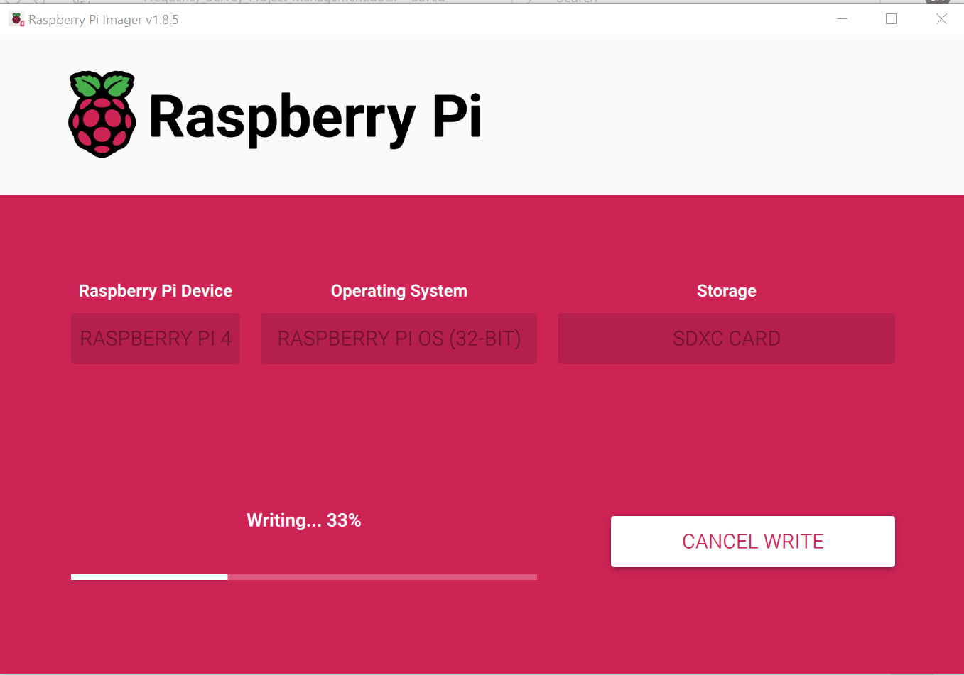

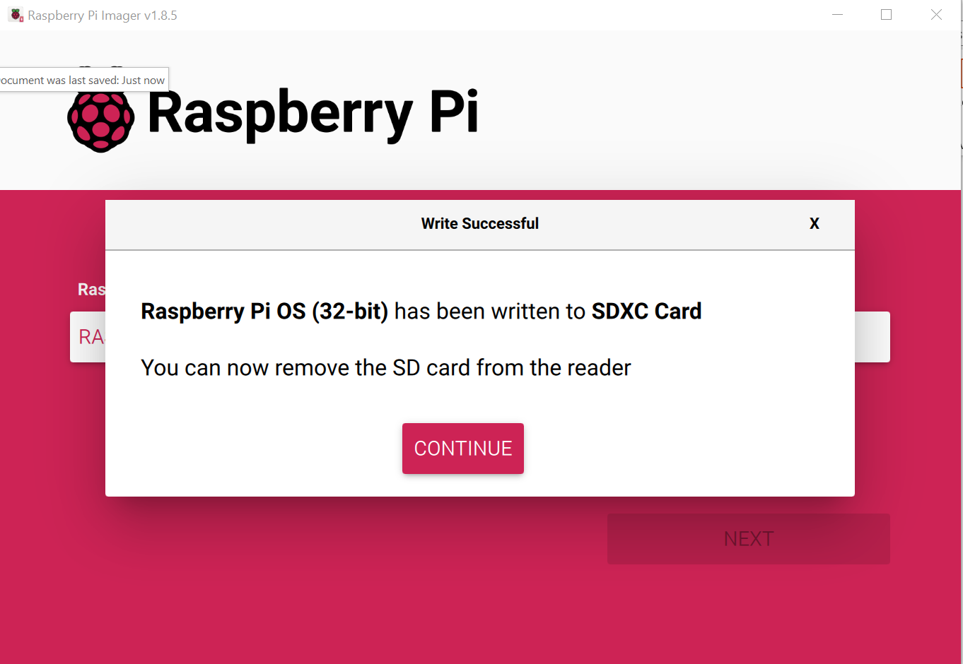

Microsoft Windows [Version 10.0.19045.5737]
(c) Microsoft Corporation. All rights reserved.

C:\Users\N5QC>ssh unicycle9312@198.168.4.190
ssh: connect to host 198.168.4.190 port 22: Connection timed out

BAD IP: 198.168.4.190 192.168.4.190

unicycle9312@192.168.4.190

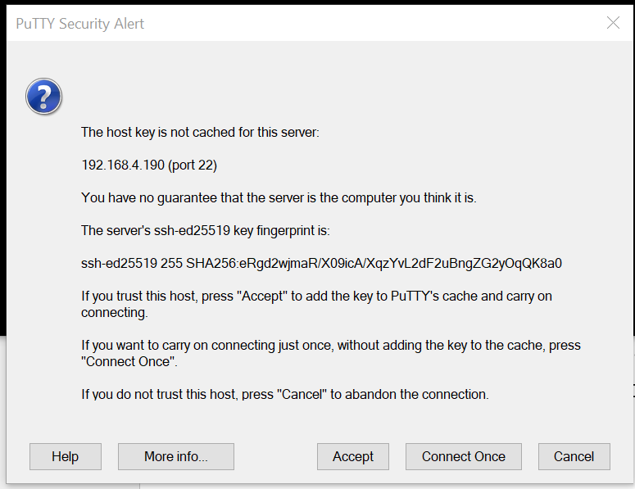

sudo apt-get update
sudo apt-get upgrade
sudo apt-get dist-upgrade
logout or exit
sudo reboot
shutdown -h now

sudo apt install rtl-sdr python3-matplotlib python3-numpy sox git

git clone https://github.com/keenerd/rtl-sdr.git
cp rtl-sdr/rtl_power/heatmap.py ~/sdr-monitor/

unicycle9312@Frequency:~ $ cp rtl-sdr/rtl_power/heatmap.py ~/sdr-monitor/
cp: cannot stat 'rtl-sdr/rtl_power/heatmap.py': No such file or directory
unicycle9312@Frequency:~ $ ls
Bookshelf Desktop Documents Downloads Music Pictures Public rtl-sdr Templates Videos
unicycle9312@Frequency:~ $ cd rtl-sdr
unicycle9312@Frequency:~/rtl-sdr $ ls
AUTHORS CMakeLists.txt COPYING git-version-gen librtlsdr.pc.in Makefile.am rtlsdr.conf src
cmake configure.ac Doxyfile.in include m4 README rtl-sdr.rules

unicycle9312@Frequency:~/rtl-sdr $ shutdown -h now
Call to PowerOff failed: Interactive authentication required.
unicycle9312@Frequency:~/rtl-sdr $ sudo shutdown -h now

Broadcast message from root@Frequency on pts/1 (Wed 2025-04-23 20:49:50 CDT):

The system will power off now!

4/24/25

Tiger VNC

- Enable VNC Server with sudo raspi-config

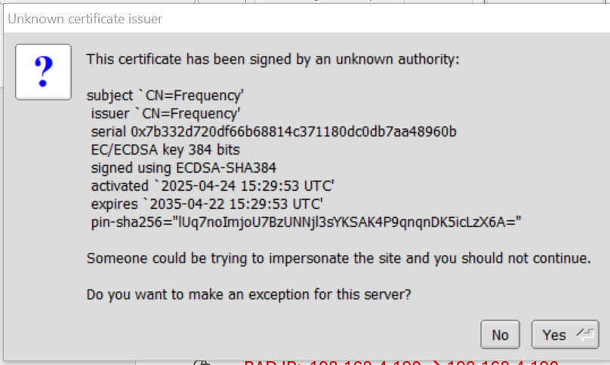

sudo apt install rtl-sdr sox git python3-pip screen

echo 'blacklist dvb_usb_rtl28xxu' | sudo tee /etc/modprobe.d/no-rtl.conf

sudo reboot

rtl_power -f 440M:450M:25k -i 15s -e 1h traffic.csv
rtl_power -f 430M:450M:25k -i 15s -e 1h traffic.csv

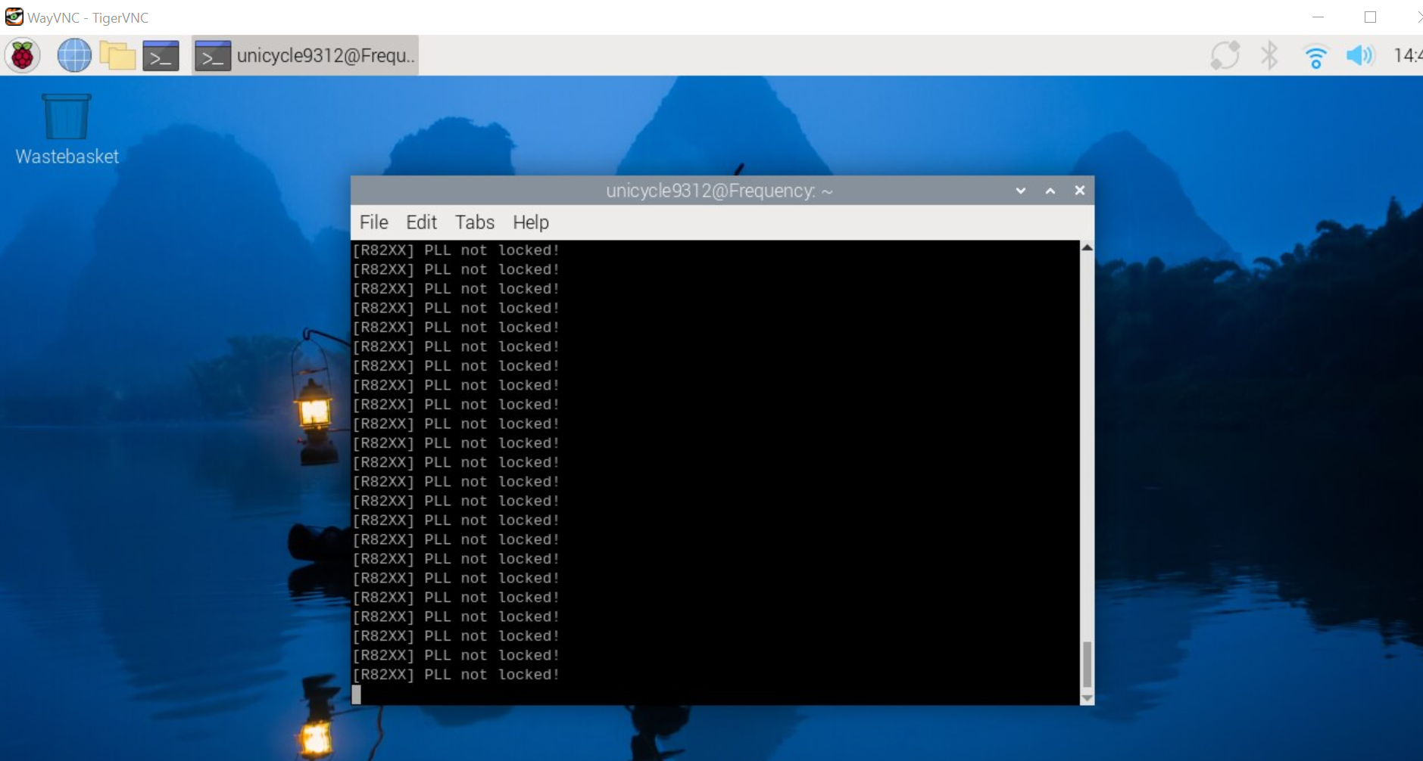

Don’t worry about message – look at data.

rtl_power -f 430000000:450000000:25000 -i 15s -e 1h traffic2.csv

04/25/25

Cloned Repository to Raspberry Pi

Set up Data Directory Tree

python3 heatmap.py bandlog.csv output.png

traffic.csv Traffic_Map.png python3 heatmap.py traffic.csv Traffic_Map.png

heatmap.py': [Errno 2] No such file or directory

Download heatmap.py to:
cd ~/sdr-monitor

~/Documents/Repositories/D-Star/Frequency_Survey/Data/2025_04_24
python3 heatmap.py logs/scan_2025-04-25_13-00.csv output/heatmap_2025-04-25_13-00.png

cd ~/sdr-monitor
python3 heatmap.py ~/Documents/Repositories/D-Star/Frequency_Survey/Data/2025_04_24/traffic.csv ~/Documents/Repositories/D-Star/Frequency_Survey/Data/2025_04_24/Traffic_Map.png

loading
x: 1025, y: 240, z: (-29.840000, -3.740000)
drawing
labeling
/home/unicycle9312/sdr-monitor/heatmap.py:470: DeprecationWarning: getsize is deprecated and will be removed in Pillow 10 (2023-07-01). Use getbbox or getlength instead.
s = f.getsize(label)
/home/unicycle9312/sdr-monitor/heatmap.py:475: DeprecationWarning: ANTIALIAS is deprecated and will be removed in Pillow 10 (2023-07-01). Use LANCZOS or Resampling.LANCZOS instead.
return w_img.resize((s[0]//3, s[1]//3), Image.ANTIALIAS)
saving

traffic2.csv Traffic_Map2.png

python3 heatmap.py ~/Documents/Repositories/D-Star/Frequency_Survey/Data/2025_04_24/traffic2.csv ~/Documents/Repositories/D-Star/Frequency_Survey/Data/2025_04_24/Traffic_Map2.png

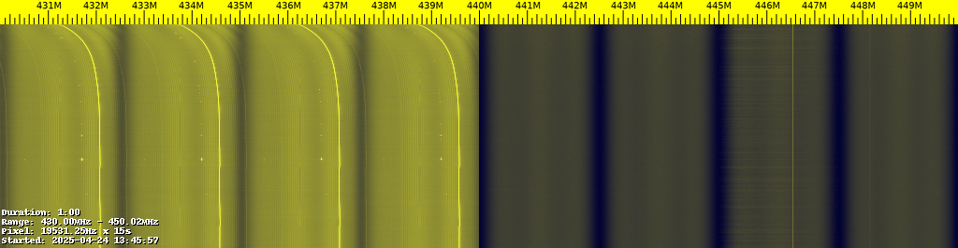

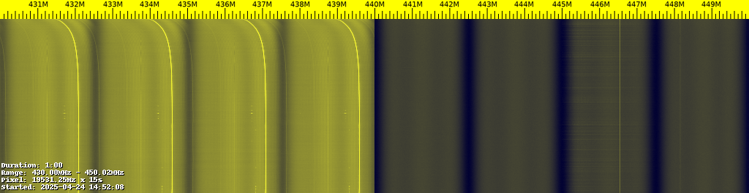

Absolutely — let’s take a closer look at your two heatmaps and interpret what’s happening across the 70 cm band (430–450 MHz).

🛰️ Overview of Your Heatmaps
Common Settings
- Scan range: 430.000 MHz to 450.000 MHz (full 70 cm band)
- Step: 25 kHz
- Time per row: 15 s
- Duration: ~15 minutes (judging by the vertical dimension)

🔍 First Heatmap (Traffic_Map.png)
Start time: 2025-04-24 13:45:57
🔦 Observations:
- 430–439 MHz: Strong and continuous activity. The bright yellow vertical bars indicate persistent transmissions.
  - Likely candidates: digital trunked systems, control channels, or repeated emissions.
- 440–445 MHz: Sparse activity. Most of this region is dark, suggesting it's mostly unused.
- Around 446 MHz: A narrow vertical stripe of medium-brightness — possibly a D-Star repeater or another narrowband digital signal.
- 449–450 MHz: Mostly quiet.

🔍 Second Heatmap (Traffic_Map2.png)
Start time: 2025-04-24 14:52:08 (a little over an hour later)
🔦 Observations:
- Nearly identical pattern to the first one:
  - 430–439 MHz: Same consistent, high-strength usage.
  - 441–445 MHz: Still mostly unused.
  - 446 MHz: Still present — consistent signal, likely a repeater.
  - No major new signals, suggesting low variation in traffic during this time period.

🧠 Interpretation Summary
Frequency Band | Activity | Likely Use
430–439 MHz | Very active | Control/data channels, trunked digital, maybe P25 or DMR
440–445 MHz | Mostly quiet | Candidate for simplex or custom experiments
446 MHz | Active narrow signal | Possibly D-Star or digital repeater
447–449 MHz | Sporadic/light usage | Possible repeater outputs or unused frequencies

🧪 Suggested Next Steps
✅ Experiment 1 Follow-up:
You’ve clearly identified active vs. quiet zones. Nice work!
Try plotting activity over time for just the quiet regions (e.g., 441–444 MHz) to catch rare usage.
✅ Experiment 2 Preparation:
The 446 MHz signal is a great candidate to investigate further:
- Try tuning in live with gqrx or SDR++
- Use dstar_demod.py or dsd to try decoding
- Log IQ samples for offline decoding if needed

Would you like a custom script to extract power levels over time for just one frequency (like 446.0 MHz) to see patterns in Excel? Or do you want help trying to decode that 446 MHz signal?

Steve’s Next Steps:

RTL-SDR Above:
- Eliminate 430 – 439 due to continuous strong activity
- Even if I don’t interfere with them, they might interfere enough to mess me up at low power

Previous ChatGPT Targets:
- Remaining Recommendations
  - 446.500
  - 446.525
  - 446.550

Band Plan:
445.00-447.00 | Shared by auxiliary and control links, repeaters and simplex (local option)
KF5SCI B 447.750 – 5.000 447.750 and 442.750

AF5SH-D 449.600 – 6.00 449.600 and 443.600

Scan 445.000 – 447.000

rtl_power -f 445M:447M:25k -i 15s -e 1h simplex1.csv

rtl_power -f 445M:447M:25k -i 15s -e 24h simplex24.csv

04/26/15

simplex1.csv
simplex24.csv

cd ~/sdr-monitor

python3 heatmap.py ~/Documents/Repositories/D-Star/Frequency_Survey/Data/2025_04_25/simplex1.csv ~/Documents/Repositories/D-Star/Frequency_Survey/Data/2025_04_25/Simplex1_Map.png

python3 heatmap.py ~/Documents/Repositories/D-Star/Frequency_Survey/Data/2025_04_25/simplex24.csv ~/Documents/Repositories/D-Star/Frequency_Survey/Data/2025_04_25/Simplex24_Map.png

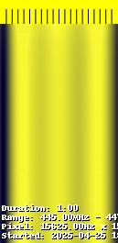

Yes, let’s dive into these new heatmaps you posted!

🛰️ Overview of Your Two New Heatmaps

📈 First Image: Simplex1_Map.png
- Scan Range: ~445–446 MHz (narrow slice)
- Duration: 1 minute
- Observation:
  - The band is mostly solid bright yellow.
  - Very little variation across the minute.
  - Interpretation:
This suggests very strong, continuous, full-band RF activity across this narrow range.
It’s likely some constant wide-area repeater output, a control channel, or digital emissions.
  - There is no clear "bursty" traffic (like people keying up a mic); it looks continuous.

📈 Second Image: Simplex24_Map.png
- Scan Range: Same ~445–446 MHz
- Duration: Much longer — judging by the vertical stretch, probably 24+ minutes.
- Observation:
  - Top portion: Bright yellow → continuous RF activity.
  - Lower portion: Black (silence) with a few faint lines.
  - Interpretation:
At first: Strong, steady transmission.
Later: The strong transmission stopped and the band went quiet (black).
This suggests:
    - The source (repeater or other emitter) was turned off.
    - Or a periodic transmission ended.
    - Could even be a repeater’s ID beacon that timed out.

🔍 Summary Table
Item | Simplex1_Map.png | Simplex24_Map.png
Range | 445–446 MHz | 445–446 MHz
Duration | 1 minute | ~24 minutes
Traffic pattern | Strong, constant | Strong, then silence
Likely Source | Continuous repeater / beacon | Beacon, repeater, or digital system shutting down

🧠 Next Steps You Could Take
- 🎯 Focus: Narrow in around 445.9–446.1 MHz for live listen with gqrx or SDR++.
- 📡 Identify: Try DSDPlus or dsd decoder to see if it’s a digital mode like DMR, D-Star, or NXDN.
- 📝 Log: Record when transmissions start/stop — see if it’s periodic.
- 🛠️ Analysis: Plot RSSI (signal strength) versus time if you want a numerical view.

You’re really close to isolating the most active local 70 cm activity!
Would you like me to help you set up a simple live "activity logger" script too, so you can automatically track when transmissions start and stop without watching the heatmaps manually? 🚀
(Only needs rtl_power and a little Python.)
Yes, let’t focus on the frequency range 446.475 to 446.575 mhz. Can we set it up to run for 24 hours?

Awesome — you have a sharp target: 446.475 MHz to 446.575 MHz, a very smart slice (only 100 kHz wide)!
✅ We can absolutely scan just that range continuously for 24 hours, and automatically log activity!
Here’s the plan:

🛠️ RTL-SDR Activity Logger Setup
1. Use rtl_power to sweep and record
We'll call rtl_power with settings for:
- Center Frequency: 446.525 MHz
- Range: 100 kHz (446.475–446.575 MHz)
- Sample Step: 10 kHz (fine enough to catch narrowband signals)
- Integration Time: 30 seconds (reasonable balance for logging)
- Duration: 24 hours
Command Example:
rtl_power -f 446.475M:446.575M:10k -i 30s -g 40 -e 24h output.csv
Setting | Meaning
-f | Frequency range and step
-i 30s | Average each measurement over 30 seconds
-g 40 | Gain setting (adjust if needed)
-e 24h | Run for 24 hours
output.csv | Save to a CSV file for analysis

2. Automatically plot or detect activity
When it's done, we can:
- Plot a heatmap like before.
- OR run a simple Python script that:
  - Reads the CSV,
  - Finds signals above a threshold (e.g., -70 dB),
  - Logs start and end times of active transmissions.
(Optional) 3. Live Monitor (bonus)
You could also tail the CSV file during the run to watch for real-time bursts if you want.

📋 Quick Checklist Before Starting
Item | Ready?
RTL-SDR Stick | ✅
Raspberry Pi 4 | ✅
rtl_power installed | ✅ (part of rtl-sdr package)
Enough Disk Space | ✅ (maybe ~50–100MB for 24h sweep)
Power Supply Stable | ✅ (important for a full day run)

🚀 If you're ready, here’s the exact action steps:
- Run this on your Raspberry Pi terminal:
rtl_power -f 446.475M:446.575M:10k -i 30s -g 40 -e 24h output.csv
(Leave the Pi running and recording all day.)
- After the run, upload or view output.csv.
- I'll help you make a heatmap, activity timeline, or automated event list based on it!

⚡ Would you also like me to give you the Python script now that will read and automatically detect signal events after the 24-hour capture finishes?
(You can set it up ahead of time so you’re fully ready!) 🎯

Yes, let’s set up the script to read and automatically detect signal events after the 24-hour capture finishes.

Here’s a starter script that will read the captured CSV file from your 24-hour scan, detect when signals are above a threshold, and log them neatly to a text file!
- Threshold: Set at -70 dBm for now (adjustable).
- Results: Saved in detected_events.txt with timestamp, frequency, and power.
- Next steps: We could also group close events together or create a better visualization if you want.
Would you also like me to show you how to schedule all of this to run automatically after the 24-hour scan ends? 📈⏳

04/27/25

Processing output.csv...
Traceback (most recent call last):
File "/home/unicycle9312/Signal_Detect.py", line 28, in <module>
timestamp, freq_start, freq_step, powers = parse_rtl_power_line(row)
^^^^^^^^^^^^^^^^^^^^^^^^^
File "/home/unicycle9312/Signal_Detect.py", line 11, in parse_rtl_power_line
timestamp = datetime.datetime.strptime(row[0], "%Y-%m-%dT%H:%M:%S")
^^^^^^^^^^^^^^^^^^^^^^^^^^^^^^^^^^^^^^^^^^^^^^^^^^^^^^^
File "/usr/lib/python3.11/_strptime.py", line 568, in _strptime_datetime
tt, fraction, gmtoff_fraction = _strptime(data_string, format)
^^^^^^^^^^^^^^^^^^^^^^^^^^^^^^
File "/usr/lib/python3.11/_strptime.py", line 349, in _strptime
raise ValueError("time data %r does not match format %r" %
ValueError: time data '2025-04-26' does not match format '%Y-%m-%dT%H:%M:%S'

First successful run

Detected 7079 events.

=== Signal Statistics ===
Mean Power: -43.24 dBm
Standard Deviation: 4.05 dB
Mean + 3?: -31.08 dBm
Mean - 3?: -55.40 dBm
Minimum Power: -60.59 dBm
Maximum Power: -38.51 dBm

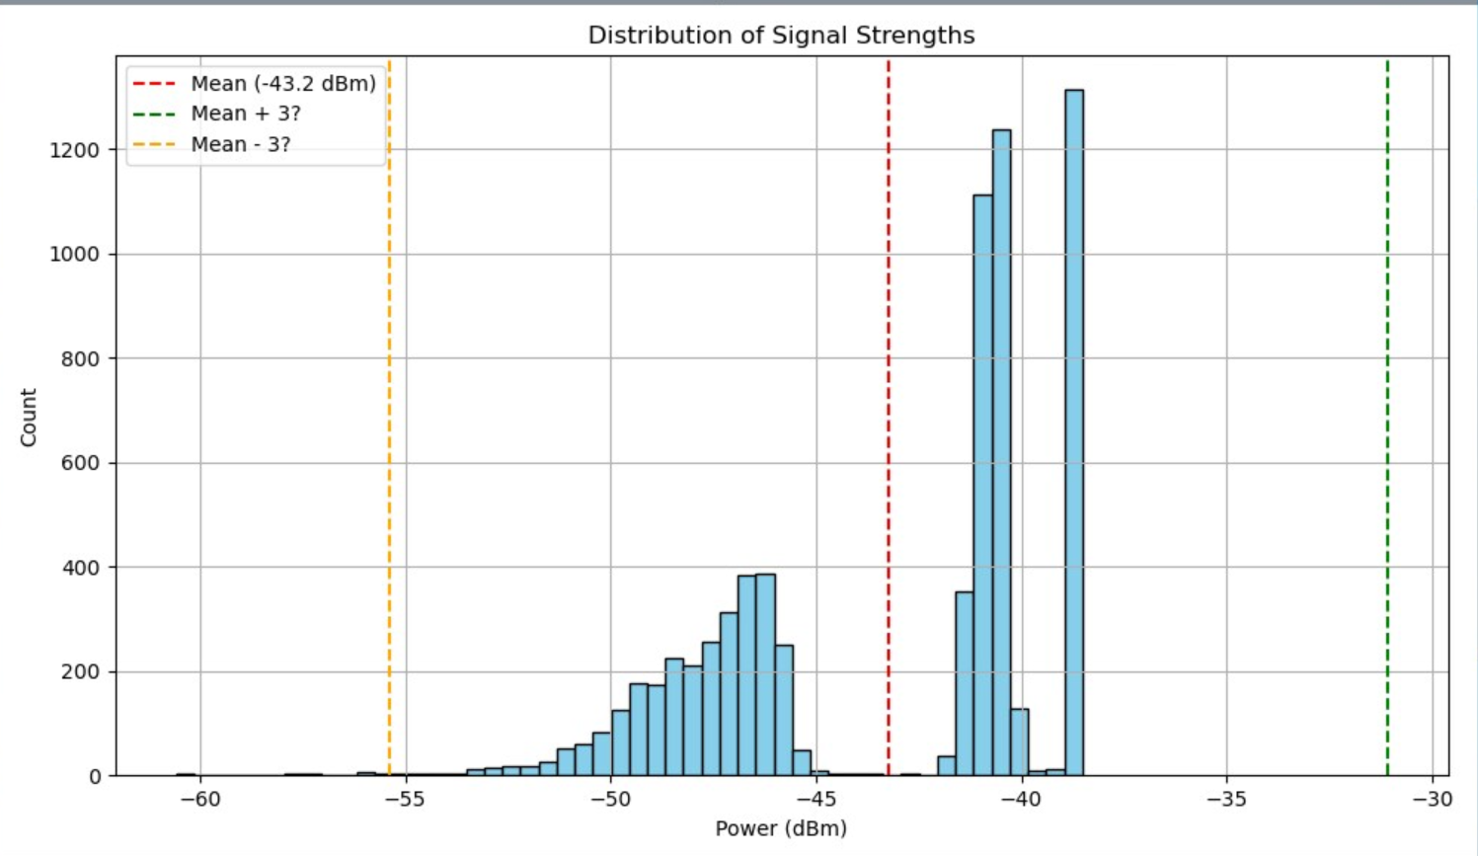

cd ~/sdr-monitor

python3 heatmap.py ~/Documents/Repositories/D-Star/Frequency_Survey/Data/2025_04_26/output.csv ~/Documents/Repositories/D-Star/Frequency_Survey/Data/2025_04_26/Output_Map.png

https://github.com/SteveN5QC/D-Star.git

5/3/25

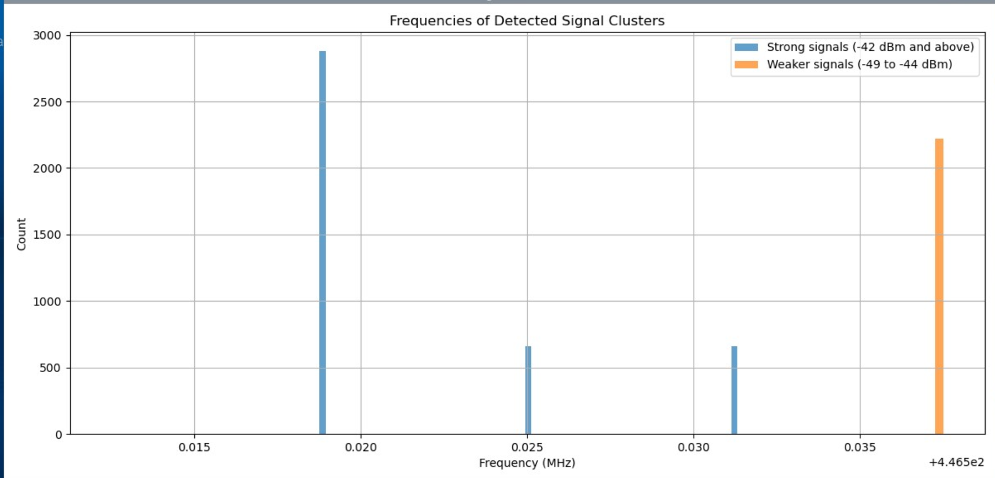

Ah! Thanks for sharing this new histogram — now I can see exactly what's going on.
Let’s analyze it step-by-step:

🔍 What I see in the chart:
✅ 4 main peaks:
- One large peak around 0.020 MHz (20 kHz)
- Two smaller peaks at ~0.025 MHz and ~0.030 MHz
- And an orange (weaker signal) peak around 4.465e2 MHz → 446.5 MHz
⚠️ Notice:
- That last orange bar has an x-axis label shown as +4.465e2, meaning it's plotted at 446.5 MHz offset!
- The other peaks are near 0 MHz, but with an x-axis shift of +446.5 MHz implied by the scale
In other words, your plot is getting auto-offset by matplotlib/scientific notation formatting!

💡 What’s happening:
The x-axis is labeled relative to 446.5 MHz.
Matplotlib is trying to save space by showing the axis like:
"all x-values ≈ 446.5 MHz → I’ll write them as +4.465e2 plus a small number"
So instead of showing:
446.5 MHz
446.52 MHz
446.53 MHz
it writes:
+4.465e2
0.020
0.025
0.030
meaning:
446.5 + 0.020 MHz → 446.520 MHz
✅ Therefore:
- Your main signals are clustered around 446.520 MHz, 446.525 MHz, 446.530 MHz → 🛰️ FRS/PMR-type frequencies or similar band
- Weaker cluster at exactly 446.5 MHz

🎯 Interpretation of peaks:
Labeled x-axis | Actual frequency (MHz) | Likely source
0.020 | 446.520 | Channel 2 or similar
0.025 | 446.525 | Channel 3 or similar
0.030 | 446.530 | Channel 4 or similar
+4.465e2 | 446.500 | Channel 1 or control channel
These align well with standard radio channel spacings (e.g., 446.500, 446.525 MHz).

📈 What’s wrong?
Nothing structurally wrong! But:
→ Matplotlib’s axis formatting is confusing you by showing offsets instead of absolute MHz.

✅ Fix suggestions:
👉 Add plt.ticklabel_format or ScalarFormatter to force full MHz display.
In your plotting code:
import matplotlib.ticker as ticker

plt.gca().xaxis.set_major_formatter(ticker.ScalarFormatter(useOffset=False))
OR:
plt.ticklabel_format(style='plain', axis='x')
This will disable the "+4.465e2" offset and show actual frequencies like 446.500, 446.520, 446.525, etc.

📝 Bottom line:
✔️ Your frequency detection is working.
✔️ You're detecting signal clusters at 446.5 MHz ± small channel steps.
✔️ Plot is correct numerically, just visual formatting needs fixing.

Would you like me to write a cleaned-up code snippet that applies this formatting + saves a better plot? 🎨

import matplotlib.pyplot as plt
import pandas as pd
import matplotlib.ticker as ticker

# Load your frequency data
strong_freqs = pd.read_csv('strong_cluster_freqs.csv', header=None)[0]
weak_freqs = pd.read_csv('weak_cluster_freqs.csv', header=None)[0]

plt.figure(figsize=(12, 6))

# Plot histograms
plt.hist(strong_freqs, bins=100, color='steelblue', alpha=0.7, label='Strong signals (-42 dBm and above)')
plt.hist(weak_freqs, bins=100, color='orange', alpha=0.5, label='Weaker signals (-49 to -44 dBm)')

plt.xlabel('Frequency (MHz)')
plt.ylabel('Count')
plt.title('Frequencies of Detected Signal Clusters')

# ✅ Disable scientific notation & offset
plt.ticklabel_format(style='plain', axis='x')
plt.gca().xaxis.set_major_formatter(ticker.ScalarFormatter(useOffset=False))

plt.legend()
plt.grid(True)

plt.tight_layout()
plt.savefig('frequency_clusters_histogram_cleaned.png')
plt.show()

