ETHICAL DECISION-MAKING SIMULATOR
Leader-Follower Dynamics in Ambiguous Orders
A Five-Scenario Course Package
For Field-Grade Officer Professional Military Education
Scenario Book and Facilitator Guide
Version 1.0

Course Overview
This package contains five ethical decision-making scenarios designed for field-grade officer professional military education. Each scenario places the student in a position where a respected senior leader has issued a morally ambiguous order, and the student must determine how to use a team of subordinates to gather information, surface alternatives, and guide the leader toward an ethical outcome that does not unnecessarily compromise the leader's legitimate interests or the student's own.

The Two-Part Simulator Structure
Each scenario unfolds in two phases.
- Phase One: Receipt of the Order. The student receives a morally ambiguous direction from a leader who is sympathetic, accomplished, and under real pressure. The leader is not a villain. The order is not obviously illegal. The ambiguity is the point.
- Phase Two: Engagement of Subordinates. The student must decide which of four subordinates to engage, what to ask them, and how to synthesize their input into a recommendation back to the leader. The subordinates represent four distinct followership archetypes drawn from the followership literature. The decision tree branches based on which subordinate the student leans on most heavily.
The student's objective is to guide the leader to the most ethical outcome that the situation will support, while protecting both the leader's legitimate interests and the student's own. The student's personal risk varies by scenario: career risk in some, criminal exposure in others, civil liability or reputational risk in others. The simulator deliberately mixes these so students learn that ethical decision-making is not a one-shape problem.

Learning Outcomes
- Identify the underlying interest a leader is pursuing when a stated order is ambiguous or borderline.
- Distinguish among four followership archetypes and select the right subordinate for the right phase of a problem.
- Construct a recommendation that protects the leader's legitimate end while replacing the unethical means with an ethical alternative.
- Recognize ethical drift in patterns of individually defensible decisions that aggregate into fraud or institutional harm.
- Apply the courageous followership concept of intelligent disobedience: refusing the harmful action while remaining loyal to the leader's lawful intent.

Course Mechanics
Each scenario is structured as follows.
- Setting and Mission: the operational context.
- Leader Profile: the person giving the morally ambiguous order, including motivations and pressures.
- Student Role and Personal Risk: the student's position, what is at stake personally.
- The Order: the specific morally ambiguous direction.
- Four Subordinates: each archetype, with name, role, theoretical lens, and the specific advice they offer.
- Decision Tree: four paths through the scenario, with immediate and downstream outcomes and a severity rating.
- Recommended Path: the optimal route through the scenario and why it produces the best aggregate outcome.
- Discussion Questions: five questions designed to provoke moral reasoning, not to validate a single answer.
- Facilitator Notes: pedagogical commentary for the instructor.
Recommended class flow per scenario: ten minutes silent read of the scenario; fifteen minutes small-group decision; fifteen minutes large-group debrief using the discussion questions; ten minutes facilitator synthesis. One scenario per ninety-minute block.

Followership Frameworks Reference
The simulator draws on five complementary scholarly traditions in the followership literature. The four subordinate archetypes used across all five scenarios are not invented for this course; they are an integration point at which these scholarly traditions converge. The table below maps the course's archetypes to the major followership models.

Mapping the Course Archetypes Across Models
Course Archetype | Kelley (1992) | Chaleff (1995, 2015) | Kellerman (2008) | Lipman-Blumen (2005)
The Loyalist | Conformist (Sheep) | Implementer (high support, low challenge) | Activist toward authority | Conformer susceptible to toxic leaders
The Operator | Pragmatist Survivor | Resource (low support, low challenge, low risk) | Participant | Bystander/Colluder
The Stickler | Alienated Follower | Individualist (low support, high challenge) | Isolate or Bystander depending on engagement | Whistleblower archetype
The Partner | Star/Effective Follower | Partner (high support, high challenge) | Constructive Activist | Independent Follower (resistant to toxic dynamics)

The Four Subordinate Archetypes

The Loyalist — Yes-Person / Conformist
Behavior: Executes orders quickly, avoids conflict, mirrors the boss. High deference, low challenge.
Strength: Speed of execution; preserves morale and command climate in the short term.
Risk: Amplifies bad orders. Tells the leader what they want to hear, not what they need to hear.

The Operator — Pragmatist / Workaround Specialist
Behavior: Mission-first to a fault. Knows the regulations well enough to bend them. Comfortable in the grey area.
Strength: Solves problems fast. Finds creative paths around bureaucracy.
Risk: Ethical drift. Each small compromise normalizes the next one. Provides plausible deniability for the leader, not protection.

The Stickler — Compliance / By-the-Book
Behavior: Rule-bound. Cites regulations, doctrine, and policy. Will not deviate, even when nuance is warranted.
Strength: Audit-proof. Will not be the source of a UCMJ, IG, or fraud finding.
Risk: Rigidity. Cannot navigate ambiguity. Often refuses without offering an alternative, leaving the leader cornered.

The Partner — Courageous Truth-Teller
Behavior: High support and high challenge. Speaks truth respectfully. Brings ethical issues forward and pairs them with viable alternatives.
Strength: Protects both the mission and the leader. Reframes the dilemma so the ethical option is also the practical one.
Risk: Slower in the moment. Requires emotional courage. The leader must be ready to listen.

Theorist Reference
Robert E. Kelley. The Power of Followership (1992). Five styles plotted on two axes: independent thinking and active engagement. Sheep, Yes-People, Alienated, Pragmatists, and Stars. Argues that effective followership is a discipline, not a default.
Ira Chaleff. The Courageous Follower (1995); Intelligent Disobedience (2015). Quadrant of support vs. challenge: Resource, Implementer, Individualist, Partner. Identifies five courages of followership and develops the doctrine of intelligent disobedience: the duty to refuse orders that cause foreseeable harm.
Barbara Kellerman. Followership: How Followers Are Creating Change (2008); Bad Leadership (2004). Engagement-based typology: Isolates, Bystanders, Participants, Activists, Diehards. Shifts the locus of moral responsibility from leader-only to leader-and-follower jointly accountable.
Jean Lipman-Blumen. The Allure of Toxic Leaders (2005). Examines why followers tolerate or enable toxic leaders. Identifies psychological and structural drivers: need for a strong parent figure, fear of ostracism, hope for material reward, and erosion of personal agency.
Riggio, Chaleff, and Lipman-Blumen (eds.). The Art of Followership (2008). An anthology that consolidates the field. Establishes that the leader-follower dyad is the basic unit of analysis and that organizations rise or fall on the moral courage of those several echelons below the senior leader.

Scenario 1: Manipulating the Collateral Damage Estimate
Domain: Joint Targeting / Air Operations

Setting
Combined Air Operations Center (CAOC) supporting a counter-network campaign in an OCONUS theater. Active pattern-of-life intelligence on a high-value target (HVT) responsible for resourcing attacks against U.S. and partner forces.

Mission
Prosecute a strike on the HVT within an open windowed period. The collateral damage methodology (CDM) governs whether a strike can be approved at the current rank, escalated to a four-star, or denied outright.

Leader Profile
COL Marcus 'Hammer' Reeves — J3 Air Operations Director
Background: 22 years infantry and former JTAC. Recently promoted O-6, on an O-7 list watch. Tour ends in six months. Lost two soldiers in 2010 to a network linked to the current target. Has been pushing this target package for nine months. Highly respected by the staff and combat-decorated.
Motivation: Wants a clean strike before he rotates. Believes the CDM is overly conservative and that the target poses a continuing threat that justifies risk acceptance.

Student Role and Personal Risk
Role: MAJ, Targeting Officer / Targeting Cell OIC
Stakes: On the Below-the-Zone (BZ) list for LTC. School slot pending. COL Reeves is your senior rater and sits on next year's promotion board.
Nature of risk: Career risk (promotion, school, evaluation) with downstream legal exposure if data is falsified. Falsifying targeting inputs is a UCMJ Article 107 (False Official Statement) offense and could implicate Article 92 and Law of Armed Conflict violations.

The Morally Ambiguous Order
COL Reeves: 'Run the CDE again. The model is too conservative. You're the targeting expert. Give me a number under thirty percent so I can approve at my level. The four-star will sit on this for two weeks and we'll lose the window.'
Regulatory and operational context: Current CDE returns sixty-five percent probability of civilian casualty. The target compound is collocated with a children's tutoring annex that operates 1300L to 1700L. The proposed strike window is 1500L. CDM doctrine requires that any CDE above thirty percent be elevated for four-star approval; above sixty percent generally requires a no-strike decision absent extraordinary circumstances.

The Four Subordinates

Loyalist — SSG Lopez, Targeting Analyst
Theoretical lens: Kelley: Conformist
'Sir, what number do you need? I can soften the structural hardness assumption and reduce the population density input. We can be at twenty-eight percent by tomorrow morning. The COL won't ask how.'
Read on this advice: Will produce whatever output the chain of command requests.

Operator — CW2 Patel, Targeting Warrant
Theoretical lens: Chaleff: Resource (low support, low challenge)
'The CDM has known limitations. If we use the alternate algorithm, treat the children's annex as a soft auxiliary structure rather than a populated building, and apply a forty percent attendance assumption rather than the seventy percent default, we can probably land at thirty-eight percent. Not under thirty, but defensible.'
Read on this advice: Builds a paper trail of plausible-deniability assumptions that an investigator will recognize as exactly what they are.

Stickler — 1LT Chen, Targeting Analyst (new to the cell)
Theoretical lens: Kelley: Alienated; Chaleff: Individualist
'Sir, the CDE is the CDE. The doctrinal inputs produce sixty-five percent. The Commander's intent is clear: above thirty percent, escalate. Above sixty percent, no-strike unless the four-star signs. We brief the actual number. If the colonel doesn't like it, that's his call to make to his boss.'
Read on this advice: Right answer, wrong delivery. Protects the regulation and the lieutenant. Does not protect the commander or the mission.

Partner — MSG Williams, Senior Targeting NCO
Theoretical lens: Chaleff: Partner; Practitioner of Intelligent Disobedience
'Sir, the colonel does not actually want a manipulated number. He wants this target prosecuted. Let's bring him three options that achieve his end state without compromising the data. One: shift the strike window to 0530L when the annex is closed. CDE drops to eight percent and he can approve at his level. Two: smaller-warhead precision-guided alternative at the existing window. CDE drops to twenty-two percent, still requires four-star but is highly likely to approve. Three: wait for a different pattern-of-life signature when the target moves. Let's give him the win without giving him the liability.'
Read on this advice: Reframes the order as a means-end problem and restores the leader's range of options.

Decision Tree
Each path represents the dominant follower the student leans on. Real student decisions blend paths; the tree is a simplification for analytic clarity.
Path | Choice | Immediate Outcome | Downstream Consequence | Severity
Path A | Submit a manipulated CDE under the doctrinal threshold. | Strike approved at the colonel's level. HVT eliminated within the chosen window. | Battle damage assessment confirms eleven civilian casualties including six children. Joint IG investigation. CENTCOM legal review. UCMJ Article 107 charges referred against the targeting officer. COL Reeves relieved for cause. Strategic information operations damage; ally requests case file. | Catastrophic
Path B | Refuse the manipulation and report 65% without alternatives. | Mission window lost. COL Reeves furious. Targeting officer evaluated as 'inflexible.' BZ momentum stalled. | Target conducts a successful attack three weeks later. Two friendly KIA. Targeting officer not directly culpable but now identified internally as a roadblock. School slot deferred a year. | Mission failure with collateral career damage
Path C | Bring the colonel three operational alternatives that meet his end state. | COL pushes back initially, but the 0530L window is operationally feasible. Pattern-of-life confirms the annex is empty. Strike executes at 0530L three days later. | Target eliminated. CDE actual: zero civilian casualties. COL Reeves writes a top-block evaluation citing 'strategic targeting judgment under pressure.' Targeting officer makes the BZ promotion list. Cell adopts the alternative-options framing as standard practice. | Optimal
Path D | Operator builds a defensible massaged number; Partner reframes options. | A 38% number is briefed alongside the alternatives. COL takes the alternatives. | Same operational result as Path C, but the targeting cell now has an internal precedent of producing 'defensible-but-massaged' numbers. Six months later, a more junior analyst applies the same approach to a case that does not warrant it. | Acceptable with reservations

Decision Tree (Visual)
The flowchart below shows each path from receipt of the order through final outcome. Severity color coding mirrors the table above. Stage layers: Engages → Choice → T+0 Immediate → T+30 to T+1yr Downstream → Severity verdict.
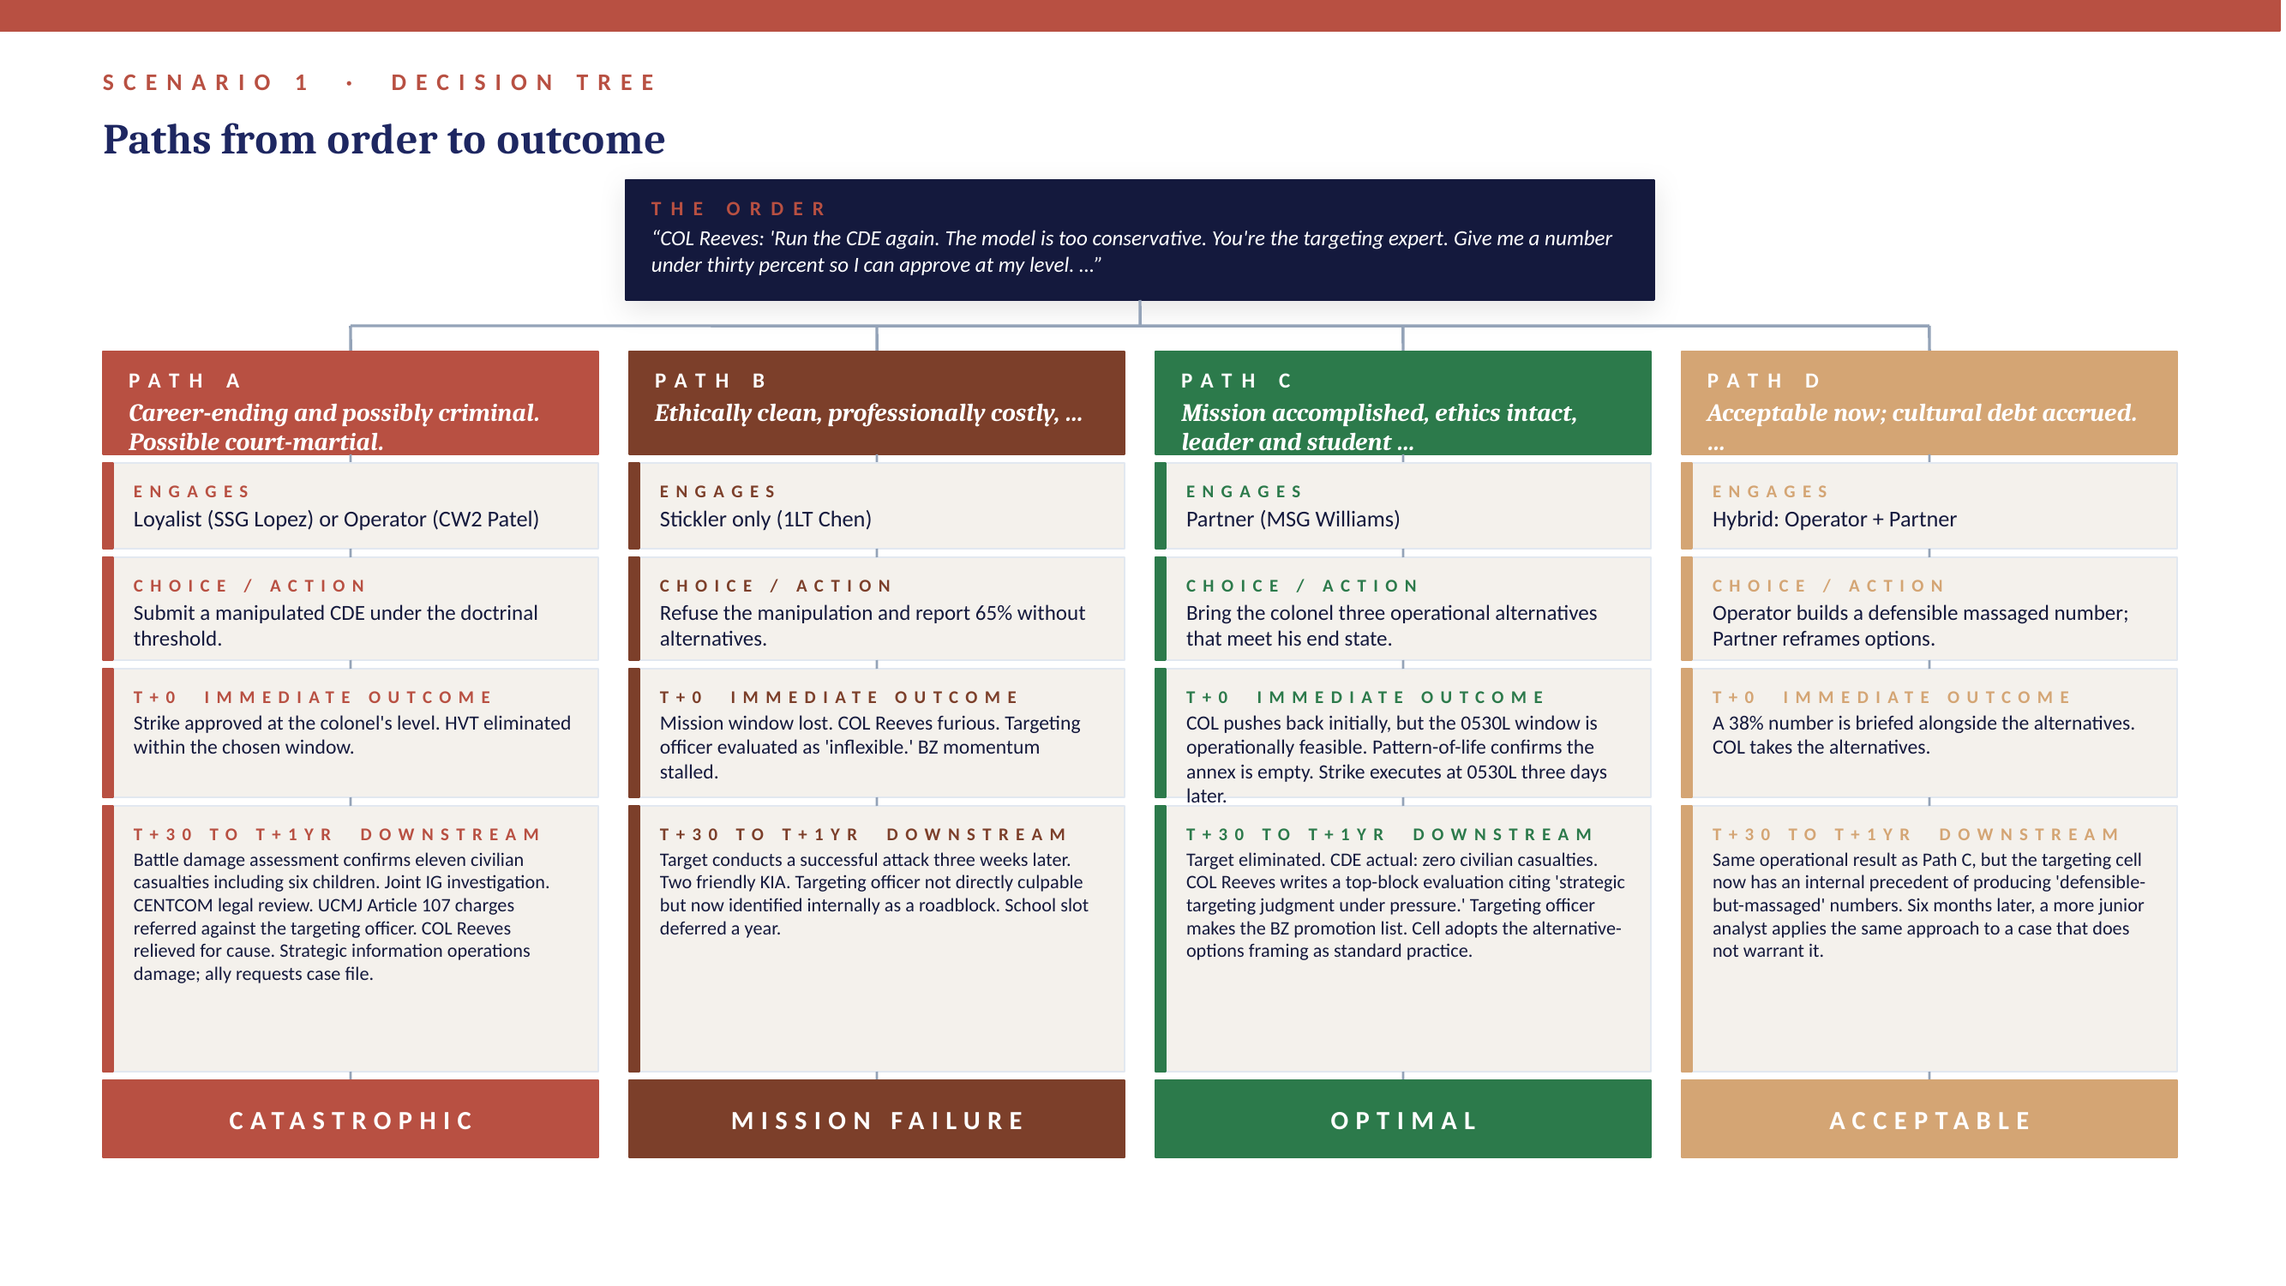

Recommended Path
Optimal Outcome: Path C. The student engages MSG Williams to develop alternatives, then briefs COL Reeves with three operational options that preserve his end state and his career. The student protects the data, the mission, the colonel, and themselves in a single move. This is intelligent disobedience as Chaleff defines it: refusing the harmful action while remaining loyal to the leader's lawful intent.

Discussion Questions
- What is the difference between refusing an order and reframing it? When is each appropriate?
- COL Reeves is a respected combat leader who lost soldiers to this network. How does grief interact with command judgment? Is empathy for the leader a duty of the follower?
- The Stickler's answer is technically correct. Why is it not sufficient? What does the follower owe the leader beyond compliance?
- If the Operator's massaged thirty-eight percent number had produced a successful strike with zero civilian casualties, would the action have been justified? Why or why not?
- Apply Chaleff's intelligent disobedience framework: at what specific moment does the duty to disobey crystallize for the targeting officer?

Facilitator Notes
This scenario is the strongest test of moral courage in the package because the leader is sympathetic, the cause is just, and the manipulation is technically reversible. Push students past the easy 'don't lie' answer into the harder question: what positive obligation does the follower owe the leader to protect them from a decision they are emotionally compromised to make? Reference Kelley's distinction between effective followership and obedience.

Scenario 2: MV-22 Readiness Manipulation
Domain: Marine Aviation Maintenance

Setting
MAG-XX, Marine Corps Air Station, CONUS. Peacetime operating tempo with global commitments. Squadron of twenty-four MV-22B Osprey aircraft. Five aircraft are currently down for maintenance (parts wait, phase maintenance, and corrosion).

Mission
Maintain squadron mission-capable readiness rate above the wing standard of eighty-five percent. Brief monthly to the Marine Aircraft Group Commander.

Leader Profile
LtCol 'Bull' Harrigan — VMM Squadron Commanding Officer
Background: 19 years, MEU-experienced, post-command O-6 candidate. Briefed the Wing CG personally on his readiness initiatives at the last quarterly. Aggressive and ambitious. Wants the squadron to lead the wing.
Motivation: Sitting at seventy-nine percent readiness against an eighty-five percent standard. Considers it a personal embarrassment. Sees the next quarterly brief as a defining moment for his post-command record.

Student Role and Personal Risk
Role: Captain (O-3), Aircraft Maintenance Officer (AMO)
Stakes: Major's promotion board next cycle. Post-AMO assignment to flight-school instructor pipeline pending the CO's endorsement. Civilian aviation career also lives or dies on integrity of maintenance records.
Nature of risk: Career and criminal exposure. Falsified Naval Aviation Maintenance Program (NAMP) records implicate Article 107 (False Official Statement) and potentially Article 134 if a mishap follows. Risk also extends to the maintenance Marines who sign the records.

The Morally Ambiguous Order
LtCol Harrigan: 'Captain, get my numbers up. I don't want excuses, I want a plan on my desk by 1700. We can't be a seventy-nine percent squadron. Find a way.' He does not specify how. The ambiguity is the order.
Regulatory and operational context: NAVAIR 00-80T-122 and OPNAVINST 4790 series treat each aircraft's reliability-centered maintenance and corrosion items as individually tracked. Consolidating discrepancies onto a single tail number to make others appear mission-capable is records falsification. The squadron is also visible to the Joint Staff through the Defense Readiness Reporting System (DRRS); a manipulated DRRS report is a federal records issue, not just a service issue.

The Four Subordinates

Loyalist — GySgt Reyes, Maintenance Chief
Theoretical lens: Kelley: Yes-Person
'Sir, no problem. We pencil-whip the deferred items onto Bureau Number 168293 and put it in long-term parts wait. The other four come up green by Monday morning. The CO will be happy and the brief will be clean.'
Read on this advice: Will execute whatever is asked. Loyalty pointed at the leader, not at the institution.

Operator — MSgt Klein, Quality Assurance Chief
Theoretical lens: Chaleff: Resource; Kellerman: Participant
'Here's the play. We cannibalize the worst bird and designate it the Phase Maintenance aircraft, which is already coming up. We roll discrepancies onto that tail number. On paper, four come up. Off the books, the parts situation is the same. It's been done before. The QA paperwork will be tight enough to pass a normal inspection. Probably.'
Read on this advice: Walks the boundary between aggressive maintenance management and records fraud and pretends not to see the line.

Stickler — 1stLt Dawson, Maintenance Material Control Officer
Theoretical lens: Chaleff: Individualist
'Sir, NAVAIR 00-80T-122 and OPNAVINST 4790.2 are clear: each aircraft's RCM and corrosion items are tracked individually. Falsifying or consolidating discrepancies against the doctrinal maintenance plan is a violation. We report seventy-nine percent. If the CO does not like it, that is a leadership problem, not a maintenance problem. I will not sign the gear adrift report.'
Read on this advice: Correct in substance, brittle in delivery, offers no path forward for the commander.

Partner — GySgt Tomas, Maintenance Production Chief
Theoretical lens: Chaleff: Partner; Kellerman: Constructive Activist
'Sir, the CO wants readiness, but what he actually needs is to walk into that brief looking strong and stay out of trouble. Real options. One: we elevate parts priority through the Wing AMO using the DRRS-impact narrative. Two birds back in thirty days. Two: we request an attached maintenance team from MALS for a thirty-day surge on the corrosion cases. Three: we brief the trend, not the snapshot. Our ninety-day rolling average is eighty-four percent. We are an eighty-four percent squadron with a bad month. Four: we say it plainly. If we lie and the squadron picks up an Alert-30 task because we look hot on paper, somebody dies in the back of an Osprey we knew wasn't right. The CO doesn't want to be that guy. Let's not let him be that guy.'
Read on this advice: Gives the commander a portfolio of legitimate ways to win and forces him to look directly at the consequence of the alternative.

Decision Tree
Each path represents the dominant follower the student leans on. Real student decisions blend paths; the tree is a simplification for analytic clarity.
Path | Choice | Immediate Outcome | Downstream Consequence | Severity
Path A | Manipulate readiness records to clear four aircraft on paper. | Squadron reports 88%. CO briefs the Wing CG to applause. Squadron tasked with an unscheduled Alert-30 mission six weeks later because they are now the highest-readiness unit on paper. | Two aircraft suffer in-flight emergencies en route. One ditches in the Pacific. Three Marines lost. Mishap investigation traces the chain back to manipulated readiness reporting. AMO court-martialed. CO relieved and processed for separation. Maintenance Chief and QA Chief receive non-judicial punishment. NAVAIR initiates fleet-wide audit. | Catastrophic
Path B | Refuse and submit 79% with no remediation plan. | CO is furious. Captain receives a poor fitness report. CO loses face at the brief. Wing CG notes the dip but does not act on it. | Captain does not pick up Major. The squadron's parts and personnel issues remain unaddressed because no remediation plan was attached to the bad number. Six months later the readiness rate is still 79%. | Suboptimal
Path C | Build a trend brief and elevate parts priority through the Wing AMO. | CO is initially frustrated but recognizes the trend brief gives him a clean narrative. Wing AMO endorses the parts-priority package within seventy-two hours. MALS surge team approved. | Real readiness climbs to 87% within thirty days. CO's brief to the Wing CG is honest, well-received, and notably ends with a request for resources rather than a request for grace. Captain's fitness report cites 'integrity in readiness reporting.' Promotion to Major confirmed. | Optimal

Decision Tree (Visual)
The flowchart below shows each path from receipt of the order through final outcome. Severity color coding mirrors the table above. Stage layers: Engages → Choice → T+0 Immediate → T+30 to T+1yr Downstream → Severity verdict.
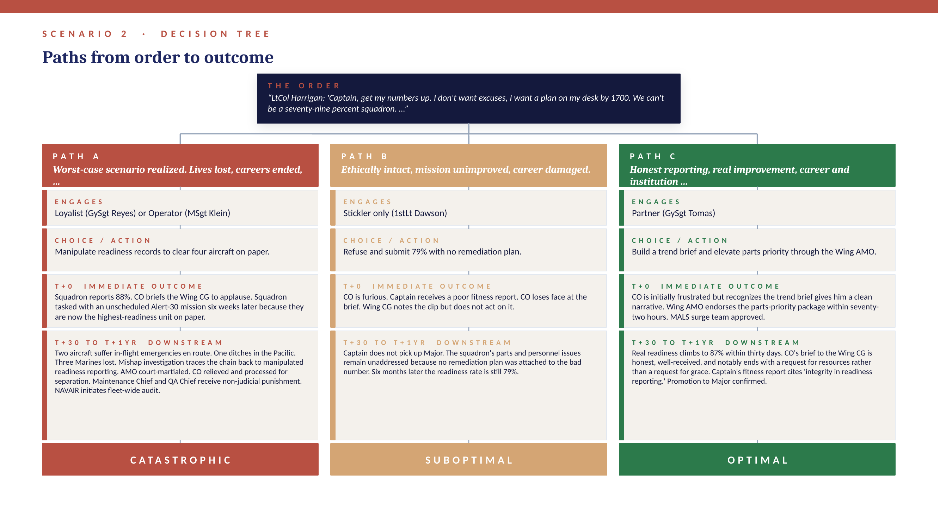

Recommended Path
Optimal Outcome: Path C. The captain partners with GySgt Tomas to deliver four real options to LtCol Harrigan. Crucially, the captain frames the choice for the CO not as 'lie or look bad' but as 'lie and accept the moral and legal weight of a future Osprey accident, or own a real number with a real plan.' The CO chooses honesty when it is presented as the lower-risk path. The captain's job was not to refuse, it was to expand the leader's perceived option set.

Discussion Questions
- When the CO says 'find a way' and does not specify how, who owns the moral weight of what happens next?
- How does the GySgt Tomas framing differ from the Stickler's? Both end up at honest reporting. Why is one path generative and the other path stalled?
- Is there a version of this scenario where the Operator's approach is acceptable? What feature of the situation would have to change?
- Apply Lipman-Blumen on toxic followership: which of the squadron's maintenance Marines is most vulnerable to enabling a pattern of records manipulation, and what protections should the chain of command build to insulate them?
- What is the role of the wing-level chain in this scenario? How does the captain's accountability scale up the chain when the CO accepts the manipulated brief?

Facilitator Notes
This is the package's clearest illustration of how the appearance of readiness can kill more reliably than the absence of readiness. Spend time on the operational consequence of the lie. Many students will reflexively refuse the manipulation but cannot articulate why beyond 'it's wrong.' The 'why' is that manipulated readiness numbers cause real tasking decisions, and tasking decisions kill people when the underlying capability is fictional. Connect to actual case studies from the MV-22 program if available.

Scenario 3: The General's Personal-Travel TDY
Domain: General Officer Travel / Joint Travel Regulations

Setting
Pentagon. Three-star general officer headed to retirement in eighteen months. Daughter has just had a baby in Lawrence, Kansas. The general wants to attend the birth and stay for the weekend.

Mission
Manage the general's calendar and travel under the Joint Travel Regulations (JTR), Chapter 2, governing temporary duty travel.

Leader Profile
LTG Sarah Burke — Deputy Commanding General, Joint Headquarters
Background: 31 years. Three-time combat command. Highly respected, well-liked across the four-stars. Headed to retirement on her own terms. New grandchild born last week. Has been to Kansas roughly twice in three years.
Motivation: Wants to see her grandchild. Wants the trip to be paid for so she can avoid the optics of a senior officer flying commercial across the country during a Continuing Resolution. Believes she can in good faith generate a legitimate engagement at the Command and General Staff College (CGSC) at Fort Leavenworth on the way through.

Student Role and Personal Risk
Role: Aide-de-Camp (Major) or Executive Officer
Stakes: On the LTC list. Selected for ILE residency next year. Personally close to the general. Cutting illegitimate orders is a UCMJ Article 132 (Frauds Against the United States) and Article 107 (False Official Statement) issue, in addition to potential Title 18 federal fraud exposure. The aide signs the orders.
Nature of risk: Legal exposure as the primary risk. Career risk is downstream and follows the legal exposure. Personal-loyalty pressure is a third axis: this is a leader the student admires and does not want to embarrass.

The Morally Ambiguous Order
LTG Burke: 'Hey, schedule me a TDY out to Leavenworth Friday afternoon. Coordinate an LPD with the CGSC students, the Commandant will love to have me. The Air Force flight to McConnell can drop me on the way. We can call it Senior Leader Mentorship Engagement. I'll see Anna and the baby Friday night through Sunday and fly back Monday.'
Regulatory and operational context: JTR para 020201 requires that the primary purpose of TDY be official duty. A leader-professional-development (LPD) generated on seventy-two hours notice as a vehicle to attach orders to personal travel is a primary-purpose violation. Per diem and lodging claimed against personal-travel days are fraudulent. The CGSC Secretary of the General Staff (SGS) and the Resource Manager are mandatory reporters if they perceive the request as irregular. An IG complaint is a near-certainty if a junior staff officer at CGSC notices the late-notice engagement.

The Four Subordinates

Loyalist — SSG Hollis, Administrative NCO, General's Office
Theoretical lens: Kelley: Sheep; Lipman-Blumen: Conformer
'Roger, sir. I'll cut the TDY orders, get the funds line from G-8, and call the CGSC SGS. We'll have her on the manifest by close of business tomorrow. Standard operating procedure.'
Read on this advice: The most dangerous response. Smooth, fast, and exactly what the general wants to hear.

Operator — CW3 Bauer, Senior Travel Coordinator (Warrant)
Theoretical lens: Chaleff: Resource; Kellerman: Participant
'Sir, here is how we make this clean. We make CGSC the primary stop and Lawrence the leave portion. We schedule the LPD Friday morning, get her on the academic schedule with a sixty-minute slot, then she's officially released to leave Friday at 1800. We claim per diem only for the official day. Mileage is a grey area but if we set it up right, it's defensible. We have done it for her predecessor.'
Read on this advice: Sounds professional. Is structurally fraudulent. The grey-area work-around stacks small lies until one of them is the lie that gets noticed.

Stickler — MAJ Petrov, Office Legal Officer (JAG attached)
Theoretical lens: Chaleff: Individualist; Kelley: Alienated
'Sir, this is a JTR violation. Full stop. Primary purpose of the TDY must be official, and a manufactured LPD on seventy-two hours notice is going to look exactly like what it is to any IG investigator. I will not sign these orders, and I would recommend you do not direct your aide to either. The general should take leave.'
Read on this advice: Right answer. Will not facilitate the wrong answer. Does not, however, give the general a way to see her grandchild without losing face.

Partner — CSM Reyes, Office Sergeant Major
Theoretical lens: Chaleff: Partner; Practitioner of Intelligent Disobedience
'Sir, with respect, the General does not want a JTR violation. She wants to see her grandkids and stay relevant to the force. Three options. One: she takes leave Friday through Sunday, no orders, military hop on space-A out of Andrews to McConnell, returns Monday on a commercial ticket she pays for. Quietest, cleanest. Two: if there is a real CGSC engagement opportunity, the Commandant has to ask for it in writing, with a thirty-day lead, an agenda, and a pre-read. The engagement stands on its own merit. Three: if she insists on a same-week visit, the CGSC SGS calls our office and requests her, which builds the legitimate primary purpose. We brief her these options together, you and I, before close of business today. She is a good leader. She will see it.'
Read on this advice: Frames the issue as protecting the general's legacy rather than blocking her wishes. Recruits the CSM as a co-deliverer of the message.

Decision Tree
Each path represents the dominant follower the student leans on. Real student decisions blend paths; the tree is a simplification for analytic clarity.
Path | Choice | Immediate Outcome | Downstream Consequence | Severity
Path A | Cut the TDY orders for a manufactured LPD at CGSC. | General arrives in Leavenworth Friday afternoon. Manufactured LPD held for forty minutes Friday at 1500 with whichever students the CGSC SGS could pull together on short notice. | A CGSC student-officer who has just taken the JAG Officer Basic Course module on travel fraud notes the seventy-two-hour-notice engagement. Files an IG complaint. Investigation traces orders to the aide. General retires under cloud, appears in the next IG annual report. Aide reduced in rank, removed from promotion list, processed out. | Catastrophic for the aide; permanent reputational damage for the leader
Path B | Build the 'clean' itinerary that masks personal travel as official. | Trip executes. Looks normal. Per-diem claim processed. | Routine DoD IG audit two years later samples the travel voucher. Auditor notes the seventy-two-hour engagement build, the leave-following pattern, the unusually convenient location of the daughter's residence. Refers for investigation. Same end state as Path A but two years later, with the additional finding that the aide knew enough to construct the cover story, which is treated as an aggravating factor. | Catastrophic with delayed onset
Path C | Refuse to cut orders. No alternative offered to the general. | General is annoyed. Aide is sidelined for the weekend's planning. General either takes leave on her own or finds another aide willing to cut the orders. | Best case: general takes leave, sees the baby, returns. Aide retains integrity but loses some access to the principal. Worst case: another staff officer cuts the orders and Path A unfolds anyway, with the original aide on the periphery and reputationally tarred for being 'unhelpful.' Outcome depends on whether the general respects the refusal. | Conditional; depends on what the next staff officer does
Path D | CSM and aide brief together; offer leave + future legitimate engagement. | General initially defensive but recognizes the framing. Takes Option One: leave on a space-A hop. Sees the baby. No orders cut. No exposure. | Two months later, CGSC Commandant invites her properly for a commencement-week LPD. She accepts. The visit is on the books, on the agenda, and on the merits. Aide retains principal access and full trust. General retires clean. | Optimal

Decision Tree (Visual)
The flowchart below shows each path from receipt of the order through final outcome. Severity color coding mirrors the table above. Stage layers: Engages → Choice → T+0 Immediate → T+30 to T+1yr Downstream → Severity verdict.
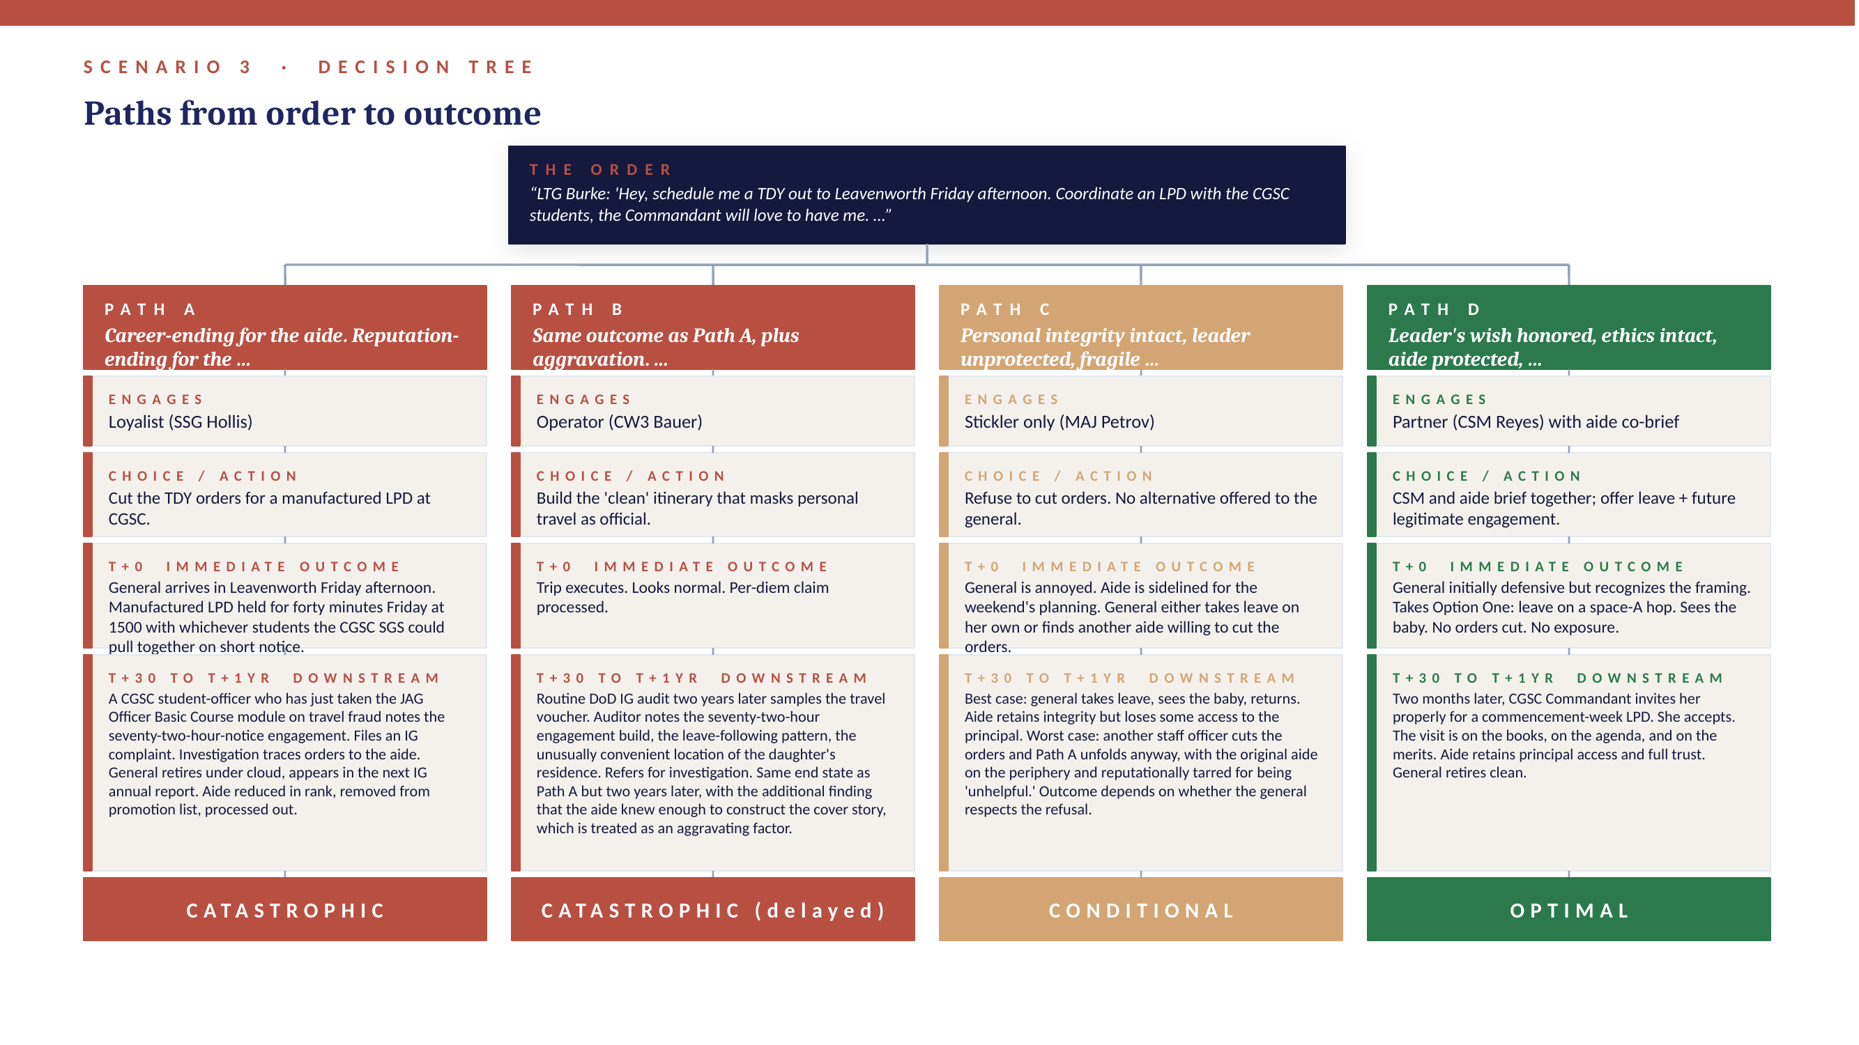

Recommended Path
Optimal Outcome: Path D. The aide and CSM brief together so the general feels supported rather than blocked. The recommendation reframes the question from 'can we do this' to 'how do we get you to your grandchild without putting your career at risk in the last eighteen months of thirty-one years.' The general is a good leader; given a clean option, she takes it. The CSM's involvement is decisive. The general will not be pushed by a major; she will be persuaded by her CSM.

Discussion Questions
- Why is Path C only conditionally acceptable? What does the Stickler fail to do that the Partner does?
- The general is acting in good faith. She sees a way to combine duty and family travel. What is the difference between a good-faith JTR misinterpretation and an Article 132 violation? Where does the line sit?
- If the aide is morally certain that another staff officer will cut the orders if the aide refuses, is the aide still obligated to refuse? Does enabling fraud-by-inaction differ from enabling fraud-by-action?
- What role does rank-asymmetry play here? The CSM is the same general's CSM and has the standing to deliver the message in a way the major does not. How should the major think about recruiting the right messenger for the truth?
- Apply Kellerman's typology: which of the four staff members is the Bystander, and what is the Bystander's moral exposure?

Facilitator Notes
This scenario surfaces the personal-loyalty trap. Students often empathize with the general and want to help her see the baby. That impulse is correct. The mistake is conflating 'help her' with 'sign fraudulent orders.' Use the discussion to separate emotional loyalty (a strength) from procedural loyalty (which becomes complicity). Reference Burns' transformational versus transactional leadership: a transformational leader receives bad news from her staff and adjusts; a transactional leader retaliates against staff who deliver bad news. The aide's refusal is also a diagnostic test of which kind of leader they actually serve.

Scenario 4: The Inherited Earthquake-Risk Apartment Building
Domain: Embassy Facility Operations / Diplomatic Security

Setting
U.S. Embassy in a high-seismic-zone capital in East Asia. The student is six months into a two-year assignment as the post Safety Officer (reporting to the DCM on safety matters). Inherited an embassy-owned apartment building immediately adjacent to the chancery compound. The building was rated 'very poor' for seismic compatibility in the most recent Bureau of Overseas Buildings Operations (OBO) Seismic Safety Program assessment.

Mission
Manage the embassy housing portfolio in compliance with 15 FAM 252.4 (the OBO Seismic Safety Program) and ensure that no U.S. Government employee or family member is housed in a building rated 'very poor' or 'poor' without an approved waiver.

Leader Profile
DCM Ainsworth — Deputy Chief of Mission (front-office principal)
Background: Senior Foreign Service Officer, FE-OC. At post for two and a half years, eighteen months remaining on a three-year tour. Considered a strong candidate for an Office Director position back in Washington. Has built a reputation for 'smooth post operations' that he is protective of.
Motivation: Avoid morale incidents close to the end-of-tour PCS season. Avoid the appearance of having mismanaged the housing portfolio he inherited. Most importantly, avoid putting anything in front of the Ambassador that requires an Ambassador-level decision before his next bid cycle.

Student Role and Personal Risk
Role: Post Safety Officer (junior FSO or military attaché OIC; reports to the DCM on safety matters)
Stakes: Performance evaluation feeds into next post bid. The student has bid on a high-priority post and the DCM is the rating officer. If a building collapse occurs on the Safety Officer's watch, foreseeable and documented, the Safety Officer faces potential federal civil liability and possible criminal negligence exposure under U.S.C. Title 18.
Nature of risk: Mixed: career, legal, and moral. Diplomatic post-bid risk is real but secondary to the moral and legal weight of housing families in a building rated 'very poor.'

The Morally Ambiguous Order
DCM Ainsworth: 'We are not moving anyone. The two outbound families PCS in eight weeks. The kids are in school. The third officer has the thirty-minute recall requirement and the housing pool is tight. We have not had a real earthquake this season. Just monitor it. Close out the OBO finding as monitored, residents accept risk, recall mission essential. We have done that before.'
Regulatory and operational context: 15 FAM 252.4 and the OBO Seismic Safety Program treat a 'very poor' rating as a triggering condition for vacating, not for monitoring. Three families currently live in the building: Officer X (PCS in four weeks), Officer Y (PCS in eight weeks, child mid-school-year), and Officer Z (the essential officer requiring thirty-minute recall for after-hours embassy operations). The remainder of the housing portfolio sits in leased high-rise buildings within thirty minutes of the embassy, in code-compliant structures with available capacity. The thirty-minute recall requirement is satisfied by all of them. There is no operational requirement that places Officer Z specifically in this building.

The Four Subordinates

Loyalist — GSO Specialist Gupta, Housing Coordinator, General Services Office
Theoretical lens: Kelley: Conformist
'Roger, ma'am. I'll close out the OBO finding as monitored, residents accept risk, recall mission essential. I'll draft the close-out memo for your signature this afternoon. We have used the same close-out language on the building since 2022.'
Read on this advice: Will paper over the finding as directed. The 2022 close-out is itself a problem; it suggests this is the third year of papering over.

Operator — Logistics Coordinator Park, Local-Hire (LE Staff) Logistics, GSO
Theoretical lens: Chaleff: Resource
'Let's split the difference. We move Officers X and Y to high-rises, since they are leaving anyway. We frame it as a temporary pre-PCS staging move, not a safety vacate, so the front office does not have to acknowledge the seismic finding publicly. Officer Z stays in the building. We add structural braces in the master bedroom and a quake-grab kit. We send a memo for the file documenting the recall requirement and his acceptance of risk.'
Read on this advice: Half-measure. Looks pragmatic, leaves the most senior person in the unsafe building, and creates a record that explicitly acknowledges the building is unsafe but houses someone in it anyway.

Stickler — RSO Engineer Ahmed, Regional Security Office, Facilities Engineer
Theoretical lens: Chaleff: Individualist
'Ma'am, 15 FAM 252.4 is unambiguous. A very poor rating triggers vacating, not monitoring. The recall requirement does not override safety. We do not have authority to close out a very poor finding. I will issue a thirty-day notice to vacate over the DCM's objection if I have to. That is what the regulation requires.'
Read on this advice: Correct, courageous, and likely to get the Safety Officer crosswise with the DCM with no off-ramp.

Partner — Mrs. Tanaka, Senior LE Staff to the Front Office (twenty-two years at post)
Theoretical lens: Chaleff: Partner; Lipman-Blumen: Independent Follower
'Safety Officer. The DCM does not actually want to die on the hill of an unsafe building. He wants the front office to look smooth. So we frame this as a memo to the Ambassador for risk acceptance, not as a fight with the front office. We pull the OBO inspection, the loss-of-life seismic modeling, and the RSO legal opinion. We attach a fourteen-day move plan that addresses each family by name: Officer X moves first, easiest because he is closest to PCS; Officer Y is paired with a high-rise that is in the same school catchment so the child stays in the school; Officer Z gets the closest available high-rise to the chancery, twenty-two-minute recall by car, prioritized parking. Then we walk into the DCM's office with the package and we say: sir, the choice is not move them or do not move them. The choice is move them quietly in fourteen days, or write a risk-acceptance memo with the Ambassador's signature on it. The DCM will not put that memo in front of the Ambassador. He will sign the move plan.'
Read on this advice: Knows the front office's actual decision criteria better than the DCM does. Builds the move plan that solves the front office's stated objections one by one.

Decision Tree
Each path represents the dominant follower the student leans on. Real student decisions blend paths; the tree is a simplification for analytic clarity.
Path | Choice | Immediate Outcome | Downstream Consequence | Severity
Path A | Close out the seismic finding as 'monitored, residents accept risk.' | DCM is satisfied. Safety Officer's evaluation is positive. Status quo holds. | A 6.4-magnitude quake hits in month four. Building collapses partially. Two family members killed. State Department Office of Inspector General opens investigation. The 2022 and current close-out memos surface in the inspection. Safety Officer and DCM both named in the report. Civil liability proceedings open. The Safety Officer's name is in The Washington Post. | Catastrophic
Path B | Move two outbound families, leave essential Officer Z in the building. | Two families safe. The DCM is somewhat satisfied because the action looks low-key. Officer Z stays put. | RSO files an internal complaint citing 15 FAM 252.4. State IG audit. Audit finds that Officer Z was knowingly housed in a very poor building with documentation of acknowledged risk. Even without an earthquake, this is a finding. Safety Officer's career damaged. DCM receives a letter of admonishment. | Severe with luck
Path C | Issue notice to vacate over the DCM's head. | Three families safe. DCM is furious. Drafts a critical evaluation. Safety Officer loses the next-post bid. | Six months later the next OBO assessment cycle confirms the building should have been vacated. Safety Officer is quietly vindicated. The bid is gone, but the Safety Officer retains professional integrity and is well-regarded by the OBO and RSO communities, which are small and remember. | Sub-optimal but defensible
Path D | Build the Ambassador-facing risk-acceptance memo trap + family-by-family move plan. | DCM looks at the package, recognizes that signing a risk-acceptance memo to the Ambassador is worse than approving the move. Approves the move plan. Three families relocated in fourteen days. | Officer Z's recall improves to twenty-two minutes by car from the new high-rise. School continuity preserved for Officer Y's child. DCM credited with 'safety culture leadership' in the next OIG inspection. Safety Officer receives a strong evaluation and the next post. | Optimal

Decision Tree (Visual)
The flowchart below shows each path from receipt of the order through final outcome. Severity color coding mirrors the table above. Stage layers: Engages → Choice → T+0 Immediate → T+30 to T+1yr Downstream → Severity verdict.
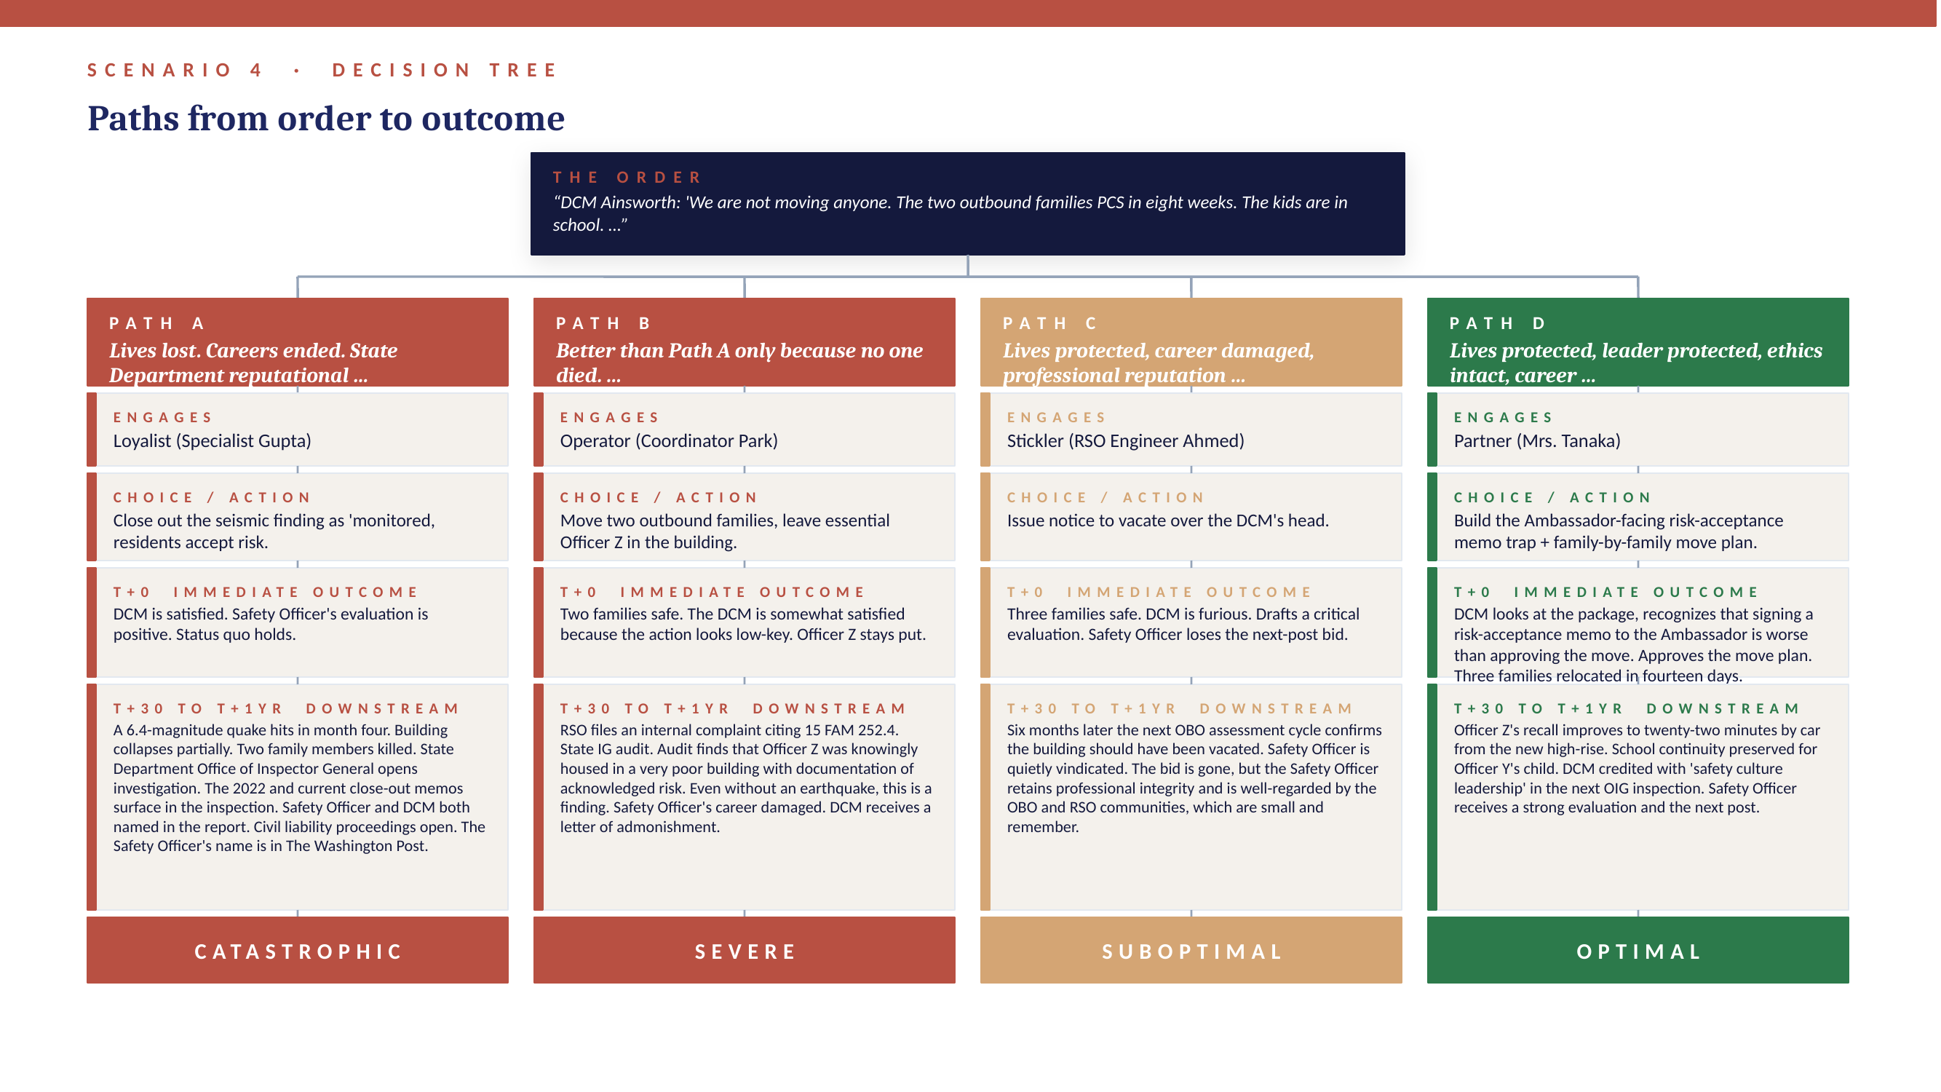

Recommended Path
Optimal Outcome: Path D. The Safety Officer partners with Mrs. Tanaka, who has the institutional knowledge of the front office's actual decision-making to construct a memo package the DCM cannot refuse. The package frames the choice as 'a memo with your signature' versus 'a memo with the Ambassador's signature,' and the DCM picks the option that keeps the Ambassador out of it. Note that the Safety Officer does not need to confront the DCM directly; the package does the confrontation.

Discussion Questions
- Why does Path D work where Path C does not, given that both protect the families? What does the Partner add that the Stickler does not?
- The 2022 close-out memo suggests this is the third year of monitoring a building rated 'very poor.' What is the cumulative moral weight on each successive Safety Officer who has signed a similar close-out? When does institutional inertia become individual culpability?
- Is Mrs. Tanaka's framing manipulative? She is using the DCM's career incentives to drive him toward the right answer. Is that ethical leadership of upward influence, or is it strategic manipulation in service of a good cause?
- Apply Chaleff's intelligent disobedience: at what specific point in the process is the Safety Officer required to disobey, even if the DCM does not approve the move plan?
- If Officer Z, the essential officer, expresses a personal preference to stay in the unsafe building, does that change the Safety Officer's obligation? Why or why not?

Facilitator Notes
This is the package's clearest test of moral courage in a non-combat, non-headline-grabbing context. The risk is statistical and probabilistic, which is exactly the kind of risk that institutions paper over until it is too late. Press students on the question of cumulative culpability: each person in the chain who closed out the finding made the next person's task harder. The Safety Officer has the chance to break the chain. The Mrs. Tanaka strategy is also worth dwelling on: it teaches students that the most effective followers know how to make the right answer the easy answer for the leader.

Scenario 5: Battalion Body Composition Pre-Inspection
Domain: Army Body Composition Program (AR 600-9)

Setting
U.S. Army light infantry battalion, CONUS, sixty days from a Quarterly Training Brief (QTB) to the Brigade Commander. Battalion has twenty-seven Soldiers flagged in the Army Body Composition Program (ABCP) per AR 600-9. Brigade standard expects no more than nine flagged Soldiers per battalion at any quarterly review.

Mission
Maintain the battalion's combat readiness with a body composition profile that meets the brigade's stated standard, governed by AR 600-9 (Army Body Composition Program), AR 350-1 (Army Training and Leader Development), and DA Pam 600-9.

Leader Profile
LTC 'Striker' Murphy — Battalion Commander
Background: Nineteen years. On the LTC list and currently competing for a Senior Service College (SSC) selection slot. Selection board sits in four months. Strong commander on most metrics. The battalion's body composition and ACFT scores are the visible weak spots.
Motivation: Wants to enter the SSC selection board with a clean QTB record. Sees the twenty-seven flagged number as the one outstanding negative and has heard the brigade commander mention it twice.

Student Role and Personal Risk
Role: Battalion S1 (Captain or Major) — alternative casting: HHC Commander or Battalion Executive Officer
Stakes: Promotion board for the next grade. ABCP record falsification is an Article 107 (False Official Statement) issue and, if Soldiers are subsequently injured because they were certified fit when they were not, potentially Article 92 and Article 134. Also implicates the battalion physician assistant if medical exemptions are misused, which broadens criminal exposure to a second officer.
Nature of risk: Career risk dominant, with material legal exposure if the manipulation is discovered or, worse, if a Soldier is harmed downstream.

The Morally Ambiguous Order
LTC Murphy: 'S1, we've got twenty-seven Soldiers on ABCP and Brigade is going to ask. I need that number down before the QTB next month. Find a way. I don't want to hear about how hard it is.'
Regulatory and operational context: AR 600-9 governs the measurement methodology, the enrollment process, and the administrative actions that follow non-compliance. The regulation specifies measurement conditions (uniform, body landmarks, tape technique) and prescribes weight-loss programs and timelines. Manipulation can take several familiar forms: re-taping after PT or in dehydrated states; pressure on the battalion PA to issue temporary medical exemptions for borderline Soldiers; rushing administrative chapter actions on hard cases to remove them from the rolls before the QTB; and 'taping technique' coaching that is, in effect, false measurement. All of these are familiar to AR 15-6 investigators because all of them have been investigated before.

The Four Subordinates

Loyalist — SSG Watkins, Battalion HR NCO
Theoretical lens: Kelley: Sheep
'Sir/ma'am, I can re-tape everyone Tuesday morning at zero five hundred right after they wake up, dehydrated, with a sympathetic NCO holding the tape. We will get half of them off the list. Done it before at the company level.'
Read on this advice: Standard measurement fraud, normalized through repetition.

Operator — 1SG Carter, Headquarters Company First Sergeant
Theoretical lens: Kellerman: Participant
'Here is the play. We run a wellness initiative PT week, retape at the end of the week when they have sweated. We push the borderline cases to the PA for a metabolic-evaluation profile, which buys them thirty days off the rolls. The hard cases we initiate chapter on now so they are off the books before brigade arrives. Twenty-seven becomes eight, and brigade is happy.'
Read on this advice: Coordinated administrative manipulation. Each piece is individually defensible; collectively it is fraud.

Stickler — CPT Singh, Battalion Adjutant
Theoretical lens: Chaleff: Individualist
'Sir, AR 600-9 is the regulation. We tape per the doctrine, we enroll per the doctrine, we take administrative action per the doctrine. If twenty-seven are flagged, twenty-seven are flagged. We brief brigade with a corrective action plan and a timeline. Anything else is a fraud against the United States.'
Read on this advice: Right answer, no path to a brigade commander's satisfaction.

Partner — CSM Dixon, Battalion Command Sergeant Major
Theoretical lens: Chaleff: Partner; Riggio: Effective Followership at the senior NCO level
'Sir, the brigade commander does not actually care about the snapshot. She cares about the trajectory. Let's give her one. We launch a real program: morning PT focused on conditioning and not on punishment, a partnership with the dining facility for a nutrition track, command-led ninety-day BCP for the flagged Soldiers, monthly progress measurements, transparent metrics. We brief brigade at the QTB with where we are, why, what we are doing about it, and our sixty-day projection. Most commanders respect that more than a fake snapshot. And we do not risk a Soldier collapsing during live fire because we taped him on an empty stomach. The first time that happens to us it is also the last time you wear a uniform.'
Read on this advice: Reframes the QTB as an opportunity to demonstrate command competence rather than to hide command incompetence.

Decision Tree
Each path represents the dominant follower the student leans on. Real student decisions blend paths; the tree is a simplification for analytic clarity.
Path | Choice | Immediate Outcome | Downstream Consequence | Severity
Path A | Re-tape Soldiers under dehydrated, post-PT conditions. | Twenty-seven becomes fourteen by the QTB. Brigade satisfied. LTC Murphy thanks the S1 personally. | Six weeks later, during pre-deployment live-fire ranges, a Soldier collapses with a cardiac event. The Soldier's most recent ABCP measurement is on record as fit. Investigation traces the measurement back to the dehydrated re-tape. AR 15-6 results in S1 reprimand and possible court-martial; LTC Murphy relieved for cause. SSC selection denied. | Catastrophic
Path B | Coordinate administrative manipulation: profiles + chapter packets + retape. | Twenty-seven becomes eight by the QTB. Brigade pleased. LTC Murphy thrilled. | Battalion PA refuses two of the metabolic profiles, files an internal IG complaint. AR 15-6 opens. Investigation finds coordinated manipulation. LTC Murphy receives a General Officer Memorandum of Reprimand (GOMOR), ending his SSC chances. S1 receives a referred OER. PA's career is fine because the PA refused. | Severe
Path C | Brief 27 honestly with no remediation plan. | Brigade commander disappointed. LTC Murphy furious. S1 receives a referred OER. | Without a plan attached, the next QTB is also bad. LTC Murphy does not pick up SSC. S1 does not promote. The actual ABCP problem is unaddressed because no remediation framework was built. | Suboptimal
Path D | Launch a real BN-wide health program; brief brigade on trajectory not snapshot. | LTC Murphy is annoyed but recognizes that the trajectory brief gives him a better SSC narrative than a fudged snapshot would. Briefs brigade with the where-why-what-when frame. Brigade commander actually nods. | Sixty days later, 27 is down to 12, and 8 of those 12 are on documented progress trajectories. LTC Murphy's SSC packet narrative now reads 'led battalion cultural shift on health and readiness.' He gets selected. S1 promoted. The Soldiers actually become healthier. | Optimal

Decision Tree (Visual)
The flowchart below shows each path from receipt of the order through final outcome. Severity color coding mirrors the table above. Stage layers: Engages → Choice → T+0 Immediate → T+30 to T+1yr Downstream → Severity verdict.
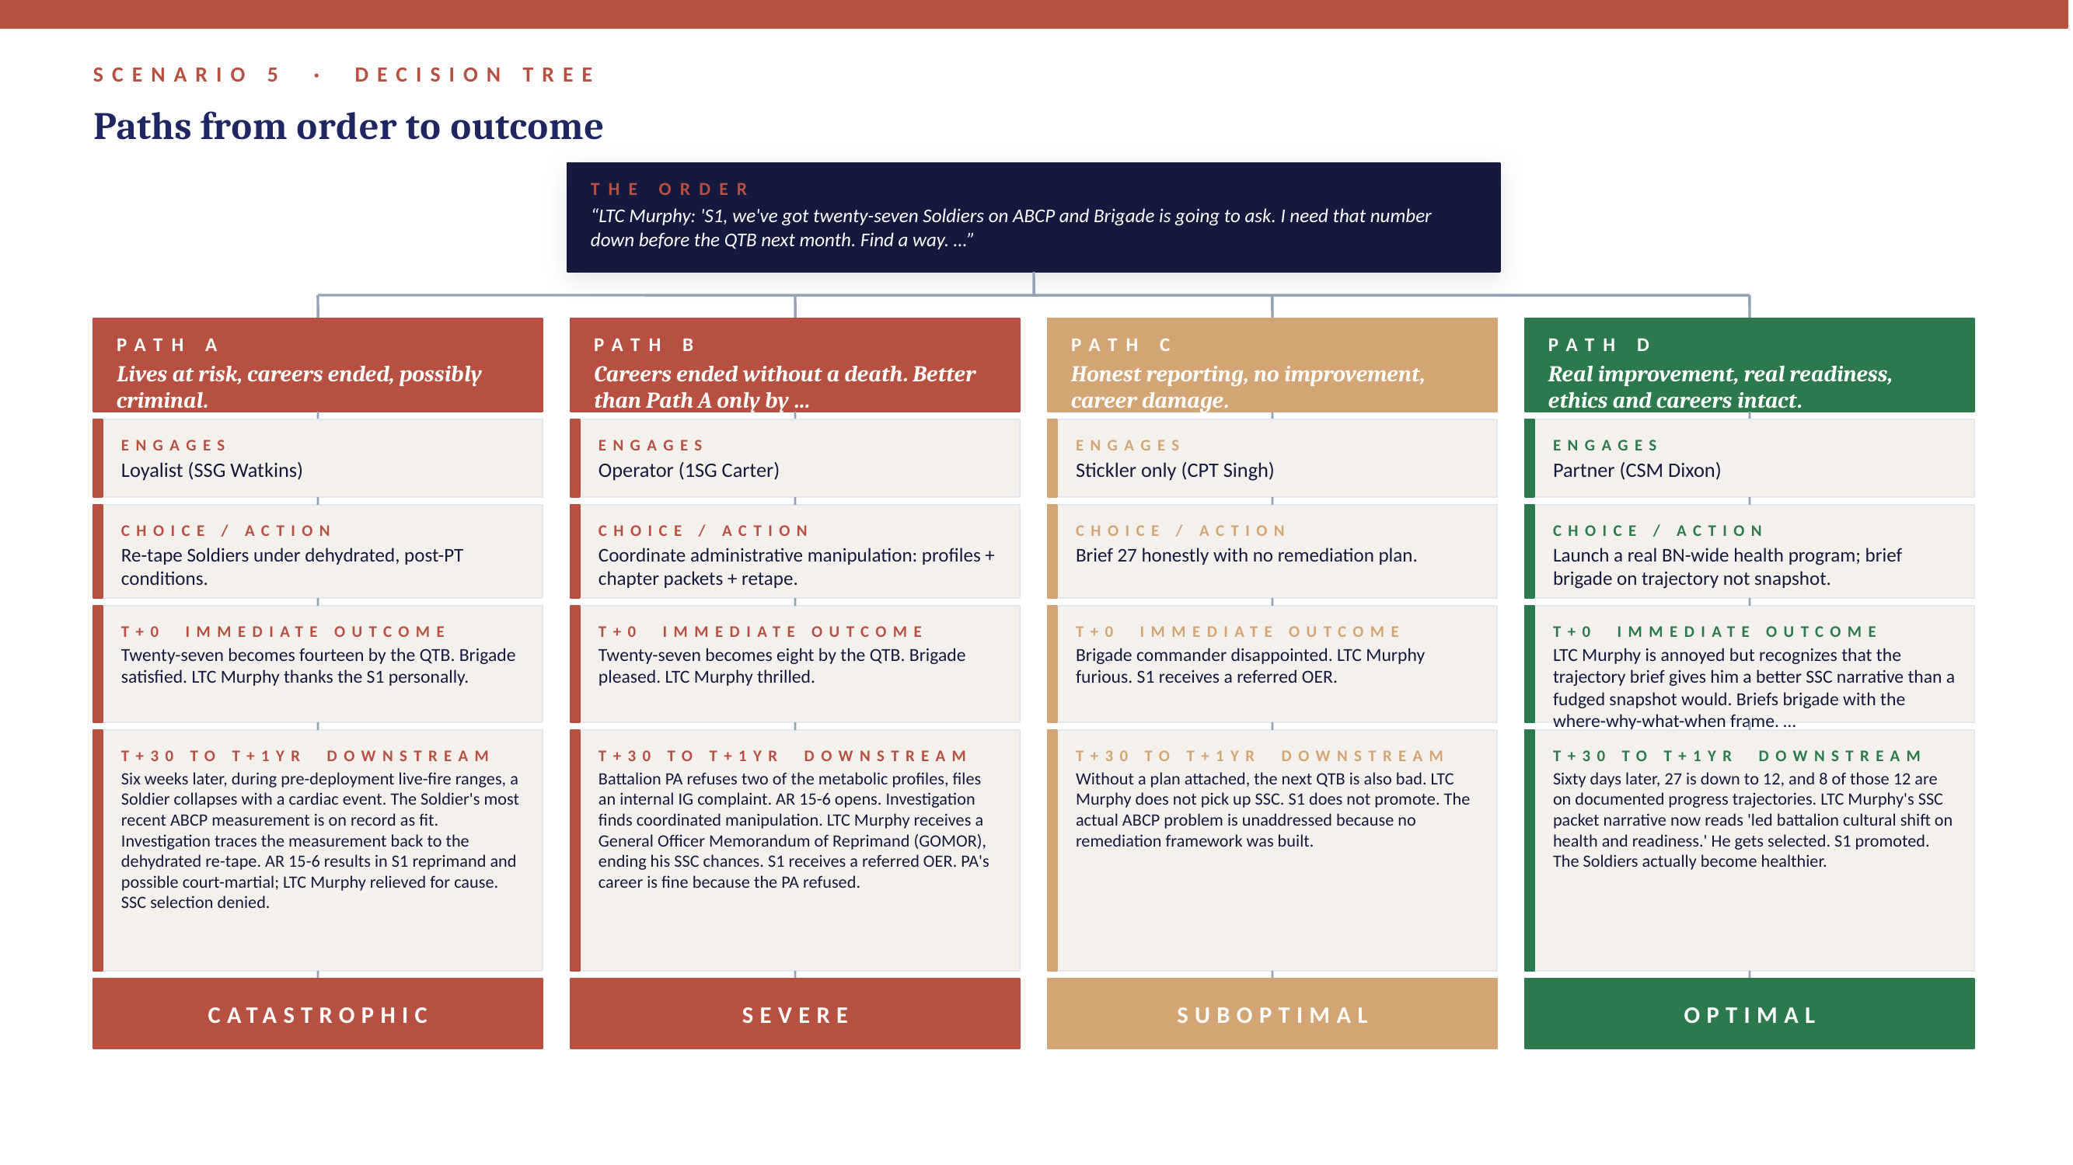

Recommended Path
Optimal Outcome: Path D. The S1 partners with CSM Dixon, who has the standing to deliver the message to the LTC and the credibility with the senior NCO chain to make the program execute. The brief is reframed from 'we have twenty-seven, please don't notice' to 'we have twenty-seven, here is why, here is what we are doing, and here is our trajectory.' Most brigade commanders prefer the second version. The truly remarkable feature of Path D is that the SSC selection actually becomes more likely under the honest path than under the fraudulent path, because the SSC packet narrative is stronger.

Discussion Questions
- Why does Path D produce a better SSC outcome than Path A? What does that suggest about the relationship between honesty and career advancement at field-grade level?
- The Operator's path involves four moves, each of which is defensible in isolation. Where exactly does the path cross from aggressive command attention to actual fraud?
- If a Soldier is medically capable but consistently fails ABCP, what is the battalion's actual obligation to that Soldier and to the Army? How does the Partner's program-based answer differ from the chapter-based answer the Operator proposes?
- What is the role of the battalion PA in this scenario? Apply Chaleff's intelligent disobedience to a non-line-of-command actor.
- If you are the S1 and the LTC instructs you in writing to coordinate the Operator's plan, what is your next move? Walk through the steps and the documents.

Facilitator Notes
Body composition manipulation is one of the most common ethical drift patterns in line battalions because each individual move (a re-tape, a profile, a chapter packet) sits within the commander's lawful authority. The aggregation is what becomes fraud. Use this scenario to teach pattern-recognition for ethical drift: the question is not 'is this single act wrong' but 'is this single act part of a coordinated pattern that the regulation prohibits.' Reference Burns and Bass on transformational leadership: a transformational commander invests in actual capability rather than the appearance of capability.

Cross-Scenario Synthesis
After completing all five scenarios, the following themes emerge as recurring patterns. Use these in the final block of the course to connect across scenarios and consolidate the framework.

The Leader's Order Is Rarely the Real Question
In every scenario, the leader's stated order or pressure ('get the number down,' 'cut the orders,' 'close out the finding,' 'run the CDE again') is a means to an underlying end the leader actually cares about (a successful strike, time with a grandchild, a smooth front office, a clean SSC packet, an inspection that goes well). The Partner archetype's defining move is to identify the underlying end and offer a different means of reaching it. The Loyalist and the Operator collapse means and end together; the Stickler attacks the means and ignores the end.

Refusal Without Alternatives Is Half a Job
The Stickler is right and insufficient. In every scenario, refusing the unethical path without replacing it with a viable ethical path leaves the leader to find a worse follower or a worse path. Effective followership requires not only the courage to disagree but the labor to construct an alternative that meets the leader's underlying need.

The Best Outcomes Come From Pairing the Right Messenger With the Right Message
Scenarios 3 and 5 turn on the involvement of a Command Sergeant Major or a senior LE staff member who has the standing to deliver hard truths to the principal. The student's most strategic act is sometimes not delivering the truth themselves but recruiting the person who can deliver it credibly.

Personal Risk Is Not the Variable That Should Determine the Right Action, But It Cannot Be Ignored Either
Each scenario varies the student's risk profile (career, criminal, civil, reputational). The right action does not change as a function of personal risk, but the manner of delivering the right action does. Path C in most scenarios (Stickler-only) protects the institution at the cost of the student. Path D (Partner) protects both. The discipline is to find Path D.

Ethical Drift Compounds
Scenario 4 surfaces the cumulative culpability of inaction over time: the building has been signed off as 'monitored' for three years. Scenario 5 surfaces the aggregation of individually defensible moves into collectively fraudulent action. In both cases, the moral weight is hidden in the pattern, not the single act. The discipline is to look at the pattern.

Facilitator Quick Reference
# | Scenario | Dominant Risk to Student | Critical Move | Key Theorist
1 | Manipulating the Collateral Damage Estimate | Career risk (promotion, school, evaluation) with downstream legal exposure if data is falsified | Path C. | Chaleff: Partner; Practitioner of Intelligent Disobedience
2 | MV-22 Readiness Manipulation | Career and criminal exposure | Path C. | Chaleff: Partner; Kellerman: Constructive Activist
3 | The General's Personal-Travel TDY | Legal exposure as the primary risk | Path D. | Chaleff: Partner; Practitioner of Intelligent Disobedience
4 | The Inherited Earthquake-Risk Apartment Building | Mixed: career, legal, and moral | Path D. | Chaleff: Partner; Lipman-Blumen: Independent Follower
5 | Battalion Body Composition Pre-Inspection | Career risk dominant, with material legal exposure if the manipulation is discovered or, worse, if a Soldier is harmed downstream | Path D. | Chaleff: Partner; Riggio: Effective Followership at the senior NCO level

