[Linux Setup](http://192.168.1.4:8090/display/TS/Linux+Setup)

* Created by [Steven Boland](http://192.168.1.4:8090/display/~steven), last modified on [Apr 17, 2018](http://192.168.1.4:8090/pages/diffpagesbyversion.action?pageId=12386307&selectedPageVersions=17&selectedPageVersions=18)

Here is a placeholder page to setup Linux specifically Ubuntu 16.04 on Windows using Virtual Box

Download VirtualBox from here

<http://www.oracle.com/technetwork/server-storage/virtualbox/downloads/index.html#vbox>

or get from Z:\Technology\Software\VirtualBox-5.2.8-121009-Win.exe

Follow all prompts

Next, download Ubuntu 16.04 from here

<https://www.ubuntu.com/download/desktop>

or get from Z:\Technology\Software\ubuntu-16.04.3-desktop-amd64.iso

Finally, here is great web site that instructs how to Install Ubuntu inside Windows using VirtualBox

<http://www.psychocats.net/ubuntu/virtualbox>

Launch Virtualbox

New

Ubuntu | Linux | Ubuntu (64-bit)

Next

Memory size

Suggested 4GB (4,096MB) if you have 16GB total RAM

Next

Create Virtual Machine

choose Create new hard disk

Create

Hard disk file type

VDI (VirtualBox Disk Image)

Next

Storage on physical hard disk

IMPORTANT ensure you choose "Fixed size"

Next

file location and size

Ubuntu

Select the size of the virtual hard disk in megabytes

Suggested 20GB on C:\ drive if you can afford   
i.e. try to increase beyond the default 10GB as is easier to run out-of-disk space after the fact  
and with being "Fixed size" it does not seem possible / obvious to increase storage afterwards

Create

Click **Create** and wait for the virtual hard drive to be created.   
This is actually just a very large file that lives inside of your Windows installation.

The next thing to do to make the (currently blank) virtual hard drive use the Ubuntu disk image (the .iso) downloaded previously

First, copy the ISO file from Z:\Technology\Software\ubuntu-16.04.3-desktop-amd64.iso to where VirtualBox created VM

e.g.

C:\Users\sboland\VirtualBox VMs\Ubuntu\

Note : technically speaking don't need to do this but may be good idea if you have Solid State Disk (SSD) for C:\ drive  
and you have enough storage space here

Click on **Settings** and **Storage**.

Click "Empty"

Click the icon next to the "Optical Drive" IDE Secondary, Master

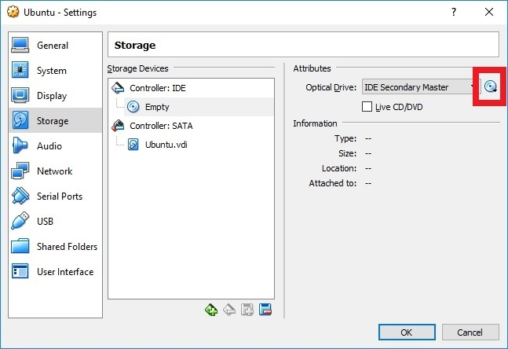

Navigate to the ubuntu-16.04.3-desktop-amd64.iso file

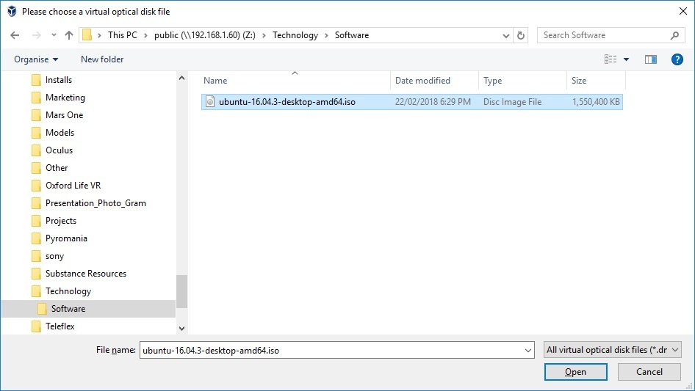

Open | OK

Double click Ubuntu virtual machine to start it up

Wait for Ubuntu to boot up

Choose Install Ubuntu when prompted

Preparing to install Ubuntu, I choose both options here

Download updates while installing Ubuntu

Install third-party software for graphics and Wi-Fi hardware, Flash, MP3 and other media

Continue

Installation type

Erase disk and install Ubuntu

Install Now

configure location, keyboard type

enter your name / computer name / username / password

Note : if you are new to Linux, the username will also be the name of your $HOME directory

e.g.

/home/username

Restart the computer once prompted after installation is complete

Once signed into Ubuntu, check that you have Internet connection  
In theory there should be no additional configuration here as should use the wired network connection from desktop PC

Verify

Settings (top right hand side)

System Settings

Network | Wired

Launch Firefox browser and navigate to any website to also confirm that you have Internet connectivity

**GOOGLE CHROME**

By default Google Chrome is not installed.  Launch Firefox and Google "download Google Chrome"

Important : downlaod and Save File to your Downloads folder /home/<username>/Downloads  
  
Now as this is a "fresh" installation of Ubuntu, it is quite possible that dependent packages are not installed

Therefore, it can be a good idea to manaully install software via the Terminal becuase if the install fails then you will be notified what dependent packages are missing!

e.g.

Launch Terminal => click Ubuntu icon top right (Ubuntu home) and type Terminal.

Once displayed in the side bar you may want to right click and choose "Lock to Launcher"

Type if the following commands

cd  
cd Downloads  
sudo dpkg -i google-chrome-stable_amd64.deb

<enter password>

If this fails then determine what dependent package is not installed

e.g.

libappindicator1

Therefore type in the following commands

sudo apt-get update  
sudo apt-get -f install

OR you manually install and dependent packages individually  
e.g.  
sudo apt-get install libappindicator1

sudo apt-get install libnss3-1d  
sudo apt-get install libxss1

Now click Ubuntu home again and type "Google" and should be able to click Google Chrome to launch

Right click Google Chrome icon and choose "Lock to Launcher"

Note you can click the "handles" on the side of the icon and drag up/down to move position of icon for application in the launcher

Install other softare

If you would like to install any other software then the general syntax is "sudo apt-get install" from the Terminal window

e.g.

sudo apt install git  
sudo apt install subversion

MOUNT DRIVE

If you would like to connect to shared folder on File Print server e.g. public on \\192.168.1.60 then do the following

Launch Files from launcher (this is similar to Windows Explorer)

Click "Connec to Server" bottom left had side

Server Address

smb://192.168.1.60

enter credentials

e.g.

Username : sboland  
Domain : IMMERSIVE  
Password : NT password

Navigate to public folder

Good tip

In Files use key shortcut Ctrl + L to paste in absolute file drectory

e.g.

/home/<username>/Downloads

smb://192.168.1.60/public/Technology/Software

etc

TROUBLE SHOOTING

After a Windows Update, there may be an error when launching Virtual Box afterwards:

**VT-x is not available (VERR_VMX_NO_VMX).**

If you receive this error when launching Virtual Box then this seems to resolve the issue  
Reference: <https://forums.virtualbox.org/viewtopic.php?f=6&t=84618>

Launch the Terminal command prompt as Administrator

Start | Programs | right click Command Prompt | Run as administrator

Type the following command  
**dism.exe /Online /Disable-Feature:Microsoft-Hyper-V**

Restart when prompted.  Note Windows may perform additional updates one or two more times!